Health board unveils groundbreaking charter to support older people
Tuesday, 19 December 2017
A new initiative to promote and protect the rights of older people across South West Wales has just been launched.

ABMU is the first health board in Wales to create its own Older People’s Charter and it had been developed following close consultation with people living in Swansea, Neath Port Talbot and Bridgend.

The health board’s Director of Therapies and Health Science Christine Morrell said: “We want to transform our perception of older people and shine a spotlight on the importance of their wellbeing as well as their health.

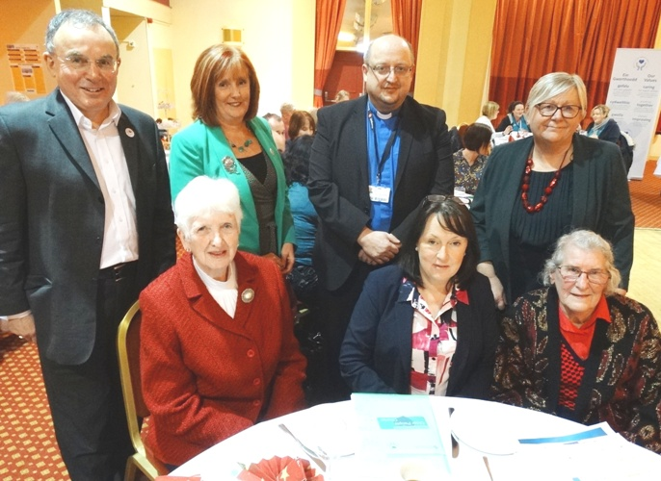
(Back, from left) ABMU Chairman Prof Andrew Davies, Assistant Director of Strategy Joanne Abbott-Davies, Head of chaplaincy and spiritual care the Rev Lance Sharpe and Director of Therapies and Health Science Christine Morrell with (front) Catherine Coombs, of Swansea Over-50s Forum, Older People’s Commissioner for Wales Sarah Rochira and guest Kay Coleman.

“Older people are the largest users of our services so it is very important for us to develop this charter. It is something we’re very proud of, especially as we have been guided by the public and what they want.”

She and Assistant Director of Strategy Joanne Abbott-Davies led the project to create a charter, which outlines the basic rights an older patient can expect to be upheld, based on the UN Declaration of Rights of Older People.

A series of engagement events were held earlier this year giving third sector groups, carers and the public the chance to say what was important to them – and nearly 600 older people and those who work with them took the opportunity. This was then further developed through discussions with staff.

Christine added: “All older people possess the same lifelong rights as any other adult in Wales, we sometimes need to be reminded of these rights and that is the purpose of both the Declaration and our Older Persons Charter.”

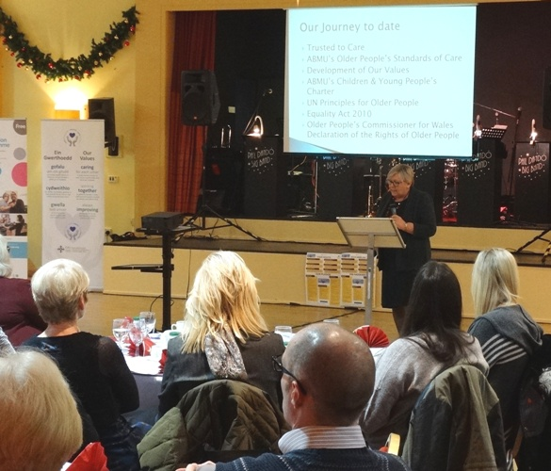
It is the second groundbreaking document of its kind launched by the health board this year. The Children’s Rights Charter setting out basic human rights for children and young people using health services, and became the first of its kind in Wales when it was launched in March.

Christine Morrell outlines the charter to guests at the launch.

The Older People’s Charter was launched at a special event in Port Talbot which not only brought together those who had helped shape it but also representatives of the younger generation – pupils from nearby Sandfields Primary School who joined guests for an afternoon tea dance.
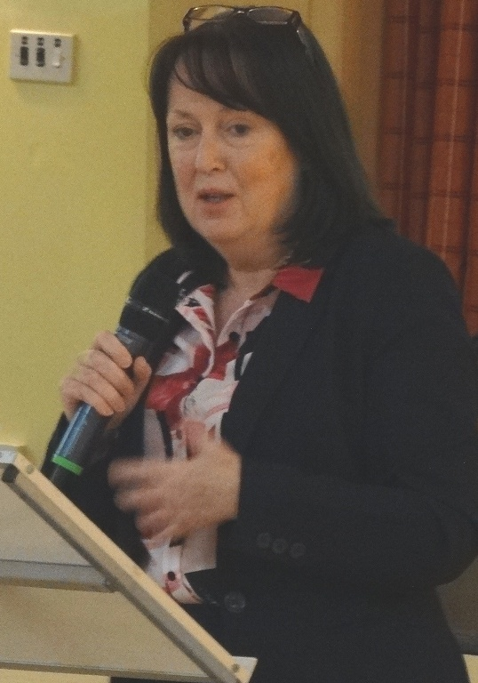
Congratulating ABMU on the initiative, guest speaker Older People’s Commissioner for Wales Sarah Rochira (right) said: “We have all got a huge vested interest in what you have done.

“A rights-based approach to care is good for you and those that you love. What you are beginning here is really really important.”

To reinforce the health board’s commitment to care for the elderly, the event also saw the announcement of a major investment of £156,000 for 60 new Hi-Lo beds.

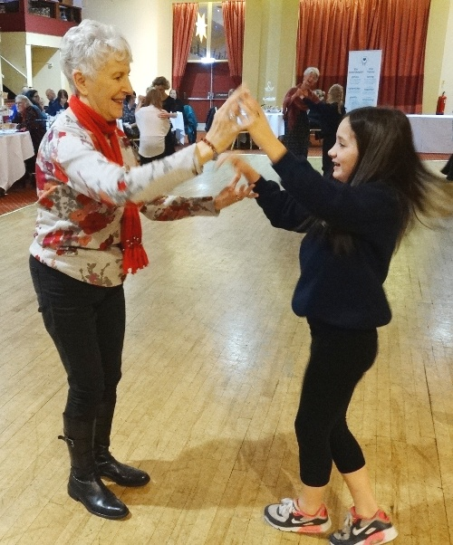
The specialist beds, which aim to reduce risk of patient falls and staff injuries, will be divided between mental health and learning disabilities, Neath Port Talbot, Morriston and Princess of Wales hospitals. Singleton Hospital already has its own.

The cost of the new beds will be paid for from the health board’s charitable funds.

ABMU Chairman Andrew Davies, who opened the event by thanking everyone who had contributed to the charter, added: “We know the average age of our patients is increasing and we are caring for more frail and elderly people. That is why we need to focus on older people’s needs as reflected in our new Charter.

“These new Hi-Lo beds will really help enhance care for older patients in key areas of our services.”

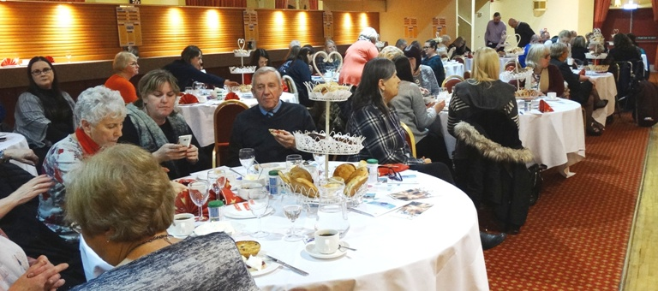
A tea dance brought the generations together following the formal launch.

Source: Abertawe Bro Morgannwg University Health Board

