Second Sepsis 6k charity run to take place in Swansea
Friday, 17 August 2018
Trainers at the ready – the second annual Sepsis 6k charity run will take place in Swansea next month.
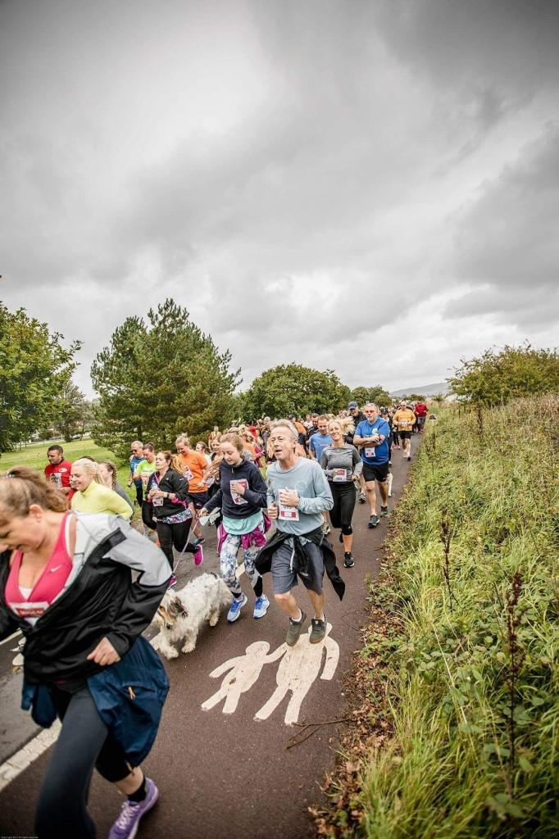
The event is again organised by Morriston Hospital staff as part of their campaign to raise awareness of sepsis – known as the silent killer.
Last year’s hugely successful inaugural event (left) raised thousands of pounds, and a limited number of places are now available for the second.
Morriston’s Emergency Department set up a working group called SeGMED (Sepsis Group Morriston ED) in 2016.
Their mission is to improve the recognition and management of sepsis in ABMU, and raise public awareness of sepsis across Wales.
Their work led to them receiving the Putting Patients First award at the 2018 ABMU Chairman’s Awards.
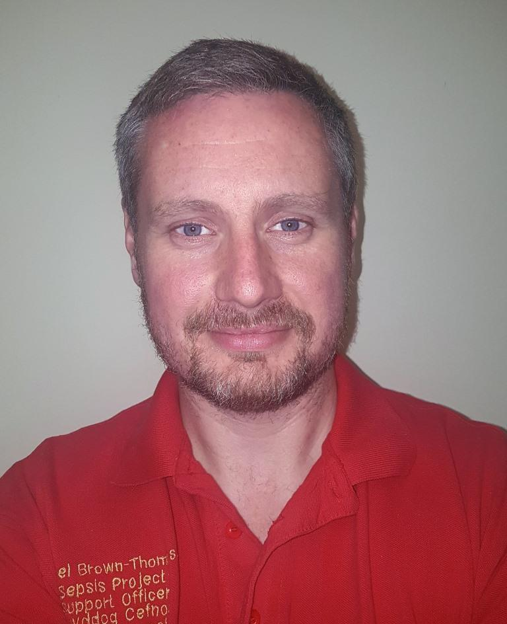
Sepsis project support officer Michael Brown-Thompson said: “We pride ourselves on the work we are doing in Morriston.
“We have a long road ahead of us but we couldn’t have achieved what we have done to date if it wasn’t for the hard work and dedication of the sepsis team and the hospital as a whole.
“We thank everyone for their support and look forward to what the future will bring with sepsis awareness in Wales.”

Right: Michael Brown-Thompson
Sepsis occurs when the body’s response to infection injures its own organs. This can lead to shock, organ failure and death, especially if it is not recognised and treated early.
Very often it is caused by common bacteria which people come into contact with every day without any adverse effects.
Early detection and treatment is the key to preventing deterioration. But identification can be difficult because the symptoms often resemble other, less serious conditions.
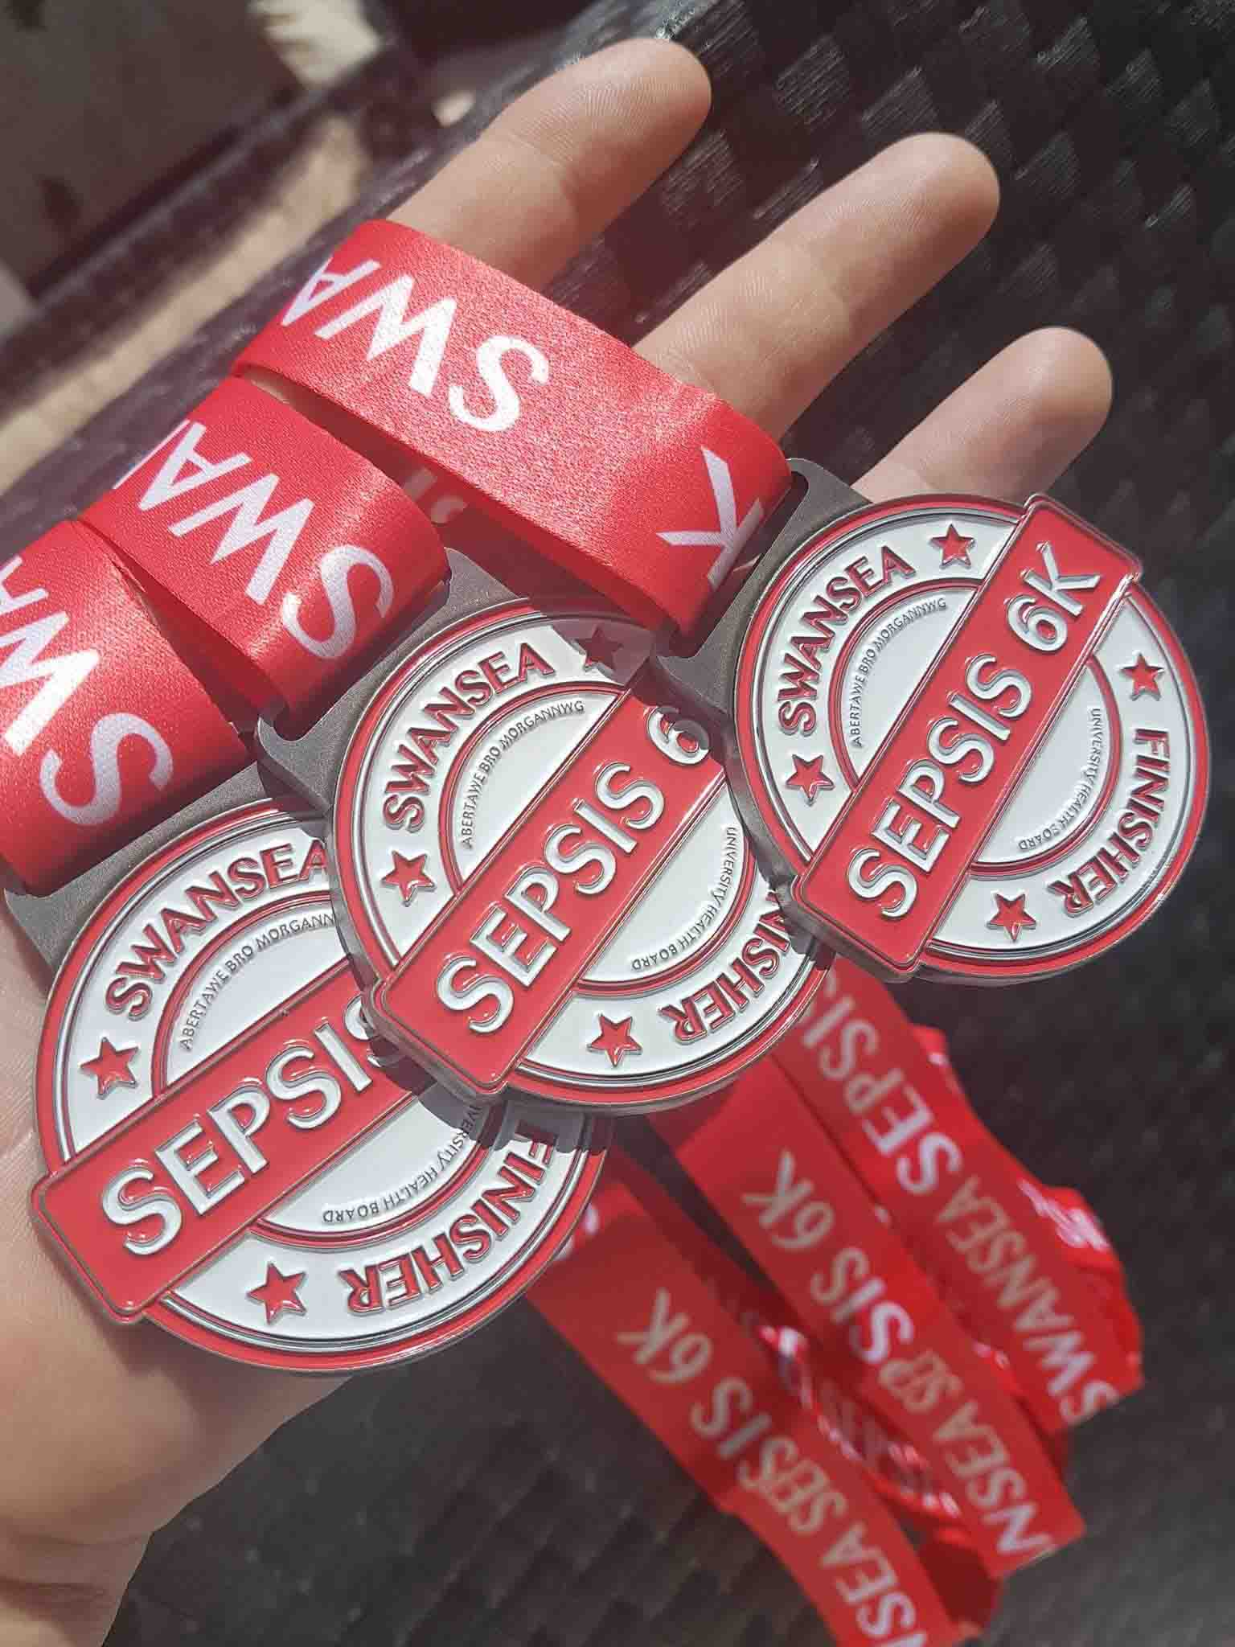
As part of their campaign, the SeGMED team have updated the existing sepsis screening tool using the latest research and data, making it more accurate and in-depth, yet easier to use.
They have also hosted a series of open days to promote early treatment and management of sepsis among staff.
Meanwhile, the hospital’s sepsis champions are actively supporting the campaign and helping to spread the word about how important early detection is in treating the condition.
Last year the team organised the Swansea Sepsis 6k. It was named after the half-dozen interventions clinicians can use – collectively known as the Sepsis Six – including antibiotics and fluids.
That raised £8,000, with the fund receiving donations from various people and companies, including TK Maxx which gave £1,500.
The 2018 event, organised by SeGMED and Unison, will take place on Sunday, 30th September. It will set out from the Blackpill Lido at 12.30pm, with registration starting at 10.45am.
Mr Brown-Thompson said: “This year’s run is open to staff and members of the public.
“Places are limited to 499 so we are advising people who want to take part to register in advance.
“Children are welcome to join us as we want this to be a family event, but they will have to be registered.”
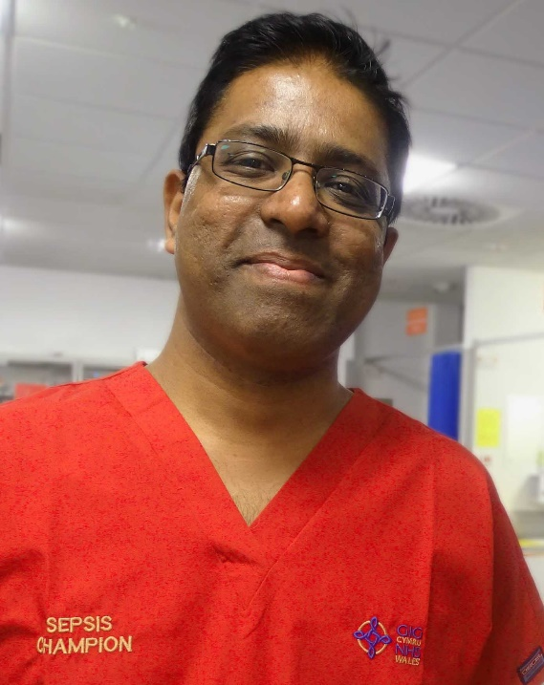
Proceeds will go to the Morriston ED Sepsis Fund, which the team set up last year.
Morriston’s sepsis clinical lead Dr Rangaswamy Mothukuri (pictured right) said: “The fund is used for education, equipment and supporting further sepsis awareness campaigns and events in the hospital and the community.”
You can register for the run here.

And you can donate to the Morriston ED Fund’s JustGiving page here.

Source: Abertawe Bro Morgannwg University Health Board

