Brave George conquers Pen y Fan to raise funds for baby unit
Tuesday, 7 August 2018
George Webborn’s arrival into the world was fraught with panic.
His mum Naomi had to have an emergency Caesarean section and then her new son was diagnosed with a serious and rare birth defect, which prevented him from feeding properly.

But the pair were supported through those first frightening hours by staff at Swansea’s Singleton Hospital, which enabled George to not only survive, but thrive.

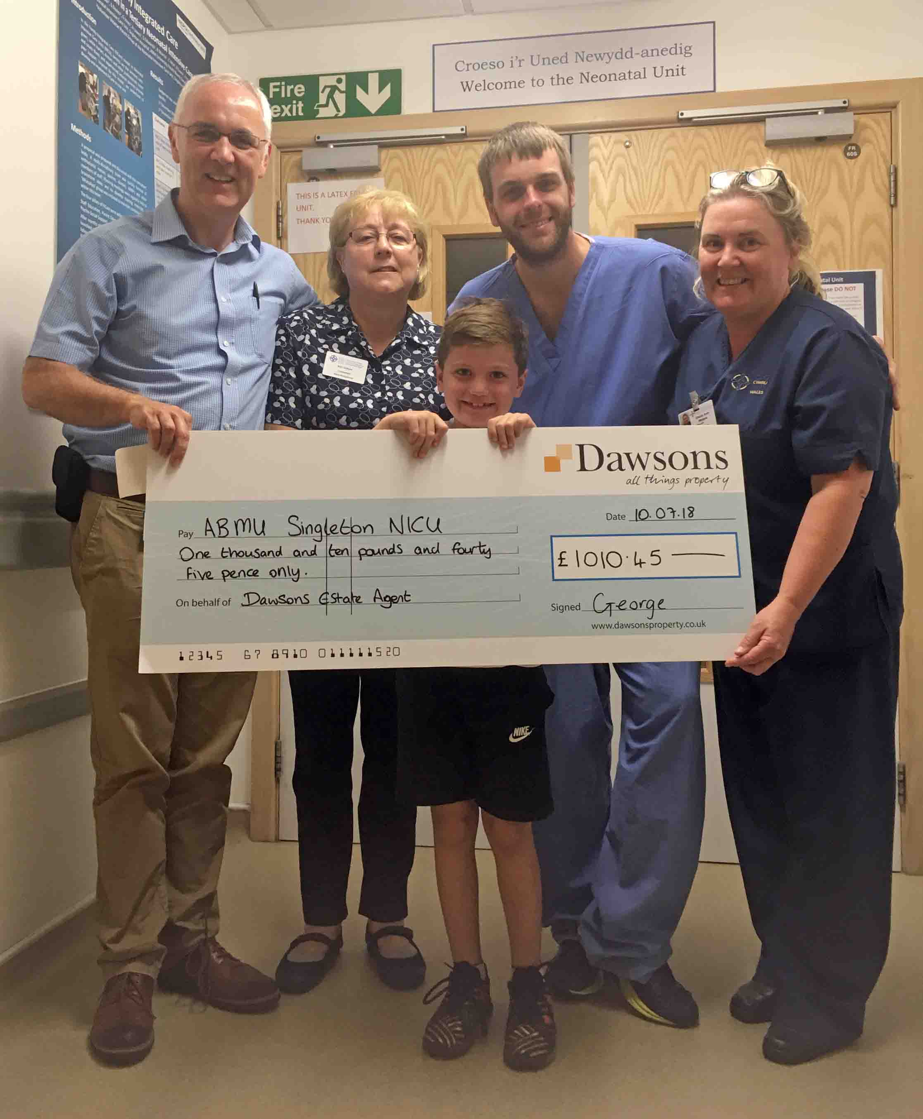
Now aged seven he has returned to the neonatal unit to say a big thank you.

He presented staff with a cheque for more than £1,000 which had been raised by George and staff from Dawsons Estate Agents in Swansea – where Naomi works – when they undertook a sponsored walk up South Wales’ highest peak, Pen y Fan.

Left: George Webborn, seven, presents the cheque to staff at Singleton Hospital’s neonatal unit

Naomi said George had been determined to complete the tough challenge in April.

“He has developed well beyond our and the paediatricians’ expectations in so many ways. But when he said he wanted to take part in the sponsored Pen Y Fan climb I was sceptical,” said Naomi, who lives in Sketty, Swansea.

“But he not only did it, he carried the banner and half way, when I had to turn back as my youngest was not feeling well, he stated he must get to the top as soon as he could as he was carrying the banner for the photo with everyone.

“He had such determination and was so proud of himself. Also, when he came to Singleton to present the cheque and was asked questions, he really opened up and was not the shy boy he has always been.

“Whilst we reached our monetary target, I think this climb has truly allowed George’s self-confidence to grow.

“He is now looking at other ways he can raise money for both the hospitals that saved him and the charity TOFS (supporting those born unable to swallow) which is fantastic for us to see.”

George was born in Singleton in November 2010, where paediatrician Dr Maha Mansour diagnosed him with tracheo-oesophageal fistula (TOF) and atresia.

TOF is where a connection forms between the lower part of the oesophagus and the windpipe (trachea). This causes air to pass from the windpipe to the oesophagus and stomach, and stomach acid to pass into the lungs. These defects mean affected babies cannot swallow safely, if at all.

Atresia is a condition in which the upper part of the oesophagus doesn’t connect with the lower oesophagus or stomach, meaning food cannot reach the stomach.

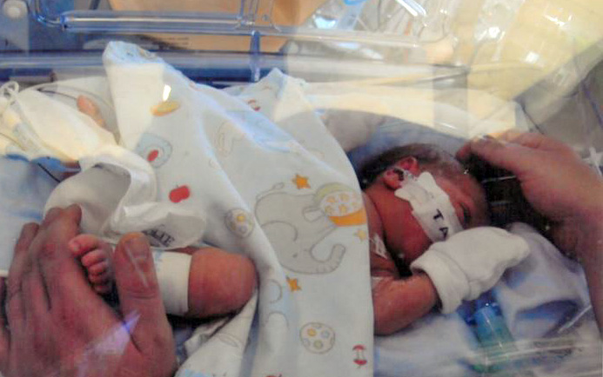
Right: George pictured just after he was born

Naomi said: “George only spent a few hours in Singleton NICU (neonatal intensive care unit) before being transferred to the University Hospital of Wales in Cardiff for an operation, but the staff were extremely thoughtful and helpful in our brief time there.

“He has since undergone a series of hospital visits with further investigations due to breathing and choking difficulties and internal bleeding. He’s also had operations and barium studies.

“But he has a huge commitment to raising money for both the hospitals that saved him and the TOFS charity, which is fantastic for us to see.”

The total amount raised by George and Dawsons, which carries out several charity fundraising events every year, was £1,010.

Geraint Morris, clinical director of children’s services at ABM University Health Board said: "This is a fantastic achievement for George, who along with his mum’s colleagues, and at such a young age, raised a substantial amount of money for our neonatal unit by climbing South Wales’ highest mountain.

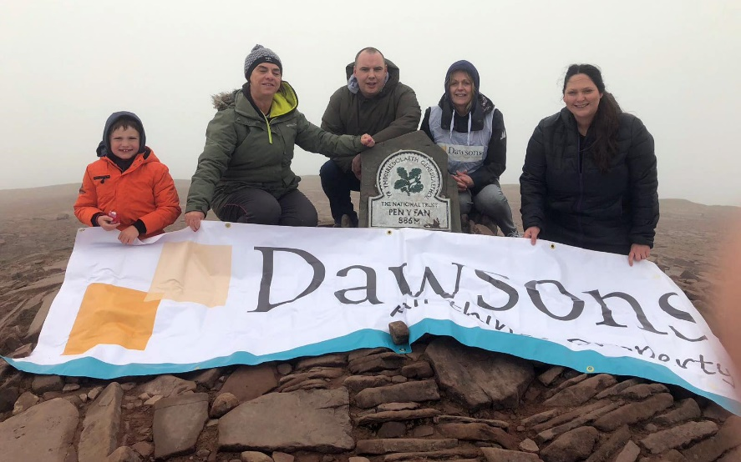
“It’s great that the team felt that the money should go to the neonatal unit where George himself was cared for after he was born.”

Left: George Webborn, seven, on top of Pen y Fan with Julie Long, Simon Mclaren, Alison Williams and Gemma Savage, who all work for Dawsons Estate Agents

Source: Abertawe Bro Morgannwg University Health Board

