Apprentice team wins top workforce award
Wednesday, 22 August 2018
They are dedicated to strengthening and developing the health board’s workforce so patients can access the best possible care.
But now the team behind many staff achievements has itself secured an award.

The ABMU Apprentice Academy, which offers apprenticeship opportunities in a number of departments, has received the People’s Choice Award for Excellence in Workforce, OD (Organisational Development) and HR (Human Resources) at the HPMA Wales Awards 2018.

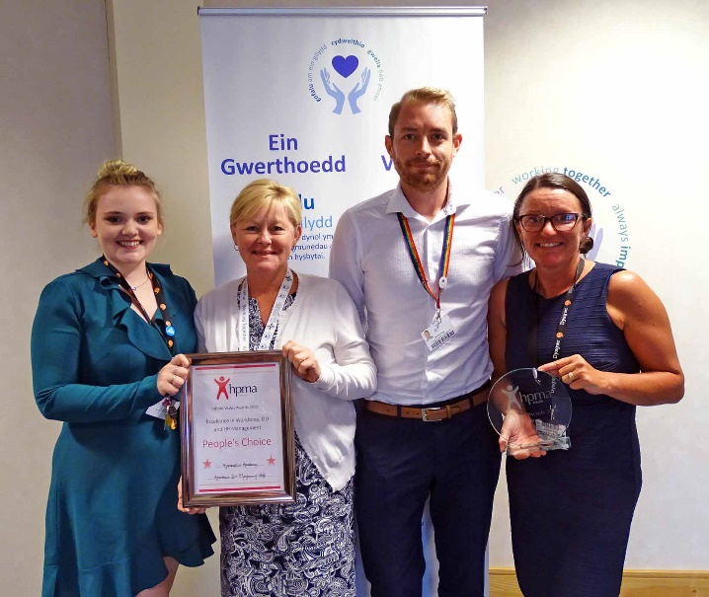
The academy, managed by Ruth Gates, is endorsed by ABMU leaders and has more than 140 apprentices working in jobs that vary from administrators to health care support workers while undertaking training and achieving qualifications.

Pictured left to right are Giorgia-May Towns, Ruth Harding, Mitchell Jones and Ruth Gates

The academy team includes Mitchell Jones, apprenticeship and widening access co-ordinator (Swansea, Neath Port Talbot), Ruth Harding, apprenticeship and widening access co-ordinator (Bridgend) and Giorgia-May Towns, higher-level apprentice learning and development.

HPMA (Healthcare People Management Association) Wales supports and promotes learning among its members.
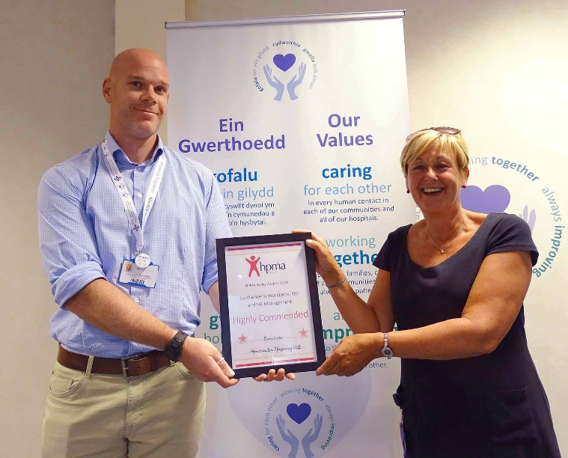
A training programme called Footprints, which supports managers to develop the right behaviours to get the best out of their own teams, was also highly commended for Excellence in Workforce, OD and HR by HPMA Wales.

“It is about retracing our steps and going back to basics and looking at how we can engage our staff to want to come to work not because they have to, but because they want to,” said Ruth.

The Footprints delivery team are Stuart Davies, learning and organisational development manager, and Caroline Cameron, workforce development officer, who are pictured right.
- Are you interested in stepping into a career in the NHS? ABMU’s annual Apprentice Recruitment Open Day takes place this Friday, August 24, at Morriston and Neath Port Talbot hospitals between 11am and 3pm. It’s an opportunity to meet staff from departments that are recruiting in September, discuss the job role and learn more about the various departments.
Source: Abertawe Bro Morgannwg University Health Board

