Team stretch themselves during gruelling 48-hour challenge
Tuesday, 8 August 2017
Eight adventurous colleagues from across ABMU Health Board are recovering after putting their talents to the test at this year’s Exercise Medical Stretch.

The annual challenge, run by 203 (Welsh) Field Hospital, brings together teams from all over NHS Wales along with DVLA staff for a series of tasks and challenges.

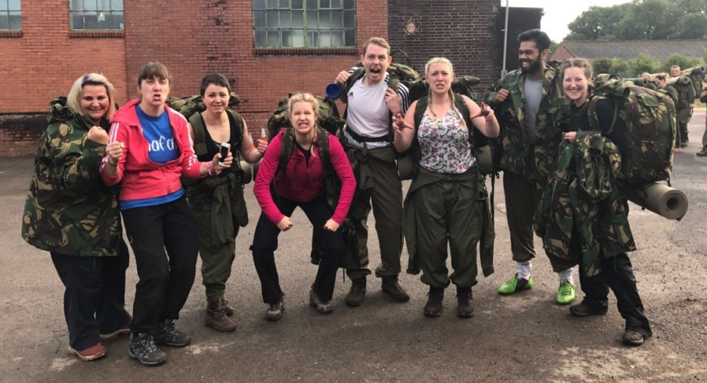
ABMU’s Exercise Medical Stretch team (from left) Karen Jackson, Tracey Scogings, Ruth Davies, Meghann Reynolds, Mitch Jones, Abi Young, Bahar Chowdhury, Sarah Hatfield.

It aims to give the participants a chance to develop a range of skills, including teamwork, problem solving and leadership, which they can bring into the workplace.

ABMU has won the event for the past two years and in the team hoping to secure a third victory were Abi Young, Ruth Davies, Sarah Hatfield and Meghann Reynolds (graduate trainee managers at Neath Port Talbot, Primary and Community Care, Singleton and Morriston respectively), apprenticeship and widening access coordinator Mitch Jones, legal services officer Bahar Chowdhury, MIU receptionist Karen Jackson and Tracey Scogings, acute pain CNS at Princess of Wales Hospital.

This year’s event, hailed as the most challenging yet, saw 10 teams kicking off the weekend by spending the night in a disused aircraft hangar at the Caerwent Army base in Monmouthshire.

After just four hours sleep the team took part in a gruelling 12-hour challenge involving navigation, cross country hiking and a range of physically and mentally demanding timed tasks.
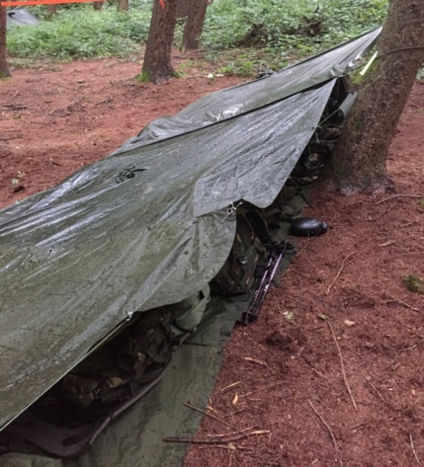
This was followed by a rainy night spent sleeping in the Welsh forest in a makeshift shared bivi (left).

In drier weather the following day, the team rounded off the weekend with a PT session, half-mile team stretcher run over rolling hills and a stint on the shooting range.

Despite suffering injuries and blisters and enduring saturated clothing the team members not only managed to push themselves to their personal limits but also pulled together as a unit to persevere and successfully complete every challenge.

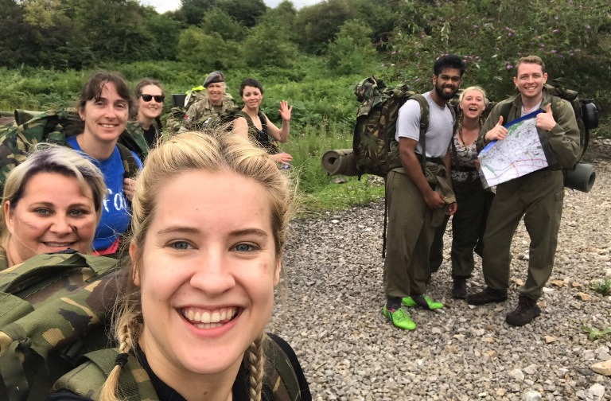
From unscrambling coded messages to scaling walls carrying equipment, reassembling a cannon and pulling a Land Rover to escape from enemy territory, the team kept smiles (or were they grimaces) on their faces.

Meghann Reynolds said: “Although it was one of the toughest 48 hours we have ever endured, the shared experiences and personal accomplishments made every single second of pain and every single blister completely worthwhile.

“The weekend was brutal but brilliant, and I will definitely be signing up for next year and urge anyone who is curious to join me.”

The team will be reunited with their fellow participants at a special presentation when they can share their experiences and reflections about the weekend.

They will also find out their overall ranking in the final results and see if the coveted Exercise Medical Stretch Trophy remains in ABMU hands.
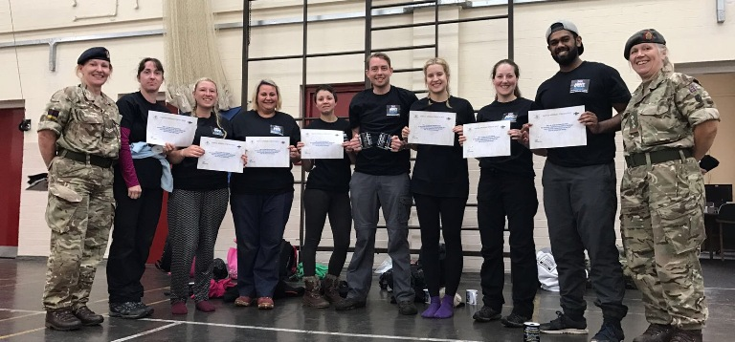
The team with their certificates after successfully completing the challenge.

Source: Abertawe Bro Morgannwg University Health Board

