School nurses spread healthy messages to children during summer holidays
Tuesday, 22 August 2017
It may be the summer holidays but ABMU school nurses have been as busy as ever spreading healthy messages to youngsters.

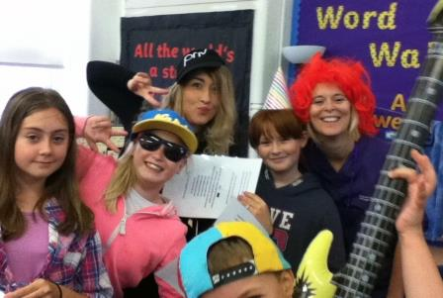
They have been making a splash sharing the importance of good hand hygiene, and how it can keep the bugs at bay, to primary pupils in Neath Port Talbot.

School health nurse assistant Lauren Puckett and second year student Clare Williams with some of the youngsters on the summer programme

The youngsters at Ysgol Bae Baglan, Eastern Primary and Melin Primary schools were enjoying activities as part this year’s school holiday enrichment programme organized by Neath Port Talbot Council.

The nurses came along in fancy dress to deliver sessions attended by the pupils and their parents, and showed them how to wash their hands properly using glitter and a glow box.

School nurse Clare Donoghue explained: “When the children put their hands underneath the glow box it shows up where there are still germs so they can see with their own eyes just how to do it properly.
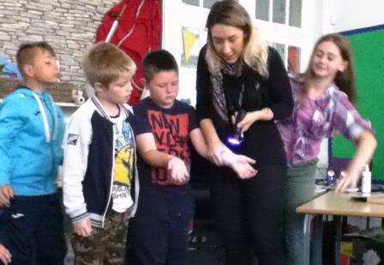
“The message is such a simple one but it really matters – good hand hygiene stops the spread of germs which is vital in schools as we head towards the flu season this winter.”

Right: School health nurse assistant Lauren Puckett demonstrates the importance of hand washing; below: the glitter box exposes any germs

The Welsh Government-funded enrichment programme offered summer fun clubs complete with lunches to help parents cope with the long break.

The idea was to help support disadvantaged families who normally rely on free school meals for their children during the year.

The scheme ran in the Neath Port Talbot area for three weeks. Pupils who attended not only enjoyed fun activities but also received visits from other public services including the police and fire service.

“We were up against some really tough competition but we were determined to make our contribution as entertaining as possible for the children,” said Clare.
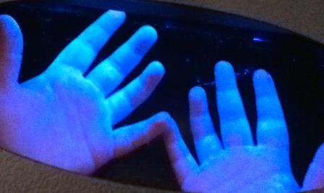
“We came in dressed up with props like blow up musical instruments and we had made up a song all about handwashing to the tune of Uptown Funk to get the message across in a fun way.

“We wanted to grab their attention and stop them from getting bored – and the kids loved it.”
Clare said the events had also given the school nurses a chance to meet the children they help look after all year round.

“We had the opportunity to interact with the children and families now know who they can talk to if they do have any health concerns.

“We spent the day with them so they really got to know us and that will make things easier when we come to school later this year to give them their nasal flu vaccinations.”

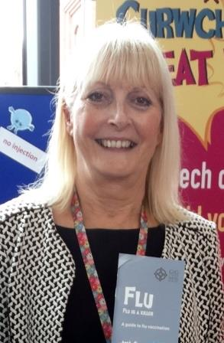
ABMU’s lead nurse for school health nursing Susan Jones (left) said taking part in the programmes had come at one of the busiest times for school nurses but had been very useful.

She said: “This work really highlights that children and young people living in ABMU have access to their school nurse 52 weeks of the year and how we work in partnership with our local authority colleagues to make that happen.

“We are currently preparing questionnaires that will go out to parents of new reception pupils about the health, weight and eye checks that we carry out for children.

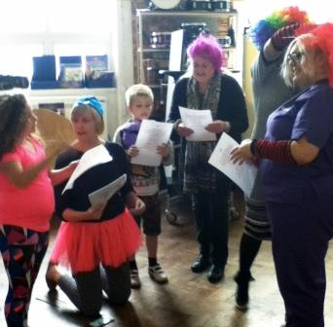
“Everyone has a school nurse and by sharing healthy messages now we are helping children to grow up to be healthy adults.”

Right (L-r): School health nurse Clare Donoghue, school health nurse assistant Gaynor Jones, school health nurse Precious O’Driscol and student Jayde Summer Cook in action.

ABMU’s 41-strong team of school nurses looks after pupils in 218 schools and this year they will be giving the Fluenz nasal spray to children in reception class and Years one, two, three and four in primary school.

They are hoping to build on their success which saw them win a Public Health Wales Beat Flu Award earlier this year for their work increasing the number of eligible children vaccinated after influenza.

In 2016/17 the nurses vaccinated more than 17,000 children, an increase of 12 per cent on the previous year.

Susan explained why having the flu vaccination is so vital for children: “It's important for any child or young person with a chronic condition that puts them in a high-risk group to be vaccinated as flu is likely to be more debilitating for them.
“It is important for children in the primary school programme themselves to avoid flu but evidence also shows this age group is the one which spreads the flu bug in the community.

“So being vaccinated helps to protect the whole community and especially the older generation who can be very poorly if they are infected. Remember it's just a nasal spray...no needle involved!”

Source: Abertawe Bro Morgannwg University Health Board

