Physio Tom first in Wales to switch to intensive care role
Tuesday, 29 August 2017
A Morriston Hospital physiotherapist has become the first in Wales to be accepted for an exciting new role in intensive care.
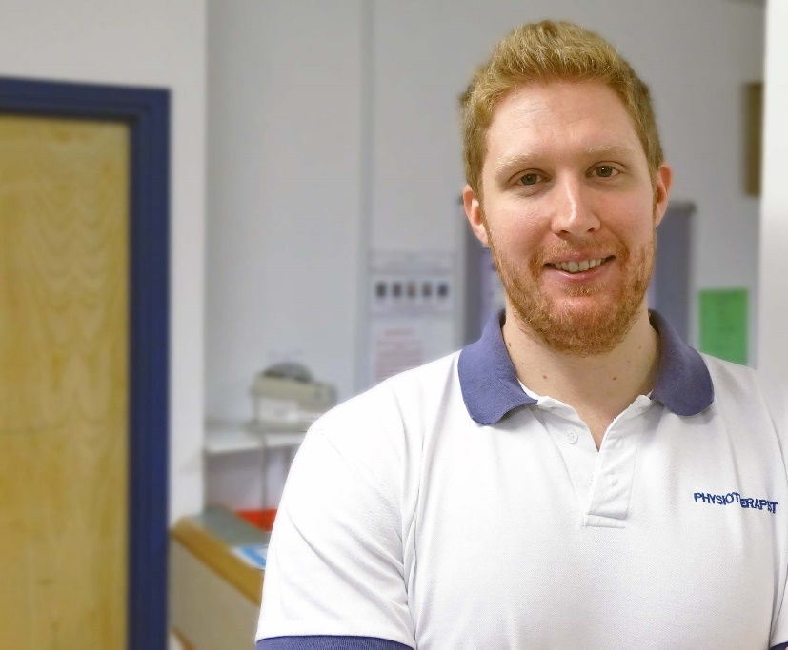
Tom Bromfield is one of just a handful of physios across the UK to be taken on as an Advanced Critical Care Practitioner trainee.

These places are normally awarded to senior intensive care nurses and are highly sought after.

Tom, who has worked in Morriston Hospital since 2012, is a respiratory physiotherapist based within the critical care unit.

“A lot of people come in with complications like pneumonia or chest sepsis,” Tom said.

“These patients can also go on to suffer with muscular weakness and general deconditioning.

“My physiotherapy work while on the ITU usually involves managing patients’ chests and also providing rehabilitation during and after their critical illness.

“There’s a lot of evidence that rehabilitation helps people get out of ITU quicker and leads to better outcomes.”

The role of Advanced Critical Care Practitioner is a relatively new one.

There are currently three ACCPs working in Morriston’s Ed Major Critical Care Unit – named in honour of the former lead clinician and director of critical care who founded it.

Tom said: “I saw what the ACCPs were doing and it really appealed to me. It seemed like a natural progression.

“Over time I had become more involved in other aspects of intensive care that weren’t just physio-related. That gave me a taste for wanting to do more – and I felt like I could do more.”

ACCPs are clinical professionals who receive further training to be able to make critical decisions that can save lives.

They are trained to diagnose and treat healthcare needs or refer to an appropriate specialist if necessary.

They work with all members of the multidisciplinary team, including intensive care clinicians, surgeons, physicians, nurses and allied health professionals.

Tom, who is originally from Gorseinon and still lives in the area, did his BSc honours degree in physiotherapy at Oxford Brookes University.

“I have always wanted to do something healthcare-based and looked at various options.

“I was accepted for nursing but decided on physiotherapy because I thought that was what I’d be best suited to.”

After graduating, Tom spent a year working with Buckinghamshire Health Trust before joining the Morriston Hospital team.

He starts his new role in Morriston ITU in September and his training will last two years.

It will consist of a series of Masters-level modules including clinical assessments, requesting and performing diagnostic tests, and carrying out interventions such as inserting lines.

Most current ACCPs have a background in nursing but there are some from allied healthcare professions. Tom is the first physiotherapist in Wales to be accepted, following a long and thorough selection process.

“The number is growing, but there are only a handful of physiotherapists in the UK doing this role so I am really pleased to have been accepted,” Tom said.

ABMU Interim Head of Physiotherapy, Joanne Mahon, said it was a fabulous achievement for Tom.

“He will be a great loss to our department but he has worked really hard to get there and at least he will be staying within Morriston Hospital.

“Although he will be a hard act to follow, he is flying the flag for physiotherapy as a profession but also for ABMU as another first in Wales.”

Source: Abertawe Bro Morgannwg University Health Board

