Mayor’s fundraising mission kicks off with memorial rugby tournament
Wednesday, 16 August 2017
A Swansea mayor has pledged to use his year in office to raise as much cash as possible to support the care of cardiac patients across ABMU.

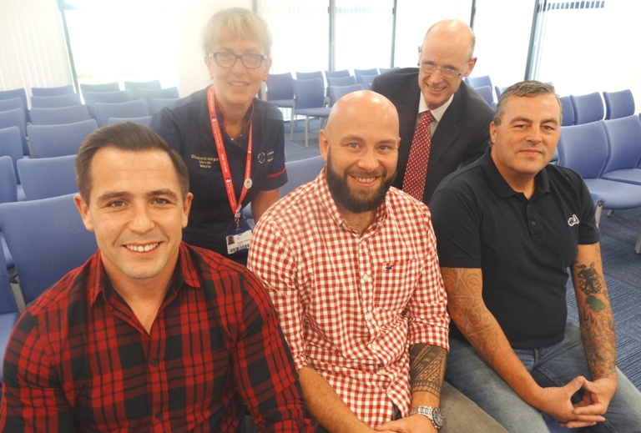
Andrew Stevens, the current Mayor of Gorseinon, is determined to provide a lasting legacy in memory of his friend Richard Thomas who died of cardiomyopathy at Singleton Hospital.

Mayor of Gorseinon Andrew Stevens with (from left) cardiology matron Elizabeth Morgan, Jon Bowen, consultant cardiologist Dr Mark Anderson and Dai Thomas.

Former soldier Richard, known to his many friends as Decky, was just 29 when he died in June after being diagnosed with the condition in 2011.

Andrew, who had played rugby alongside Decky, said when it came to picking a good cause to support as mayor, this had been an easy decision.

“We wanted to do something in his memory so I had a chat with his father Dai before I went ahead and he gave us his blessing. Now I just want to do all that I can to help drive up the total,” said Andrew.

Dai accompanied Andrew and Loughor RFC captain Jon Bowen, another friend and former team-mate of Decky’s, when they visited Morriston Hospital to meet senior cardiology staff to discuss the campaign.

Consultant cardiologist Dr Mark Anderson said: “We are really grateful. It makes such a difference to us and the work that we are doing. We look forward to speaking with Andrew and Richard’s family about how the funding should be used in future to benefit as many people as possible.”

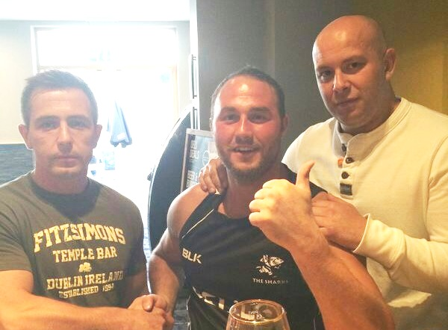
Dai, from Gorseinon, said he would like to increase awareness of cardiomyopathy, a disease of the heart muscle which affects its ability to function normally. There are a variety of related conditions including hypertrophic cardiomyopathy which claimed the life of Terry Yorath’s teenage son and halted the career of Premier League footballer Fabrice Muamba.

Andrew Stevens, Richard ‘Decky’ Thomas and Jon Bowen.

Keen sportsman Decky, who had represented the army at rugby and running, was diagnosed with the condition after breaking his sternum playing rugby.

Dai said: “If it hadn’t been for that injury we wouldn’t have known to his day that he had cardiomyopathy - we might never have found out.

“One thing I would like the money put towards above anything else is awareness. I want to make people aware that no matter how fit and how strong you are you could have this.

“It’s like a brand new car, it may look good but the engine might be faulty.”

Scaffolder Decky had been due to fly to Ibiza to play in a sevens rugby tournament when he was taken ill and he died at Singleton Hospital shortly after hearing his side had won.
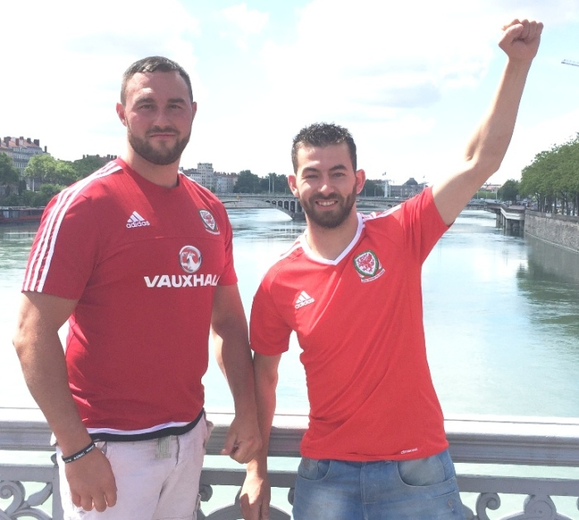
“The nursing staff on Ward 9 were absolutely outstanding, they were brilliant. The night he passed away there was so much going on, one nurse was supposed to have finished but she stayed on with him. I will never forget how staff treated me after he died,“ said Dai.

Richard ‘Decky’ Thomas with his brother Jason.

Cardiac senior service manager Jonathan Gates told him: “From a staff point of view, for you to be thinking of us when you have suffered such a loss really is of enormous value. Our teams work in difficult and challenging situations and to know they were appreciated will be very important to them.”

Dai added: “When Richard was diagnosed the first thing I told him was he would have to give up rugby and scaffolding but he just wouldn’t accept he was ill – and if hell had frozen over he wouldn’t give up rugby.”

Given his passion for the sport Andrew said it seemed only appropriate to kick off the fundraising appeal with a touch rugby tournament which is being held at Loughor RFC on Sunday, 27th August, 2017.

The Decky Memorial Tournament will see 20 teams from a variety of local clubs and social groups doing battle in the day-long event.

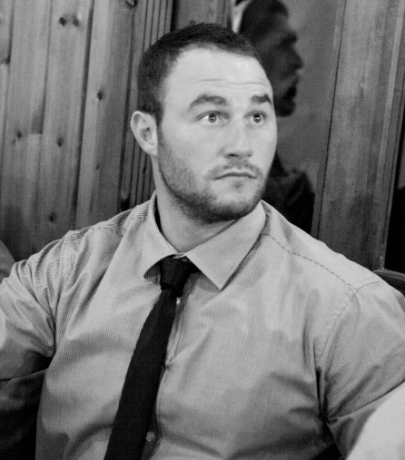
Spectators are welcome to come along to see the matches which will be followed by a hog roast and live entertainment. Among those taking part on the day will be his mates Andrew and Jon as well as Dai and Decky’s brother Jason. Cheering them from the touchline will be his sisters Whitney and Tiffany.

t is hoped this will become an annual fixture for local teams and marks the first of a string of money-spinning activities organised by Andrew who aims to exceed the £2,500 total he has set to raise by his annual Mayor’s Dinner next April.

Richard ‘Decky’ Thomas

Dai added: “We’re making the best of a bad situation, Richard would never have sat around, he would have got up and got on with things and that’s what we’re doing.”

If you would like to support Andrew’s appeal go to https://www.justgiving.com/fundraising/andrew-stevens

To find out more about cardiomyopathy go to https://www.bhf.org.uk/heart-health/conditions/cardiomyopathy/dilated-cardiomyopathy

Source: Abertawe Bro Morgannwg University Health Board

