Health board staff collect mountain of foodbank donations
Friday, 4 August 2017
Caring ABMU health board staff have donated van loads of groceries and toiletries to help local foodbanks, whose stocks are badly depleted.

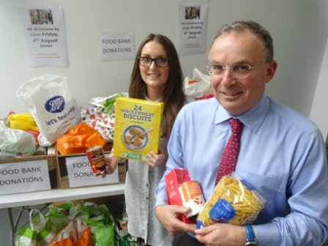
Staff at Morriston, Singleton, Neath Port Talbot, Princess of Wales and Cefn Coed hospitals, and also at the health board’s headquarters, have been gathering bags and boxes of donations this week after it emerged that the school summer holidays had put intense pressure on Swansea foodbanks.

Left: ABMU chairman Andrew Davies, and communications assistant Nia Phillips, with some of the staff foodbank donations.

Families whose children had free school meals have been struggling with the schools closed for six weeks.

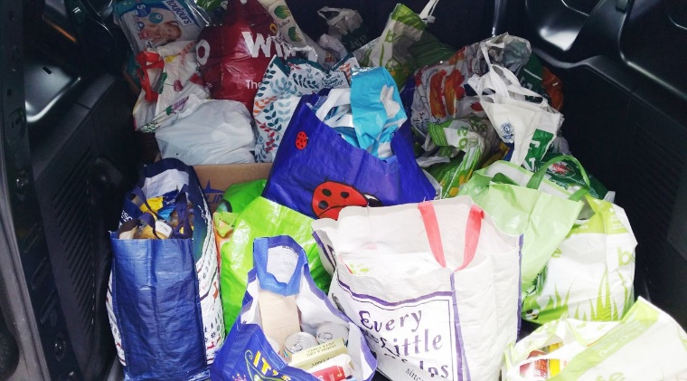
Swansea East MP Carolyn Harris, raised the urgent issue in the media, and kind-hearted ABMU staff immediately rose to the challenge and began collecting.

The Swans Community Trust also lent their support by providing a van and driver to collect the donations from the hospitals.

However so many bags and boxes of goods were donated that the van was packed to the roof from the initial visits to Neath Port Talbot Hospital and health board HQ in Baglan. So the van had to be offloaded first before heading off to the other hospitals to pick up the remaining donations.

Meanwhile, Princess of Wales Hospital donations were collected locally and taken to Bridgend foodbanks.
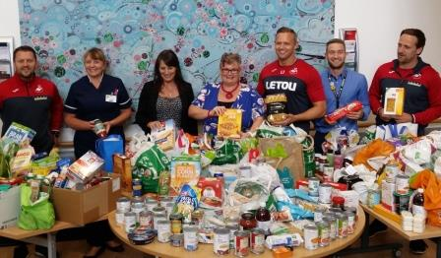
Lee Trundle (third from right) with MP Carolyn Harris (fourth right), Morriston Hospital Nurse Director Nicola Williams (second left) and members of the Swans Community Trust during the collection from Morriston Hospital

ABMU Chairman, Andrew Davies, said:

“I’m really pleased with this fantastic show of support by staff for the foodbanks. The health board is an integral part of our local community and when there is a need like this, it’s heart-warming to see how many staff have responded so generously.”
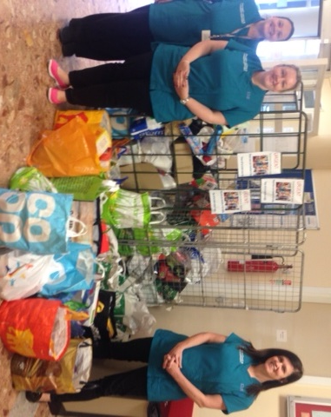
ABMU already holds an annual staff winter collection for homeless people, and is now planning to make the summer foodbank collection another date firm date on its calendar.

Right: Overseeing the collection at Singleton Hospital are the Patient Advisory Team of Hannah Thomas, Emma Davies and Sarah Butchers

Source: Abertawe Bro Morgannwg University Health Board

