From Singleton to Sierra Leone – GP fulfills ambition to help sick children
Thursday, 3 August 2017
A Swansea doctor is swapping Singleton Hospital’s Acute GP Unit for a new challenge volunteering 5,000 miles away in Sierra Leone next month.

Michael Bryant will become the lead paediatric doctor at a medical centre serving the Kono district, which has the same population as the area covered by ABMU Health Board.

He will be joined by his wife Bethany to become the only doctors with paediatric training serving 500,000 people.

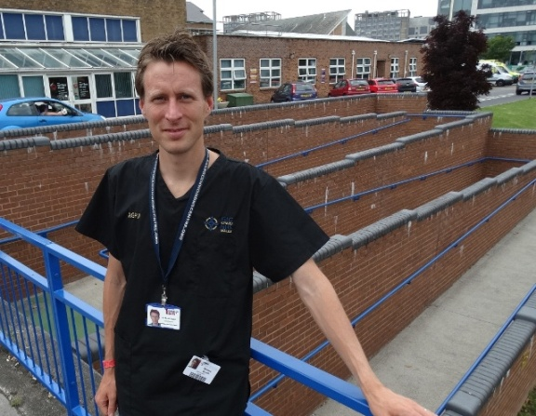
Their immediate aim is to establish a dedicated children’s ward at the Adama Martha Memorial Community Health Centre.

But in a medically deprived country still reeling from the ebola outbreak, their skills are going to be in demand in many other areas.

And, he says, that is why his two years working in Singleton have been so valuable.

GP Michael Bryant outside the Acute GP Unit at Singleton Hospital
and (below) at the medical centre in Sierra Leone where he will be based.

“Here you don’t know what’s coming through the door next. We take referrals from GPs and function initially as a triage service but we do see a lot of unwell patients. In terms of my ability to manage emergencies that has been absolutely vital and it has really benefited my clinical skills.

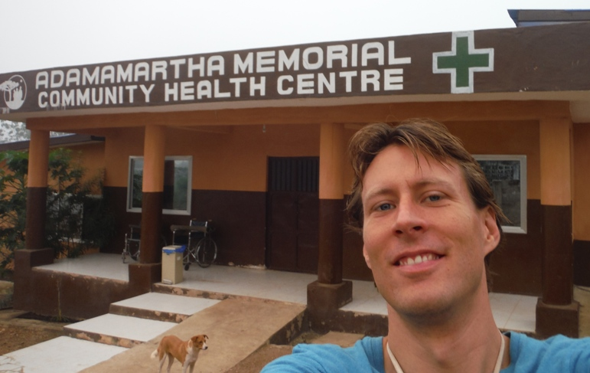
“In Kono there are so few doctors - maybe less than 10 – that inevitably we are going to be doing everything so it is important to have a broad understanding and the ability to work in other settings.”

The health centre the couple will be based at was purpose built during the height of the ebola crisis in 2015 to treat other conditions neglected during the outbreak.

Michael, who also works for the GP out-of-hours service and as a GP at Llansamlet Medical Centre, said: “Malaria and typhoid numbers have gone through the roof and there’s been a measles epidemic due to the devastated immunisation programme.

“We’ve been given a remit to do as much as we can, not just clinical duties but also organising teaching because if you have the right people you don’t need a massive amount of staff.

“In many ways it’s like a game of football, to win you need to do the simple things well – like knowing when to use oxygen and how to do transfusions because when children get severe malaria they become malnourished and can get very anaemic.”

For Michael, Sierra Leone is unfinished business. He had worked there on several occasions, most recently during the ebola crisis when he was involved in identifying suspected cases of the virus.

He had always pledged to return and still carries two ID cards with him – the ABMU one he wears on duty and the one issued by the Aberdeen Women’s Centre in the capital of Freetown where he worked for two years.

“When I arrived in 2010 they gave me this name badge and it is really special to me. I have kept it with me to show I haven’t really left.”

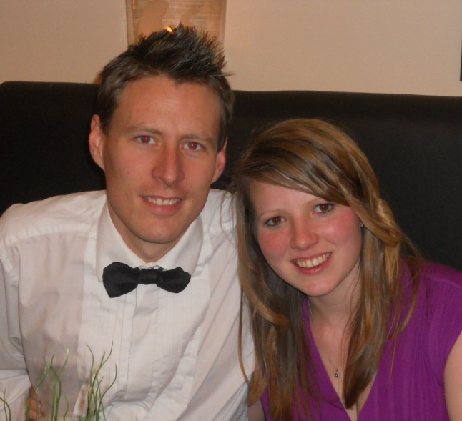
When he does go back he won’t be empty handed. The Bryants, who live in Pontardawe, plan to raise £3,000 for a much-needed blood bank.

Michael and Bethany Bryant.

“The first thing we are going to do when we get there is set up an oxygen system, but the next thing is going to be a transfusion system. We know this will get us off to a flying start.”

They are already over half way to their total but now Michael, a member of Swansea Harriers, and Bethany hope to boost the figure through sponsorship as they take on weekly Park Runs across South Wales dressed in nurses’ scrubs.

Their long-term aim would be to combine working in Wales with time spent volunteering in Sierra Leone.

That way Michael can continue to fulfill an ambition he’s had since his childhood in Senegal where his parents were teachers. When Michael was 12 his younger brother fell ill with encephalitis – an inflammation of the brain.

“He was ill for weeks, a lot of people weren’t quite sure he was going to make it and he would have died if we hadn’t been able to get him to a hospital. That was the trigger for me, not only to study medicine but also to think about the other local people who don’t have access to healthcare. “

He added: “While I’m gone I will miss the way that things really work here at Singleton, there is water, heating, light and oxygen on tap. I come into work every day and things are functioning. Of course, it’s not perfect but there is a structure, whereas in Sierra Leone there isn’t.

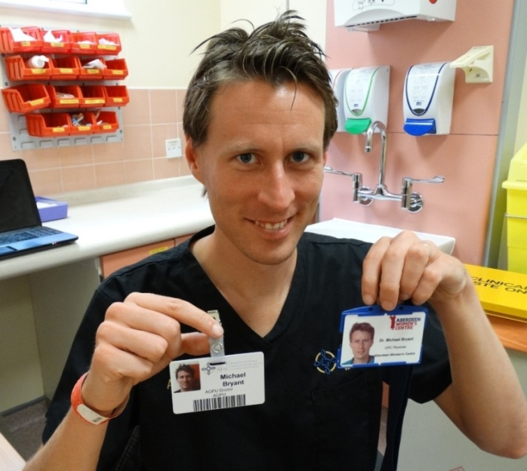
“More than half the population is under 15. Children are being treated but by people who are not trained. They are doing their best in difficult circumstances and they need some help – that’s why we are going.”

Michael Bryant with his two ID badges - one ABMU, the other from his original stint in Sierra Leone.

If you would like to support Michael’s fundraising go to https://www.justgiving.com/crowdfunding/transfusionsforchildren

Source: Abertawe Bro Morgannwg University Health Board

