Doctors provide care to Syrian refugees surviving in desperate conditions
Wednesday, 9 August 2017
Heartbreaking and desperate – these were the scenes that greeted two ABMU doctors who treated hundreds of refugees fleeing the Syrian war.
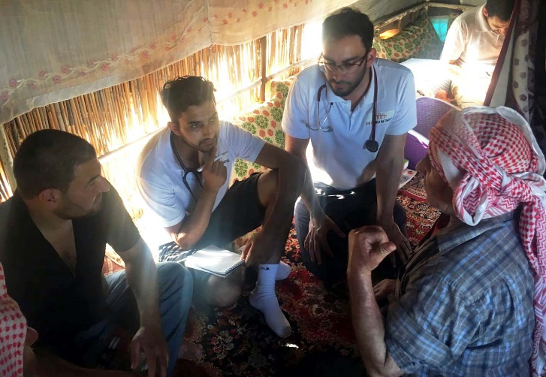
Zubair Wani and Haroon Ali, both from Swansea, travelled to Turkey with three other doctors, part of a wider group of 12 humanitarian workers with non-profit organisation the United Aid Network.

Haroon Ali and Zubair Wani (second and third left) at work in the Adana camp

They raised more than £15,000 before travelling over. Medical supplies including antibiotics, painkillers, creams and dressings, were donated and carried out to Turkey in suitcases.

There are now 4.9 million refugees as a result of the Syrian war, and poverty, poor sanitation and the risk of disease are rife in camps such as those around the city of Adana in southern Turkey where the doctors worked for six days.

These camps are home to around 7,000 men, women and children – all unregistered refugees with no access to food, water, shelter, healthcare and education.

Haroon said what he saw there was heartbreaking. “The situation was desperate. Living conditions were extremely poor.

“Around 10 people would live on the floors of makeshift tents. These people hadn't seen a doctor for years.

“We encountered a wide variety of conditions, from primary care problems to problems caused by the living conditions which were hygiene related.

“A lot of the children were dehydrated, malnourished and had fevers.

“It's difficult to guess how many patients we saw but it was probably hundreds.

“We tried our best with limited resources and were able to diagnose and treat simple diseases, as well as give advice to more chronic problems.”

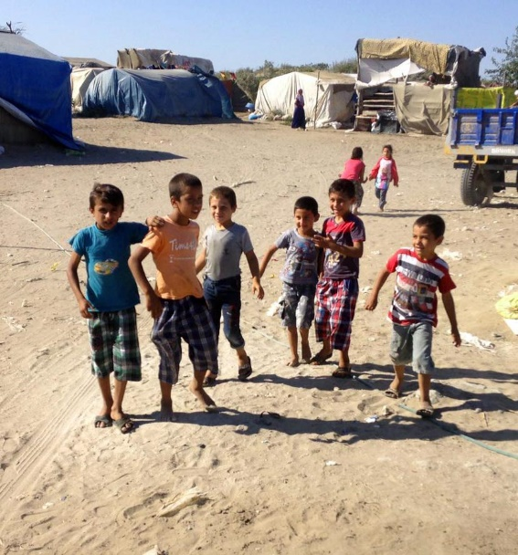
Right: Children at play in their camp

Once word got around that there were doctors present, a huge queue of people quickly built up outside the tent.

Zubair recalled struggling to cope with temperatures of around 40 degrees despite air conditioning – a luxury none of the camp residents enjoyed.

“Women and children worked the fields in the sweltering heat to support their families.

“The toilets consisted of a small tent with a hole in the ground flanked by two sandbags, with waste collecting on the other side.

“There were flies collecting on the other side, and these flies were also in contact with people’s food.

“Needless to say, the potential for disease was evident.”

Despite this, Zubair said, the Syrians were some of the most welcoming and hospitable people he had ever met.

“Given their unfortunate circumstances, they insisted we have tea on each visit, and prepared large meals for us.

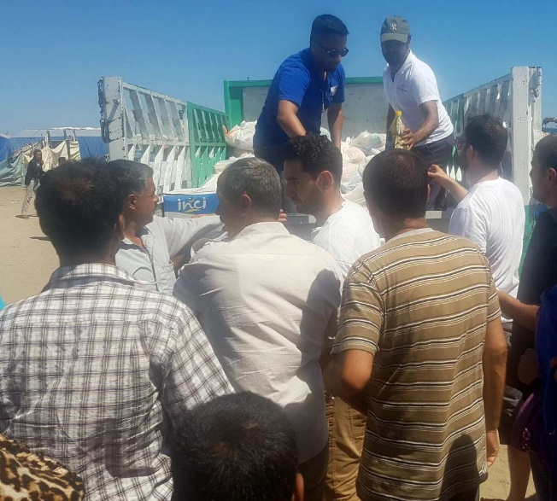
“This presented a dilemma, as I could only guess how many days’ worth of food they had selflessly prepared, but at the same time it is seen as disrespectful to refuse food when offered.”

As well as running the clinic they also worked in a warehouse, organising equipment and making up four tons’ worth of food packs for distribution.

Left: Distributing supplies

Haroon, a junior doctor who has started GP training in Morriston Hospital, said the work was not done as the war showed no sign of ending soon.
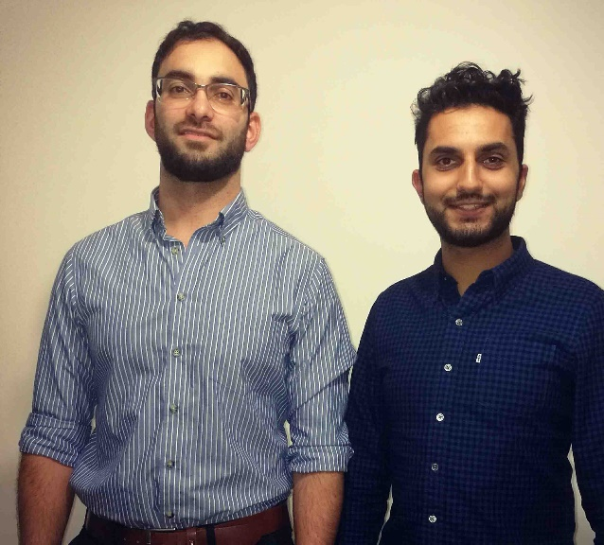
He, Zubair – a trainee GP currently working in palliative care in Princess of Wales Hospital – and the other doctors are hoping to coordinate a regular medical mission to the region in future.

Pictured right: Zubair (left) and Haroon, before they set off for Turkey

“We would like to extend our sincere thanks to ABMU and all of our donors who supported us,” Haroon added.

“Their help was greatly appreciated by the refugees. Every donation made such a big difference to those people that it is impossible to convey in words.”

Source: Abertawe Bro Morgannwg University Health Board

