ABMU wins £10k grant to help preserve historic hospital’s past
Tuesday, 1 August 2017
Exhibitions, computer games and even an interactive 3D model are part of a special project to mark the history of one of Swansea’s most iconic buildings.
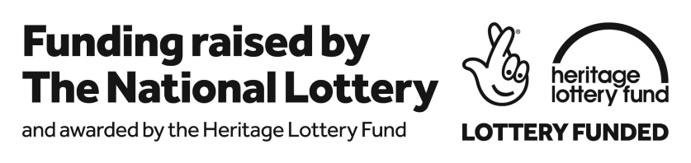
Now the call is going out to former members of staff at Cefn Coed Hospital to come forward to share their memories and volunteer to be part of the project called A Mental Picture: Celebrating the History of Cefn Coed Hospital 1931 to 2018.

Thanks to a £10,000 grant from the Heritage Lottery Fund, ABMU’s own dedicated Heritage Group can now go ahead with its ambitious plans for the multi-faceted scheme which is also set to include specially commissioned poetry, oral histories and a display of objects providing a tactile link to the past.

Heritage Group lead Martin Thomas said the project aims to provide a legacy of information about the hospital which occupies an imposing position on a hill above Cockett - its distinctive water tower can be seen for miles around and even featured in an early Dylan Thomas poem.

Built in1929, it was based on an older, Victorian design and, though it is not a listed building, it is one of the last remaining mental health hospitals of its era in the UK.
No longer considered fit for purpose for 21st century mental health care, services have gradually been transferred to modern purpose-built facilities, some in the grounds of Cefn Coed.

As the building had played such a significant role in healthcare over the decades the group was eager to mark its contribution and capture the working life and stories of the hospital which was originally planned as an asylum serving Swansea and Merthyr.

In his application for funding Martin said: “The hope is that the health board will create a legacy for the future, sharing stories and life from behind locked doors and helping to destigmatise mental health problems through a variety of human stories and creative engagements.

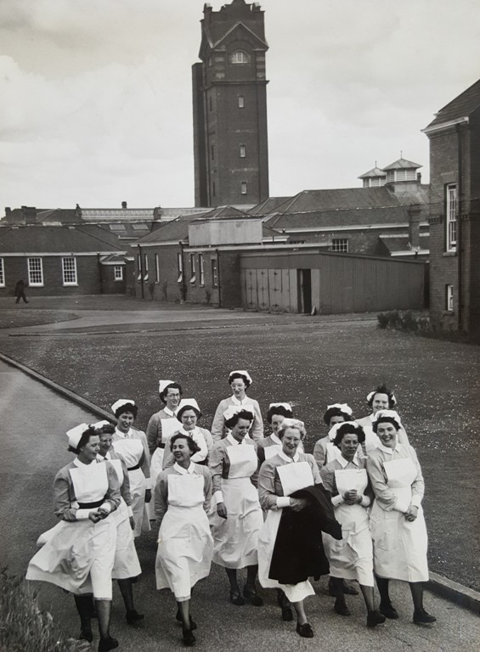
“Our project will document and capture those stories and celebrate its working life through a number of different mediums.”

Nurses at Cefn Coed Hospital during the 1960s.

The Heritage Group was established in 2013 to preserve and protect the health board’s many historical artifacts, since then Martin, assisted by Rebecca Kelly, has been busy collecting and documenting a wide variety of pictures, documents and items from across many sites.

However, this project will be the biggest that they have undertaken and will see them working in partnership with Swansea University and the city’s museum which is providing exhibition space.

It is hoped to use the talents of PhD students currently reading History of Mental Health to assist with the project but Martin says they are eager to get people with more personal experience of Cefn Coed involved.

He said: “I know lots of staff are interested in Cefn Coed‘s history and many of them are part of its story. We are looking for volunteers who would be willing to share their experiences for an oral history recording. It should create a fascinating archive.

“We are also looking for volunteers to be part of the project and help with exhibitions, at Swansea Museum and the university. I can assure anyone who would like to get involved that it will be very interesting work.
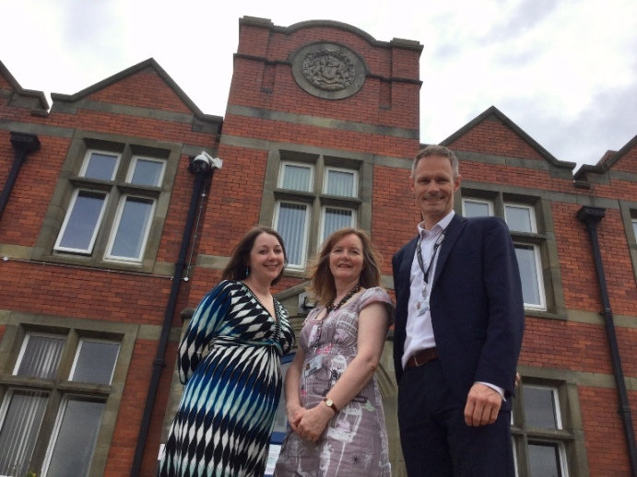
“This whole project – with its many different aspects – will be a way of marking our history like never before.”

ABMU Heritage Group lead Martin Thomas with Rebecca Kelly (left) and property manager Fiona Edwards at Cefn Coed.

Among those elements will be a state-of-the-art 3D digital model of the hospital which will be created using interior photography by Douglas Neil, of ABMU’s Medical Illustration department.

Martin also plans to enlist the support of teenage gamers to help create a special Cefn Coed Hospital version of computer game Minecraft using the original plans of pioneering architect George Thomas Hine.

ABMU Chairman Andrew Davies said: “I would like to congratulate Martin and the Heritage Group on doing a great job in securing the funding. It is no mean feat as I know how much competition there is for lottery funding - it really shows the passion and commitment Martin and Rebecca have for this project.

“As we come up to the 70th anniversary of the NHS next year and celebrating the founding of the NHS in 1948 by Nye Bevan, recording and celebrating the hospital’s history for future generations is very important and this innovative project is a great way of doing that.”

Martin added: “I am very excited about being awarded this grant and I can’t wait to start, although it’s a little daunting considering all the work ahead but I know we will do something special!”

Head of HLF in Wales Richard Bellamy added: “A Mental Picture: Celebrating the History of Cefn Coed Hospital 1931 to 2018 is a fine example of HLF’s Sharing Heritage programme that, thanks to National Lottery players, makes it possible for local people to choose what is important to them, what they want to save, and how they want to spread the word throughout their community.”

To contact Martin email him at Martin.Thomas4@wales.nhs.uk and keep up to date with the group’s latest news at its Facebook page https://www.facebook.com/ABMheritage/

Source: Abertawe Bro Morgannwg University Health Board

