Team’s expert care lets patients recover in comfort of own homes
Monday, 16 April 2018
People suffering a health crisis are being saved the trauma of hospital admission by a community-based team of nurses and doctors.
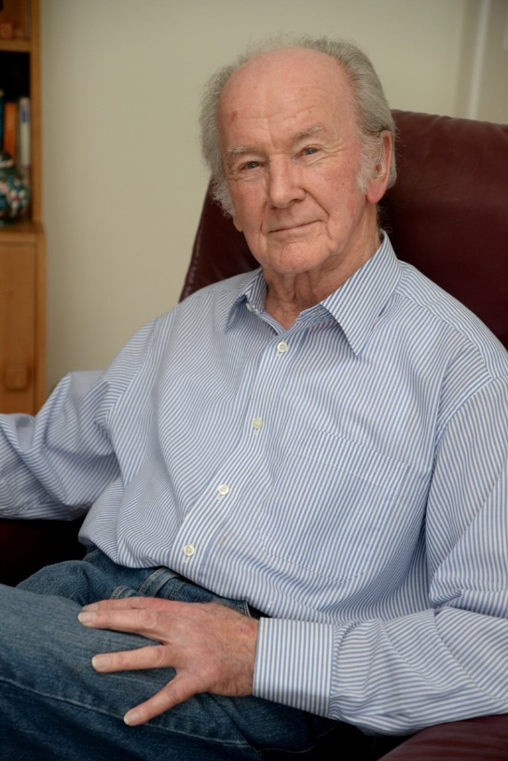
The Acute Clinical Team is giving short-term medical care to frail patients who would rather be treated in their own homes – providing, in effect, a hospital at home.

The team has been helping people like 83-year-old David Randal Davies, (right) who recovered from a serious bout of pneumonia at his home in Penclawdd, Gower.

“I had a very bad cough for weeks that just got worse and worse. The doctor said it was serious and offered me the choice of going into hospital or having treatment at home,” said David.

“They came to see me every day for seven days and I am lost for superlatives.

“There was nothing they could have done in hospital that wasn’t being done at home, except I was in the comfort of my own bed.

“Being at home has a powerful psychological effect and I’m sure I recovered more quickly because of that.

“My being treated at home also saved my wife Margaret, who suffers from severe rheumatoid arthritis, from all the difficulties of hospital visiting.”

The Acute Clinical Team (ACT) is based at Bonymaen Clinic but covers the whole of Swansea. It is an advanced nurse practitioner-led service made up of a consultant geriatrician, GPs, advanced practitioners, community sisters, staff nurses and health care support workers.

They can also call on other teams to provide treatment in the home, like physiotherapy. The team provides care between the hours of 8am and 8pm, seven days a week and 365 days a year.

David’s care needs were assessed by advanced practitioner Emma Lacey after he was referred to ACT by his GP.

“We carried out tests and observations to agree on a clinical plan of action and monitored him every day. Our time with each patient is not limited so we can give them the nursing care they need,” said Emma (left with David).

“They might need our help for just one day or several weeks.”

David welcomed the personal, one-to-one approach in being cared for at home.

“In talking to the staff who come along, you develop a personal relationship and all the care is given in the friendliest of atmospheres,” he said.

The 46-strong team may expand to meet demand as awareness of the service grows. With research showing that the majority of older people wish to be cared for in their own homes, the demand for ACT look set to increase.

“The feedback we’ve had from both patients and GPs has been very positive.

“Once GPs have used the service and are aware of what we do, they come to us again and again,” said Delyth Rucarean, community senior sister.

GP Desiree Bensusan, of the Fforestfach Medical Centre, said: “The Acute Clinical Team has been invaluable to the surgery and has prevented several patients being admitted to hospital by enabling them to stay at home with direct input from the ACT, whilst liaising with the doctors.”

The Acute Clinical Team can also be called out by the ambulance service, social workers, district nurses and the voluntary sector. It also works with paramedics to avoid unnecessary hospital admissions from 999 calls.

The figures reflect the success of the service. ACT helped 1,570 patients in 2017 and saved 1,422 of them from going to hospital. That in turn saved 8,660 hospital bed days.

If patients do end up being hospitalised, ACT can also help achieve an early discharge.

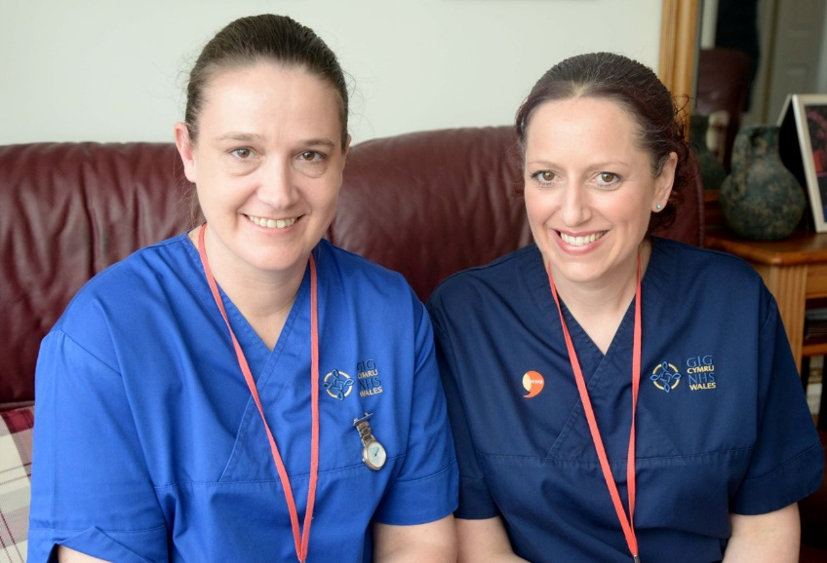
Sarah Davies, Acute Clinical Team lead, said: “ACT provides a multi-disciplinary service, rapid assessment and clinical interventions for patients in the community, including residential and nursing homes.

“The aim is to ensure that the patient receives the right intervention at the right time from the right professional.”

Delyth Rucarean, community senior sister, with Emma Lacey.
- There is also an Acute Clinical Team service in the Neath Port Talbot area, based at Cimla Health and Social Care Centre, and another ACT team covers the Bridgend area from its base at Trem-Y-Mor Resource Centre, Bettws.

https://www.youtube.com/watch?v=1foqESJfC9c

Source: Abertawe Bro Morgannwg University Health Board

