Swansea mini-stroke clinic in the running for national award
Tuesday, 3 April 2018
A clinic in Swansea for people who have had a mini-stroke is in the running for a prestigious national award.

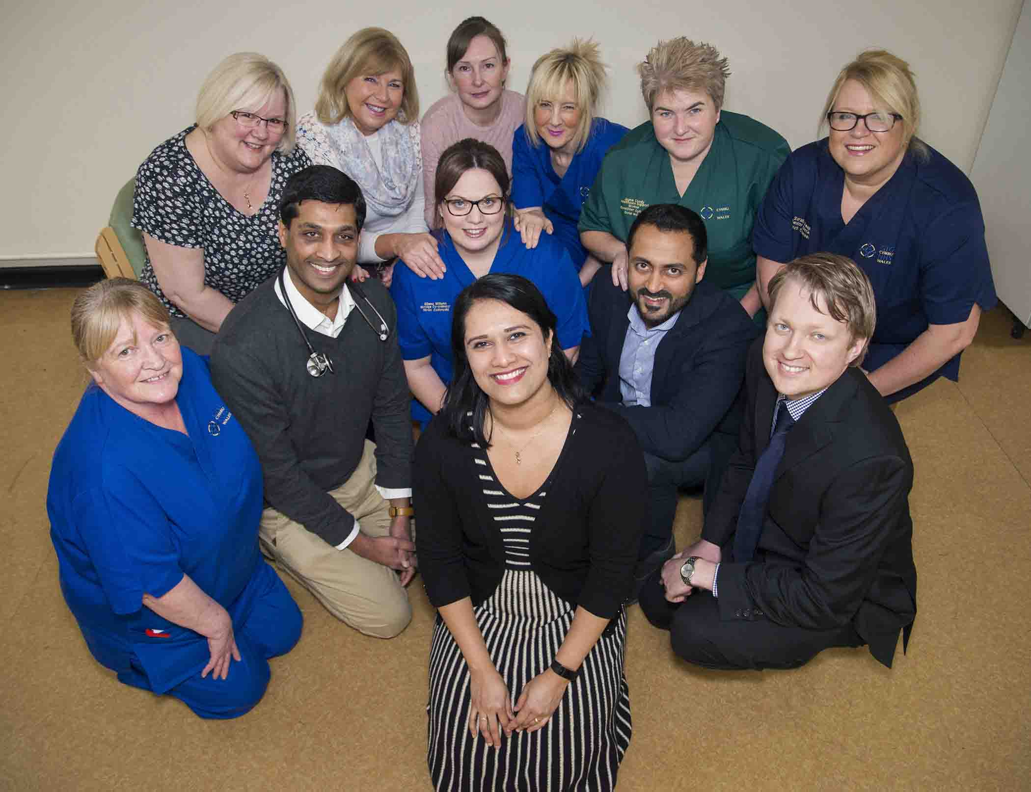
Waiting times at the TIA clinic in Morriston Hospital have been cut from nine days to three in the space of just one year and without additional resources.

Dr Manju Krishnan (front) and the TIA clinic team

Now the project which led to that turnaround has been shortlisted in this year’s BMJ Awards – the only one from Wales to be recognised.

Two years ago the TIA (Transient Ischaemic Attack or mini-stroke) clinic was struggling with an increasing number of referrals.

The average waiting time for the clinic, which sees patients from across Swansea and most of Neath Port Talbot, was nine days.

But, following a clinical improvement project led by Dr Manju Krishnan, that has been reduced to three days.

Dr Krishnan, clinical lead for stroke services in Swansea, said: “We had to find a new way of doing things, within the available resources.

“It was about working differently and flexibly. That is how we were able to achieve this.”

The clinic was established in 2013 but did not have a dedicated space, instead using a side room in the medical admissions unit.

At the time the number of referrals was around 550. By 2016 that had risen to almost 800, making it impossible to see people within the recommended seven days of referral.

TIA symptoms are the same as those of a stroke but last only minutes to an hour. Referrals to the TIA clinic are made by the Emergency Department or a GP, depending on where the person first attended.

Clinic sessions are run by a stroke consultant and specialist stroke nurse. The patient undergoes a range of tests and investigations, and the consultant then reviews the results.

For most people everything, including any medication changes or lifestyle advice, is done in that single visit. However, some may have to return to hospital at a later date if they need further investigation.

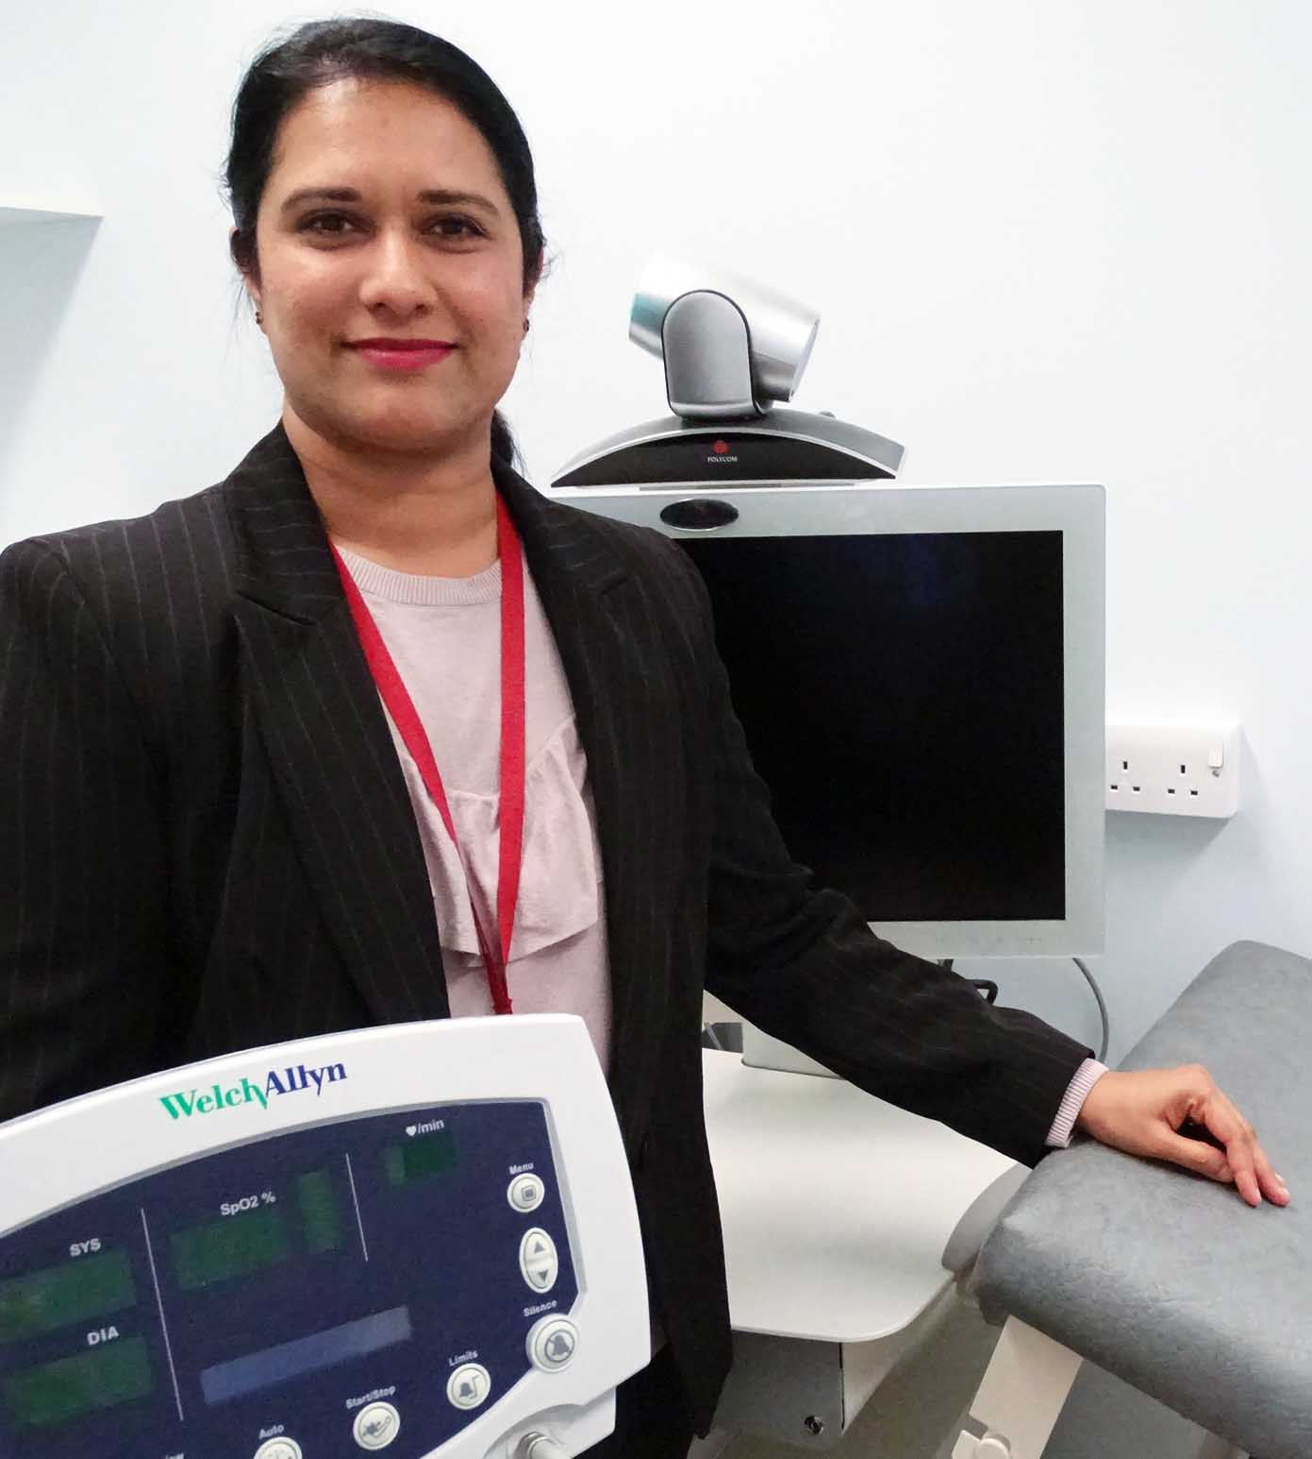
Previously, clinics may have been cancelled because the consultant was either on call, dealing with a medical emergency or on leave.

So Dr Krishnan (pictured right in part of the TIA clinic) introduced a new system to ensure another consultant is available should that happen.

The opening last October of a new TIA clinic in a converted rest room next to Ward F, Morriston’s stroke ward, has also helped the team.

Having this dedicated space provides flexibility to expand the number of patients the clinic can see.

With the support of the Ward F sister, healthcare assistants also now carry out some investigations, such as blood pressure checks and ECGs, which were previously undertaken by the specialist nurses.

Established 10 years ago, the BMJ Awards are the UK’s leading medical awards. The 2018 winners will be announced at the Park Plaza in Westminster on Thursday 10th May.

The Morriston clinic has been shortlisted in the Clinical Leadership Team category.

Dr Krishnan said: “We are obviously very pleased to have been shortlisted for this award.

“We just want the team to be recognised, because it is very much a team effort – so fingers crossed on the night.

“It’s an honour to be representing the health board and to be representing Wales.”

Source: Abertawe Bro Morgannwg University Health Board

