Paws for smiles as Bailey spreads a little happiness on the ward
Thursday, 12 April 2018
The ward may be B2 but the star attraction is canine at Neath Port Talbot Hospital where it’s smiles all round thanks to a loveable dog.

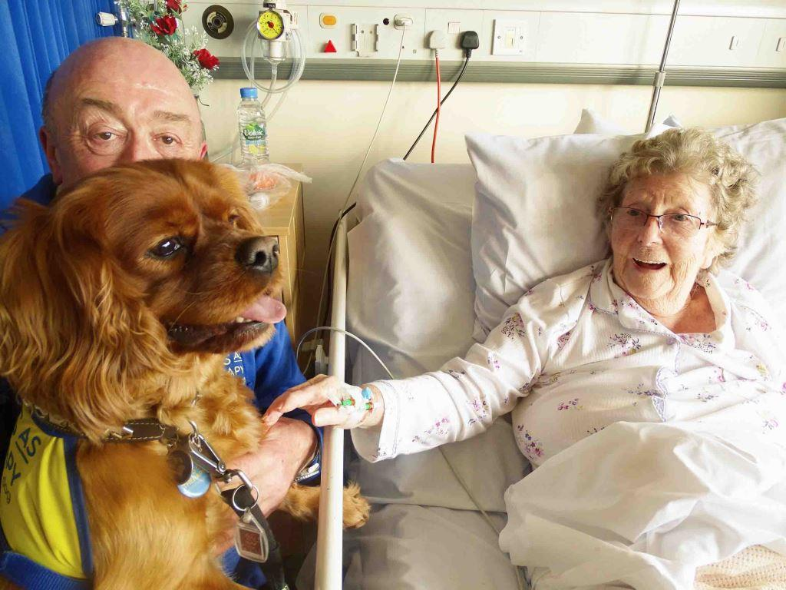
Bailey the cavalier King Charles spaniel has been cheering up patients, visitors and staff during his visits to Ward B2 since February.

He’s there on Wednesday afternoons with owner Brent Oatway as part of the Pets As Therapy (PAT) charity.

Bailey with owner Brent Oatway and Ward B2 patient Dilys Lawrence, from Baglan

The idea came about after a conversation between speech and language therapist Alison Buller and junior doctor Naomi Robbins.

Both were aware of the well-documented positive impact a dog can have on people who have had strokes.

Alison said: “I thought it would be great for the patients I see on the ward.

“They are mainly people who have had strokes and a lot of them are aphasic so they have had a stroke that has taken away their ability to understand speech and produce speech.

“I also deal with a lot of people who have dementia. And I just think there’s something so positive about pets in general but dogs in particular that livens people up, that makes them happy, and can stimulate conversation.”

Getting a registered PAT dog proved difficult to begin with as the charity did not have any owners living locally.

Alison said: “It was just by chance that I was talking to Brent’s wife Linda, who is a staff nurse in the hospital’s elderly day unit.

“She said their dog was now PAT registered and I asked if he would come in – and that’s how it started.”

Pets As Therapy is a national charity which provides a visiting service taking behaviourally-assessed animals into hospitals, special needs schools, nursing homes and other venues across the UK.

Brent, who himself teaches at a special needs school, became aware of the charity after seeing a poster in a veterinary surgery.

He said: “As I’m coming up to retirement in a year or so, I thought it would be good to do something to keep me occupied and maybe cheer a few people up.

“I took Bailey for his assessment and he passed with flying colours.”

Alison said the reaction from patients, visitors and staff had been really positive.

“The first time Bailey came in, we had one patient who was very poorly and at the end of her life.

“Her daughter was naturally very upset. She had a little cwtch with the dog and said it made the world of difference to her.

“We get staff popping in just to say hello to the dog on Wednesday afternoons.

“It’s great for the patients, it’s great for visitors and it just promotes happiness.”

Dr Robbins, who completed a project on PAT while in medical school, said Bailey’s visits also helped stimulate conversations between patients.

“You get interaction between people in the same bay who haven’t spoken to each other before.

“They ask each other about the pets they used to have, so it’s starting conversations that would never normally have happened.

“For me it has been nice and positive. And while it’s meant to be about the patients, the staff have loved it as well.”

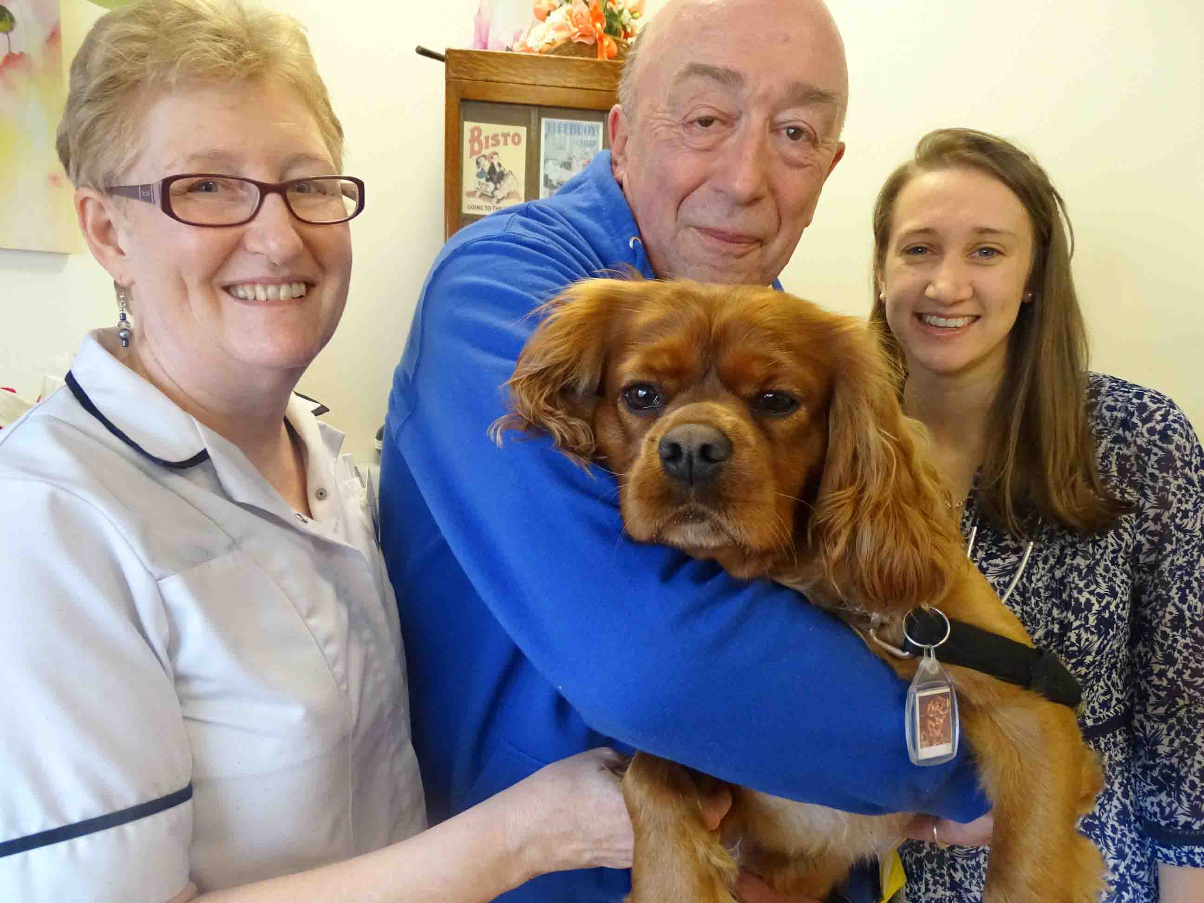
Pictured right: Bailey and Brent with Alison Buller (left) and Naomi Robbins

Brent said he would be more than happy to continue his and Bailey’s hour-long visits for as long as they were wanted.

“It’s lovely from when you walk through the door. Everybody starts to smile as soon as they see him. The staff stop and smile, visitors stop and smile, and more importantly the patients love it.

“The first day we were here, one of them moved her arm to smooth Bailey when I lifted him up. As I understand, it was the first time she had moved her arm for weeks.

“It’s great. It’s nice to see people and everybody has got to know us. We’re all on first-name terms now.”

Source: Abertawe Bro Morgannwg University Health Board

