Unit is first in Wales to let parents share care of their premature babies
Tuesday, 11 April 2017
New parents are being offered the chance to give hands-on care to their premature babies as part of a groundbreaking initiative introduced by ABMU.

Singleton Hospital’s neonatal intensive care unit is the first in Wales to offer Family Integrated Care or FiCare which allows parents to be involved in looking after their newborn babies even when they are very tiny or sick.

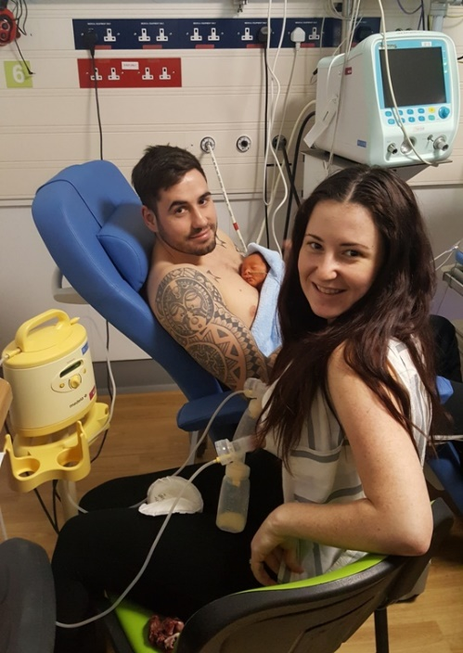
The mums and dads are given training and encouragement to care for their babies by taking on skills such as tube feeding, taking temperatures and giving medication.

And the new approach is proving a big hit with parents keen to learn all they can about helping their babies.

Among the first families to take part in the initiative, introduced in November 2016, were Ellia and Jordan Williams, of Clydach whose son Harry was born nine weeks early, weighing 3lb 10oz.

Little Harry Williams enjoys skin-to-skin contact with his dad Jordan while mum Ellia expresses milk for tube feeding.

Ellia said: “When Harry was first on the unit I hated the thought of leaving him and someone else looking after him when I went home every day.

“I felt helpless, like I wasn’t doing enough for him but then the staff explained how we could get involved.”

During Harry’s five weeks at Singleton, Ellia and Jordan both enjoyed carrying out his daily care including having regular skin-to-skin sessions as well as learning how to spot his feeding and stress cues.

“I was so glad Family Integrated Care was encouraged and the nurses were there to help us. We both felt included, it helped us bond with Harry and we really feel it has made it easier now we have him home with us,” she added.

Family Integrated Care lead nurse Sarah Davies said the idea was to help develop a partnership between parents and neonatal staff.

“There is no pressure on parents to do anything they are uncomfortable with. We want parents to become more confident in looking after their babies.

“FiCare has been shown to improve breast feeding rates, reduce parental stress, reduce infection rates and reduce the length of stay for babies.

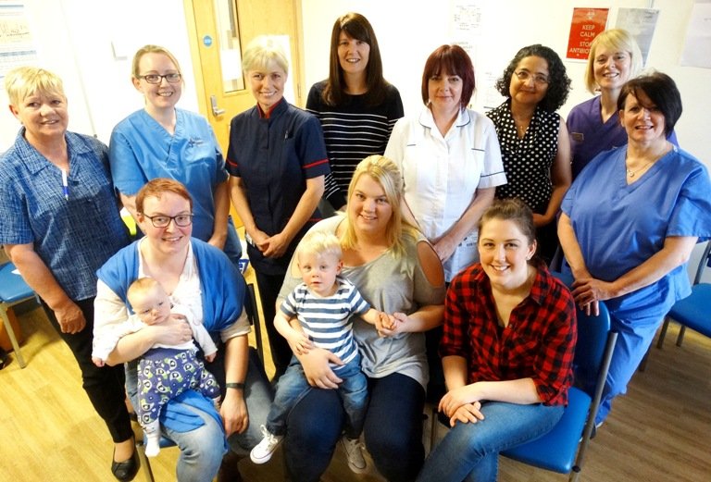
“When families are involved in decision making – even about simple things like when they can take their baby out of a cot – it makes them feel included and more responsible for their baby’s care.”

Members of ABMU’s Family Integrated Care Team at Singleton neonatal intensive care unit.

Neonatal consultant Maha Mansour added: “We have already seen the positive impact this is making on relationships between parents and their babies.

“FiCare definitely helps give parents a better understanding of the treatment their babies are receiving, why nurses and doctors are doing what they are doing, and in turn this can help ease their anxieties and it makes them feel more included.”

Now she says the team is looking to extend the initiative.

“FiCare staff training is under way in the special care baby unit at the Princess of Wales Hospital and we hope to launch there in the next few weeks.”

Family Integrated Care began in Estonia and its key principles were adopted at a hospital in Toronto where staff saw the difference it made to newborns. After hearing about their success at an international neonatal conference, Dr Mansour shared information about FiCare with her ABMU colleagues who were eager to see how it could be introduced in Swansea.

The team behind the initiative at Singleton is made up of nursing staff, doctors, receptionists and therapists as well as parents like Cerys Wyn, of Ammanford, whose daughter Alex was treated on the unit 18 months ago.

“This has been a long time in development and it is so good to see parents being given the opportunity to help more. I am very proud to have been involved,” said Cerys.

Other mums who shared their experiences to help develop the initiative include Shauni Osborn, mum to 13-month-old Carter, and Rachel Evans, one of the volunteers who come in every week to offer support to mums as they begin breastfeeding.

Cerys added: “Because parents are here at the unit for a long time with their babies they do build up relationships with staff and that can make it easier for nurses to show them how to get involved.”
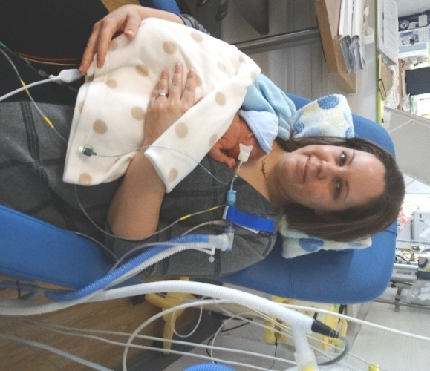
Occupational therapist Amanda Lawes said: “We want to make sure the parents have everything they need to help them manage day-to-day tasks.

“This shows parents how they can be a part of the baby’s care because a mother can help her baby like nobody else can.”

Kirsty Thomas, (left) of Llanelli, is at Singleton with son Corey who was born 16 weeks early, weighing 1lb 3oz.

“He was so fragile when he was born and I was very nervous at first. But it’s your baby and you want to be involved and the staff are all very good teachers.

“Now I can help look after him, do his daily care and tube feed him. My husband is involved too and we enjoy being able to have skin-to-skin contact.

“Corey is doing really well and it is good to feel that we doing our part.”

Sarah added: “It has meant a big change for staff who have taken on the challenges of teaching and supporting parents but there is real goodwill towards this project and we have had great support from management.

“We are very proud to be the first in Wales to do this.”

Source: Abertawe Bro Morgannwg University Health Board

