Henry's endurance challenge two years after life-changing accident
Thursday, 13 April 2017
A trainee whose life was saved at the hospital where he works is now rebuilding it with the support of his colleagues there.
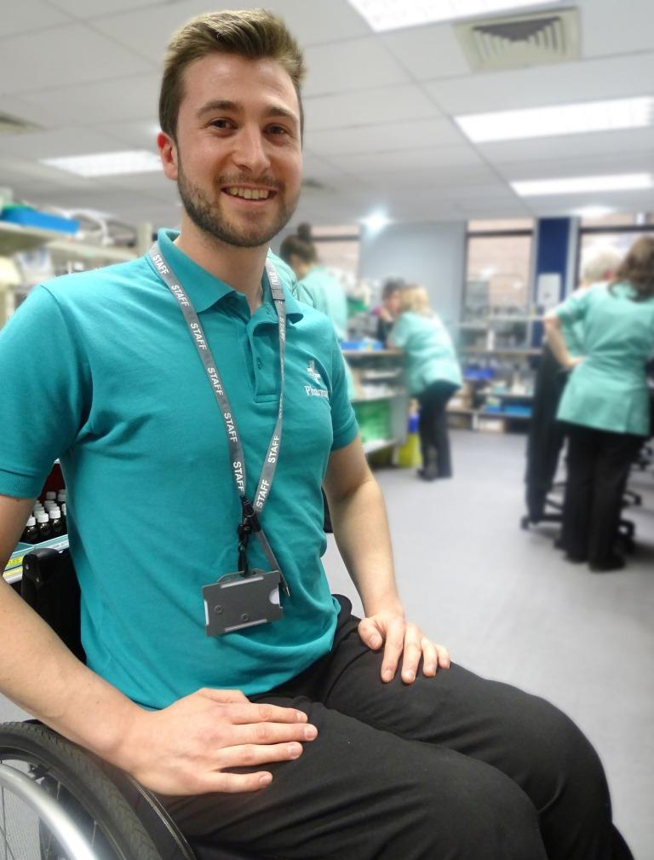
Henry House suffered serious spinal and head injuries after a fall in 2015.

Although it left him with lower limb paralysis, that hasn’t stopped him from signing up for a sporting endurance challenge to raise money for charity.

The 25-year-old had only started work at Morriston Hospital a few months before his accident, and it was to the hospital’s Emergency Department that he was taken.

After undergoing surgery Henry was transferred to a specialist rehabilitation unit in Cardiff, and was in hospital for a total of five months.

Fortunately his post as a trainee pharmacy technician at Morriston was kept open and he is now once again doing the job he loves.

Henry was badly hurt in a fall in Swansea in January, 2015.

He said: “I was taken to Morriston A&E. I was very poorly, in a really bad way when I came in.

“I had a fractured vertebra and a brain injury as well.

“After A&E I was moved to Ward A and following that I had surgery on my spine.

“I went to Ward B, then to the Rookwood specialist rehabilitation centre in Cardiff. I was there until June 2015.

“The accident left me with lower limb paralysis – I’m paraplegic and in a wheelchair.”

He said he wanted to thank everyone involved with saving his life and caring for him in hospital, including the neuro-physiotherapy team which supported him after he left Rookwood.

Henry, who is from Rhossili, had only started work at Morriston Hospital a few months before his accident.

He had joined the pre-registration pharmacy technician programme, which consists of the Level 3 Technical Certificate in Pharmaceutical Science and the Level 3 Diploma in Pharmacy Service Skills (NVQ) (QCF).

Henry said: “I was off work until May last year. Fortunately they kept my place open for me and I came back part-time to begin with.

“I actually restarted the course in September and it will take me around 18 months to two years to complete it and become a registered pharmacy technician.”

Henry has always enjoyed keeping fit. Next month will see him take part in his first wheelchair race to raise funds for Wings for Life, a not-for-profit spinal cord research foundation.

Its mission is to find a cure for spinal cord injury, funding first-class scientific research and clinical trials internationally.

The Wings for Life World Run takes place at locations around the globe on one day each year, starting at the same time. It is open to athletes, casual joggers and wheelchair users of all ages.

Half an hour after they start the race, a chase car begins to track them down, starting at a certain speed and then gradually accelerating until every competitor has been caught.

Henry and girlfriend Josie Evans will be taking part in the UK event in Cambridge, setting off at noon on Sunday May 7th.

He has a collection pot in the Morriston pharmacy and has set up a donation page through Wings for Life.

“Physically I’m doing well. I’m exercising. Before my accident I was massively into fishing and I really want to get back into that.

“Working here is really helping. I love my job and I was very keen to come back. Everyone is looking after me – they’re just brilliant.”

You can support Henry by clicking here or by going to https://fundraising.wingsforlifeworldrun.com/gb/EN/4c1046e613fc11e7b21a0a9de91963a7

Source: Abertawe Bro Morgannwg University Health Board

