Families invited to log on to get extra information
Wednesday, 19 April 2017
A website dedicated to making sure important information for families is just a click away is going from strength to strength.

A team of children and young people’s therapists have spent the past three years developing their page on the ABMU website into a detailed and trusted resource for parents, teachers and health professionals.

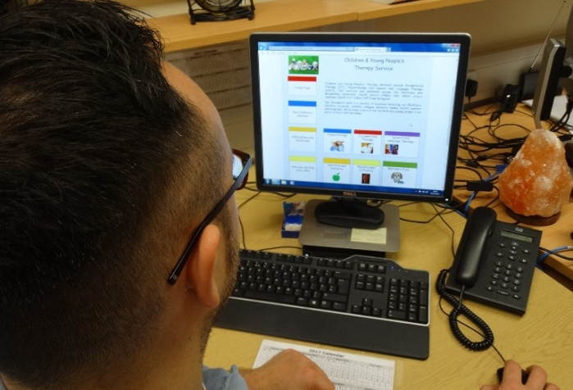
Now they say their hard work is paying off as the number of hits the Children and Young People’s Therapy Service site gets is increasing along with the amount of positive feedback they have received.

The team were eager to create somewhere families and carers of children across ABMU could go to find information to help their child without the need to access specialist services.

The brightly coloured site contains links to common difficulties and conditions seen by the service and the many organisations which can offer help and support plus community resources that staff encourage parents to use.

Occupational therapist Rhiannon Carpenter, who is based at Singleton’s Hafan y Mor children’s centre, said: “We know we are now dealing with a really technologically aware generation who expect to be able to find information they need online.

“We felt it was important to keep up with that and to create a site that was not only informative but also engaging. We wanted to harness the website’s potential because it really is a fantastic way of providing information.”

Rhiannon added: “We have also been using it to manage our waiting lists by referring people to a members-only area where they can access specific advice while they are waiting to be seen, if they do require a specialist service.“

Rhiannon is part of the web team, drawn from across ABMU, who keep the site up and running.

Paediatric physiotherapy technicians Lewis Davies and John Clifford, paediatric occupational therapy technician Jo Wheeler, Caroline Geil of occupational therapy admin, physiotherapists Briony Cross and Liz Davis together with paediatric physiotherapy manager Rebecca Kennedy meet regularly to decide on new content.

Rhiannon said: “We don’t want children to go through unnecessary appointments if it can be avoided.

"In some cases a parent or teacher can find advice on the site that answers their questions and that means a child may not need to access our services – all they needed was a steer in the right direction about something.”

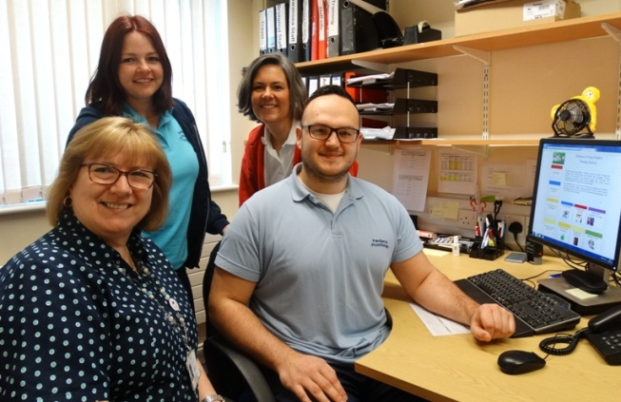
The team also say they have been delighted to receive positive feedback from people who have used it successfully.

Website team members (from left) Caroline Geil, Jo Wheeler, Rhiannon Carpenter and Lewis Davies.

One mum said: “The advice on cutlery skills was really clear and helpful. Thank you.”

Another added: “I’ve been able to help my son learn to brush his teeth using information from this website. The dressing strategies are really useful too.”

Teachers are also finding the website very useful. Emma Davies, of Ysgol Bae Baglan, got in touch with the team to tell them how strategies outlined on the site had proved particularly effective with one pupil.

She added: “Another member of staff has been using the programmes as part of her nurture group that she runs with our lower school pupils. The dressing techniques and oral hygiene have been used during life skills lessons and have been a big help. Thanks for allowing us to use your website.”

Rhiannon said the team were now eager to spread the word about the site’s free resources and links.

“We are very proud of the work we have done and want not only families but also schools, health visitors and other professionals involved in the care of children to know about it.

“We are always looking at ways of developing the site, it has to keep evolving and in future we would like to make it more dynamic with more multimedia content,” she said.

“The more engaging we can make it, the more people will want to use it and the more children we can help.”

Find out more at www.abm.wales.nhs.uk/childrensdevelopment

Source: Abertawe Bro Morgannwg University Health Board

