Expert ABMU team to host all-Wales summer conference in Swansea
Monday, 10 April 2017
Experts from around Wales will gather in Swansea for a national health conference hosted by ABMU later this year.

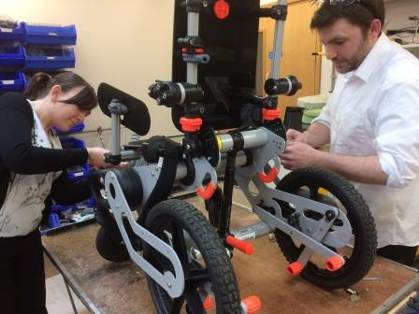
The annual All Wales Medical Physics and Clinical Engineering Summer Meeting takes place on Friday 16th June 2017 in the Village Hotel in SA1.
ABMU rehabilitation engineer Kelly Jones and workshop technician apprentice Steven Reynolds adjust a highly specialised wheelchair. It was designed and built within the Department of Medical Physics and Clinical Engineering

This year’s theme, working together – always improving, reflects the variety of staff working in this specialist service and how they share innovation and improvement in patient care.

Each year a different health board or NHS trust in Wales hosts the event. This year it is the turn of ABMU’s medical physics and engineering team.

It’s an opportunity for those developing scientific techniques, engineering and technology for diagnosing, treating and supporting patients to demonstrate their work.

Hospital staff working in different areas such as radiotherapy, nuclear medicine, medical electronics, rehabilitation engineering and renal services, will share what they are doing in their areas of expertise.

Throughout the day, guest speakers will present research, innovations and improvements from their services to the conference.

Delegates can take these back to their own teams to apply to their patients’ care.

Dr Simon Ryde, ABMU’s Director of Medical Physics and Clinical Engineering, described it as a very important meeting.

He said: “It provides an opportunity to bring together scientists, clinical engineers and technologists from all the health boards, NHS trusts and higher education centres in Wales.

“Together they can discuss recent innovations, work in progress and advancements or improvements in patient care.

“It also provides an opportunity to discuss professional matters such as national education and training strategies.

“The meeting is a mixture of formal presentations, abstracts and posters covering a wide variety of subjects to share important issues for the NHS in Wales.”

Source: Abertawe Bro Morgannwg University Health Board

