Couple decide to tie the knot after near-fatal heart attack
Tuesday, 25 April 2017
A husband and wife have told how they decided to tie the knot while he recovered in hospital after surviving a massive heart attack.
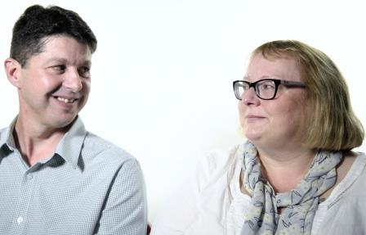
David Lloyd collapsed at home with severe chest pains in February 2015 and was revived by his partner Anita Davies.

Paramedics arrived and rushed 44-year-old David to Morriston Hospital where he went into cardiac arrest while in the catheter lab.

David and Anita Lloyd talk on camera about their dramatic experiences

He remained critically ill and in an induced coma for nine days but thanks to the skill of hospital staff has since made an excellent recovery.

David and Anita, who married six months later, have now told their remarkable story in a new video explaining the work of the catheter lab in Morriston’s cardiac centre.

Heart attack patients need to go directly to a centre providing primary percutaneous coronary intervention, or PCI.

A heart attack is a blockage by blood clot in one of the arteries, damaging that area of heart muscle.

It’s treated through an angioplasty, a procedure that uses balloons and stents to open the blocked artery and restore blood flow to the heart muscle as quickly as possible.

David was at home in Cefn Cribbwr, near Bridgend, when he felt pins and needles in his arm. He told Anita he didn’t feel right – and then collapsed, clutching his chest.

In the video, Anita recalled how the colour drained from his face and he stopped breathing. She gave him CPR and called an ambulance.

David was rushed to Morriston’s catheter lab, one of only two centres in Wales which does primary PCI – the other is in Cardiff.

He went into cardiac arrest and CPR was started. David went into arrest a second time and a CPR machine was used while staff concentrated on stenting the artery to restore blood flow.

In the video, consultant cardiologist Mark Ramsey says David’s first 24 hours in intensive care were very difficult.

“He was on maximum support to keep the circulation going.

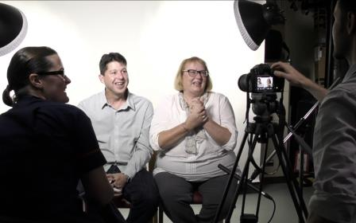
“We had to be very guarded as to whether he would survive this and, just as importantly, how much injury there might be to the brain due to the lack of blood supply during resuscitation.

“While the resuscitation was prompt, he’d had low blood pressure for quite some time.”

Filming the video with Catherine Theron (left) and cameraman Steve Atherton

Fortunately over the next few days there was marked improvement in David’s heart function. Dr Ramsey said: “His progress after that was really very encouraging indeed.”

David was in an induced coma for nine days. Anita recalled the first three things she said to him when he woke up.

“Can you hear me? And he shut his eyes to say yes. I said, do you love me? And he said yes. Shall we get married? And he said yes.

“So we did – we got married six months later. He got stronger every day because he had a purpose.”

David also talks about coming home, when he realised all the support was gone. His first night, he said, was terrifying, and he didn’t get much sleep.

“…very anxious but as the weeks went on I slowly got better.”

The video was made by ABMU cardiology matron Catherine Theron and Steve Atherton of the health board’s medical illustration team.

Catherine said the video would help staff and patients alike understand the wider picture.

“It’s the whole story of a patient – all parts of our team here don’t often see that entire picture.

“Staff on the wards don’t go to the catheter labs so they don’t get to see the whole process. Hearing it directly from a patient ready does add a whole other dimension.

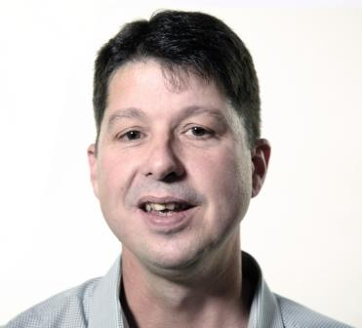
“Likewise, staff in the catheter labs don’t see what goes on afterwards, how the patient recovers.

“Many patients coming in don’t actually remember being in the catheter lab. David couldn’t remember anything either.

“Hearing from a patient who has been through exactly the same thing fills in the gaps for them.

“The things David says are the things all patients go through so it’s good for them to hear it from another patient and not just healthcare professionals.

“We cannot thank David and Anita enough for agreeing to tell their story.”

David and Anita, who made a £200 donation to the catheter lab when they got married, immediately agreed to take part in the video when Catherine approached them.

“It was a way of giving something back after what they did for me,” said David.

Although he is not in work at the moment, David helps around the house and is studying for an Open University degree to keep his mind active.

“I’m feeling well. I do get a bit tired now and again but other than that things are good.”

You can watch the video below or by clicking here

Source: Abertawe Bro Morgannwg University Health Board

