Edition: 2
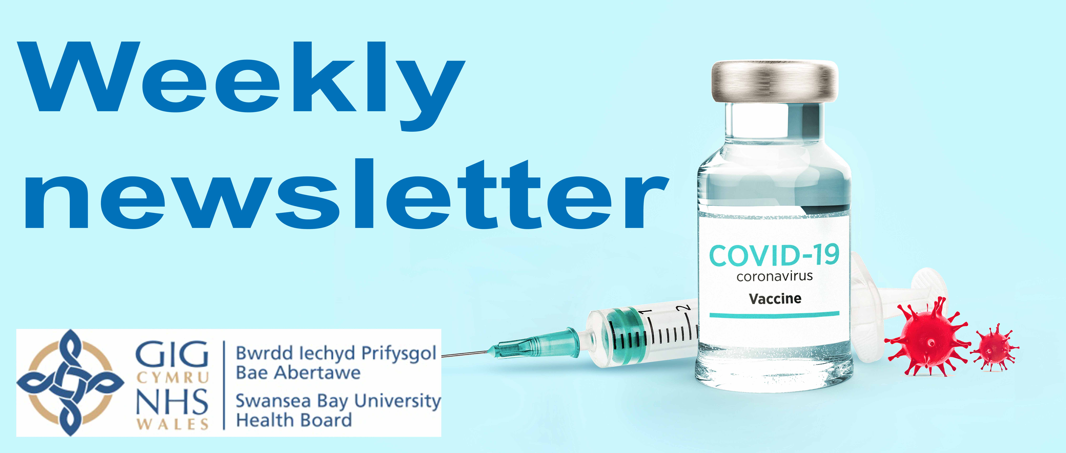
Date: 19/01/21
Introduction
Welcome to the second edition of our weekly Covid vaccination newsletter for our partners and stakeholders in the Swansea Bay area.
Sent to you directly every Tuesday, it will provide an overview of where the Swansea Bay University Health Board programme is and a forward look in a user-friendly format which will help you to keep your constituents and group members up to date.
We’d very much welcome your thoughts and any feedback on how we can improve it. Email senior communications officer: Abby.Bolter@wales.nhs.uk
So, let’s get started with what everyone wants to know…
How many people have been vaccinated so far?
20,830
(NB: Figure correct as of 7pm Monday. Please note the true figure may be higher due to a slight delay in data inputting.

A running total will be published on our main social media channels daily Monday to Friday:
Swansea Bay NHS
@SwanseabayNHS
It is also our intention in the coming weeks to provide a breakdown of figures by cohort once a week. We will keep you posted.
Who’s had the vaccine?
Latest
This week we have begun to vaccinate those aged 70 years of age and over (priority groups 3 and 4) – starting with the eldest in that group – in our Mass Vaccination Centres. We will work down through the age range and aim to have completed this group by February 14th in line with the Welsh Government’s priority milestones. However this is, as always, subject to vaccine supply and we will continue to be responsive in our approach.
GP practices will shortly be commissioned to vaccinate patients in the extremely clinically vulnerable group. We’ll update you when we know more. Again, our aim is to have offered a vaccination to everyone in this group by February 14th, but this is reliant on supply.
Care homes
Thanks to the brilliant work of our primary care clusters around 80% of our care homes have now been visited by vaccinators. A large number of homes indicate that 100% of their residents have been vaccinated.
We aim to have offered vaccinations to all care home residents by the end of the month. However, those who have tested positive for COVID in the last 28 days will be done in early February once they are eligible.
Over 80s
We know many in the community are concerned that they or older family members have still not been contacted to arrange an appointment, especially as we have now started to vaccinate the over 70s group.
The over 80s are being vaccinated by GP practices, while the over 70s will be called by the health board to one of our Mass Vaccination Centres.
These groups are being vaccinated in tandem to allow us to reach as many of our vulnerable population as quickly as possible.
Practices are working through their patient lists and will contact them by letter or telephone call to arrange a vaccination appointment over the next couple of weeks.
Please be patient, we will get to you.
Our aim is to have offered a vaccination to all those over 80 within the next 2-3 weeks.
Frontline health and social care staff
Remaining frontline health and social care staff are also being vaccinated at our MVCs. At least 75-80% of our health and social care staff have been vaccinated, and we will continue to offer vaccination through our Mass Vaccination Centres.
**We have had some reports of carers not receiving text messages prompting them to book an appointment. We are looking into this. But where we have been made aware of individuals not receiving a text, we have passed their details on to our booking centre so they can be contacted directly.
How to help
The Covid vaccines offer us real hope for the future.
But for now everyone – even those who have been vaccinated - must stick to the rules: Hands, Face, Space

Latest News

- Our third MVC opens on Thursday at Canolfan Gorseinon Centre on Millers Drive, Gorseinon, Swansea.
We will be vaccinating the over 70s here, as well as some health and social care staff.

- The health board has been impacted by the delay in delivery of one batch of Oxford vaccine. We have adjusted the volume of vaccine that will be available to individual practices in light of this issue, however, we can confirm that all GP practices in Swansea Bay University Health Board will have a supply of vaccine to enable to continue with their programme of vaccinating patients aged over 80’s this week.

- You may have seen a news story on one elderly patient who was asked to travel 90 miles (round trip) to Bronllys to have Covid vaccination.

We are aware of some patients living in the north of Neath Port Talbot who are registered with GP surgeries in Powys and therefore come under their vaccination programme.

To ensure a quick start Powys rolled out the vaccines via their Mass Vaccination Centres at first and offered those in priority groups the chance to have the vaccine there. However, with the arrival of the Oxford vaccine they are beginning to roll out the programme to GP surgeries, so those affected patients will have the opportunity to be vaccinated nearer their home.

What’s Next?

- Our Executive Medical Director Dr Keith Reid told the Gareth Lewis programme on Good Evening Wales on Monday that despite criticism of the speed of the vaccine rollout in Wales, we are continuing to scale up the programme, including looking at how we can deliver the more fragile Pfizer vaccines in new ways to increase the reach of the programme.

- We are also working on a mobile vaccination service which will help us reach vulnerable groups. More information soon.
And Finally
Just in case you missed these on social media, we thought we’d share a couple of stories from the past week.
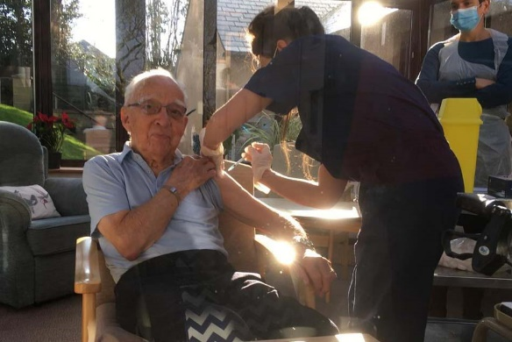
Care home residents have celebrated getting their Covid vaccinations with a sherry and a sing song.
So thrilled were the residents at Swansea’s Newton Court with the visit from vaccinators from West Cross and St Thomas Surgery that the gathering for jabs turned into an impromptu party.
“When the vaccinations were done one of our residents requested Danny Boy, staff got the Baileys and sherry out and it went from there," said Assistant Manager MIchelle Ross.
“It was a joyous occasion because we have managed to go through the whole pandemic without a case in our home.”
*You can watch the video on our Facebook page.
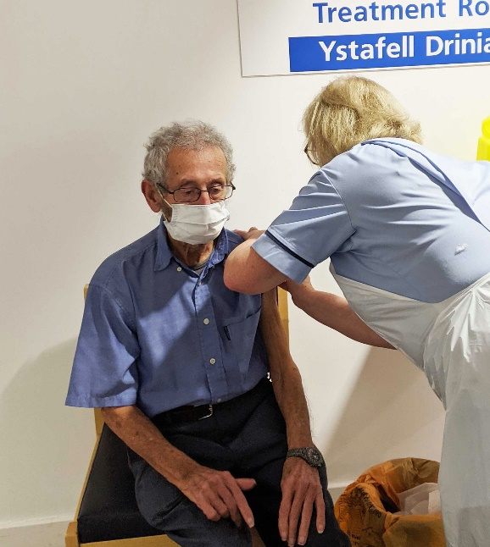
Great grandfather John Collins, a retired steel worker, had two reasons to celebrate last Thursday.
Not only did he mark his diamond wedding anniversary with wife Ann, 79, he also received the Covid vaccination.
It was given by Sandra at King’s Surgery in the Port Talbot Resource Centre at 11am.
John from Baglan, who turns 83 on Saturday, said: “I feel good about having it and would like to thank the surgery.”
Daughter Suzanne Collins said: “They have had their card from the Queen and dad getting his vaccination has been another very nice glimmer of hope in a dark month.”

Thanks for reading – see you again next week.

