Edition 1:

Date: 12/01/21
Introduction
Welcome to the first edition of what will be a weekly Covid vaccination newsletter for our partners and stakeholders in the Swansea Bay area.
Sent to you directly every Tuesday, it will provide an overview of where the Swansea Bay University Health Board programme is and a forward look in a user-friendly format which will help you to keep your constituents and group members up to date.
As this is the first newsletter, we’d very much welcome your thoughts and any feedback on how we can improve it. Email senior communications officer: Abby.Bolter@wales.nhs.uk
So, let’s get started with what everyone wants to know…
How many people have been vaccinated so far?
13,171
(NB: Figure correct as of 4pm today. Please note the true figure may be higher due to a slight delay in inputting data.)

Who’s had the vaccine?
Frontline health and social care staff, the majority of care home residents and, as of this week, the 49 GP practices in the Swansea Bay area are beginning to vaccinate residents over 80 who do not live in care homes.
First doses are being given – Pfizer BioNTech to staff and Oxford AstraZeneca to over 80s and those living in care homes.
Due to the guidance around the interval between first and second doses increasing, anyone who has received a first dose will be called for their 2nd dose after 11 weeks.
Each of our Primary Care clusters has taken a lead in vaccinating care home residents while individual GP practices will contact patients over 80 in their usual way, either by letter or phone, to arrange an appointment. Some of these patients will be asked to visit the surgery or a community venue for vaccination, while those that are housebound will receive a vaccine in their own home..
We are on target to be able to vaccinate all care home residents with a first dose by the end of January and we hope that we will be able to offer a vaccine to all those over 80 in January too.
Across Swansea and Neath Port Talbot, the total number of people aged 80+ is approximately 24,000.
One thing we must mention is that vaccinators cannot vaccinate everyone in care homes currently experiencing an outbreak so that may cause a slight delay in some cases. They may need to come back and vaccinate staff and residents who are unwell at the time of the first visit.
How to help
Anxious about getting the vaccine for yourself or a relative?
Please WAIT to be contacted by your GP surgery.
DO NOT telephone as they are experiencing a high volume of calls.
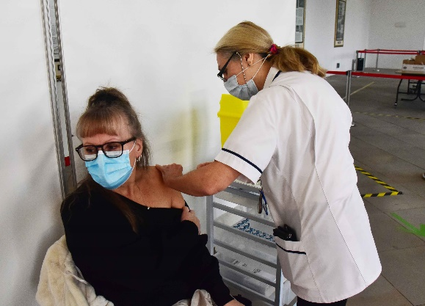
Latest news
- Our latest Mass Vaccination Centre (MVC) opened at Margam Orangery yesterday (11/01/21). It joins our other MVC which is the Bay Field Hospital.
We are currently vaccinating health and social care staff at Margam. It will deliver upwards of 500 doses of vaccine every day when it is fully up and running.

You can read the full story on our website.

- The milestones for the vaccination programme in Wales were announced on Monday by the Welsh Government:
By Mid-February – all care home residents and staff; frontline healthcare and social care workers; clinically extremely vulnerable people and all over 70s should have received their first dose.
Spring - People with an underlying health condition. All over-50s.
Autumn - all adults in Wales who are defined as eligible by the Joint Committee on Vaccination and Immunisation (JCVI).

- New testing centre - A walk-through coronavirus testing facility has been opened at Milland Road Car Park in Neath as part of the drive to improve the accessibility of coronavirus testing in the area.
Testing will take place from 8am to 8pm, 7 days a week. It will play a key role in helping to protect communities from the spread of coronavirus by providing more tests within the region, and helping to cut down on the distance that people who need a test have to travel.

- Scam alert! Scam text messages inviting people for a vaccine are circulating. You will only be contacted by the NHS, usually by phone and post. No genuine text from the NHS will ever ask for bank details or payment. Report scam texts by forwarding to Ofcom on 7726.

What’s Next?

- From early next week a joint letter from ourselves, Swansea and Neath Port Talbot councils will be delivered to each household across the area. It outlines the general approach to vaccination.
- We are on course to vaccinate all 23,000 frontline staff in the Swansea and Neath Port Talbot areas by the end of January.
- Our next MVC will be at Canolfan Gorseinon Centre. It is due to open some time during the week beginning Monday, January 18th. We hope to be able to tell you more in next week’s newsletter.
- From next week, we will be inviting patients in the 75-79 year old age group to receive their vaccination. We will be starting with those who are oldest and then working through the age groups. Patients will receive a letter with an appointment time at one of our mass vaccination centres and they will be able to change the appointment if they are unable to attend.

How to help
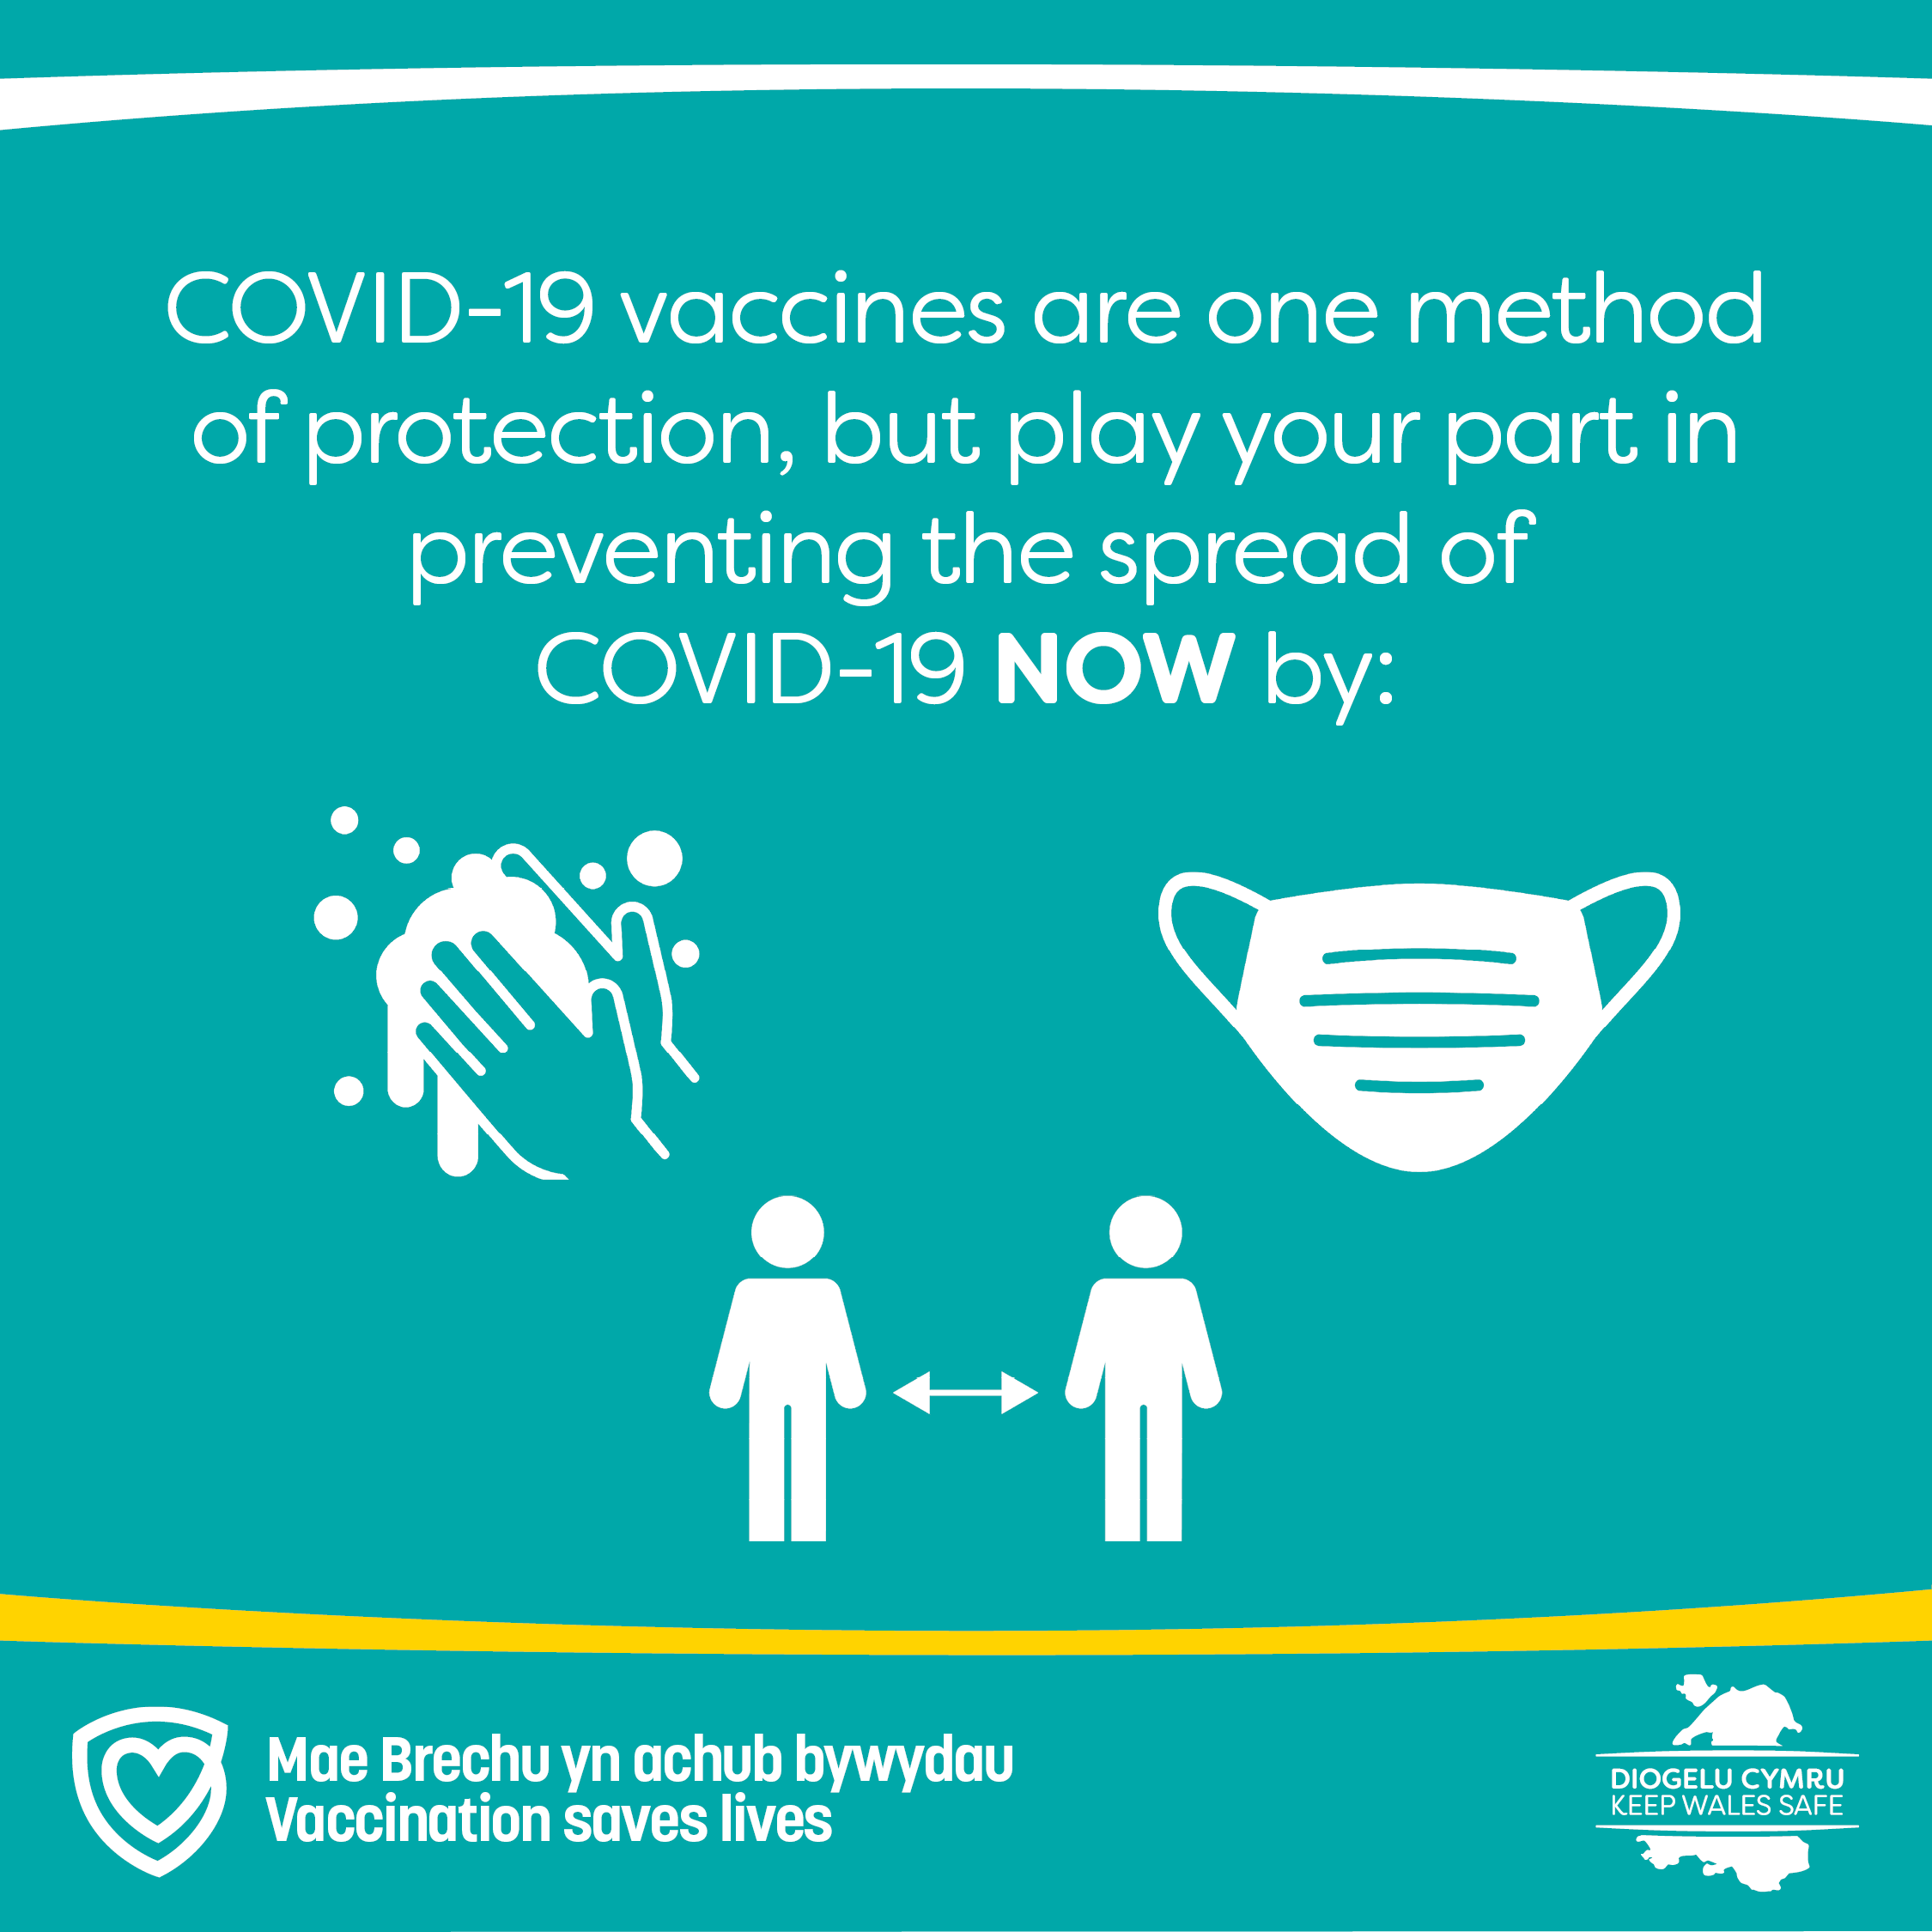

Thank you. That’s all for now. We’ll catch up next week.

