
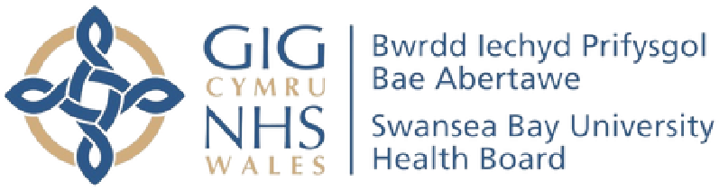

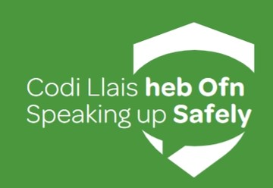
SPEAKING UP SAFELY
TOOLKIT

Table of contents

Table of contents 2
Introduction 3
Our Commitment 4
Our People Strategy 4
Our Values 5
How Can I Speak Up Safely in SBUHB? ...................................7
Terms and Conditions of Employment 8
Trade Union Representatives 9
Bullying, Harassment or Abuse 14
Violence and Aggression 15
Safeguarding Concerns 16
Health & Wellbeing 17
Potential Traumatic Events 18
Incidents & Near Misses 19
Learners, Students and Medical Trainees 20
It's something else, it doesn't seem right ...............................21
Policies and Guidance 23

Introduction
We understand how isolating and vulnerable it can feel to have something worrying you at work and not knowing where to turn. We also understand that even accessing this toolkit may have been a big step for you, but one that is essential you and your wellbeing, your colleagues and for the safety and outcomes of our patients.
Staff knowing how to raise a concern in work, easily and appropriately is a priority for us in Swansea Bay and would like to thank you for taking this first step towards making a choice to speak up and make a positive difference to yourself, your colleagues, patients and service users.
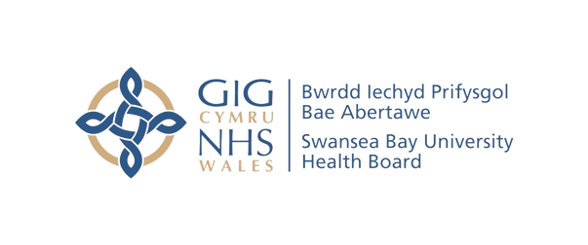

Our Commitment

Our commitment is to create a safe and supportive environment where everyone feels comfortable to speak up and raise concerns and when they do, we act.

Our People Strategy
This toolkit aligns with our Health Board's ten-year vision to become a high-quality organisation. This vision places our patients and service users at the heart of everything we do. As a manager, you play a crucial role in bringing this vision to life. By empowering your team and creating a positive work environment, you can help us achieve our goals and deliver exceptional care.
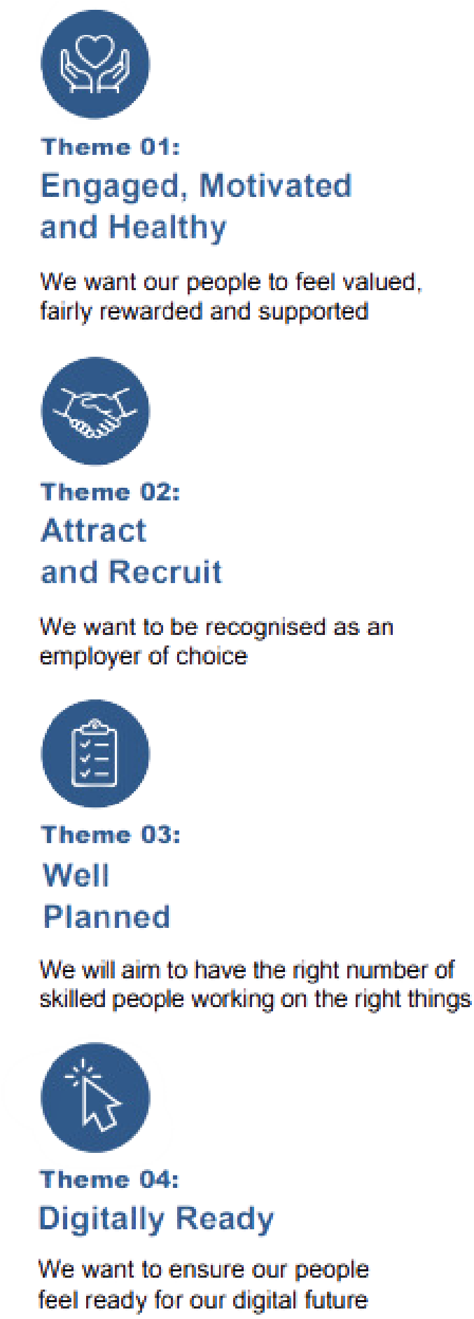
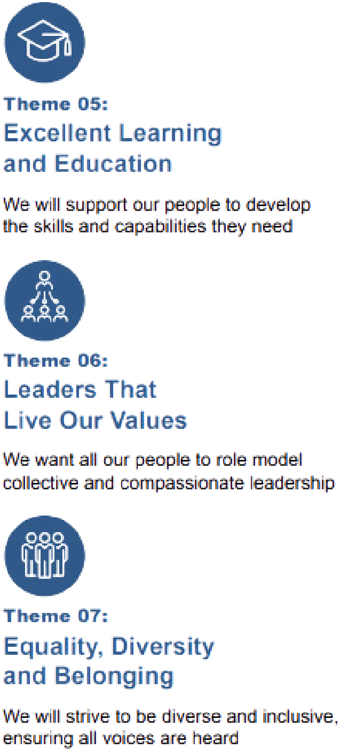
Our People Strategy consists of seven strategic aims:

Our Values
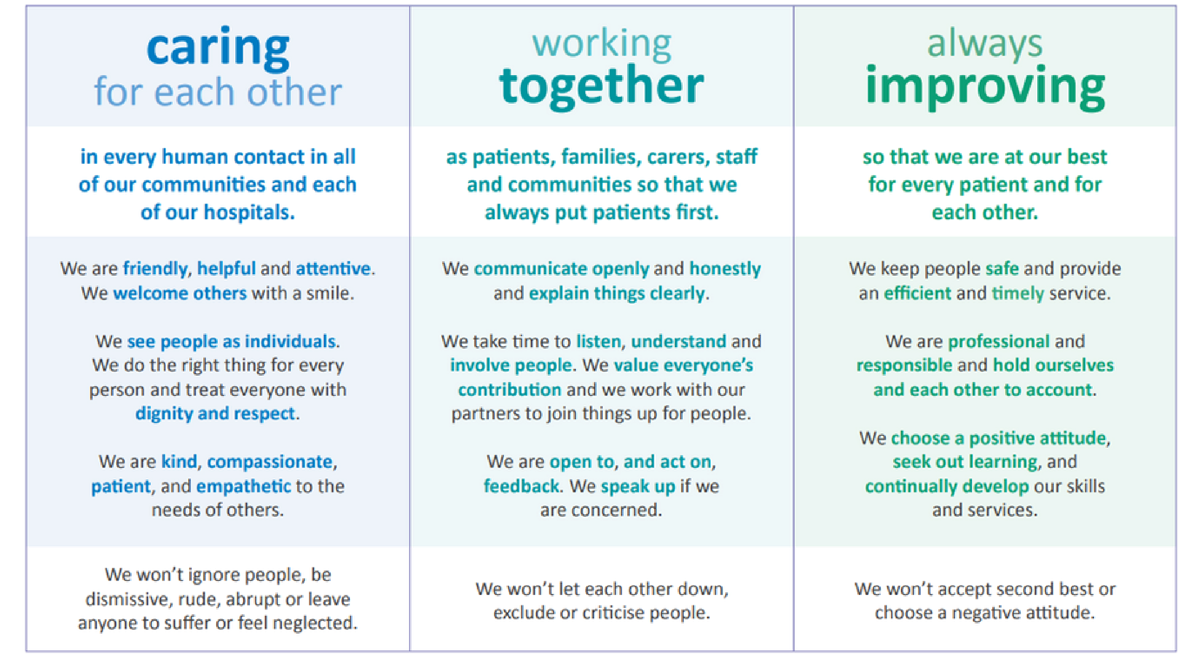
Our values are the heart of our employee experience. They shape our culture, guide our decisions, and influence how we interact with one another. By embodying these values, we create a positive and supportive work environment where everyone feels valued, respected, and empowered. When our employees feel connected to our values, they are more engaged, motivated, and committed to our shared goals.

How can I Speak Up Safely in SBUHB?
Research tells us that most people prefer to speak to those they know, trust and work closest with when it comes to sharing their worries or concerns, such as their colleagues or line managers, rather than use formal services or processes.
We would always encourage you to speak to those you work closest with and to share concerns with your line manager first, to prevent things from escalating and enable the right course of action to be taken early.
We also understand that there may be times and reasons when you don’t feel comfortable speaking up and raising concerns within your immediate team or via your direct line manager. This is why in Swansea Bay we have a number of alternative options available for you to take forward your workplace concerns.
The following pages will help you understand the options available and to select the right one for you and your concern.

Terms and Conditions of Employment
Information on terms and conditions of employment and workforce policies and guidance can be accessed by contacting the Operational Workforce Team. You can do so by searching ‘Operational Workforce’ on Sharepoint.
You can also, contact SBU.HRHub@wales.nhs.uk directly for further information and have to your queries answered.
If you are medical or dental colleague, you can contact Medical HR directly by calling 01792 532157.
There are also a number of Trade Union and professional bodies within Swansea Bay that can offer friendly, helpful advice in matters relating to your employment.
The contact details for each are detailed on the next page.

Trade Union Representatives
Please note – all details are correct at time of publication. Details may periodically change before this document is republished. Please see Intranet Sharepoint for the latest information.

Sean Davies – Estates Department - Morriston
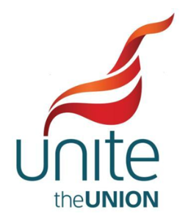
0754686354 – Sean.Davies@wales.nhs.uk

Steve Davies – Estates Department - Singleton
07931329434 - Steve.Davies10@wales.nhs.uk

Julie Ftizgerald – Penclawdd Health Centre
01792851756 – Julie.Fitzgerald@wales.nhs.uk

Gary John – Unite Full Time Officer
07789114768 – Gary.John@wales.nhs.uk

Ieuan Rees – Catering Department – Morriston
07791866725 – Ieuan.Rees@wales.nhs.uk

Health Richards – THQ
07773895449 – Heather.Richards@wales.nhs.uk

Walter Thomas – Medical Physics – Singleton
01792205666 – Walter.Thomas@wales.nhs.uk

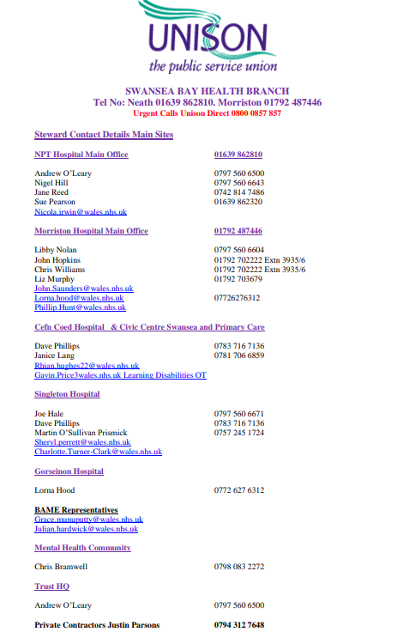
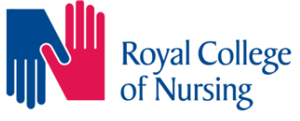

Branch Office at Morriston Hospital TEL: 01792 516508
RCN Wales Website - https://www.rcn.org.uk/wales
RCN Direct Website - https://www.rcn.org.uk/direct



David Arnold
01639862061 – 07815697630
David.Arnold@wales.nhs.uk


Manessa Faal
Alice Mayo
Eli Morris
Emma Harper
Emma Bonvonni
Jonathan Hinder
David Fligelstone
Ceiron Browning
Holly Speare
SBU.CSPStewards@wales.nhs.uk

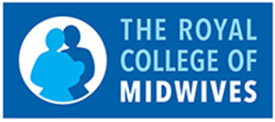

Ann Saunders – Maternity
07891485872 – Ann.Saunders@wales.nhs.uk

Katie Donovan – Maternity
07779595141 – Katie.Donovan@wales.nhs.uk


Victoria Millson - Podiatrist
0300 300 0024 Victoria.millson@wales.nhs.uk

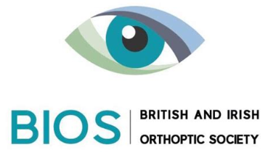

Moazzama Iqbal
01639 862278
Moazzama.Iqbal@wales.nhs.uk

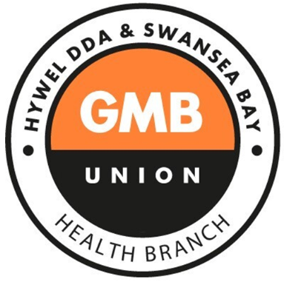
Nathan Holman - Fulltime Regional Officer
02920491260 - nathan.holman@gmb.org.uk
Joanne Small - Branch Secretary and Accredited Staff Side Rep
07722361599 - Joanne.Small@wales.nhs.uk
joanne.small@gmbactivist.org.uk

Tony James - Accredited Staff Side Rep
07539338287 tony.james@wales.nhs.uk

Claire Wright - Accredited Staff Side Rep
07580824178 claire.l.wright@wales.nhs.uk

Bullying, Harassment or Abuse
There are a number of options available to raise a concern relating to bullying, harassment or abuse in the workplace. We would always encourage you to share these concerns with your line manager first, to prevent things from escalating and enable the right course of action to be taken early. If this isn’t possible or doesn’t feel like the right option for you, further options are provided below:
Contact the Operational HR Team by emailing SBU.HRHub@wales.nhs.uk
If you are medical or dental colleague, you can contact
Medical HR directly by calling 01792 532157.
Contact your Trade Union using the details on pages 9-
13
Contact the Mediation Network by emailing
SBU.MediationRequests@wales.nhs.uk
Contact the Guardian Service by calling 0333 5773132 or emailing Contact@TheGuardianService.co.uk
We are all responsible for our relationships at work. Taking time to listen, recognise, value, and know each other helps us bond. When we are in a team which values and respects us, the benefits impact us and our patients. Better relationships and team working means better care.

Violence and Aggression

There are also a number of Trade Union bodies within Swansea Bay that can offer friendly, helpful advice. The contact details for each are provided on pages 9-11 of this toolkit.

The Guardian Service are an independent, confidential option available to 24/7 365 days a year. Their dedicated phone line is 0333 5773132 or they can be contacted directly via e-mail:
Contact@theguardianservice.co.uk

Safeguarding Concerns
The duty-desk hours are 8am - 8pm, Monday - Friday. The Team can be contacted for safeguarding advice and guidance.

Telephone: 43164 (01639 683164)
Email: sbu.safeguarding@wales.nhs.uk
Location: First Floor, Swansea Bay UHB, Headquarters, One Talbot Gateway, Seaway Parade, Port Talbot, SA12 7BR

The following are the emergency duty team telephone numbers for periods beyond business hours:
01792 775501 - Swansea LA
01639 895455 - NPT LA

Email: edt@npt.gov.uk

Health & Wellbeing
There are a range of services, training and support available through our Occupational Health and Staff Wellbeing Department. You can use their contact details below:
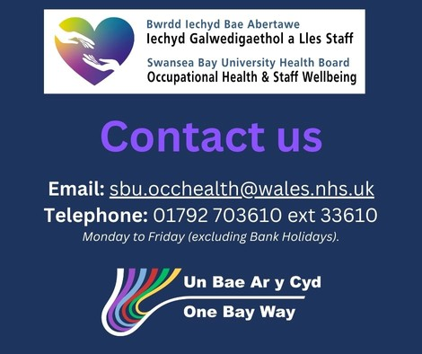
Canopi is also a free external, confidential service providing access to mental health and wellbeing support for NHS and Social Care staff in Wales.
Contact Canopi@cardiff.ac.uk or 0800 058 2738.
SBU’s Chaplaincy and Spiritual Care service are also available to provide support.
You can call 01792 70330

Potential Traumatic Events
TRiM (Trauma Risk Management) is a peer support initiative for staff who have been exposed to a potentially traumatic incident.
The TRiM model proposes that individuals who share similar experiences are best placed to connect and support colleagues exposed to trauma and encourage open dialogue about their experience.
Swansea Bay has worked with March on Stress to train staff from across all areas who are able to provide peer support, to monitor trauma exposed individuals and, where necessary, assist them to access professional support.
TRiM trained staff understand the effects that traumatic events have on colleagues and are able to offer support, education and practical advice while normalizing the response that individuals may have to traumatic events.
For more information, please contact
SBU.TRiMTeam@wales.nhs.uk

Incidents & near misses
It is important to remember, if a patient/service user has suffered moderate or serious harm which could be linked to their care, from the 1st April 2023 they have the legal right to be informed.

That doesn’t mean patients must be informed immediately after an adverse incident happens. However, the legislation introduces this step as part of the wider process of reporting adverse incidents.

The Duty strengthens the fundamental principles of the 'Putting Things Right' 2011 Regulations and provides a robust process to support openness and transparency.

Being open should feel like the right thing to do with our patients, service users and their families.
To report an incident or near miss relating to patients or staff, you can do this by completing a DATIX. You can find further information on the intranet or by contacting SBU.Datix@wales.nhs.uk .

You can also contact our complaints team on:
SBU.LetsTalk@wales.nhs.uk or 01639 684440

Learners, Students and Medical Trainees
Health Education and Improvement Wales (HEIW) have launched a resource to help learners, students and non-medical trainees feel comfortable, confident and supported in raising concerns.

In addition to the local support and options available to staff, students and volunteers within Swansea Bay UHB, a digital toolkit has been created to support and encourage learners to feel safe and able to speak up and raise concerns during their practice or work-based learning experiences.
For more information and to access the toolkit for non-medical students and trainees, visit the HEIW Raising Concerns Reflective Toolkit webpage using the below URL:
https://heiw.nhs.wales/support/raising-concerns-and-speaking-up-safely/raising-concerns-toolkit-students/

For Doctors and Dentists in Postgraduate Medical Programmes, there is additional support via the following web pages: https://heiw.nhs.wales/support/quality-management/raising-training-concerns/
The Gwella Learning Portal, hosted by HEIW also provides a range of additional S0peaking Up Safely resources including articles, additional weblinks to related topics and short on-line learning for ease of access: https://nhswalesleadershipportal.heiw.wales/speaking-up-safely/resources
You can also contact Medical HR by calling 01792 532157.

It’s something else / Something just doesn’t feel right

Sometimes, we get a ‘gut feeling’ about something. This might be something small that doesn't quite fit into one of the categories, or it could be something you're uncomfortable with but you're not sure where to go next.
We have a legal, moral, professional and ethical duty to speak up. In the first instance, talk to your line manager. If this isn't possible, or you feel uncomfortable, then contact the HR team on SBU.HRHub@wales.nhs.uk .

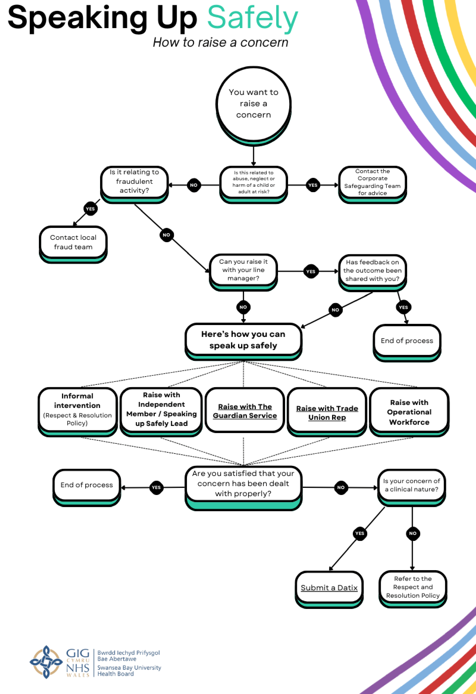

Policies and Guidance
The Speaking Up Safely Framework was agreed by the
Welsh Partnership Forum and launched by Welsh Government in Autumn 2023. It aims to enhance existing procedures in Health Boards, ensure a minimum standard across NHS Wales and provide assurances to staff, that concerns will be taken seriously, heard fairly and that they will not suffer personal detriment as a result of speaking up.


“The framework will support organisations to create that culture; one where individuals feel safe and able to speak up about anything that gets in the way of delivering safe, high-quality care or which negatively affects their experience. This includes, but is not limited to, matters related to patient safety, safe staffing, the quality of care, bullying and harassment (and cultures which enable this), as well as financial malpractice or fraud.
To support this, leaders and managers need to be willing to listen, and to be open to constructive challenge. Speaking up and bringing these issues into the open is a brave and vulnerable thing to do, and therefore should be welcomed and seen as an opportunity to listen, learn and improve” (HEIW, 2023).
In conjunction with the National Framework, the Raising Concerns Procedure for NHS Staff in Wales offers further information and guidance to staff wanting to raise a concern.
A copy can be found under the policies section of the intranet.
