A better future for all: Swansea Bay’s Population Health Strategy

Dr Keith Reid, Executive Director of Public Health
February 2023

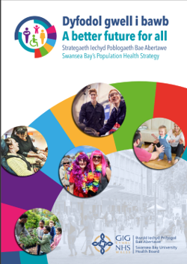




Acknowledgements

My thanks go to all those who have contributed to the production of this document, in particular:
- The many stakeholders and partners that shared their valuable insight and enthusiasm and helped in co-producing the recommended actions
- The Swansea Bay Public Health Team for authoring the report.

Contact details: Swansea Bay Public Health Team SwanseaBayLPHT.Admin@wales.nhs.uk

Contents
Section 1: Preface
Section 2: Making the case and why it matters
Section 3: What have we learnt that guides us to be more successful in the future?
Section 4: The Marmot approach
Section 5: What is Population Health
Section 6: What we did and what we heard
Section 7: The six Marmot policy objectives
- The Marmot approach
- What is Population Health
- What we did and what we heard
- The six Marmot policy objectives
- Objective 1: Give every child the best start in life
- Objective 2: Enable all children, young people and adults to maximise their capabilities and have control over their lives
- Objective 3: Create fair employment and good work for all
- Objective 4: Ensure a healthy standard of living
- Objective 5: Creating healthy and sustainable places and communities
- Objective 6: Strengthen the role and impact of ill-health prevention
- Two additional cross-cutting themes
Section 8: What this means for us
Section 9:Calls to action

References

Section 1: Preface
This Population Health Strategy sets out how Swansea Bay University Health Board will work to improve the health of local people. It is a strategy for the whole of the Health Board and, in its focus on our need to tackle inequity, a strategy to deliver for everyone in our communities.

For those who seek to work in partnership with the Health Board to improve health and wellbeing in Swansea Bay, the strategy sets out what you can expect from us – what types of action we see as the most important and how we are organising ourselves to deliver.

Despite our collective efforts, health has not improved year on year and inequalities in health have continued to widen within our communities. This is not because we don’t know what to do to improve health, it is because we have failed to act on our collective knowledge. Successive reports dating back to the Black Report in 1980 have highlighted the level of health inequalities in the UK and set out a range of approaches to address them. Responses have been ineffective - too often action at all levels of the system hasn’t followed or hasn’t been followed through to have a lasting effect.

In shaping this strategy for Swansea Bay, we have used an approach first set out by Professor Sir Michael Marmot in his 2010 report ‘Fair Society, Healthy Lives’ and subsequently developed in light of practical implementation and endorsed internationally. This approach identifies six key areas for action to improve health and tackle inequities. These initial actions are now joined by the need to tackle racism as a specific form of discrimination linked to health inequity and the need to address environmental sustainability.

While the Marmot approach is based on ‘whole of system’ responses the strategy also provides an approach to how we can organise ourselves within SBUHB to deliver effective action to improve health. The ‘four pillars’ approach sets out that as a health organisation we can look to what services we deliver to our communities and how we deliver them, the relationship we build with our employees and how we look after them, how we behave as a corporate body when we conduct our business, and how we work with others to achieve things we cannot by acting alone.

These are generic approaches that any and all organisations can adopt to help shape their contribution to improving the health and well-being of the people of Swansea Bay. However, there is a challenge for us as a Health Board collectively to rally around these approaches and to back up the words of the strategy with changes in how we do things. And to demonstrate our impact.

Taking effective action to improve health and reduce inequities is a collective effort. This Population Health Strategy is an approach for the whole health sector and requires a whole of sector response. It also requires us as individual organisations and as a sector to enter into genuine partnerships with individuals and with other agencies across Swansea Bay, meeting them where they are and working together to a common goal – better, healthier lives for all in Swansea Bay.

The evidence shows that when we come together to work effectively and consistently, we can make our communities healthier and more equal places. It is our joint responsibility to make that the reality for everyone in Swansea Bay.

Dr. Keith Reid
Executive Director of Public Health
Swansea Bay University Health Board

Our Vision: A Better Future for All

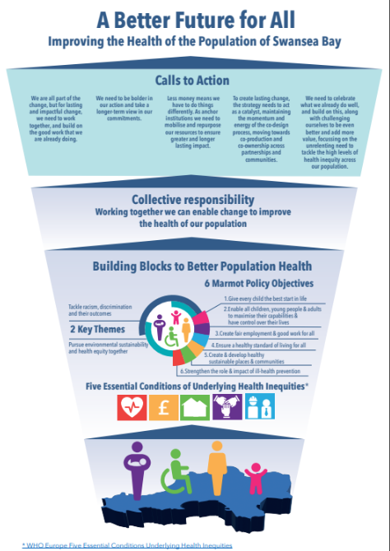

Section 2: Making the case and why it matters.

Swansea Bay University Health Board has a corporate responsibility for the health of its population – not just those we see through routine or clinical practice. We know however, that people’s experience of health is not the same across the population and that for those living in Swansea Bay, there are significant and concerning differences in health outcomes that need to be addressed.

What is the impact of deprivation?

There are two key measures that are often referred to when looking at a population’s health status. The first is life expectancy (how long someone is predicted to live) and the second is healthy life expectancy (how long someone is predicted to live with ‘good’ or ‘very good’ health).

These two measures are closely related to people’s socioeconomic circumstances (e.g. their income, job, education). The most common summary measure of these circumstances across a population is deprivation, and this is commonly summarised as the Index of Multiple Deprivation (IMD) or in our case the Welsh IMD.

Many studies have contributed to our understanding that there is a systematic relationship between deprivation (how ‘poor’ an area is) and both life expectancy and healthy life expectancy, sometimes referred to as the social gradient of health. Deprivation is the lack of access to opportunities and resources which we might expect in our society. Deprivation has a significant impact on life expectancy and life experience. Deprivation is about more than just income, and tools that measure deprivation include other factors such as employment, education and housing. The social gradient in health is a term used to describe the phenomenon whereby as people become less advantaged in terms of socioeconomic position, they have worsening health (and shorter lives) than those who are more advantaged. Taken from Social Gradient - IHE (instituteofhealthequity.org).

These differences in health outcomes for those in the most deprived areas compared to those in the least deprived areas are described as health inequalities. is taken from the ‘Fair Society, Healthy Lives’ Fair Society Healthy Lives (The Marmot Review) - IHE (instituteofhealthequity.org). The Marmot Review, 2010 and illustrates at a population level the impact of this on a population. While this reflects data from some time back, we know that the situation has not improved and the gradient still remains not only for England but very much so for Wales.

People living in the poorest neighbourhoods will on average die seven years earlier than people living in the richest neighbourhoods. Even more concerning is that the average difference in life expectancy for those with disabilities was, at that time, 17 years between the most and least deprived. So, people in poorer areas not only die earlier but also spend more of their shorter lives with life-limiting poor health. It also means that for the time that people are in poor health, they will need to use health and care services.

Deprivation in Swansea Bay

Swansea Bay has relatively more deprived communities than average for Wales with over 1 in 4 of our communities falling into the most deprived category. The areas of deprivation are particularly focused in urban parts of Swansea, Neath Port Talbot and the upper valley communities. For those living in our most deprived areas, they can expect to die up to 13 years sooner than those in the least deprived areas of the Health Board and won’t reach retirement age before they experience poor health. Indeed, they can expect to start experiencing poor health from early to mid-50s in our poorest communities compared to late 60s to early 70s for our most affluent areas.
We know that these inequalities in health arise because of inequalities in society and the conditions in which people are born, grow, live, work, and age – leading to differential levels of vulnerabilities. To change this, we need to act on what we term the ‘root’ causes.
These ‘root’ causes can be thought of as the basic building blocks for health such as good education, good quality housing, fair work, money and resources, the social fabric of our communities and our surroundings. Without these, our health and well-being is affected, leading to ill-health that is avoidable and unfair.

Section 3: What have we learnt that guides us to be more successful in the future?

What do we mean by equality, inequality, equity and justice?

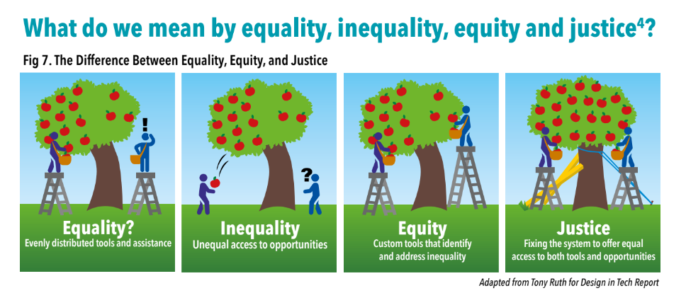
These terms are used to describe the way in which people are treated by society. Although they are often used interchangeably, each of them has a slightly different meaning and are important concepts that have to do with fairness and justice.

- Equality – in its simplest terms means each individual or group of people are given the same resources or opportunities and hence are treated in the same way, making sure that they get the same resources, time, money, opportunities etc.

- Inequality – is the opposite of equality and in simple terms means someone has less than an equal share of something. They are in essence being treated differently. It can be measured, for example by looking at the distribution of health, wealth, educational achievement or a number of other measures, in a population.

- Equity – recognises that each person has different circumstances and allocates the exact resources and opportunities needed to reach an equal outcome. Equity recognises that people have different needs and assets and hence that people therefore need different opportunities, access, resources and support.

While in this illustration the tree appears to be a naturally occurring system, it is important to remember that social systems have been intentionally designed and often over such a long time period that the system’s outcomes may appear unintentional but are actually rooted in discriminatory practices.

- Justice – equity is a solution for addressing imbalanced social systems. Justice takes equity one step further by fixing the system in a way that leads to long-term, sustainable, equitable access for generations to come.

What have we learnt about tackling inequalities?

Tackling health inequalities is not new and there have been numerous calls to action over decades including:
- 1980: Inequalities in health: report of a research working group
- 1998: Independent Inquiry into Inequalities in Health
- 2002: Securing our future health
- 2008: Fair society, healthy lives
- 2015: Well-being of Future Generations (Wales) Act
- 2018: A Healthier Wales
- 2020: Build Back Fairer
- 2020: Health Devolution commission
- 2022: Equity and endurance: how can we tackle health inequalities this time
A working group, chaired by Sir Douglas Black was commissioned in 1977 by the Labour Government to investigate the variation in health outcomes across social classes and consider the causes and policy implications. The report ‘Inequalities in health: report of a research working group’ was published in 1980 ‘Black report’ on health inequalities | Policy Navigator.
They found that there were differences in death rates across the social groups with those in lower socioeconomic groups suffering higher rates of mortality. It also found inequalities in access to health services, particularly preventative services with low rates of uptake by those in lower socioeconomic groups. Their recommendations focused on not only increased spending on community health and primary care, but also broader social policy such as increasing child benefit, improving housing and agreeing minimum working conditions with unions. Due to a change in government at the time of publishing, the recommendations were not accepted or endorsed at the time.
An ‘Independent Inquiry into Inequalities in Health’ ih.pdf publishing.service.gov.uk), chaired by Sir Donald Acheson published their report in 1998. The purpose was to inform the government’s public health strategy. It made a number of recommendations on a range of areas relating to health, environmental and social factors with many involving a re-distribution of wealth but also importantly introducing health impact assessments for all policies that were likely to have a direct or indirect impact on health and health inequalities. These included placing a partnership duty on the NHS executive and regional government to ensure local partnerships between health and local government.
Sir Derek Wanless was appointed by HM Treasury to lead the ‘Securing our future health’ review to examine the long-term trends affecting the health service ‘Securing our future health’ review | Policy Navigator. The review, published in 2002, attempted to quantify the resources needed to keep the health service comprehensive and available to all. They observed that the rise in the ageing population would have as great a pressure on social services as it would on health services and that ‘very substantial increase’ in resources for both health and social care services would be required to withstand the pressure.
However, improvements in productivity and the delivery of high-quality public health and preventative services could result in savings that might partially reduce the expected funding gap. It also found that there was excessive focus on acute care services over health improvement and maintenance interventions as well as a lack of investment in social care, compared to the levels of investment in health.
In 2008, Sir Michael Marmot was commissioned to suggest cost-effective strategies to reduce health inequalities. The subsequent ‘Fair society, healthy lives’ Fair Society Healthy Lives (The Marmot Review) - IHE (instituteofhealthequity.org) report published in 2010 found that there were wide variations in life expectancy between areas; that people in more socioeconomically deprived neighbourhoods died earlier and tended to live with disabilities for most of their lives; that there was a distinct social gradient on health inequalities and that the health status and inequalities could be determined by factors such as the environment, income, housing, education, disability and others.
Marmot argued that health inequalities were largely preventable, but that tackling them would require action across all the social determinants of health. He also made the argument that it was not only a moral necessity to ensure good health and well-being was spread evenly across the population but also an economic argument for tackling inequalities.

To achieve better health and well-being for all, the report set out two policy goals:

- to create a society that enabled individuals to maximise individual and community potential
- that social justice, sustainability and health must be at the centre of all policies.
They grouped their recommendations under six policy objectives and recognised the different life stages that would require different types of support and that to realise these objectives, the NHS, central and local government would need to work together. The six original policy objectives were:
- giving every child the best start in life
- enabling all children, young people and adults to maximise their capabilities and have control over their lives
- creating fair employment and good work for all
- ensuring a healthy standard of living for all
- creating and developing sustainable places and communities
- strengthening the role and impact of ill health prevention.
In February 2020 the ‘Health equity in England: the Marmot review 10 years on’ Marmot Review 10 Years On - IHE (instituteofhealthequity.org) was published which examined the progress in addressing health inequalities over the 10 intervening years.
They found that there had been little progress made to reduce health inequalities and found that improvements in life expectancy had stalled and for the poorest 10% of women had declined; people were living more of their lives in ill health; the gap between the least and most deprived areas had increased; and the differences in life expectancy between and within regions had increased.
A further review was commissioned, led by Sir Michael Marmot, to investigate how the pandemic had affected health inequalities. This led to the ‘Build Back Fairer’ report at the end of 2020 Build Back Fairer - Post COVID-19 - IHE (instituteofhealthequity.org. This report:
- showed how COVID-19 had exposed and amplified the inequalities highlighted in the earlier report contributing to the high and unequal death toll
- argued that the economy and health are strongly linked
- highlighted that to reduce health inequalities requires long term policies with equity at the heart
- argued for a need to invest in public health action on the social determinants of health and multi-sector action over the long term.
This learning is also reflected in the Welsh policy landscape. Since the National Assembly for Wales was established by the Government of Wales Act in 1998, Wales has become the envy of many other nations in the reach, range and innovative policy landscape that is enabling of progressive action to address health inequalities.
Of particular note among the many examples is the Well-being of Future Generations (Wales) Act 2015 The Well-being of Future Generations | GOV.WALES which is about improving the social, economic, environmental and cultural well- being of Wales. It requires public bodies in Wales to think about the long-term impact of their decisions, to work better with people, communities and each other and to prevent persistent problems such as poverty, health inequalities and climate change.
The Act requires the statutory partners, including Health Boards to work together, adopting the five ways of working to progress action against the 7 Well-being Goals with the vehicle for delivery being the Public Service Boards (PSBs).

Seven Well-being Goals:
- A Globally Responsible Wales
- A Prosperous Wales
- A Resilient Wales
- A Healthier Wales
- A More Equal Wales
- A Wales of Cohesive Communities
- A Wales of Vibrant Culture and Thriving Welsh Language

Five Ways of Working:
- Collaboration: Acting in collaboration with any other person (or different parts of the body itself) that could help the body to meet its well-being objectives.
- Integration: Considering how the public body’s well-being objectives may impact upon each of the well-being goals, on their other objectives, or on the objectives of other public bodies.
- Involvement: The importance of involving people with an interest in achieving the well-being goals and ensuring that those people reflect the diversity of the area which the public body serves.
- Long term: The importance of balancing short-term needs with the need to safeguard the ability to also meet long-term needs.
- Prevention: How acting to prevent problems occurring or getting worse may help public bodies meet their objectives.
However, despite all this knowledge it has not translated into enduring action and progress or success. Furthermore, while inequalities in health have always been a problem, the COVID-19 pandemic has led to a renewed need, desire and focus on how we address what are avoidable, unfair and systematic differences in health between different groups of people.
In 2020 The Health Devolution Commission DEVO-Report-of-the-Health-Devolution-Commission-Final.pdf (healthdevolution.org.uk) argued that a new approach is needed and that it must recognise three fundamental realities that have to be hard-wired into the implementation of any approach to successfully address health inequalities. These are:
- Endurance: This means a long-term programme that goes beyond planning or political cycles and leadership tenures with scale requiring balance of short-, medium- and long-term actions.
- Partnership: This requires a multi-agency effort. It cannot be achieved by one part of the system acting alone.
- Disruption: Intervening upstream is not an add-on project but re-invention of the status quo with the innovation that demands. It disrupts patterns of public service delivery that fail to tackle inequalities which in some cases, reinforces them.

How do we tackle inequalities?

The Kings Fund in 2022 published work undertaken that look at past attempts to address health inequalities and synthesised the learning from that Equity and endurance: how can we tackle health inequalities this time? | The King's Fund (kingsfund.org.uk). They called out three related tiers of action around the need for:
- An enduring commitment and focus to tackling inequality
- Local and national partnerships that create conditions for system success
- Local leadership that supports and nurtures bold action that will be needed to sustain success
These findings mirror the previous work, and the Kings Fund suggested practical actions required to make it happen as follows:
- A stronger focus on prevention and people with multiple unhealthy behaviours
Comprehensive policy that looks at more than providing advice but changing point-of-sale displays, gearing price and establishing supply models for healthier alternatives, providing excluded communities with Nicotine Replacement Therapy, using tax and regulation to shape product formation. Reinforcing actions are needed across different health harms as unhealthy behaviours cluster in specific populations. Solutions need to consider root causes e.g. underlying poverty.
- National targets in a locally led system
What success looks like needs to be explicit and measured. Shared outcomes which recognises distributed accountability at local level. Multiple national policies and initiatives risk divergent local action – synthesis is needed and coordination is essential
- Action needed: Opening up the data
Collecting accurate data and sharing it routinely is important as it will stimulate action and allow scrutiny across partners leading to healthy debates involving the public. Data needs to be grounded in accuracy and completeness.
- Distilling what works and sharing it
Having a systematic approach to sharing evidence and implementing best practice is needed. Capability and capacity to design and implement effective interventions are not evenly distributed across or within systems and sharing knowledge and skills will be critical e.g. peer support models, collaborations between partners, learning networks.
- Tackling health inequalities should be business as usual for the NHS
Practical steps to make it happen: NHS alone is not best placed to lead health inequality reduction, but it is an essential partner. It needs to see inequalities as a priority and to stay the course of a long-term effort to address inequalities. Engaging frontline professionals in finding their role in the effort on inequalities is important e.g. knowledge sharing models to promote frontline translational work.
- Moving money and changing outcomes
Practical steps to make it happen: Spending on inequalities cannot been seen as additional or novel, directed at specific groups or one-off projects. Shift in the way baseline funding is spent, treating inequalities spending as part of the mainstream is required for work on inequalities to endure.
- Prioritising building community capability
Practical steps to make it happen: Community capability is recognised as central to supporting neighbourhoods to overcome inequality either by directly narrowing the gap or creating resilience to manage its effects. Mindset required that values the role of informal care and volunteering work that builds trust and relationships between communities and state provision. In these hyper- local settings, at neighbourhood level, primary care can play a pivotal role in co-ordinating help and offering continuity of care.

Section 4: The Marmot Approach

There is a large body of evidence around what are the determinants of health and what contributes to the inequalities and inequities we see in our population’s health outcomes.

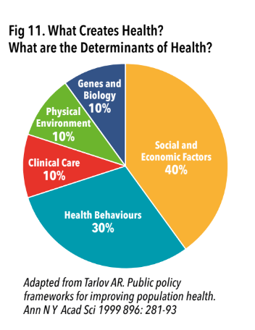

The ‘Healthy, prosperous lives for all: the European Health Equity Status Report’ (HESR) Healthy, prosperous lives for all: the European Health Equity Status Report (who.int), published in 2019, captured and analysed for the first time the relationships between health inequities, the conditions that are essential to be able to live a healthy life and the degree of investment, coverage and uptake of policies that influence health equity outcomes. What they found was that for any dimension of health, whether that be self-reported health; mental health; or life satisfaction, that there are five conditions that have impacts on health equity.
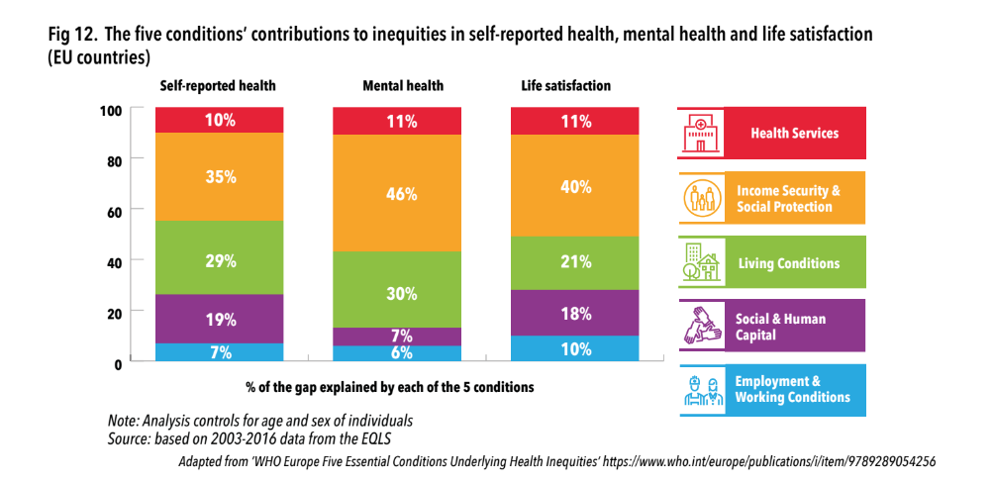
They also highlighted that as all of these life conditions are essential for people to live healthy, prosperous lives, that to increase equity, actions are needed across all five of these conditions through a combination of both targeted and universal policy approaches.
This underpins the importance of social change and the level of work that is needed, as well as the importance our partners have in influencing population health outcomes.
Therefore, in developing our Population Health Strategy, we have used a wide source of evidence generated over decades that provide a clear steer in terms of the areas for, and type of action needed in order to truly address health inequalities and inequities in our society.
We decided to use the Marmot Policy Objective areas as the framework for our strategy and the recommendations and findings within the Marmot review as core, guiding principles to inform consideration of the action we need to take across Swansea Bay, in order to tackle health inequalities.

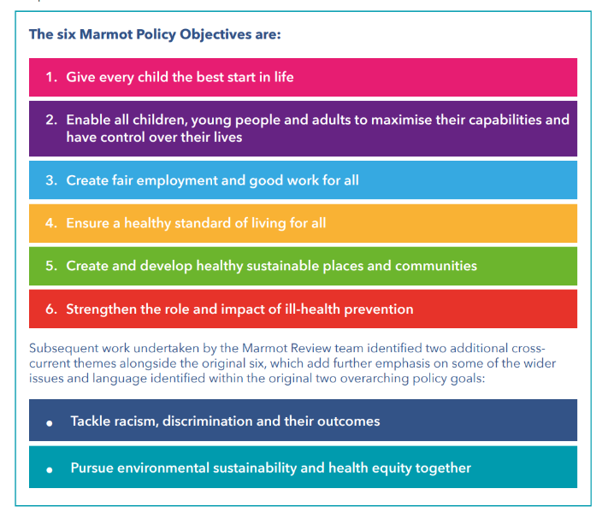
These are described and explained in more detail later in the Population Health Strategy.
For the Population Health Strategy to be successful, we recognise that to take it forward, we need:
- To reduce inequalities, action is needed across ALL six Marmot policy objectives and the two cross-cutting themes.
- Action is needed across ALL five conditions to achieve equity, through a combination of both targeted and universal policy approaches.
- As such, delivering these will require action by ALL parts of the public, private and third sector and communities.
- Effective local delivery requires effective participatory decision-making at local level – involving individuals and local communities.
- Creating a fairer society is fundamental to improving health of the whole population and ensuring a fairer distribution of good health.

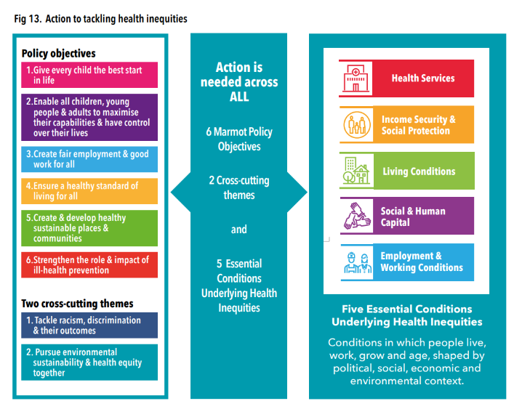

Section 5: What is Population Health?

Population health is a term we have used throughout the strategy, and it is helpful to provide some clarity on what we mean by this, as there is often confusion over population health versus public health. They are sometimes seen as inter-changeable when in reality they are not one and the same. We are defining population health as:
“...an approach aimed at improving the health of an entire population. It is about improving the physical and mental health outcomes and wellbeing of people within and across a defined local, regional or national population, while reducing health inequalities.” King’s Fund, 2021 A vision for population health | The King’s Fund (kingsfund.org.uk)

In order to develop our population health competence, the first step is in understanding that to deliver this requires an appreciation of the need and ability to join up the component areas that form population health into a comprehensive approach. The key component areas are work in the fields of:
- public health,
- population health management,
- tackling health inequalities,
- personalised care,
- engagement and experience,
- system transformation (a broader agenda often focussed on structural improvements and others)
In reviewing experiences from elsewhere, the Kings Fund A vision for population health | The King’s Fund (kingsfund.org.uk) noted that there is often a focus on one or a handful of these component areas rather than a recognition of the need for joining up of all the different components as a whole in order to achieve population health delivery. Equally, there is strength and mutuality in the varied roles of those involved in the different elements contributing to a population health approach which requires those involved to work alongside each other.

There are some concepts below that we have found useful to clarify, as part of the co-design process of developing our strategy:
- Public health - is founded on integrative thinking, is the science and art of preventing diseases, prolonging life and promoting health and well-being through the organised efforts of society.
- Population health - is about improving the physical and mental health outcomes and well-being of an entire population, through taking action on the key determinants of health, working with communities and working towards social justice, in order to reduce health inequalities within and across the population.
- Population health management - is a data-driven approach that brings together health related data to identify a specific population that health and care systems may then prioritise for particular preventative or treatment services. Common approaches are being able to segment, stratify and model ‘at risk’ or ‘rising risk’ groups that are used to design, target and adapt interventions for proactive care which reduces health inequalities.
What the Kings Fund also found from other areas is that attempts to implement population health approaches have often been hampered due to confusion, competition and disagreement on roles and expertise. It is a further reinforcement of the unhelpfulness of competing narratives or an artificial division of labour where the focus is on better NHS healthcare rather than on the social determinants of well-being and healthier lives.
For the Health Board, population health is a corporate responsibility. It doesn’t sit with the public health team, or individuals, even if one individual is leading the work. It needs to be purposefully built into all our work at all times, otherwise we won’t be successful.

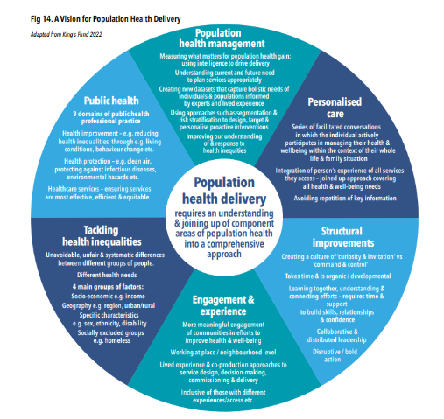

Section 6: What we did and what we heard

The Strategy sets out the guiding principles by which SBUHB and its partners will seek to improve the overall health and well-being of the local population whilst reducing the gap between our least and most deprived communities with a focus on prevention and tackling the ‘causes of the causes’ of ill-health.
The Strategy is not intended to be a full evidence review of the effectiveness of all possible public health interventions that may benefit the population. Instead, it offers a framework by which the overall priorities, informed by the Marmot policy objective areas for improving population health in the UK can be aligned with local population needs and local context.
It is intended to act as a vehicle by which evidence-informed interventions to improve the health and well-being of the population can be applied to the unique health, social, economic and political landscape in which the population resides.

What we did
We deliberately adopted a co-design approach to the development of the strategy. This was important for us as our partners’ views matter and to get to a point that we have a consensus of what action we need to take, based on our local context including our existing strengths and good practice.
We recognised that the provision of good quality, accessible healthcare is not in itself going to achieve the population health outcomes we desire. There is already a significant and diverse amount of work already going on within partnerships that positively contribute to our population’s health and well-being.
Our approach involved a range of engagement activities including one-to-one interviews, focus groups, workshops and surveys, both internally within the Health Board and externally with over 20 partners and in numerous partnership fora over several months.

What we heard
There was significant and broad support across the system for the Strategy and this population health approach. In particular what was highlighted is:
- A sense that this is the first time that there has been an approach which encompasses and recognises the collective efforts of a wide range of stakeholder and is hugely welcomed by man as a way of binding and creating synergies.
- Described by some as a ‘harmonising’ of different agendas and ‘giving voice’ to a much wider range of partners and stakeholders who are vested in key areas related to the work e.g. recognising the importance of housing, poverty, place-making, planning etc. and the intersectionality of these as issues.
- The user of the four pillars (see section 7) to conceptualise the various aspects of delivery was noted to be particularly helpful for some partners in recognising their different roles in this agenda.
- The approach in itself has helped to strengthen existing connections and develop new connections across the health system.
The following chapter provides the detail of feedback from partners on each of the Marmot Policy Objective areas, as it relates to our local population needs and context. These discussions resulted in the identification of action for each of the areas, represented as driver diagrams. Each driver diagram aims to capture the primary drivers identified in collaboration with our partners, which form the focus of action and effort in order to achieve the aim or goal. The ‘secondary drivers’ are a list of actions that would be necessary to achieve progress on the primary driver.
These should not be viewed as a comprehensive list and there may be others that we have not yet included. Equally, they are not intended to form an ‘action plan’. Instead, these form a focal point for consideration of existing programmes of work or policy development, through partnership with others. As Marmot and others have highlighted, this aims to capture the breadth and scale of the challenges and to recognise the shared responsibility and need for a whole systems approach.
In developing and agreeing these driver diagrams, it became very apparent the significant amount of existing work being done through and with partners in progressing these agendas. While some of these are relatively new and emergent, many are long standing and have already achieved much. Please see the next page.
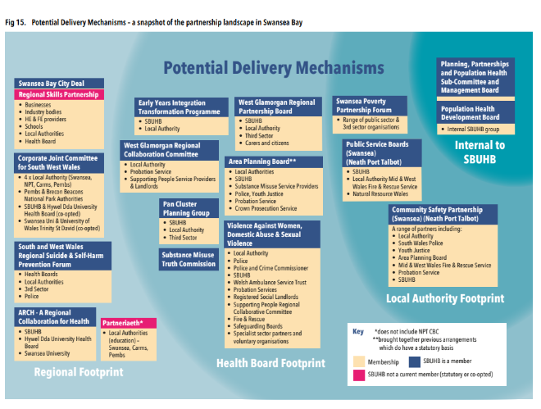
These represent important partnership spaces that we as a Health Board need to better understand and engage with purpose.
In addition to the feedback and comments which were specifically focussed on the 6 Marmot Policy Objective areas, there were some common themes that emerged throughout the co-design and engagement process which are summarised below.
Feedback theme 1: Lots of existing strategies and work in this space so need to consider how it will add value and not duplicate:
- A need to consider how action coming out of the strategy will fit within the existing delivery requirements and partnerships and system structures. We need to build synergy and avoid overburdening those who are working to meet expectations of delivery and breaking down silo working.
- Being complementary and an addition to the goals of Public Service Boards (PSBs), as well as facilitating communication between those developing strategies and policies.
- Overcoming challenges in delivering population health approaches across regional and local leadership and partnership functions and their different cultures.
Feedback theme 2: Our ways of working don’t necessarily enable effective collective action:
- Challenges of operating on different footprints e.g. Primary Care Clusters, Local Authority, Health Board footprint etc. which creates lots of interfaces – with the potential for fragmentation and disjointed working.
- Engagement activity is dispersed across the system but is often not well co-ordinated and collaborative ways of working are often not embedded.
- Language matters to avoid it being a barrier – need to help people understand concepts; and that engages, compels and stimulates collective action.
Feedback theme 3: Need to move from co-design to co-ownership of the strategy:
- Includes a need to develop existing relationships and form new ones.
- Ensure a person-centred approach and embedding lived experiences from different population groups.
Feedback theme 4: Data sharing and timely intelligence to make informed decisions is a recurring theme as limiting action:
- There is a recognition that while there is a lot of data available, there is a need to improve the co-ordination and synthesis of this complex landscape and to translate this into high quality information and intelligence to guide the most appropriate local action.
- Accurate data sharing and data collection is needed.
- This impacts at an organisational level and on individuals (information is not shared between organisations) and makes it difficult to evaluate the current situation and impact of any interventions.
Feedback theme 5: Population health and public health intersects a number of planning and policy areas:
- However, this landscape is not well understood by partners and there is an appetite to develop this understanding for more productive partnership working.
- Further exploration of this complexity and embedding a ‘Health in All Policies’ approach seen as needed in order to take a co-ordinated approach, at scale, to successfully improve population health and well-being in the Swansea Bay area.
Feedback theme 6: Short term nature of funding and projects lead to small scale, ‘safe’ initiatives in the absence of a long-term vision with limited impact at population level:
- Grant funding and short-term funding make it challenging to recruit to roles and to plan long- term services. This has gotten worse for some services since COVID-19, with multiple pots of money with short-term funding.
- There is a real desire to be able to plan for the longer term in terms of actions as well as recognising the need for bold action e.g. cost of living but can’t do that on their own - bold action needed beyond borders of one organisation.
- In the absence of long term, secure funding, need for collaboration and sharing of resources across organisations to enable longer-term thinking and reduce need for ‘firefighting’.
Feedback theme 7: Sustainability is important and requires system-wide ways of thinking, working and acting:
- Need to develop an approach to prioritisation of activities from a population health perspective.
- Recognise the wider context and backdrop of pressures which have and will continue to change over time e.g. pandemic response, urgent care demand and flow; war in Ukraine; cost of living crisis.
The key take home message from these were of the importance of and need for consideration to be given to building strong foundations in order to successfully create sustainable, population level impact. These strong foundations mirror those actions highlighted in the ‘Enablers for Change’ stage.
A Theory of Change is essentially a comprehensive description and illustration of how and why a desired change is expected to happen in a particular context. They explain the process of change by outlining causal linkages in a project. Theories of change help by mapping out the necessary steps needed to be taken to achieve a particular goal and the assumptions underpinning them. They are helpful in articulating and defining the problem you want to solve, and the long term change you want to make.

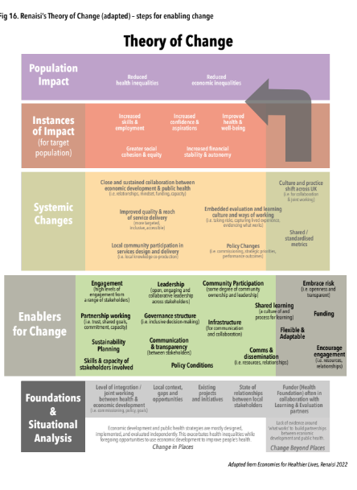

While this Theory of Change has been developed with an economic lens, as part of the Economies for Healthier Lives work, 2022 Putting health at the heart of economic development - Renaisi it describes the different stages to achieving population level impact; the actions required within each of the stages and the time frame involved. The feedback from our stakeholders was consistently clear in highlighting that our first steps in taking this Population Health Strategy forward are the need to work on the actions that are reflected in the ‘Foundations and situational analysis’ and ‘enablers for change’ stages. This feedback has therefore informed our calls to action.

Section 7: The six Marmot policy objectives

In the coming pages, we have outlined the six Marmot policy objectives, highlighting why each area is important and the evidence base behind this. We then discuss the local picture and what we know about the situation in Swansea Bay and what this means for us and our partners and the areas of work that will need to be acted on to achieve the aim or goal of the objective.
We have used Driver Diagrams to illustrate the range of action needed under each heading. These have been co-designed through the strategy engagement process with a wide range of stakeholders, taking on board the evidence base, the core principles of Marmot and our local context. Primary drivers are key areas of work that need to be acted on to achieve the aim or goal.
Secondary drivers are some of the actions that through the co-design process were collectively identified as being important areas to focus on. These are wide-ranging and represent both what we need to progress as well as what we are already working towards. The examples in the secondary drivers are not an exclusive list but do form the starting point for further work with and through partnerships to agree and to make progress in these areas.
While each objective has its own specific driver diagram, due to the range of action needed across all parts of the system in order to be able to make a successful impact on health inequalities, there are significant areas of crossover.
- Give every child the best start in life
- Enable all children, young people and adults to maximise their capabilities and have control over their lives
- Create fair employment and good work for all
- Ensure a healthy standard of living for all
- Create and develop healthy sustainable places and communities
- Strengthen the role and impact of ill-health prevention
As referenced earlier, two subsequent cross-cutting themes were added by Marmot in 2020, namely:
- Tackle racism, discrimination and their outcomes
- Pursue environmental sustainability and health equity together

Objective 1: give every child the best start in life

Childhood experiences set us on the path beyond our early years. Our experiences in childhood impact numerous factors in our lifetime across a number of areas – including school performance, employment, living conditions, and physical and mental health and well-being.
Early childhood is a crucial time for people’s physical, social, intellectual and emotional development. In fact, disadvantages start before birth and have an impact on our development during pregnancy into early years and build throughout life. Evidence tells us that the early years period is the time of life where actions to target inequalities are the most effective and cost-effective. To have positive impacts throughout a person’s life, we need to target inequalities not only in early years, but before birth.
We know that left unchecked, health inequities accumulate across the life-course.
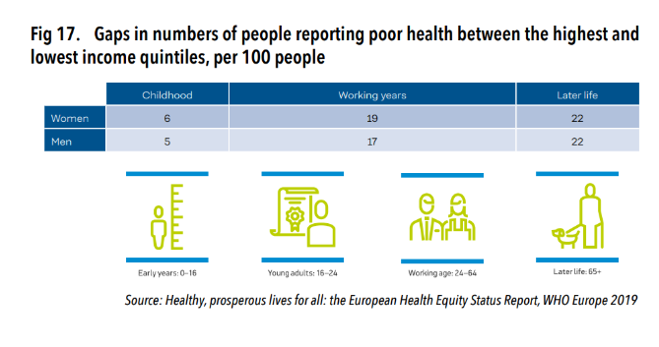
Inequities in mental health are just as prevalent. Perinatal mental health problems, which occur during pregnancy or the first year of a baby’s life, can have long-term effects on the woman, the baby, and the wider family.
Adverse Childhood Events (ACEs) are traumatic events, such as experiencing violence, abuse or neglect, witnessing domestic violence, or losing a parent through divorce or death. ACEs are known to have long-term impacts on people’s physical and mental health and well-being.
It’s estimated that nearly 9,000 women in Wales will experience perinatal mental health problems, including anxiety, depression, obsessive compulsive disorder, post-traumatic stress disorder and postpartum psychosis, each year.
- Evidence shows that positive early life experiences are closely associated with:
- better performance at school
- better social and emotional development
- improved work outcomes
- higher income
- better lifelong health, including longer life expectancy

Groups who may need additional support:
- Families living in poverty
- Parents at risk of unemployment/in unstable employment
- Children/families known to be at increased risk of Adverse Childhood Experiences (ACEs)
- Smokers who are trying to conceive or are currently pregnant and family households with smokers

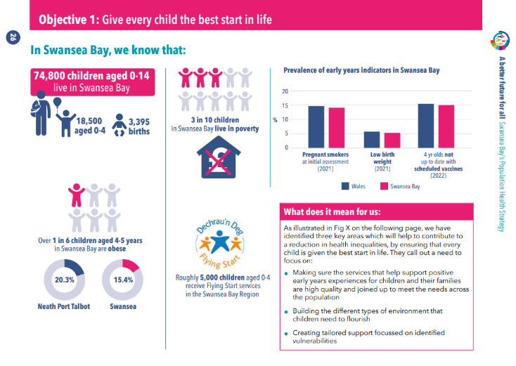
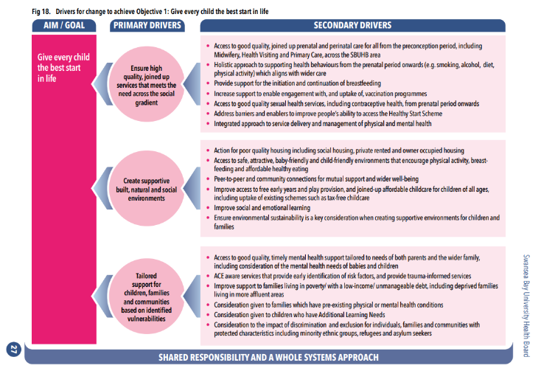

Summary of key points for Objective 1

- Early childhood is a critical time for development of later life outcomes, including health.
- There are clear, persistent socio-economic inequalities in early years development.
- The early years period is the time in life which interventions to disrupt inequalities have been shown to be most effective and cost-effective.
- The people and services that support young people need to align effectively to give the most positive impact.

Objective 2: Enable all children, young people and adults to maximise their capabilities and have control over their lives

Learning does not just happen in schools, and it does not stop when people leave school. Learning across the life course leads to better educational achievement, better employment, and improved physical and mental health.
Some groups are less likely to be able to undertake learning across the life course and are more likely to experience poor quality learning. Inequalities in educational achievement have been linked to a wide range of health and well-being outcomes. These inequalities emerge very early in life and parents’ transmission of skills across the generations is critically important in helping to prevent them. Where parents have not gained skills themselves, disadvantage is passed from one generation to another.
Good quality education and learning include:
- Development of cognitive and non-cognitive skills, personalities, talents and abilities, building resilience and self-esteem
- Parents passing on skills from one generation to another
- Adults that have opportunities for lifelong learning and skills development, not only in formal educational settings but also in the workplace and in communities
Some groups more likely to experience poor quality education and learning include:
- People from lower socioeconomic groups
- Pupils in receipt of free school meals
- Children excluded from school
- People growing up in an environment with limited family and community support

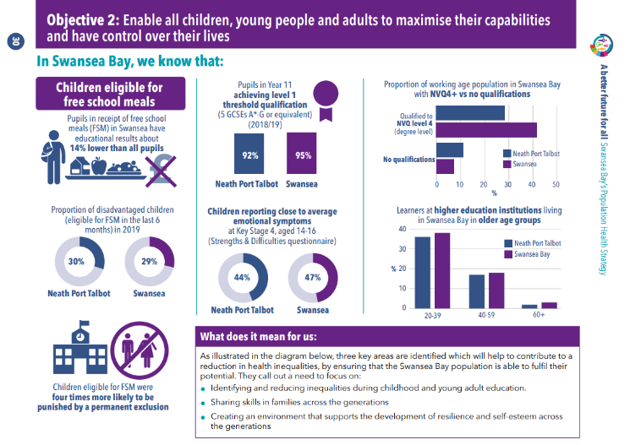
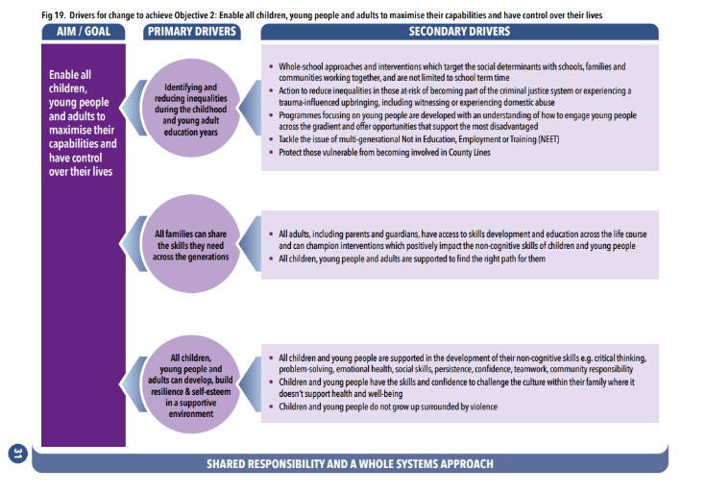

Summary of key points for Objective 2

- The acquisition of cognitive and non-cognitive skills is key to sustaining the reduction of inequalities across the gradient through the years of education.
- Inequalities in educational achievement emerge very early and parents’ transmission of skills across the generations is critically important. Where parents have not gained these skills themselves, disadvantage is passed from one generation to another.
- Access to continued learning throughout life is important to well-being in a number of ways.

Objective 3: Create fair employment and good work for all

Fair work contributes to a well-being economy, drives prosperity, is environmentally sound and helps everyone realise their potential. Being in good employment is protective of health, therefore getting people into fair work is critical for reducing health inequalities.
Unemployment is bad for health. However, it is not just having a job that matters but the nature and quality of the job that counts for health and well-being. Poor quality jobs are also bad for business as they can lead to increased levels of absence in the workforce, higher levels of staff turnover and lower productivity for an organisation.
The six characteristics of fair work (Fair Work Commission 2019) are:
- Fair reward
- Employee voice and collective representation
- Security and flexibility
- Opportunity for access, growth and progression
- Safe, healthy and inclusive working environment Legal rights respected, and given substantive effect work that includes job security and a decent wage
Some groups are more likely to experience poor quality or insecure work including:
- People from a lower socioeconomic group
- Younger people
- Those in lower paid and lower skilled jobs
- Minority ethnic groups
Some groups are more likely to experience unemployment including:
- Women
- Lone parents
- People with disabilities
- Minority ethnic groups

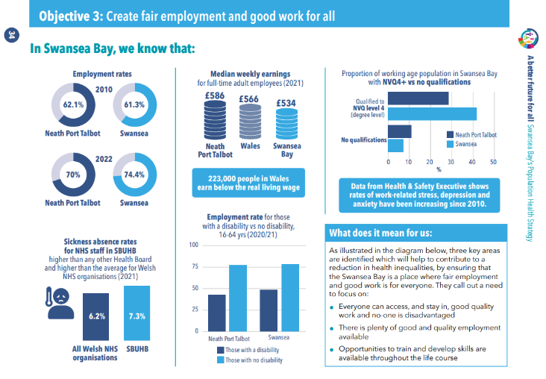
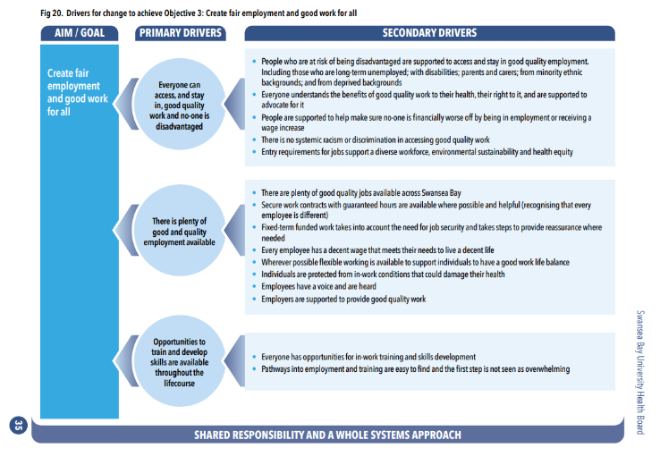

Summary of key points for Objective 3

- Being in good employment is protective of health and therefore getting people into work is critical for reducing health inequalities.
- However, being in work is not an automatic step towards good health and well-being – jobs need to be sustainable and of a minimum quality.
- Those with lower socioeconomic position, younger people, those in lower paid jobs and non-white people are all more likely to experience poor quality work with attendant impacts on health.
- Since 2010, rates of unemployment have decreased in the UK but increases in employment were often in low-paid, unskilled, self-employed, short-term or zero hours contract jobs. Rates of pay did not increase and more people in poverty were in work than out of work by 2020.

Objective 4: Ensure a healthy standard of living

Having enough money to lead a healthy life is central to reducing health inequalities and inequities. We know that poverty is one of the biggest contributors to health inequalities and inequities. Despite important steps made to tackle poverty, the proportion of the UK population living in poverty remains stubbornly high.
Poverty has a cumulative negative effect on people’s health throughout their life, which can in turn make it harder to escape poverty.
- A healthy standard of living includes:
- Access to affordable, secure and high-quality housing
- Enough money to pay for food, energy and other household costs
- Enough money to be able to make long-term cost-effective decisions
- Access to social protection schemes that act as a buffer when times are harder
In order to successfully reduce the health gap in Swansea Bay, decisions should take into account the drivers of health inequities, prioritising those which have the largest impact. The health sector alone cannot address the health gap, and other sectors play a significant role in driving and having the potential to reduce it. The NHS in Wales has the potential to be a strong ‘anchor institution’, and partnering with local communities, which could influence the wider determinants of well-being and health equity.
Some groups are more likely to experience a less healthy standard of living include:
- Workers in lower paid and lower skilled jobs
- Those who are unemployed
- Groups that experience poor health or other life-changing events e.g. divorce, new caring responsibilities
- Lone parents with children
- Disabled adults
- Minority ethnic groups

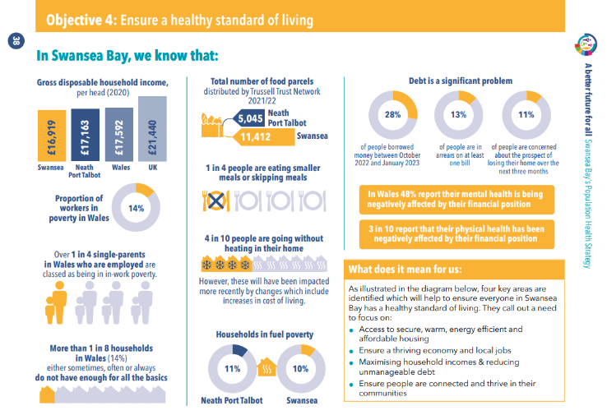
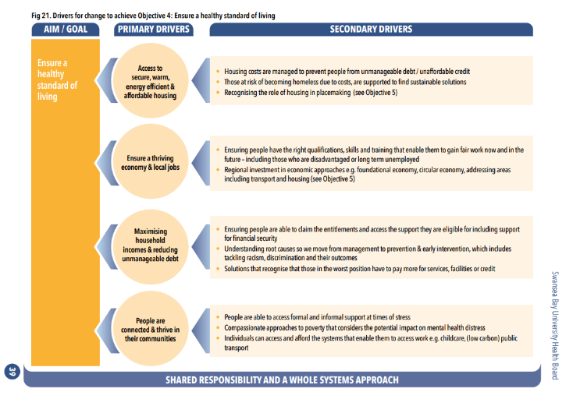

Summary of key points for Objective 4

- Having enough money to lead a healthy life is central to reducing health inequalities.
- Poverty and low living standards are strong contributors to ill health and inequalities, with health effects able to accumulate throughout a person’s life.
- These inequalities have worsened throughout the COVID-19 pandemic and other external threats will risk widening inequalities even further, including the current cost of living crisis and the increasing impacts of climate change.

Objective 5: Creating healthy and sustainable places and communities

Multiple forms of disadvantage interact and are made worse by the features of communities in which people live. Health is influenced by how our surroundings make us feel and the opportunities that the environment provides. The conditions in which people live, locality, places and communities all contribute to determining health. Despite economic disadvantage, well designed neighbourhoods and communities can encourage, and enable, people to be more physically active, feel safe and secure, access facilities and services, socialise and play.
Communities and places drive and shape health in direct and indirect ways. Communities can positively affect health through the services they provide and the resources they have e.g. good quality early years service, health, community and education services and access to green space. Communities can also positively affect health through supporting the development of social capital, social cohesion and feelings of safety.
The harm to health from climate change is increasing, and urgent action needs to be taken to address climate change.
- Living in a healthy and sustainable community includes:
- Good quality housing in a safe neighbourhood
- Access to green spaces, community, recreational and cultural facilities
- Access to good quality, affordable food
- Clean air - exposure to nitrogen dioxide (NO2) is associated with short-term and long-term health effects, including airway inflammation, increased susceptibility to lung infections and increased mortality
- Connections to other communities and areas
- Having a strong sense of community and social networks
Some groups of people are less likely to live in a healthy and sustainable communities, and more likely to be negatively impacted by climate change including:
- People who live in more deprived areas
- People who live in areas with poor infrastructure
- People from minority ethnic groups
- People with physical or mental health problems

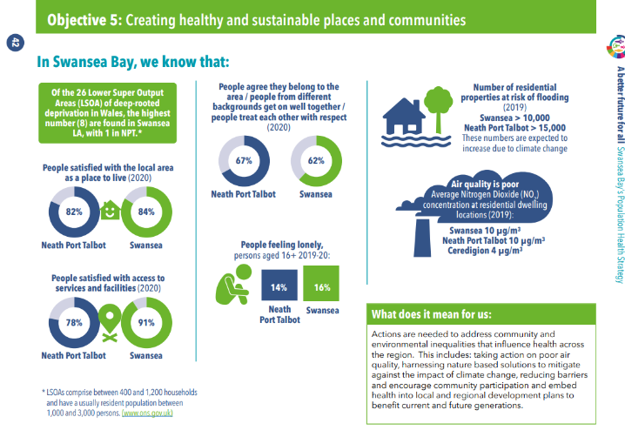
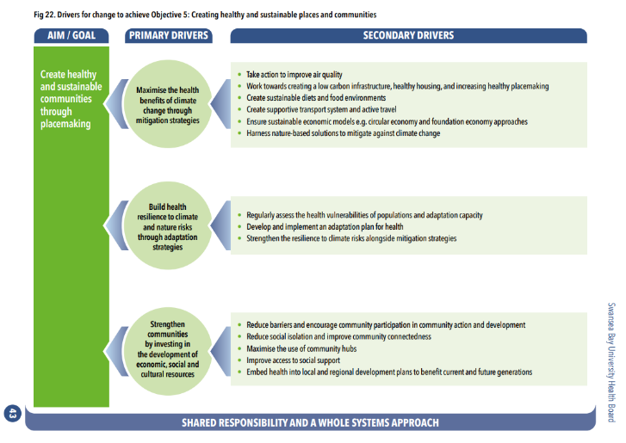

Summary of key points for Objective 5

- The influence of locality, places and communities contribute to determining health.
- Well-designed places, spaces and buildings, create community capital and opportunities that can mitigate against a range of poor health outcomes for people living in challenging situations.
- The harm to health from climate change is increasing at a global, national, and local level and this harm is not distributed equally across the social gradient.
- Some groups of people are less likely to live in healthy and sustainable communities and are more likely to be negatively impacted by climate change.

Objective 6: Strengthen the role and impact of ill-health prevention

Prevention of ill health has traditionally been seen as the responsibility of the NHS, but prevention can only be achieved when action is taken in the context of the social determinants of health. That is because a complex range of social, cultural, economic and environmental factors act at individual, community, national and global levels to influence people’s health related outcomes.
Hence prevention requires us to act more effectively to improve the conditions in which people are living and the structural drivers of these conditions, as well as positively influencing the choices that people make about health behaviours.
It requires a system based on prevention and health equity which would involve:
- A focus on supporting good health as well as preventing & treating ill health
- A focus on place – on small areas and influencing the environmental, social & economic conditions of places
- Understanding local population health and health risks through assessments that include the broader social and economic drivers of health and inclusion of those at risk of poor health
- Cross-sector collaboration between multiple organisations and sectors reaching beyond health and social care to include housing, early years services, education and many others.
- Development of proportionate universalist approaches where additional & different resources and actions are needed for more deprived communities and areas.
Approaches that focus on improving health equity may look quite different to those that focus only on improving average population health, as they are responsive to those with the greatest levels of need and the highest risks of poor health.
It is therefore clear that the prevention of ill-health is not the sole responsibility or sole domain of the NHS. A shared responsibility between partners and a whole of system approach is key. Decisions that are made at a national, regional or local level in schools, the workplace, at home and in government as well as across the NHS, all have the potential to help or hinder ill health prevention
This policy objective recognises that to prevent ill health:
- Prevention & early detection of conditions most strongly related to health inequalities should be prioritised across all organisations and sectors
- Increased availability of long-term and sustainable funding in ill-health prevention across the social gradient
- Evidence-based programmes of ill-health preventative interventions need to be implemented that are effective across the social gradient
- Interventions related to the social determinants of health should be proportionate across the gradient
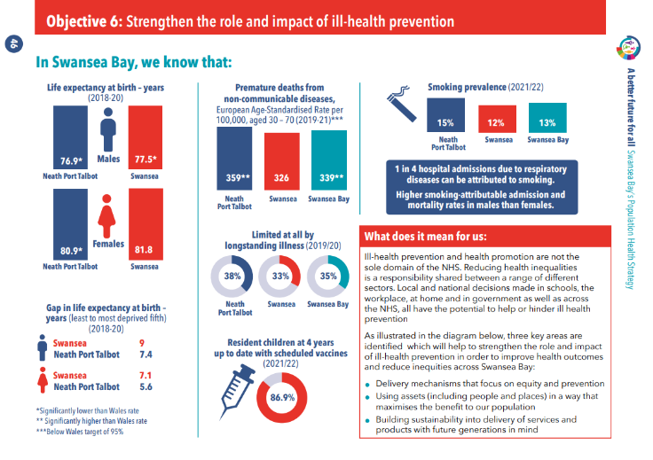
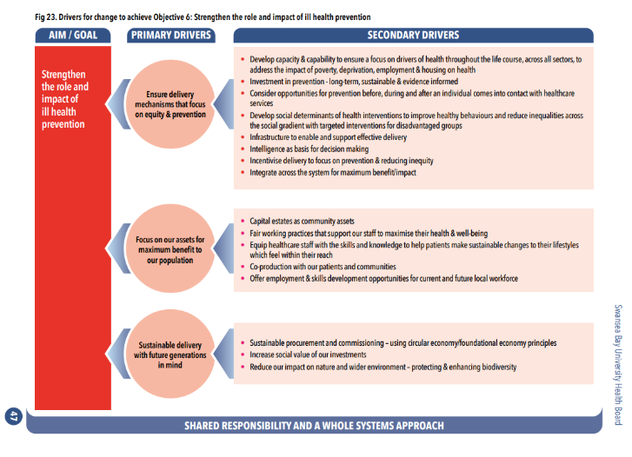

Summary of key points for Objective 6:

Marmot recommends:
- Prioritise prevention and early detection of those conditions most strongly related to health inequalities e.g. cancer, cardiovascular disease.
- Increase availability of long-term and sustainable funding in ill-health prevention across the social gradient.
- Development of capacity and expansion of focus on social determinants of health across all sectors to address the impact of poverty, deprivation, employment and housing on health.
- Develop social determinants of health interventions to improve healthy behaviours and reduce inequalities.
- It is important to recognise ill-health prevention from both a physical and mental health viewpoint.
- The NHS has an important role to play but cannot achieve a reduction in health inequality without its partners – we need to work collectively in Swansea Bay to achieve better population health.

Two additional cross-cutting themes

Cross-cutting theme 1: Tackling racism, discrimination and their outcomes
The impact of racism and discrimination on health inequalities has a more substantial impact than previously recognised in the initial 2010 Marmot Report. As highlighted by Marmot’s Build Back Fairer: The COVID-19 Review (2020), we now know that people from minority ethnic communities, particularly African, Caribbean and South Asian origin had a higher propensity to being in high-risk occupations, beyond their increased likelihood of experiencing health inequity. In addition to this, we know that people with one or more protected characteristics are more like to experience increased levels of discrimination. As such, recognising and tackling the structural racism and discrimination in our society is another element that needs to be addressed to improve population health and reduce health inequities.

Cross-cutting theme 2: Pursue environmental sustainability and health equity together
Both the 2010 and 2020 Marmot reviews highlighted the impact of climate change as an area of focus, given its impact on health. Not only do we need to take action to address the climate crisis, but tackling the environmental impact it causes, also presents opportunities to benefit our communities by reducing emissions and pollution. The climate and nature emergencies are current threats, and the impacts will continue to worsen unless we take immediate action.
Through engagement with partners these were recurring themes across all other objectives. To facilitate the inclusion of these within all other objectives, these are highlighted as cross-cutting themes.
The context in which these recommendations are implemented is critical in order to make sure that the plans are to have impacts on the health and well-being of the people of Swansea Bay and these additional areas have become much clearer in our lives in recent years. For example, recent events such as COVID-19, the war in Ukraine and extreme weather events as a consequence of climate change all worsen existing health inequalities, with impacts felt more in communities that are already facing significant challenges.
We have sought to embed these areas across the strategy as a whole. There is far more to do in both these areas as we move forward as a system. Before we can do that, we need to further develop our understanding of what this looks like in Swansea Bay and are calling out the need to build our knowledge to maximise the benefits to our population.

Section 8: What this means for us

Having listened to our colleagues and partners, we have considered what our role as the Health Board could be in implementing and progressing the agenda. We have captured some of those opportunities for action under 4 pillars. These pillars are intended to reflect both our capability and capacity as well as opportunities open to us as a large NHS provider and public sector organisation.

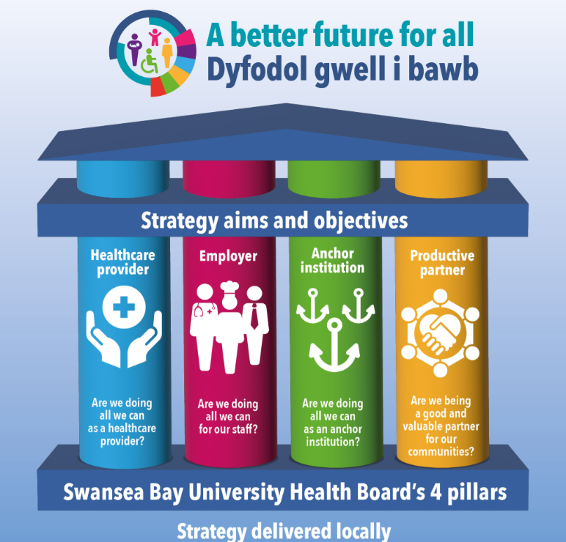

Healthcare provider: Are we doing all we can as a healthcare provider?
- Adopt a social model of health – recording and acting on information about contextual factors driving health outcomes
- Increase patient involvement – making them true partners in determining their treatment options and outcomes
- Agree and define Population Health outcomes to be achieved and recognise shared responsibility across the organisation
- Develop processes that support the consideration and embedding of Population Health principles, with a focus on reducing inequity, as part of a business-as-usual approach to decision making at all levels
- Collect accurate data and share it routinely in an accessible and practical way
- Move money and change outcomes – shift baseline funding away from a focus on targeted, additional, novel projects directed a specific groups to inequalities spending as part of mainstream
- Act as a place-based shaper at settings at neighbourhood level used to co-ordinate help; provide continuity of care; co-design services; champion and strengthen communities’ resilience
- Consider and address both mental and physical health impacts and needs across all pathways with particular regard for those with increased vulnerability and the early years
Employer: Are we doing all we can for our staff?
- Take a whole settings approach that takes bold action to create environments and policies that are health improving and tackle racism and health inequities for all our staff as default
- Provide opportunities for the local community to develop their skills in order to access and stay in good quality fair employment
- Enable the healthcare workforce to understand the social determinants of health and how they can support patients to mitigate their impacts
- Adapt employment practices to reflect insight from marginalised staff
- Ensure Fair Work practices and policies in place, in line with Fair Work Commission best practice guidance
- Recognise, champion and enable informal care and volunteering work that builds trust and relationships between patients and communities, and staff especially at neighbourhood level
Anchor Institution: Are we doing all we can as an anchor institution?
- Act as a place-shaper – develop and agree on commitments to bold action as an anchor institution – across domains that cover social mobility, local economy, and environment
- Adopt and apply foundational economy principles as part of decision-making processes
- Build on and synergise with partner agendas and commitments as part of an anchor system
- Capitalise on opportunities to influence place-making agenda through e.g. engagement with Local Development Plan and planning bodies; licensing of premises; using our buildings as community hubs; and ensuring protection for good quality play and green spaces; and active travel routes
- Communicate internally and externally our agreed shared outcomes; actions as an anchor institution; progress against intentions; definition of roles and contributions of others
- Move money to change outcomes – consider how baseline funding, contracting and commissioning is used to support health inequities and sustainability outcomes as part of mainstream spend
Productive partner: Are we being a good and valuable partner for our communities?
- Take a leadership role in ensuring, through partnerships, clear action is driven forward that addresses factors influencing people’s behaviours
- Strengthen and build our partnerships with purpose – agree shared outcomes, aligning to and agreeing priorities to focus on to achieve maximum impact and benefit
- Agree on shared outcomes with our partners to drive collective efforts at Public Service Boards, Regional Planning Boards and other partnerships
- Share data with partners to gather actionable insights that drive collective action
- Share evidence systematically and support to implement best practice – within SBUHB and with partners
- Lead on collective, evidence informed action that address health inequities as part of decision making and commitment to action in partnerships
- Prioritise and build community capability to support neighbourhoods to overcome inequity through direct action or creating resilience to manage its effects.
- Collaborate effectively with key strategic partners to mitigate against the impact and risks of climate change.

Section 9: Calls to action
The process of co-designing the Population Health Strategy with colleagues and partners has given us clarity on a mandate for moving forward to implementing this strategy. It is clear we all share a common purpose and desire to see a better, healthier and fairer Swansea Bay and our commitment to that is a great place to start from.

There are five Calls to Action:
- We are all part of the change, but for lasting and impactful change, we need to work together and build on the good work that we are already doing.

- We need to be bolder in our action and take a longer-term view in our commitments.

- Less money means we have to do things differently. As anchor institutions we need to mobilise and repurpose our resources to ensure greater and longer lasting impact.

- To create lasting change, the strategy needs to act as a catalyst, maintaining the momentum and energy of the co-design process, moving towards co-production and co-ownership across partnerships and communities.

- We need to celebrate what we already do well, and build on this, along with challenging ourselves to be even better and add more value, focussing on the unrelenting need to tackle the high levels of health inequity across our population.

References
Objective 1 references
Obesity data is most recent available from Child Measurement programme 2020/21 report : https://phw.nhs.wales/services-and-teams/child-measurement-programme/cmp-2020-21/ child-measurement-programme-report-2020-2021/
Births data (StatsWales)- https://statswales.gov.wales/Catalogue/Health-and-Social-Care/NHS-Primary-and-Community-Activity/Community-Child-Health/birthsliveandstill-by-welshbirthunit-localhealthboard-year
Population aged 0-4 (Statswales based on 2021 census for usual resident population by age and LA)- https://statswales. gov.wales/Catalogue/Census/2021/usualresidentpopulation-by-age-localauthority
Population aged 0-14 (Statswales based on 2021 census for usual resident population by age and LA)- https://statswales. gov.wales/Catalogue/Census/2021/usualresidentpopulation-by-age-localauthority
Low birth weight (StatsWales 2021) - https://statswales. gov.wales/Catalogue/Health-and-Social-Care/NHS-Primary-and-Community-Activity/Community-Child-Health/singletonlivebirthswithlowbirthweight-by-area
Smoking at initial assessment (StatsWales 2021) - https:// statswales.gov.wales/Catalogue/Health-and-Social-Care/ NHS-Primary-and-Community-Activity/Maternity/smokingatinitialassessmentandbirth-by-healthboardprovidingtheservice
4 year olds not up-to-date with routine vaccines (Vaccine Uptake in Children in Wales July to September 2022 COVER 144: Wales November 2022)- https://phw.nhs.wales/topics/ immunisation-and-vaccines/cover-national-childhood-immunisation-uptake-data/cover-archive-folder/quarterly-reports/ cover-144-wales-november-2022-july-to-sept-2022/
Poverty data- From the NPT and Swansea Well-being Assessments- In 2019/20, 30.5% of children in Neath Port Talbot were living in poverty, increasing from 27.8% in 2018/19/ Swansea saw one of the lowest increases in child poverty rates in Wales, rising from 28.8% in 2014/15 to 29.8% in 2019/20
Objective 2
Year 11 pupil attainment taken from Stats Wales (2020/2021) Catalogue (gov.wales)
NVQ graph data taken from Well Being Assessments (most recent data is 2020): www.swansea.gov.uk/psb and www.npt. gov.uk/psb
Emotional symptoms data taken from School Health Research Network report 2021/22 (most recent data).
Disadvantage gap circles = Inequalities-in-Wales-and-England. pdf (epi.org.uk

Objective 3
Employment Rate : https://lginform.local.gov.uk/reports/lgastandard?mod-metric=49&mod-period=6&mod-area=W06000011&mod-group=AllUnitaryLaInCountry_Wales&mod-type=namedComparisonGroup
Gov.uk website - 2020/21 employment rate for those with a disability vs no disability, 16-64 yrs - The employment of disabled people 2021 - GOV.UK (www.gov.uk)
Median weekly earnings = StatsWales Catalogue (gov.wales)
Sickness absence = StatsWales Catalogue (gov.wales)
Objective 4:
Total number of food parcels distributed by Trussell Trust Network 2021/22: End of Year Stats - The Trussell Trust
Fuel poverty: Fuel poverty modelled estimates for Wales (headline results): as at October 2021 | GOV.WALES
- More than one in eight households (14%) either sometimes, often or always do not have enough for all the basics Source: Snapshot-of-poverty-in-winter-2023.pdf (bevanfoundation. org)
- Large numbers of people are going without essentials including four in ten going without heating in their home and one in four eating smaller meals or skipping meals in their entirety Source: Snapshot-of-poverty-in-winter-2023.pdf (bevanfoundation.org)
- Debt is a significant problem with 28 per cent of people borrowing money between October 2022 and January 2023 and 13% being in arrears on at least one bill Source: Snapshot-of-poverty-in-winter-2023.pdf (bevanfoundation.org)
- In Wales 48% report their mental health is being negatively affected by their financial position Source: Snapshot-of-poverty-in-winter-2023.pdf (bevanfoundation.org)
- Three in ten report that their physical health has been negatively affected by their financial position Source: Snapshot-of-poverty-in-winter-2023.pdf (bevanfoundation.org)
- Proportion of workers in poverty in Wales- expected update March 2023 Measures of poverty: April 2020 to March 2021 | GOV.WALES
- Single parents in Wales who are employed are classed as being in in-work poverty- expected update March 2023 Measures of poverty: April 2020 to March 2021 | GOV.WALES

Objective 5
All data taken from Well-being of Wales - Data Cymru
Objective 6
National Survey for Wales (2022) Adult lifestyles by local authority and health board, 2020-21 onwards (gov.wales)
Source-Public Health Outcomes Framework (2022) Public Health Outcomes Framework (2022) - Public Health Wales (nhs. wales)

Back cover
For further information please contact:
Swansea Bay Public Health Team: SwanseaBayLPHT.Admin@wales.nhs.uk

