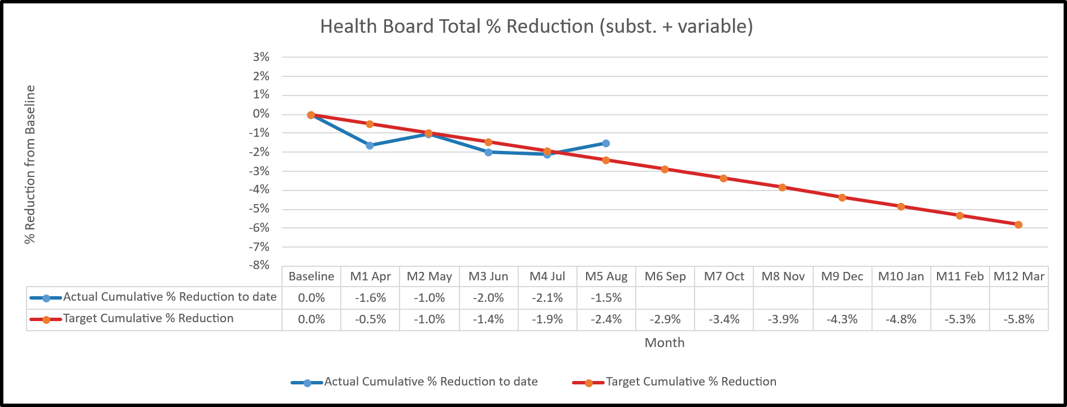
Figure 1: Health Board Total Deployed Workforce Reductions (%) Compared to March 2026 Baseline

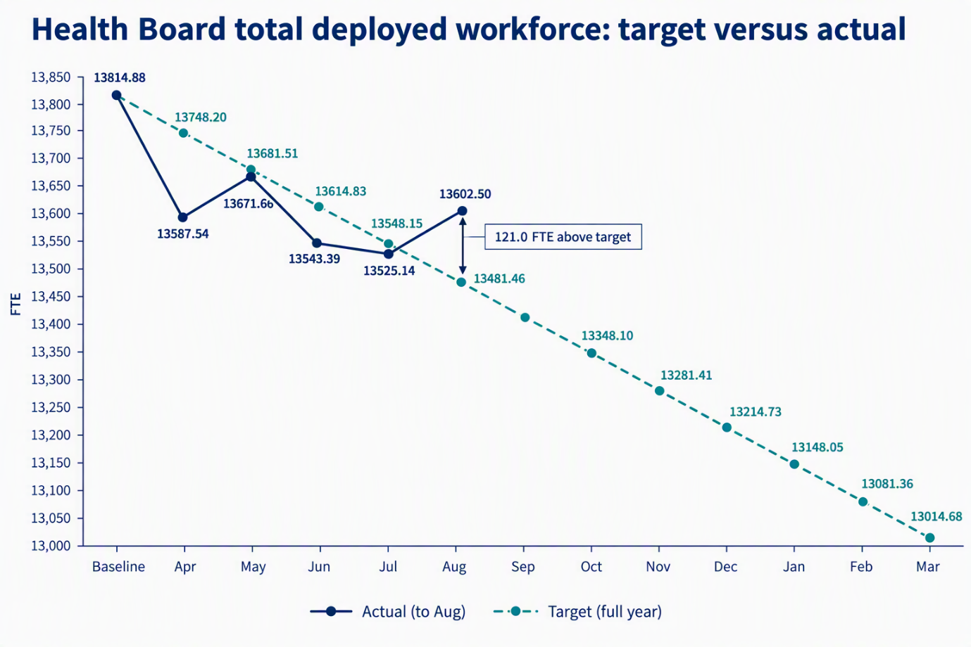
Figure 2. Health Board total deployed workforce: Month 5 actual versus full-year target trajectory in FTEs
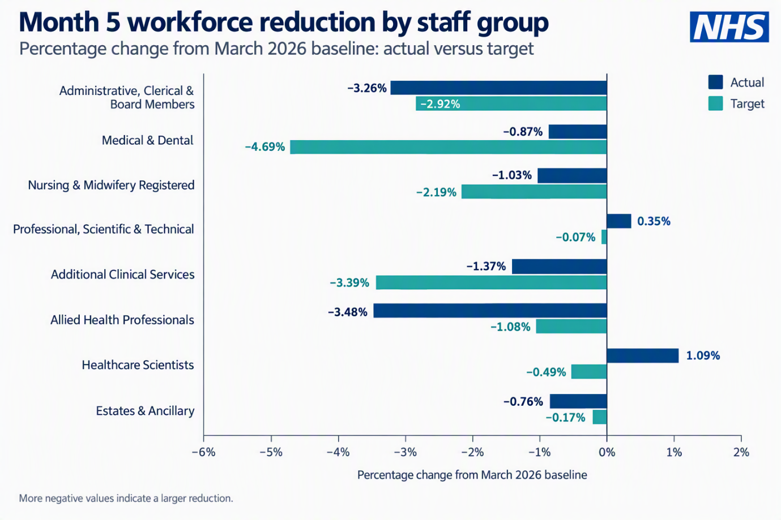
Figure 3. Month 5 percentage change from the March 2026 baseline by staff group, compared with target.

Bank & Agency Usage – WTE trend – Health Board Wide

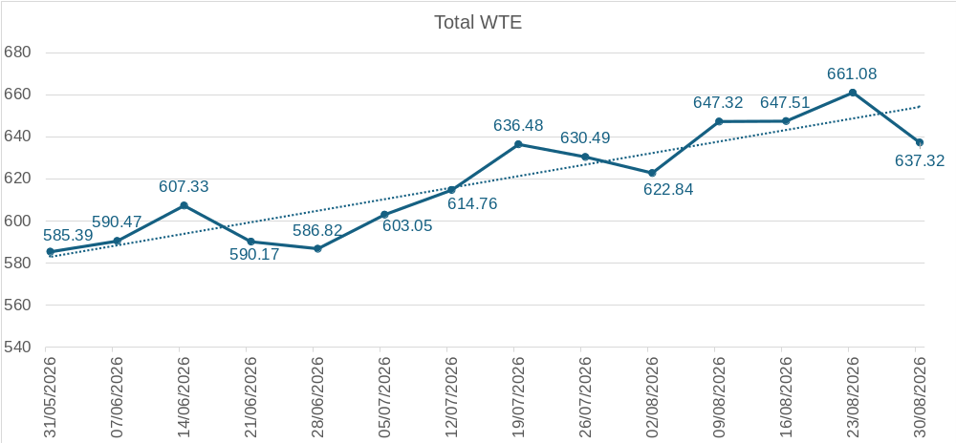

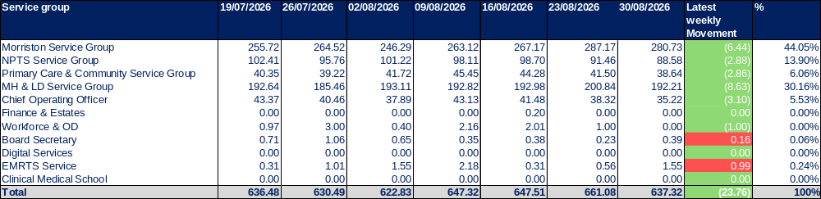

Figure 4. WTE trend for bank and agency usage.

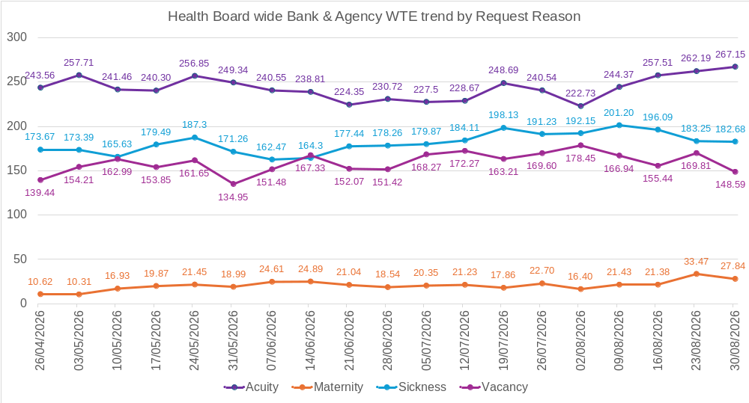

Figure 5. WTE bank/agency WTE split by reason

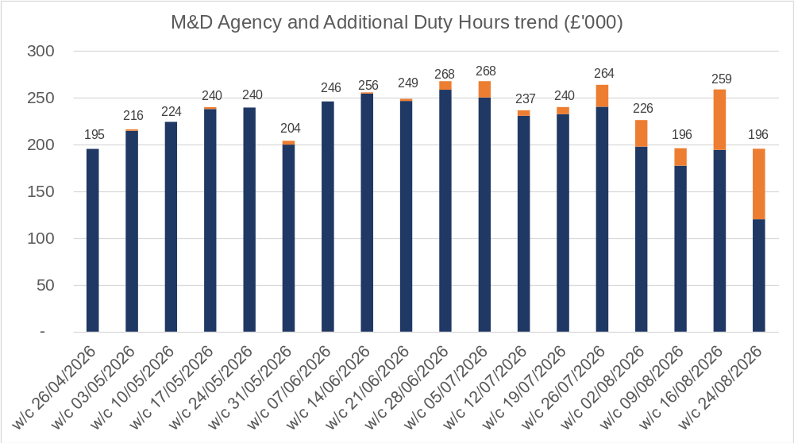

Figure 6. Medical and dental additional duty hours

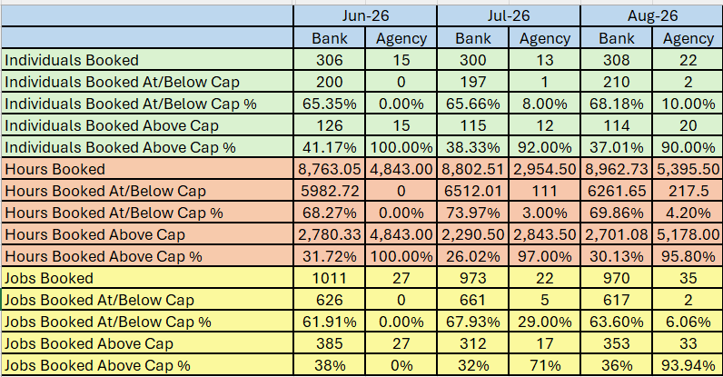

Figure 6. Medical and dental usage breakdown for June, July & August 2026

