

HEALTH BOARD RISK REGISTER
August 2025
RISKS ALLOCATED TO THE
WORKFORCE & OD COMMITTEE

Datix ID Number: 843  Health & Care Standard: |  |  | HBR Ref Number: 3  Risk Target Date: 31/03/2026 |  | Current Risk Rating  4 x 4 = 16
Objective: The Health Board is a great place to work where staff feel valued and work together towards a common goal |  | BAF Ref: 5 | Director Lead: Tina Ricketts, Director of Workforce and OD  Assuring Committee: Workforce & OD Committee
Risk: Recruitment of consultant medical & dental staff in hard to fill roles.  Due to national shortages, there is a risk that that the health board will be unable to recruit consultant medical & dental staff into particular hard-to-fill roles which may result in difficulties fulfilling rotas on all sites, and adverse impact upon patient safety, service provision, quality and financial matters. |  |  | Date last reviewed: August 2025
Risk Rating  (consequence x likelihood):  Initial: 5 x 4 = 20  Current: 4 x 4 = 16  Target: 4 x 3 = 12 | 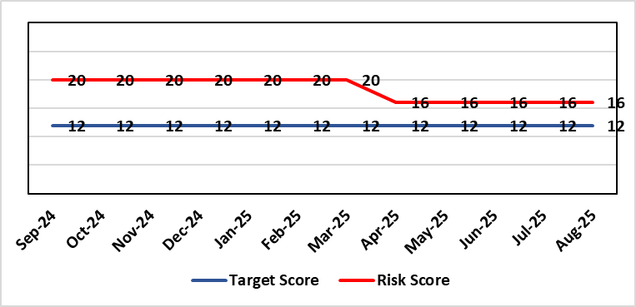 |  | Rationale for current score:  National shortages of numbers in some areas can lead to:  - Inability to recruit sufficient numbers of trainees to fulfil rotas on all sites  - Inability to attract non training grades to complete rotas  - Inability to fill Consultant grade posts in some specialties with adverse effects on patient safety and employer relations. Inability to recruit sufficient registered nursing staff.  Risk score has been reviewed and reflects current position across services as a whole. Services with particular difficulties are listed under the Assurance section. Where risk at service level is significant and/or interdependencies could lead to service collapse, these will be escalated separately.
Level of Control  = 70% |  |  | Rationale for target score:  This remains a challenge and is also a national problem.
Date added to the SBU HB risk register
April 2019
Controls (What are we currently doing about the risk?) |  |  | Mitigating actions (What more should we do?)
- Regular monitoring of recruitment position with reports to Executive Team and Board via Medical Director and Medical Workforce Board.  - Specialty based local workforce boards established to monitor and control specific issues. The Health Board Workforce & OD Committee will seek assurance of medical workforce plans to maintain services.  - Engagement of the Deanery about recruitment position.  - Weekly workforce delivery meetings with Executive Medical Director to review progress against critical medical and clinical posts  - Working with specialist agency and head-hunters to improve chances to fill hard to recruit posts  - Working with a marketing agency to develop a branding and attraction campaign for the health board.  - Consideration of the RPO (Recruitment Process Outsourcing) model.  - Implemented the CESR (Certificate of Eligibility for Specialist Registration) framework to grow our own consultants  - Revised Consultant Development Programme, sponsored by the Medical Director. |  |  | Action | Lead |  | Deadline
 |  |  | Medical training initiatives pursued in a number of specialties to ease junior doctor recruitment | Service Group Medical Directors |  | 31/03/2026
 |  |  | The Medical Workforce Board continues to monitor recruitment and junior doctor’s rotas. | Executive Medical Director |  | 31/03/2026
 |  |  | Continue to recruit internationally where appropriate. | Director W&OD |  | 31/03/2026
 |  |  | Continue to work with head-hunters | Director W&OD |  | 31/03/2026
Assurances (How do we know if the things we are doing are having an impact?)  - General situation monitored through W&OD Committee  - Regular communication with Deanery  - Ongoing and targeted recruitment campaigns  - Monitoring by Service Group teams and specialty based local workforce boards  - Monthly workforce planning and deployment taskforce meetings with service groups  - Weekly workforce delivery meetings with CEO as above  - Areas currently experiencing recruitment difficulties are: mental health, oncology, anaesthetics, acute care physicians, care of the elderly, pathology and haematology. |  |  | Gaps in assurance (What additional assurances should we seek?)  Locum cover  Adequate supply of doctors who can work in this country  Ability to flexibly deploy doctors in training.  Dedicated work between workforce and finance to review and confirm budgeted medical workforce establishment by service group to confirm SIP and vacancy factor.
Additional Comments / Progress Notes
04/08/2025: Some success with recruitment but no material change to the situation
20/08/2025: The position has not changed since the last update.

Datix ID Number: 1759  Health & Care Standard: |  |  | HBR Ref Number: 51  Risk Target Date: TBC |  | Current Risk Rating  3 x 3 = 9
Objective: Care is high quality, safe, efficient, and delivers the best possible outcomes for people |  | BAF Ref: 2.1 | Director Lead: Elizabeth Rix, Executive Director of Nursing  Assuring Committee: Workforce & OD Committee
Risk: Non-Compliance with Nurse Staffing Levels Act (2016) – Section 25B Wards  The Nurse Staffing Levels (Wales) Act 2016 (NSLWA) legally requires the health board to make provision for appropriate nurse staffing levels within their nursing services. In accordance with section 25B, there is a duty to calculate nurse staffing levels in adult and paediatric acute medical and surgical inpatient wards. There is a risk we may not meet these requirements fully due to increased acuity, unplanned staff absence and vacancies. The potential impact of this maybe non-compliance with the ‘Act’, poor patient outcomes and experience, and suspension of services. |  |  | Date last reviewed: August 2025
Risk Rating  (consequence x likelihood):  Initial: 4 x 4 = 16  Current: 3 x 3 = 9  Target 3 x 3 = 9 | 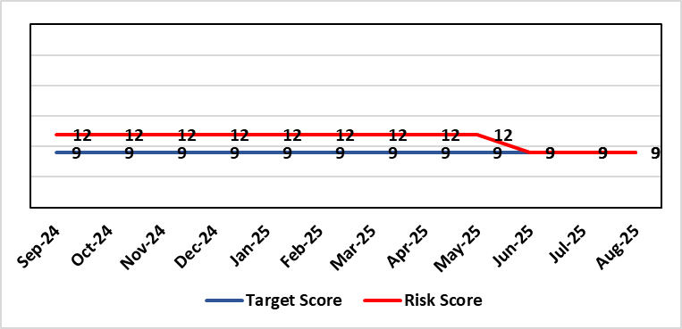 |  | Rationale for current score:  - The scope of the risk has been reviewed to disaggregate the 25B reportable wards as part of the NSLWA to enable clearer identification of risk of non-compliance with the’ Act’ from the aggregated risk across all nurse staffing areas of inadequate staffing levels previously scored 20.  - There has been a steady decline in the number of vacancies across the 25B wards as a result of successful international recruitment and student streamlining  - The Service Group risk assessments for 25B wards reported at the Nursing and Midwifery Safe Staffing Assurance Group NMSSAG (Jun 2025) are as follows:  - Morriston Service Group – 9  - NPTS Service Group – 9  - Paediatrics: In-patient wards – 9
Level of Control  = |  |  | Rationale for target score:  - The Health Board has the required structures and processes in place to provide reassurance to the Board that SBUHB is compliant under the Act and as such are allocating resources accordingly.  - Health boards are duty bound to take all reasonable steps to maintain nurse staffing levels.  - Ward skill mix, recruitment and induction plans impacting on ward  - Projected continued decrease in vacancies by end of 2024.
Date added to the SBU HB risk register
Apr 2019
Scope Refreshed:
Jan 2024
Controls (What are we currently doing about the risk?) |  |  | Mitigating actions (What more should we do?)
- The designated person as part of the requirements of the ‘Act’ is the Executive Director of Nursing & Patient Experience  - The responsibility for decisions relating to the maintenance of the nurse staffing level rests with the health board is based on evidence provided by, and the professional opinions of the Executive Directors with the portfolios of Nursing, Finance, Workforce, and Operations  - Bi-annual calculations undertaken across all Section 25B wards using the triangulated methodology which Service Groups formally present at Executive led scrutiny panels with representation from Nursing, Workforce and Digital and Finance Colleagues.  - The Ward Sister / Charge Nurse, Senior Nurses and Group Nurse Director continuously assess the situation and keep the designated person formally apprised  - The health board has representation at the All-Wales Nurse Staffing Group and its sub groups to ensure the organisation is aware of national updates  - The Board receive a bi-annual report - May (agreed Once for Wales) and November (mandatory). The final 3 yearly mandatory paper was submitted to Welsh Government 7th October 2024. The mandatory nurse staffing paper was presented to Board on 28th November 2024. The statutory (agreed Once for Wales) paper will be presented to Management Board 16th April 2025.  - Workforce planning & redesign, training and development. Recruitment and retention continue. HB Workforce Group has been set up and links to HEIW Retention Work stream, HB representatives on HEIW Group are Associate Head of HR, Recruitment and Retention Manager and Matron, Corporate Recruitment. Workforce plans have been developed by Service Group Nurse Directors and each Service Group agrees staffing, with consideration of all reasonable steps to maintain the nurse staffing level  - Work assessing the impact of the 'Team around the Person' continues on a HB and All Wales basis.  - Rostering Policy - the Service Groups have a robust roster scrutiny process that is undertaken to ensure roster efficiency and appropriate utilisation of temporary staff.  - The health board has a nursing retention plan and actively supports the Retire and Return policy.  - SafeCare has been implemented, the All Wales SOP remains a working document as understanding evolves.  - Service Groups continue daily staffing huddles and daily staffing tool and escalate as appropriate. |  |  | Action | Lead |  | Deadline
 |  |  | Student Streamlining and Overseas recruitment | Executive Director of Nursing |  | Monthly ongoing
 |  |  | Review of workforce, consider more diverse skill mix, including development of Band 3 and Band 4 roles. Bi-annual re-calculations of inpatient wards have resulted in the addition of Band 3 and 4 roles within the NSA templates. These posts are being recruited into, there is a need for training and supervision for these new posts. Development of Service Group workforce plans to support an overall Corporate Workforce Plan. | Executive Director of Nursing |  | Monthly ongoing
Assurances (How do we know if the things we are doing are having an impact?)  - Ongoing robust recruitment and retention plans in place to reduce vacancies in key clinical areas.  - Accurate reporting of acuity data and governance around sign off.  - Agreed establishments are funded.  - E-Rostering implemented and roster scrutiny undertaken, ensuring effective staff allocation.  - All Wales Templates are visible informing patients/visitors of planned roster on all Section 25B wards. Service Groups have access to the All Wales Nurse Staffing Programme documents via NHS Wales Executive webpage.  - Bi-annual Board reports, provide assurance and outline compliance and any key risks, submitted in November and May each year, with the final three yearly report submitted to Welsh Government in October 2024.  - The Health Board Nursing and Midwifery Safe Staffing Assurance Group (renamed October 2024) (formally the Nurse Staffing Act Steering Group, amended July 2023) meets on a bi-monthly basis, ensuring risks from all Service Groups are presented, discussed and escalated as appropriate at each meeting. This group is chaired by an Associate Director of Nursing and reports to Nursing and Midwifery Group (formally Nursing and Midwifery Board, amended October 2024), and the Workforce & OD Committee.  - Service Group risk assessments have been updated and disaggregated into 25B and 25A areas to enable clear risk assessment and escalation of specific risks to ensure robust governance and risk assurance  - There is a clear process for scrutiny during bi-annual re-calculations and at any other time when wards require a re-calculation, for example: change to ward purpose, increased bed numbers or increase patient acuity  - SafeCare system has been implemented. Support given to help embed the system into everyday use. Use of SafeCare linked to daily staffing huddles.  - Historical information and all reporting templates available on a share drive |  |  | Gaps in assurance (What additional assurances should we seek?)  - Issue remains regarding Information Technology barriers around the capture of data required for the Act on an All- Wales and Health Board basis. All Wales work with Allocate (Safecare) to improve reporting capabilities of Safecare, via a dashboard continued to progress, SBU is pilot site for testing. Update to Allocate system received, working with rostering team and BCU NSA Lead to check accuracy of reporting.  - Ongoing work across Wales to ensure IT systems are compatible with each other for operational and reporting purposes.
Additional Comments / Progress Notes
Section 25B wards covered by this risk:
NPTSSG |  | Morriston Service Group
Ward 2, Ward 4, Ward 12, Ward A, Ward E  Paediatric: Ward M and Oakwood Ward |  | Ward G, H, W and Clydach Ward  Ward C, Cyril Evans Ward, Dan Danino Ward  Powys Ward, Tempest Ward, Cardigan Ward  Ward K, L, R, T and Pembroke Ward  Ward D, F, J, S and Gowers Ward
For information – 25A areas not covered by this risk include (These are managed within Service Groups and would be escalate for Executive consideration as appropriate).
Morriston Service Group | NPTSSG | Mental Health & Learning Disabilities | Community Areas
Critical care areas – GITU, CITU, Tempest Burns & CCU  Short stay and assessment areas  Ward E (Area for Clinically Optimised Patients over the age of 65 years)  SAU, SSSU, CSSU, Plastic Surgery Treatment Centre  Emergency Department | Neonates  Theatres  Ward B, C, D & Neuro Rehab NPTH  Ward 8 & 11 SH  Midwifery | Mental Health, Forensic Psychiatry and Learning Disabilities | District Nursing  Health Visiting  Gorseinon Hospital  Ty Olwen
26/06/2025: Following June 2025 Nursing and Midwifery Safe Staffing Assurance Group meeting score has been reduced to 9, following reduction in score in Paediatrics.
05/08/2025: No change. Next Nursing and Midwifery Safe Staffing Assurance Group meeting is in September 2025.

Risk Score Calculation

For each risk identified, the LIKELIHOOD & CONSEQUENCE mechanism will be utilised. Essentially this examines each of the risks and attempts to assess the likelihood of the event occurring (PROBABILITY) and the effect it could have on the Health Board (IMPACT). This process ensures that the Health Board will be focusing on those risks which require immediate attention rather than spending time on areas which are, relatively, a lower priority.

