Meeting Date | 02 October 2025 |  | Agenda Item |  |  | 4.4
Name of Meeting | Workforce and OD Committee
Report Title | Progress Report - Management of Sickness Absence – Theatre Services (NPTSSG)
Report Author | Jonathan Gates, Head of Nursing – Surgery
Report Sponsor | Deb Lewis, Chief Operating Officer
Presented by | Rhodri Davies, Associate Service Group Director Surgery  Ceri Gimblett, Service Group Director NPTS
Freedom of Information | Open
Purpose of the Report | To set out the progress on the actions identified to improve the management of sickness absence across Theatre Services. The information will cover:  - Data analysis: An analysis of the current sickness absence performance data for Theatre Services (available as of August 2025).  - Progress against planned actions: An overview of progress against agreed actions to improve the management of sickness absence across the service.
Key Issues | There are three main drivers for improving staff availability and sickness absence rates across the Theatre Service, these include:  - The evidence that demonstrates staff health and wellbeing has an impact on staff engagement and experience, and how this enables organisational productivity, individual performance and ultimately the quality of patient care and outcomes across the Theatre Service. The ‘NHS Wales Staff Health and Wellbeing – A Best Practice Guide’ is used as an enabler to unlock the benefits of improving staff Health and Wellbeing.  - There is an ongoing need to improve staff availability across the Theatre Service to support Theatre capacity and to deliver safe and effective care.  - The Welsh Government requires Health Boards to achieve the <5% target absence rate across all services.
Specific Action Required  (please choose one only) | Information | Discussion |  | Assurance | Approval
Specific Action Required  (please choose one only) | ☒ | ☐ |  | ☒ | ☐
Recommendations | - ACKNOWLEDGE the progress taken by the Theatre Team to make improvements to the management of sickness absence and support employee wellbeing.  - BE ASSURED of progress against the action plan.

MANAGEMENT OF SICKNESS ABSENCE – THEATRE SERVICES (NPTSSG)
- INTRODUCTION

A previous report has been presented in the Workforce and OD Committee in February 2025 which outlined previous improvement actions, planned improvement actions and the evaluation and monitoring approach.

This report will provide an update on the current sickness absence rates across Theatre Services along with progress against improvement actions. It will include:

- Data analysis: An analysis of the current sickness absence performance data for Theatre Services (available as of August 2025)
- Progress against planned actions: An overview of actions that have taken place to reduce sickness absence across the service.

- BACKGROUND

This report will provide a focus on sickness absence within the Registered Nurse, Operation Department Practitioner (ODP) and Additional Clinical Services (Health Care Assistants) staff groups, working in Theatre Services. The report does not include the Medical Staff Group.
DATA ANALYSIS – CURRENT / UPDATED SICKNESS ABSENCE RATES
Overview of the Theatre Services Workforce KPI heatmap (all staff groups):
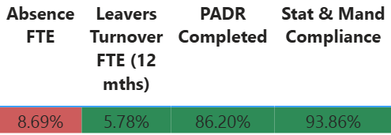

PADR rates are improving and Mandatory Training rates are consistently above the Welsh Government target rate of 85%. The service consistently observes low turnover rates, as at 08/25 LTR Headcount % turnover rate was 0.83%.

Sickness Absence (Additional Clinical Services/Registered Nurses/ ODPs)
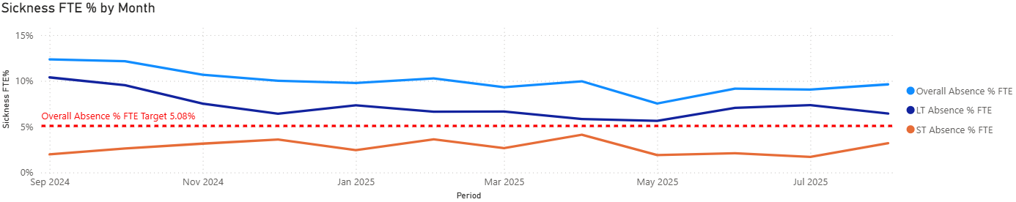
Morriston Hospital Theatres
- Overall, during the last 12-month period (up to 08/25) absence levels have improved from a peak of 12.35% in 09/24 to 9.62% in 08/25.
- Morriston Hospital Theatres have observed an overall downward trend of reduction with sickness rates however there has been an increase in 08/25 (in comparison to 07/25).

- For the last four months (May/June/July/August 2025) absence levels are below the projected (forecasted) in month rates.
- Morriston Hospital Theatres are a ‘Hot Spot’ area. There is a sickness improvement plan in place and monthly absence summits continue to take place. These actions align with the overarching sickness plan that falls under the Health Boards Recovery and Sustainability Board.
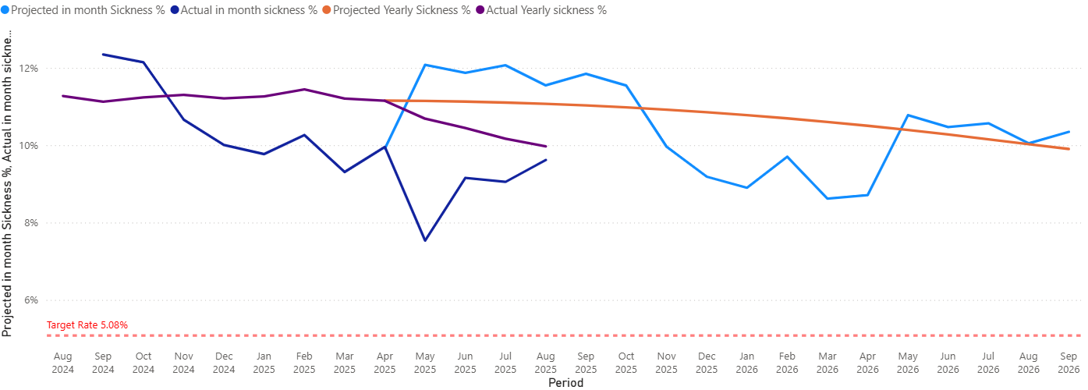

Neath Port Talbot Hospital Theatres

- Overall, during the last 12-month period (up to 08/25) absence levels have fluctuated between 5.81% in 06/25 and 13.34% in 08/25.
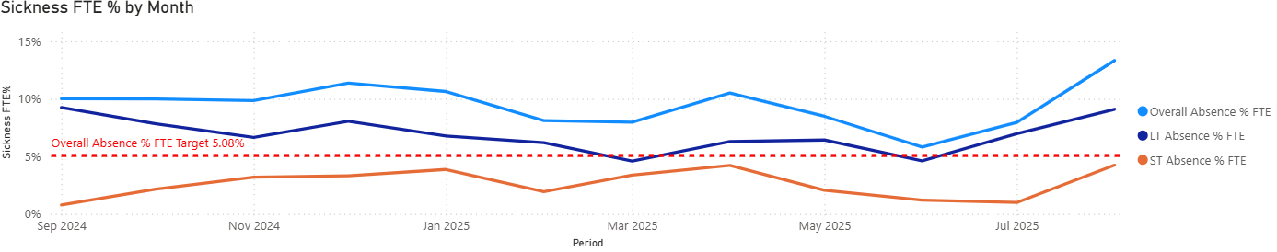

- For the last four months (May/June/July/August) in month sickness rates are following a similar trend to the projected (forecasted) sickness rates.
- As at 8/8/2025 10 staff were off sick, 2 have since returned to work, 2 have return to work dates confirmed for September, the 6 remaining staff are being managed in accordance with the MAAW policy.

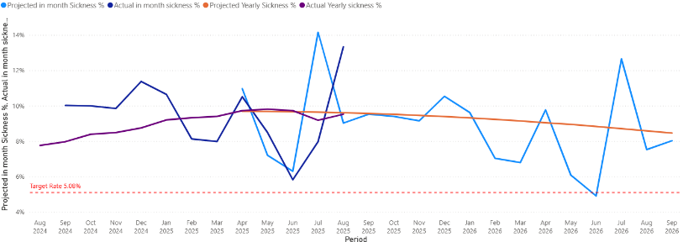

Singleton Hospital Theatres

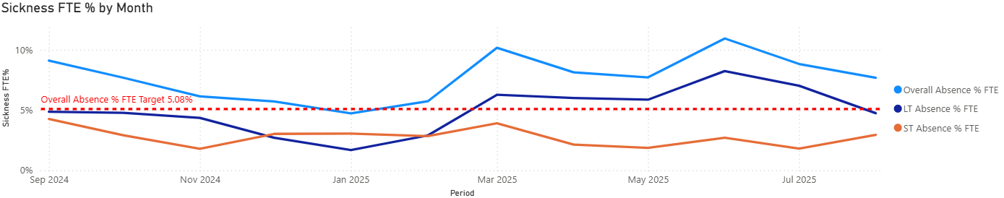
- Overall, during the last 12-months (up to 08/25) absence levels have observed a downward trend between 09/24 and 02/25. Improved absence levels have been observed in 07/25 at 8.72% and 08/25 7.67%.

- For the last four months (May/June/July/August 2025) absence levels are higher than the projected (forecasted) in month rates.
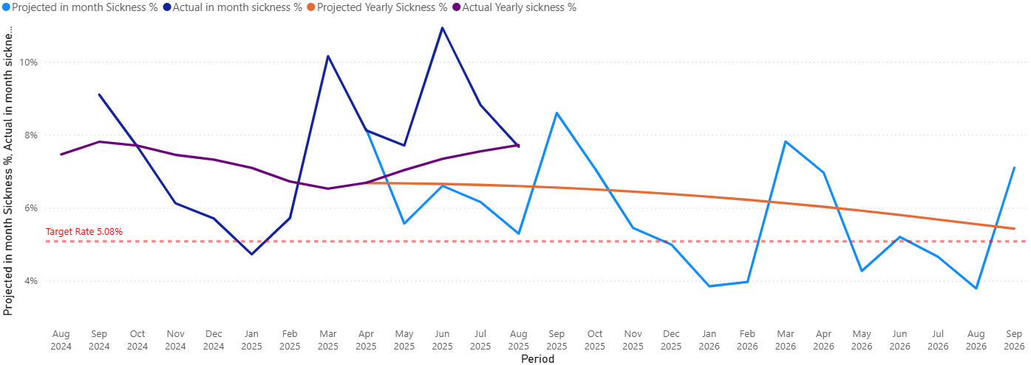
- As at 08/08/25 8 staff were off sick, two have since returned to work, one has left the Health Board and the remaining staff are being managed in accordance with the MAAW policy.

2.2 CURRENT ABSENCE IMPROVEMENT ACTIONS

Following the presentation of the previous report at the February 2025 Workforce and OD Committee the service has focussed in implementing the Sickness Improvement Actions. The summary of the improvement actions is detailed below:

 | Timescales | Improvement Measure | Responsible Person | Progress
2.21 The Theatre Team Staff Experience, Wellbeing and Retention Plan | 12/24 onwards | Workforce KPIs/  Staff Feedback/Quality KPIs/ Theatre Efficiency KPIs | Head of Nursing – Surgical Division | On Track (further detail regarding progress is included in the section below)
2.22 Develop / implement the Sickness Management Improvement Plan | 01/25-02/25 onwards | Workforce KPIs/  Staff Feedback/Quality KPIs/Theatre Efficiency KPIs | Deputy Head of Nursing – Theatres | Delayed (action predicted to be back on track as 30/9/25)
2.23 Absence Summits for Hot Sport Areas (Morriston Theatres) | 01/25 onwards | Workforce KPIs/Staff Feedback/ Theatre Efficiency KPIs | Deputy Head of Nursing – Theatres | Initial delay (commenced 06/25). Now complete and ongoing
2.24 Guardian Service | 01/25 onwards | Guardian Service Reports / Staff Feedback / Workforce KPIs | Deputy Head of Nursing – Theatres | Complete and ongoing
2.25 Evaluation and Monitoring Approach for the Improvement Plan | 9/25 onwards  Formal review to take place 11/25 (timescale adjusted) | Workforce KPIs/  Staff Feedback/Quality KPIs/Theatre Efficiency KPIs | Deputy Head of Nursing – Theatres | On Track
2.26 Sharing of Learning outcomes to benefit other services within the Health Board | 10/25-01/26 | Workforce KPIs/  Staff Feedback/Quality KPIs/Theatre Efficiency KPIs | Head of Nursing – Surgical Division / HR Business Partner Team | On Track

The Theatre Team Staff Experience, Wellbeing and Retention Plan (2.21)

The development of and subsequent effective and sustainable implementation of the ‘Theatre Staff Experience, Wellbeing and Retention Plan’ will form an essential foundation to supporting the health and wellbeing of staff working across Theatres and improved sickness rates. The project plan was developed and it identified several distinct phases alongside indicative timescales as illustrated below which are being progressed and are currently on track:
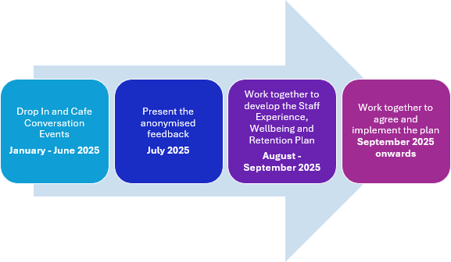

- GOVERNANCE AND RISK ISSUES

The Sickness Management Improvement Plan will be monitored and evaluated through the Division’s monthly Workforce Group and the Divisions Senior Management Team Meeting to track the progress and to evaluate the impact of the plan.

From a risk perspective the impact of unavailability and specifically sickness limits the Divisions ability to deliver the expanded schedule of operating across the three acute sites.

- FINANCIAL IMPLICATIONS

High absence levels could result in variable pay usage to maintain Theatre capacity and safeguard patient care.

- RECOMMENDATION

Members are asked to:

- ACKNOWLEDGE the progress the Service Group continues to take to address the findings of the deep dive sickness exercise to improve the management or sickness absence and support employee wellbeing across Theatre Services.
- BE ASSURED of progress against the action plan.

Governance and Assurance

Link to Enabling Objectives  (please choose) | Supporting better health and wellbeing by actively promoting and empowering people to live well in resilient communities
Link to Enabling Objectives  (please choose) | Partnerships for Improving Health and Wellbeing |  | ☐
Link to Enabling Objectives  (please choose) | Co-Production and Health Literacy |  | ☐
Link to Enabling Objectives  (please choose) | Digitally Enabled Health and Wellbeing |  | ☐
Link to Enabling Objectives  (please choose) | Deliver better care through excellent health and care services achieving the outcomes that matter most to people
Link to Enabling Objectives  (please choose) | Best Value Outcomes and High Quality Care |  | ☐
Link to Enabling Objectives  (please choose) | Partnerships for Care |  | ☐
Link to Enabling Objectives  (please choose) | Excellent Staff |  | ☐
Link to Enabling Objectives  (please choose) | Digitally Enabled Care |  | ☐
Link to Enabling Objectives  (please choose) | Outstanding Research, Innovation, Education and Learning |  | ☐
Health and Care Standards
(please choose) | Staying Healthy |  | ☐
(please choose) | Safe Care |  | ☐
(please choose) | Effective Care |  | ☐
(please choose) | Dignified Care |  | ☐
(please choose) | Timely Care |  | ☐
(please choose) | Individual Care |  | ☐
(please choose) | Staff and Resources |  | ☐
Quality, Safety and Patient Experience
Staff health and wellbeing has an impact on staff engagement and experience, and this in turn enables organisational productivity, individual performance and ultimately the quality of patient care and outcomes across the Theatre Service.
Financial Implications
High absence levels will result in variable pay usage in order to maintain Theatre capacity and safeguard patient care.
Legal Implications (including equality and diversity assessment)
Actions included in the improvement plan will be required to comply with employment legislation.
Staffing Implications
The improvement plan should contribute to improved employee availability and have a positive impact on staff health and wellbeing.
Long Term Implications (including the impact of the Well-being of Future Generations (Wales) Act 2015)
Developing and retaining a specialist workforce is a key objective of the Health Board and is a fundamental principle of the One Bay Way.
Improving population health is a key objective of the Health Board and the Theatre workforce plays a critical role in influencing the wellbeing of future generations.
Report History |  | Previous report was presented at Workforce and OD Committee in February 2025.
Appendices |  | N/A

