Meeting Date | 02 October 2025 |  | Agenda Item |  |  | 2.2
Name of Meeting | Workforce and OD Committee
Report Title | Workforce Report – Neath Port Talbot Singleton Service Group
Report Author | Ceri Gimblett, Service Group Director NPTS
Report Sponsor | Deb Lewis, Chief Operating Officer
Presented by | Ceri Gimblett, Service Group Director NPTS
Freedom of Information | Open
Purpose of the Report | The purpose of the report is to provide an update on the following:  - Workforce performance against key metrics and associated actions  - An overview of workforce risks and issues affecting NPTSSG  - Staff Survey Action Plan Progress
Key Issues | The key issues relate to the following:  - Ongoing unavailability challenges across staff groups  - Engagement in Staff Survey for Service Group  - Establishment and vacancies impact based on underlying deficit allocation  - Overview of main workforce risks
Specific Action Required  (please choose one only) | Information | Discussion |  | Assurance | Approval
Specific Action Required  (please choose one only) | ☒ | ☐ |  | ☒ | ☐
Recommendations | - ACKNOWLEDGE the Service Groups Workforce Metrics, Risks and Staff Survey Progress.  - BE ASSURED of the actions being taken to ensure compliance with workforce metrics to support and improve the health and wellbeing of staff.

WORKFORCE REPORT - NPTSSG

- INTRODUCTION

This report will provide a workforce update on the following:

- Performance against key workforce metrics and associated action
- An overview of workforce risks/issues affecting NPTSSG
- Staff Survey Action Plan Progress

- BACKGROUND

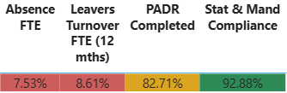
2.1 Performance against key workforce metrics and associated action

Heatmap of key workforce metrics

Sickness Absence

- Total absence across the Service Group as at 08/25 was 7.27% (in month), this is an improvement in comparison to 07/25 when the in-month rate was 7.53%.
- Over the last 12 months, the in-month absence rate has consistently been between 6.35% (05/25) and 7.70% (12/24).
- Long term absence rates peaked at 5.73% in 07/25, however rates have consistently been between 4.64% (01/25) and 5.73% (07/25).
- In month short term absence rates across the Service Group have ranged between 1.62% (05/25) and 2.62% (12/24).
- The majority of absence during the previous 12 months, can be attributed to Anxiety, Stress and Depression followed by Musculo-Skeletal (for long term absence) and Anxiety, Stress and Depression followed by Cough, Cold and Flu for short term absence.

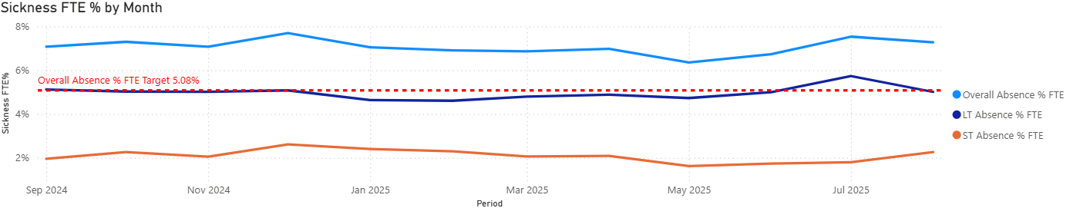

- In month absence rates across the Service Group have been below the projected (forecasted) rates until 07/25.
- 07/25 and 08/25 in month absence rates have exceeded the projected (forecasted) rates. In 07/25 the actual in month rate was 7.53% and the projected rate was 7.35% and in 08/25 the actual in month rate was 7.27% and the projected rate was 6.32%.
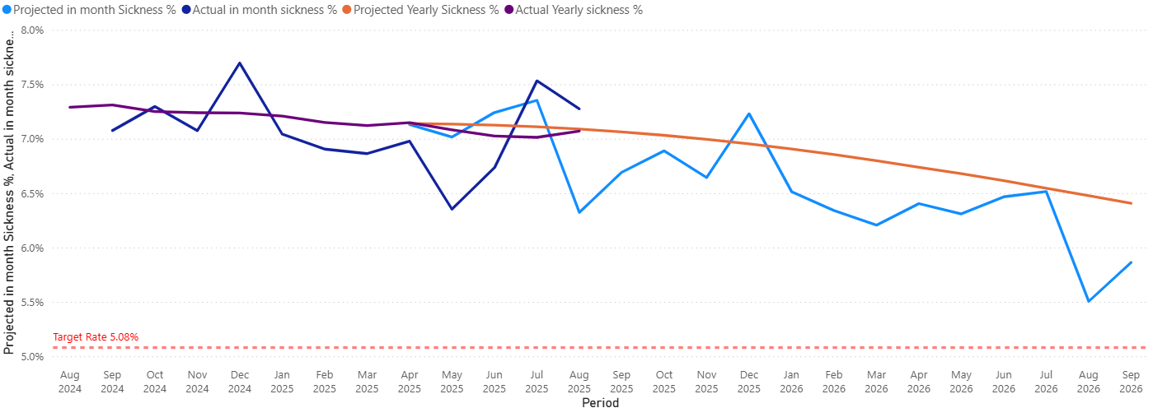

In order to address these issues the following actions are ongoing

Overarching Sickness Improvement Actions

Themes | Actions | Timescales
Leadership Engagement and Managerial Accountability | Strengthening Our Focus on Sickness Improvement:  - Clear messaging around sickness being a key priority  - Reinforcing the message that this is a key area that requires our collective attention and commitment.  - As leaders there is a vital role to play in shaping the environment our teams work in and by taking clear ownership of sickness performance, each leader has the power to make a real difference. | June 2025
Sickness Management | - Monthly programme of audits for ‘Hot Spot Areas’ scheduled between 09/25 and 01/26 with a reaudit programme commencing 01/26.  - Absence Summits – undertaken in 10 ‘Hot Spot Areas’ These summits have been designed to enable a proactive approach to supporting both Long and Short-Term staff absence. The HR Business Partner and Operational HR Team work alongside the management team to ensure Long and Short-Term cases are being appropriately managed and progressed. The Summits also instigate Case Reviews which may require specialist advice input e.g., Occupational Health. | 09/25 Onwards
Key improvement actions relating to top 3 absence reasons | Specific actions taken for Anxiety, Stress and Depression are:  - Early contact – with a compassionate approach  - Regular contact / touch points during absence period  - Regular sickness review meetings with HR Ops Team  - Immediate support and signposting  - Tailored and flexible return to work plans  - Ongoing monitoring and touchpoints on return to work  - Occupational Health referral  - Stress risk assessment to be completed  - Referral and signpost to relevant support groups and wider support  Specific actions taken for Musculo-Skeletal are:  - Early contact – with a compassionate approach  - Regular contact / touch points during absence period  - Regular sickness review meetings  - Occupational Health referral  - Workplace adjustments applied where possible  - Tailored and flexible return to work plans  - Workplace risk assessment to be completed  - Support with attending physio or other recovery appointments  - Consider manual handling refresher training where appropriate  - Ongoing monitoring and touchpoints on return to work  Specific actions taken for Cough/Cold/Flu:  - Early contact – with a compassionate approach  - Regular contact / touch points during absence period  - Provide guidance on when it’s appropriate be in work vs. stay home  - Explore alternative options such as Homeworking if staff are well enough to work  - Monitor trends and action review prompts / escalate  - Occupational Health referral where appropriate  - Promotion of flu vaccine  - Promotion and education on IPC measures, e.g., handwashing | Ongoing
Staff Experience, Wellbeing and Retention | - Development of Staff Experience, Wellbeing & Retention Plans – The approach to developing the plans draws on the evidence and best practice contained within the Staff Health and Wellbeing – A Best Practice Guide for NHS Wales. | Ongoing
Monitoring and Assurance | - Monthly Workforce Groups (KPIs are reviewed and plans agreed to improve performance if required)  - Audit / Workforce KPI Reports  - Monthly Roster Scrutiny Meetings  - Absence Summits/Audits  - Business Assurance and Accountability Meeting (sickness performance is specifically reviewed as part of this assurance and accountability process) | Ongoing
Education and Training | - Managers continue to have access to the Managing Attendance at Work Training and the Brilliant Basics Platform (interactive learning and education tool accessible 24/7).  - Support/coaching from HR Business Partner Team and HR Advisors. | Ongoing
Workforce Planning | - The HEIW Strategic Workforce Planning Toolkit has been used to develop MDT Workforce Plans across all Divisions so that services identify all opportunities to plan and design the workforce to maximise capacity and focus on effective workforce design (using the principles in the Staff Health and Wellbeing – A Best Practice Guide for NHS Wales) to support services in maximising staff availability. These workforce plans are subject to continual review. | Ongoing

PADR

- Overall PADR completion rates have increased over the last year from 73.5% in August 2024 to 82% in August 2025.
- The Staff Experience, Wellbeing and Retention Plans for each Division will include actions to use the PADR process as an enabler to support patient safety and employee wellbeing. The improvement actions will also look at how the quality of PADRs in the service can be enhanced and ensure how the PADR process will provide valuable insight into the training and development needs of the workforce.
- There is a recognition that specific improvement actions will continue to be needed to ensure the service complies with the Welsh Government target rate of 85%
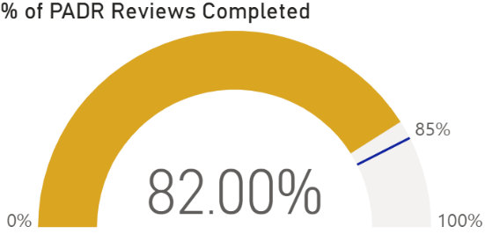

Mandatory Training

Mandatory training compliance across the Service Group exceeds the Welsh Government target rate of 85%. The rate as at 08/25 was 92.21%. Robust arrangements must be maintained to sustain this performance. All staff groups are above 90% compliance as at 08/25 with the exception of Medical Staff. There is continuous focus on improving Mandatory Training compliance within the Medical Staff Group (further increased to 76.82% in 08/25).
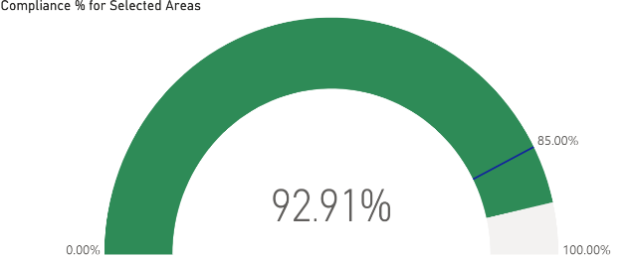

Turnover (all staff groups)

The service group has seen an improving trend in relation to turnover. The top three reasons for leaving between 09/24 and 08/25 have been Voluntary Resignation – Other Not Known, Retirement Age and Voluntary Resignation – Relocation. The highest number of leavers have been between the age of 56-60.
The service group has highlighted to Divisions the importance of recording accurately the reason why staff leave our organisation as it is essential for understanding workforce trends, identifying retention challenges, and shaping our support for staff and services. In addition, the service continues to promote the use of Exit Interviews to provide critical intelligence to further inform staff experience and retention approaches.

Vacancies

All vacancies continue to be subject to the current Workforce Controls in place across the Health Board.

However, based on the underlying deficit allocation NPTSSG assessment assumed significant vacancies across the group, therefore in order for NPTSSG to allow the underlying deficit allocation to be allocated, these vacancies needed to be removed. This presents a significant ongoing challenge as set out in NPTSSG accountability response letter.

Vacancies for NPTSSG have therefore been under scrutiny and our approach has been discussed in various meetings. Divisions alongside the NPTSSG Senior Team have undertaken vacancy review panels to identify where removal of budget has occurred as part of the underlying deficit assessment and have been working to identify risks and opportunities. This work is ongoing but to date the following are key areas of concern:
  - Integrated Medicines Management (IMM)
  - Neurodevelopmental Disorder (NDD)
  - Paediatric Continuing Healthcare
  - Community Paediatrics
  - Spinal
  - Radiotherapy

Other services are affected to a more minor level and work is ongoing for these areas to fully understand any service risks and impact on the approach adopted.

2.2 An overview of workforce risks and issues affecting NPTSSG

Workforce Risks/Issues

Medical Staff Recruitment Challenges | Recruitment challenges exist within the following specialties across the Service Group:  - Oncology  - Haematology  - Acute Paediatrics (Doctors in training posts)  - Obstetrics & Gynaecology  - Spinal  - Anaesthetics
Unavailability | High levels of sickness absence contribute to unavailability which impacts on the variable pay spend and service delivery. This applies to Medical, Nursing and Midwifery and the Additional Clinical Services Workforce.
Perinatal Service | The Service Group continues to actively respond to the requirements of both the Independent Review and Targeted Intervention status.

2.3 Staff Survey Action Plan Progress

The service group presented the Staff Survey Action Plan at Workforce and OD Committee in June 2025. It highlighted six key actions and an update on progress is included below:

Actions/ Milestones | Lead | By When | Status
Nominate SG leads to access staff survey results via dashboard. | Group Director | 03/25 | Complete
Attend webinars to support running local reports from the dashboard. | Group Director | 04/25 | Complete
Share 3 key areas of focus for the Health Board along with Divisional level staff survey results highlighting the specific themes for NPTSSG. | Group Director | 05/25 | Complete
Management teams to discuss the results and to agree how they will shape local Divisional Staff Survey Plans. | ASGDs and CD Pharmacy | 05-07/25 | Complete
Divisional Staff Survey Plan to be shared during BAAM. | ASGDs and CD Pharmacy | 07/25 | Complete
Progress update on Divisional Staff Survey Plan to be reported during BAAM ahead of the launch of the 2025 Staff Survey (Oct 25). | ASGDs and CD Pharmacy | 09/25 | On Track

To further enhance the work each Division is engaged in, to respond to the feedback from the previous staff survey, the Service Group is developing Staff Experience and Wellbeing Retention Plans for each Division.
A methodology utilising professional body research, the HEIW Retention Framework and the Staff Health and Wellbeing – A Best Practice Guide for NHS Wales are used to support the development of the plans. The methodology is aligned with the strategic aims in the Health Board’s People Plan.
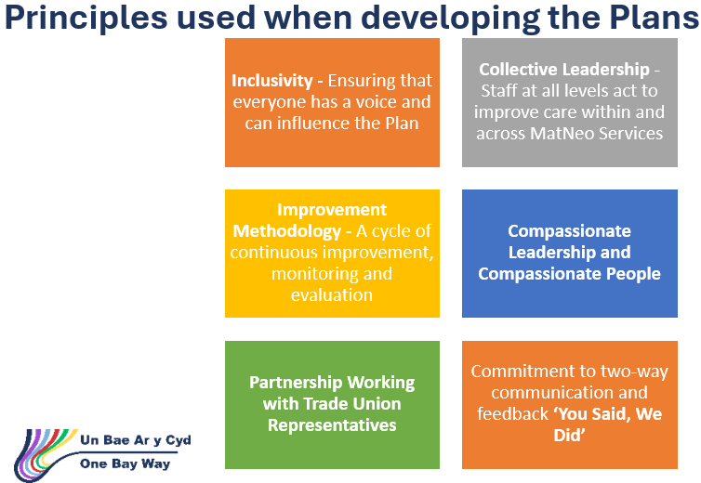
Progress developing the plans is monitored via the NPTSSG Business Accountability and Assurance Meetings.

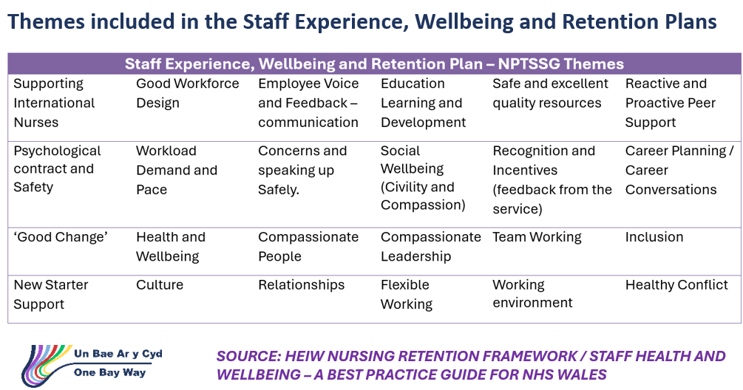

- GOVERNANCE AND RISK ISSUES

The Workforce Metrics, Risks and Staff Survey Progress will continue to be monitored and evaluated through the Division’s Monthly Workforce Groups and the Business Assurance and Accountability Meetings.

From a risk perspective the impact of unavailability and specifically sickness can impact on service delivery.

- FINANCIAL IMPLICATIONS

High absence levels above funded levels will result in variable pay usage to maintain service capacity and safeguard patient and service user care.

Although we are working to introduce the 21% fill rate on the nursing establishment (this is linked to level of overhead moving from current 26.5% to 21%) this will mean a level of variable pay is to be anticipated even if Sickness and Annual Leave are within funded levels.

Full allocation of the underlying deficit will in some places increase WTE, which in the long term will reduce variable pay (as we recognise areas that have had staffing challenges).

- RECOMMENDATION
ACKNOWLEDGE the Service Groups Workforce Metrics, Risks and Staff Survey Progress.
BE ASSURED of the actions being taken to ensure compliance with workforce metrics to support and improve the health and wellbeing of staff.

Governance and Assurance

Link to Enabling Objectives  (please choose) | Supporting better health and wellbeing by actively promoting and empowering people to live well in resilient communities
Link to Enabling Objectives  (please choose) | Partnerships for Improving Health and Wellbeing |  | ☐
Link to Enabling Objectives  (please choose) | Co-Production and Health Literacy |  | ☐
Link to Enabling Objectives  (please choose) | Digitally Enabled Health and Wellbeing |  | ☐
Link to Enabling Objectives  (please choose) | Deliver better care through excellent health and care services achieving the outcomes that matter most to people
Link to Enabling Objectives  (please choose) | Best Value Outcomes and High Quality Care |  | ☐
Link to Enabling Objectives  (please choose) | Partnerships for Care |  | ☐
Link to Enabling Objectives  (please choose) | Excellent Staff |  | ☒
Link to Enabling Objectives  (please choose) | Digitally Enabled Care |  | ☐
Link to Enabling Objectives  (please choose) | Outstanding Research, Innovation, Education and Learning |  | ☐
Health and Care Standards
(please choose) | Staying Healthy |  | ☐
(please choose) | Safe Care |  | ☐
(please choose) | Effective Care |  | ☐
(please choose) | Dignified Care |  | ☐
(please choose) | Timely Care |  | ☐
(please choose) | Individual Care |  | ☐
(please choose) | Staff and Resources |  | ☒
Quality, Safety and Patient Experience
Staff health and wellbeing has an impact on staff engagement and experience, and this in turn enables organisational productivity, individual performance and ultimately the quality of patient care and outcomes across the Service Group.
Financial Implications
High absence levels will result in variable pay usage in order to maintain the services capacity and safeguard patient care.
Legal Implications (including equality and diversity assessment)
Actions taken by the service will be required to comply with employment legislation.
Staffing Implications
Actions taken should contribute to improved employee availability and have a positive impact on staff health and wellbeing.
Long Term Implications (including the impact of the Well-being of Future Generations (Wales) Act 2015)
Developing and retaining a skilled workforce is a key objective of the Health Board and is a fundamental principle of the One Bay Way.
Improving population health is a key objective of the Health Board and the workforce plays a critical role in influencing the wellbeing of future generations.
Report History |  | None
Appendices |  | None

