10. Workforce Updates and Actions
This section of the report provides further detail on key workforce measures. Caveats and Limitations (C&L) detailed beneath data in each section.
Staff sickness rates - Percentage of sickness absence rate of staff (two metrics provided, ‘rolling 12 month’ and ‘in month’)  Sickness absence target – 5.5% | % of full time equivalent (FTE) days lost to sickness absence  Caveat & Limitations;- Report generated Sept 2024, within SBUHB (Performance Team) for substantive and FTC employee types. Data source – ESR. Target of 5.5% added as blue line
Current Performance
- Health Board total for in month sickness absence has decreased from the last reporting period to 6.67% (compared to 7.15% in June 24).
- Anxiety/stress related absence remained the highest reason for long term absence, with MSK remaining second. This is consistent across NHS Wales and is a long-term pattern.
- There has been a slight decrease in absences across MH&LD compared to the previous reporting period (7.60% in August compared to 7.73% in June 24 and 8.04% in March 24).
- Morriston and PCT absence rate remain consistent since the last reporting period
- Long term absence has increased since the last reporting period (4.86% in September 2024 compared to 4.44% in June 24 and 4.13% in March 24). Short term absence has decreased slightly since the last reporting period (2.21% in September 24 compared to 2.22% in June 24 and 2.02% March 24.

Actions for Next Period
General
Current focus on areas with high absences rates, examples of initiatives to support our employees:
- Piloting Tailored Adjustments training for managers to increase experience of using these to flexibly support staff to remain in work/return to work
- Wellbeing resource pack – physical and electronic copies available – includes new starter feedback questionnaires
- Case conference training for leaders in partnership with OH
- The HRBPs leading on the initiatives listed above are working together to share best practice with the intention to deploy initiatives across the HB
- Managing Attendance at Work stand-alone training module has been developed along with ‘how to’ guides which will be available centrally. Training attendance will be recorded on ESR.

Occupational Health and Staff Health and Wellbeing
The services continue to develop high quality multi-disciplinary interventions to contribute to an engaged, motivated and healthy workforce.
- Establish ‘Healthy People Forum’ to enable strategic overview of attendance at work and sickness absence; sharing data and best practice with membership to include staff side, senior clinicians and managers.
- Occupational Health Nurses supporting the staff flu campaign commencing October 2024 with support from Comms and Imms team; senior flu leads identified in Service Groups to coordinate local vaccinations.
- Staff health checks now launched with 669 returned initial questionnaires/cholesterol blood checks undertaken with staff. 286 follow-up screening appointments delivered, offering health advice/signposting when appropriate. Initial positive feedback received from staff.
- Occupational Health consistently meeting waiting/service delivery KPI’s and submitted relevant returns to WG, demonstrating timely OH advice and support to managers to manage sickness absence

Mandatory & Statutory Training-  Percentage compliance for all completed Level 1 competencies within the Core Skills and Training Framework by organisation  Mandatory & Statutory Training target – 85% | % of compliance (Headcount) with Core Skills and Training Framework  C&L;- Report generated Sept 2024, within SBUHB (Performance Team) for substantive and FTC employees. Data source – ESR (OLM Module). Accuracy levels subject to local maintenance and validation standards. Target of 85% added as blue line
Current Performance
- Health Board Statutory and Mandatory Training compliance rates as of 31st August 2024 are:
90.54% - 10 CSTF (Core Skills Training Framework) competencies as reported to Welsh Government (The Welsh Government target is 85%).
88.61% - *15 core competencies (including 10 CSTF, 1 Lang and 1 Mand Competence reportable to WG and an additional 3 competencies SBUHB specific)
- Medical & Dental staff Group remain the lowest performing area with 60.38% compliance.
- Compliance figures (*15 core competencies) per Service Group - MH&LD 90.29%, PCCT 92.99%, Morriston 84.92%, Finance & Estates 86.86%, NPTS 89.94%

Actions for Next Period
- Subscription to Learning Certification and Enrolment onto Statutory/Mandatory Courses (E-Learning) – User issues identified are being supported on a case-by-case basis via Action Point and from direct contact. This has been the case over a number of months and continues to be the case going forward.
- NPTS - The focus on improving Mandatory Training compliance within the Medical Staff group is ongoing, there has been an increase in compliance for this staff group which is currently at 69.93%
MH&LD - Clinical Directors & Directorate Managers to work together to focus on improvement of mandatory training for Medical staff to continue with the increasing trend on compliance for this staff group
Vacancies  Medical and Nursing and Midwifery | Vacancies (FTE) Jun 24 to Aug 24  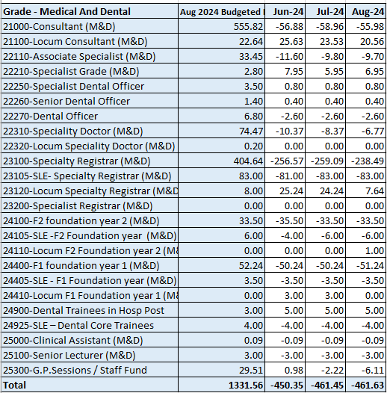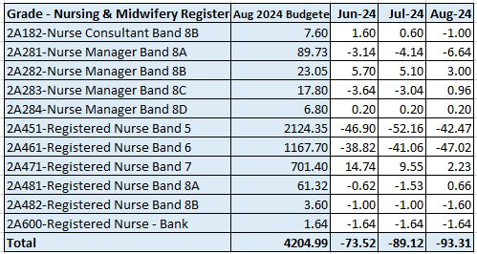  C&L;- Report generated Sept 2024, within SBUHB (ESR Team), using currently available methodology. Data source – ESR (Workforce) and General Ledger (Finance). We compare the SIP v’s the finance ledger, appreciating limitations on accuracy in some areas. Accuracy levels are subject to local validation practices based on budget holders intelligence.
Current Performance
- Although overall NMC vacancies may appear to have increased, this is not due to attrition, rather a simple case of increased budget allocation which has not yet been fully recruited into. Total number of NMC registrants in post has increased by 7.9 WTE. Overall budget has increased by a larger sum of 27.69 WTE over the period, thus accounting for the increase in vacancies.
- Likewise for Medical and Dental vacancies, with the budget increasing by 10.02 WTE over the three month period, and actual WTE reducing by just 1.3 WTE from 877.10 in June, to 875.80 WTE in August
- Our regular intake of newly qualified nurses via the streamlining process continues to assist with Band 5 nursing vacancies.
- M&D vacancies continue to appear high, however it is worth noting that SLE doctors (those for whom we hold allocated budget, but do not employ the individuals) are inflating the vacancy data at present. The Establishment Control Project is exploring this issue in the context of data cleansing and delivery in order to clarify the position. The project is anticipated for completion in September.
Actions for Next Period
- International Nurse recruitment is continuing but on a smaller scale and targeted for specialist areas (e.g. Mental Health)
- The Central Resourcing Team is continuing to support targeted recruitment to specific areas that have hard to fill vacancies
Recruitment  Metrics provided by NWSSP. Comparison with all-Wales benchmarking  Target 44 days | 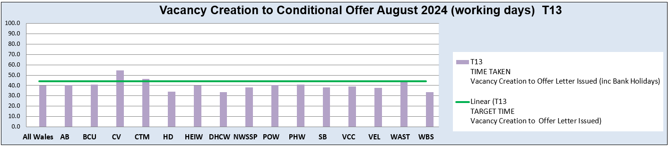  C&L;- Report generated Sept 2024, by NWSSP (Recruitment). Data source – TRAC system. Outliers are excluded. This is day to day vacancy management. Data excludes outliers.
Current Performance
- Swansea Bay UHB overall performance continues to be on target in August 24, and our monthly average over the last 12 months remains in target. In addition our performance for conditional offer to ready for start date start date was 16.4 days, which remains well below the set target of 27 days.
- The Central Resourcing Team continue to focus efforts on the recruitment of acute ward based HCSW’s and Band 5 nurses as well as providing support to specific difficult to recruit to posts and vacancy gap has closed significantly evidenced by significant reduction in nurse temporary agency spend.
- Current KPI’s (August 24) comparing SBUHB average time to hire vs the CRT on HCSW recruitment is 61.9 days vs 47.5 days based on average time taken from vacancy creation to ready to start, against a target of 71 days.
- In collaboration with NWSSP, we have been supporting the wider HB by trying to ‘chase’ outstanding actions on vacancies / pre-employment checks with applicants, in an effort to reduce the overall HB time to hire further.

Medical Recruitment

- Medical HR Team continue to focus on the recruitment of hard to recruit to posts, working closely with the relevant service groups.
- Continuing to offer high level pastoral care for international doctors relocating to the UK.
- Welsh Government have advised that Swansea Bay are an anomaly when it comes to international recruitment of doctors as all other Health Boards in Wales are unsuccessful at Junior and Senior Clinical Fellow levels.
- Medical HR has two dedicated overseas champions.

Actions for Next Period
- The Central Resourcing Team will continue focusing on the recruitment of B5 nurses, B2 ward based HCSW’s and assisting in overseas nurse recruitment. In addition, they are assisting in the recruitment of newly qualified nurses, via the all Wales Student Streamlining process, as well as specific identified hard to recruit to posts, and Exec recruitment.
- In collaboration with NWSSP, we will continue supporting the wider HB by trying to ‘chase’ outstanding actions on vacancies / pre-employment checks with applicants, in an effort to further reduce the overall HB time to hire.

Medical Recruitment
- Will continue to recruit overseas doctors on a post-by-post basis.
- Will continue to support the services for their hard to recruit to posts, looking at working with Agencies to support permanent recruitment in these hard to fill areas.
- Will continue to recruit SAS doctors to support through Portfolio Pathway (formerly CESR)
- Bid submitted to Welsh Government for funding for to aid international recruitment awaiting outcome

Turnover  % turnover by occupational group | Period Turnover Rate (Swansea Bay) – 01 Sep 2023 – 30 Aug 2024  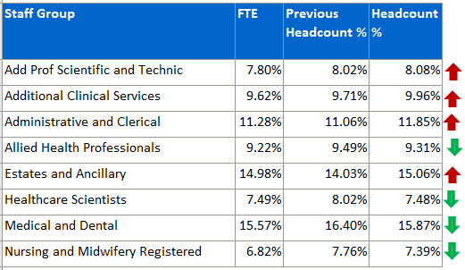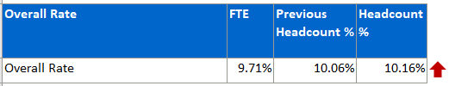  C&L;- Report generated Sept 2024, within SBUHB (ESR Team). Data source – ESR (Workforce). Small risk of margin of error due to late communication of terminations. Report excludes Bank, Locum, Honorary & Widow/Widower, Junior M&D staff. Internal movement not included – measure is about leaving Swansea Bay UHB.
Current Performance
- Organisationally our turnover has increased marginally in this reporting period (from 10.06% to 10.16%).
- It is important to recognise that this is reporting on a 12 month rolling period of turnover.
- Estates and Ancillary maintains high turnover, with an increase of circa 1%.
- Medical and Dental appears as the highest turnover, however it is important to note that expected spikes in activity created by seasonal SLE turnover which will lead to elevated M&D levels overall.
- Administrative and Clerical is the second highest area, and has seen a 0.19% increase.
- Other than Add Prof Scientific & Technical which saw a small 0.06% increase and Additional Clinical Services which saw a 0.25% in reporting period, categories are either relatively stable.

Actions for Next Period
- Health Board overall retention plan has been drafted and will be shared across appropriate forums/committees for approval
- Retention Lead continues to work closely with Workforce BP’s in order to identify and advance local retention plans
- Work ongoing to support flexible working which will support retention activities.

PADR  % staff who have a current PADR review recorded  PADR target – 85% | % of staff (Headcount) who have had a PADR in previous 12 months  C&L;- Report generated Sept 2024, within SBUHB (Performance Team). Data source – ESR (OLM Module). Accuracy levels subject to local maintenance and validation standards. Target of 85% added as blue line.
Current Performance
- Staff who have had a Personal Appraisal and Development Review (PADR) as of 31st August 2024 is 73.81%, this is a slight but steady increase from Apr 2024.
- In the past two months 51 staff have attended 130 PADR - Personal Appraisal Review for Managers the Learning and a further 11 staff have attended 130 MP PADR via Managers Pathway. The Education Team signpost colleagues to SBU ESR - ESR User Guides SharePoint Page for resources on how enter PADR Dates in ESR.
- Compliance figures per Service Group (excluding Medical and Dental Staff) – MH&LD 77.46%, NPTS 76.69%, PCCT 82.75%, Morriston 72.39%, Finance and Estates 53.85% - Deep dive completed within this area resulting in additional PADR training sessions being delivered.
Actions Planned for Next Period
- Supporting activity outlined in previous reports continues, Service Groups continue to focus on highlighting areas for focus.
- NPTS – Plans are in place to target divisions below 85%. PADR’s will be used as an enabler to support Quality and Safety Stratergy
MH&LD - Plans put in place to identify dedicated time to meet with all staff for objectives and development have resulted in a positive effect with the number of staff now requiring a PADR being reduced from 466 to 380 staff that have not received a PADR work will continue to prioritise the remaining 380 staff.
Operational Casework  Number of current operational cases. | C&L;- Report generated Oct 2024, within SBUHB (Workforce Digital). Data source – ER Tracker. Accuracy levels subject to local maintenance and validation standards.
Current Performance
- No. of open Formal Disciplinaries since the last reporting period have decreased to 40 open cases
- Number of Formal requests for Resolution has reduced to 19
- Suspensions, since the last reporting period have increased to 13, some of the cases have been resolved, additional suspensions have taken place
- ET’s have increased to 5
Actions for Next Period
- A number of actions are on-going in line with the Best Practice Review
- 3 workshops have taken place in partnership with our Trade Unions facilitated by HEIW and SBUHB covering the following: Employee Investigations – Avoiding Employee Harm.
- We have successfully launched the Management Review document, to replace the initial assessment, which allows us to determine the most appropriate course of action at an early stage with the intention to resolve cases informally where possible – education and training ongoing with HR and leaders, this is being embedded and continually reviewed
- Suspension Guidance for leaders and employees has been shared for comment with the aim of supporting both groups and clarifying the process

