


Meeting Date | 24th October 2024 |  | Agenda Item |  |  | 3.1
Report Title | SafeCare utilisation in Swansea Bay University Health Board (SBUHB)
Report Author | Allison Rees – Corporate Deputy Head of Nursing
Report Sponsor | Helen Griffiths – Corporate Head of Nursing
Presented by | Hazel Powell – Interim Executive Director of Nursing & Patient Experience
Freedom of Information | Open
Purpose of the Report | To update the Workforce and OD Committee on the utilisation of SafeCare in SBUHB
Key Issues | - SafeCare utilisation in SBUHB
Specific Action Required  (please choose one only) | Information | Discussion |  | Assurance | Approval
Specific Action Required  (please choose one only) | ☒ | ☐ |  | ☐ | ☐
Recommendations | Members of the Workforce and OD Committee are asked to  - Receive the update

SafeCare utilisation in SBUHB

- INTRODUCTION

To update the Workforce, & OD Committee on the utilisation of
SafeCare withing SBUHB.

- BACKGROUND

Since November 2022, SBUHB has been using the SafeCare system, linked to the e-rostering element of RLDatix, in all acute adult and paediatric in-patient areas (Section 25B), and within sub-acute (Section 25A) adult in-patient wards; to record patient acuity using to Welsh Levels of Care tools.
The Health and Social Care Committee produced a post legislative scrutiny report (April 2024) which has 11 recommendations, one of which is linked to barriers in the standardised use of Health visiting and Mental Health Welsh Levels of Care (WLOC) tools and cites the inability to collect and report data consistently. This also links to another recommendation regarding developing a standardised approach to reporting on Section 25A of the Nurse Staffing Levels (Wales) Act 2016 (NSLWA), which is now on the NHS Executive Nurse Staffing Programme plan.
The Health Minister has responded to the report; which can be found here: https://business.senedd.wales/documents/s152068/Welsh%20Government%20response.pdf

- GOVERNANCE AND RISK ISSUES

SafeCare has allowed Health Boards (HB’s) to gather data and report patient acuity and nurse staffing levels within Section 25B wards. SafeCare allows reporting in terms of spreadsheets, standard PDF reports and for collaborative work with nursing, rostering and digital teams to create bi-annual visualisers with Power BI. All of which inform part of the triangulated methodology used to re-calculate nurse staffing levels.

The Nurse Staffing Programme has reviewed SafeCare use, the table below shows the current position across Wales.

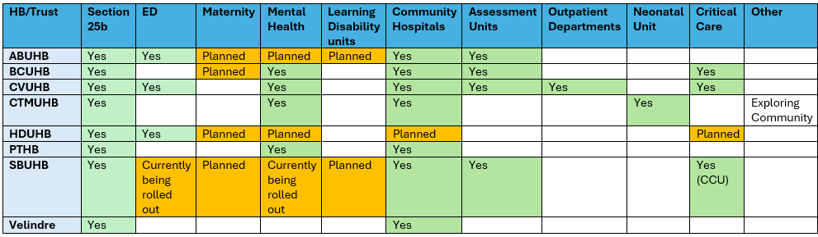

There is a WLOC tool available for Mental Health inpatient areas, which has been ratified through a Mental Health inpatient national engagement event in Cardiff on 20th February 2023 and is being used in four Welsh HBs for recording of patient acuity within SafeCare. Initial feedback is positive, although it has been noted that there are minor inconsistencies, particularly between levels 3 and 4; however, the registered nurse will use their professional judgement when deciding on a patient’s acuity level and through appropriate training this should allow for safe consistent reporting.

Maternity areas currently use Birthrate Plus within labour areas to articulate the patient acuity within labour wards, recording this data within a spreadsheet in SBUHB. Current benchmarking is shown in the table above; we have linked with Cardiff & Vale University Health Board (CAVUHB) and Cwm Taff Morgannwg University Health Board (CTMUHB) who are using SafeCare to collect acuity data within maternity services and are looking forward to understanding how they are achieving accurate consistent reporting, particularly looking at the tool used and how this works across all inpatient maternity services.

The Nursing and Midwifery Board have supported the implementation of SafeCare in Mental Health Adult admission/assessment wards. The system has been adapted to include specific task types, professional judgements and red flags applicable to Mental Health ward requirements. It was also agreed that SafeCare will be rolled out in the Emergency Department (ED) in Morriston hospital.
Training commenced on the 24th September 2024 for Mental Health & ED facilitated by the E-Rostering and Corporate Nursing team with an agreed Go Live date on the 20th October 2024.

- FINANCIAL IMPLICATIONS
Where appropriate financial implications have been discussed in relevant
Boards/Committees.

- RECOMMENDATION

Workforce, & OD Committee are asked to receive the paper for information.

Governance and Assurance

Link to Enabling Objectives  (please choose) | Supporting better health and wellbeing by actively promoting and empowering people to live well in resilient communities
Link to Enabling Objectives  (please choose) | Partnerships for Improving Health and Wellbeing |  | ☒
Link to Enabling Objectives  (please choose) | Co-Production and Health Literacy |  | ☒
Link to Enabling Objectives  (please choose) | Digitally Enabled Health and Wellbeing |  | ☒
Link to Enabling Objectives  (please choose) | Deliver better care through excellent health and care services achieving the outcomes that matter most to people
Link to Enabling Objectives  (please choose) | Best Value Outcomes and High-Quality Care |  | ☒
Link to Enabling Objectives  (please choose) | Partnerships for Care |  | ☒
Link to Enabling Objectives  (please choose) | Excellent Staff |  | ☒
Link to Enabling Objectives  (please choose) | Digitally Enabled Care |  | ☒
Link to Enabling Objectives  (please choose) | Outstanding Research, Innovation, Education and Learning |  | ☒
Health and Care Standards
(please choose) | Staying Healthy |  | ☒
(please choose) | Safe Care |  | ☒
(please choose) | Effective Care |  | ☒
(please choose) | Dignified Care |  | ☐
(please choose) | Timely Care |  | ☒
(please choose) | Individual Care |  | ☐
(please choose) | Staff and Resources |  | ☒
Quality, Safety and Patient Experience
All areas discussed relate to a focus on improved quality patient and safety experience.

Financial Implications
Financial implications have been discussed in relevant Boards/Committees where appropriate.
Legal Implications (including equality and diversity assessment)
To meet the Nursing & Midwifery council requirements.
Staffing Implications
Staffing implications are outlined as part of the report.

Long Term Implications (including the impact of the Well-being of Future Generations (Wales) Act 2015)
Long Term Implications have been considered.

Report History |  | Elements of the report have been discussed in Nursing Midwifery Board in July 2024
Appendices |  | None

