APPENDIX 2
Findings Report
Review of Leadership & Management Development Programmes delivered by Learning & Organisational Development
In line with Swansea Bay’s Vision for a High Quality Organisation and People Strategy (People Aim 6 – Leadership that Lives our Values), the Culture, OD and Staff Experience Team have undertaken a review of our management and behavioural based leadership development programme's in order to help shape the future, aligned to our on-going focus and efforts as part of developing our ‘One Bay Way culture’. The review took place during June and July 2024 and via a combination of both in-person engagement workshops and digitally via a questionnaire to enable inclusion and accessibility. A total of 39 attended the workshops, nominated from across the Health Board, staff groups and levels including; Heads of Service, Estates, Heads of Nursing, Leads for Wellbeing, Lead Nurses, Leads from Physio, Ward Managers, Librarians and OT and graduate trainees. In addition to the feedback from the workshops, 38 questionnaires were also completed.
- Summary Findings – Behaviour Based Leadership Programmes
The following summarises some of the key findings and direct feedback from the review undertaken.
What did you wish you had known when you first became a leader?

- The expectations when you are a clinician and leader- that you will need to sort the rosters etc on top of the clinical ask and therefore will have to do that in your own time.
- Wish there had been a culture of psychological safety in order to be able to learn.
- An understanding that leadership and management is a lonely place
- The scrutiny you are under as a leader from higher in the management structure and also from your team.
- How important self-care is
- To be brave enough to do it my way
- That a lot is expected of you
- That HR “won’t be your saviour” and would be hard to contact- would value training around policies and how to use them- someone to talk through key policies and how to implement
- Time management- managing your time as a leader is a challenge that has increased with the use of teams. No time to reflect between meetings. Although can delegate there is a feeling that in order to enable people to do their role and not feel overwhelmed by the sheer volume and pace of the work that they need to protect them.
- The recognition of the types of difficult conversations you may need to have with your team members but also those above you.
- How to manage up- how to influence those above and negotiate

When asked to select the most important, against the 9 Leadership domains detailed in the NHS Leadership Academy Healthcare Leadership Model, the top 3 selected were (in order of selection – highest to lowest):
- Engaging the Team
- Leading with Care
- Inspiring a Shared Purpose

What does bad leadership look like in Swansea Bay?
- Leaders who constantly flap and fire fight- then don’t have capacity to develop themselves
- Those that don’t demonstrate care, concern or listen to staff
- Those that make you feel like a number- don’t know what’s happening in your world
- Leadership where there isn’t a clear vision or goals that have been developed as a collective.
- Lack of compassion from senior teams, not listening or demonstrating the values of the Health Board.
- Constant change- moving goal posts with no acknowledgement of the impact on the teams or patient care. No recognition of the effort put in.

What are the skills and behaviours you believe are needed to support our leaders deliver our vision for a High Quality Organisation and People Strategy?
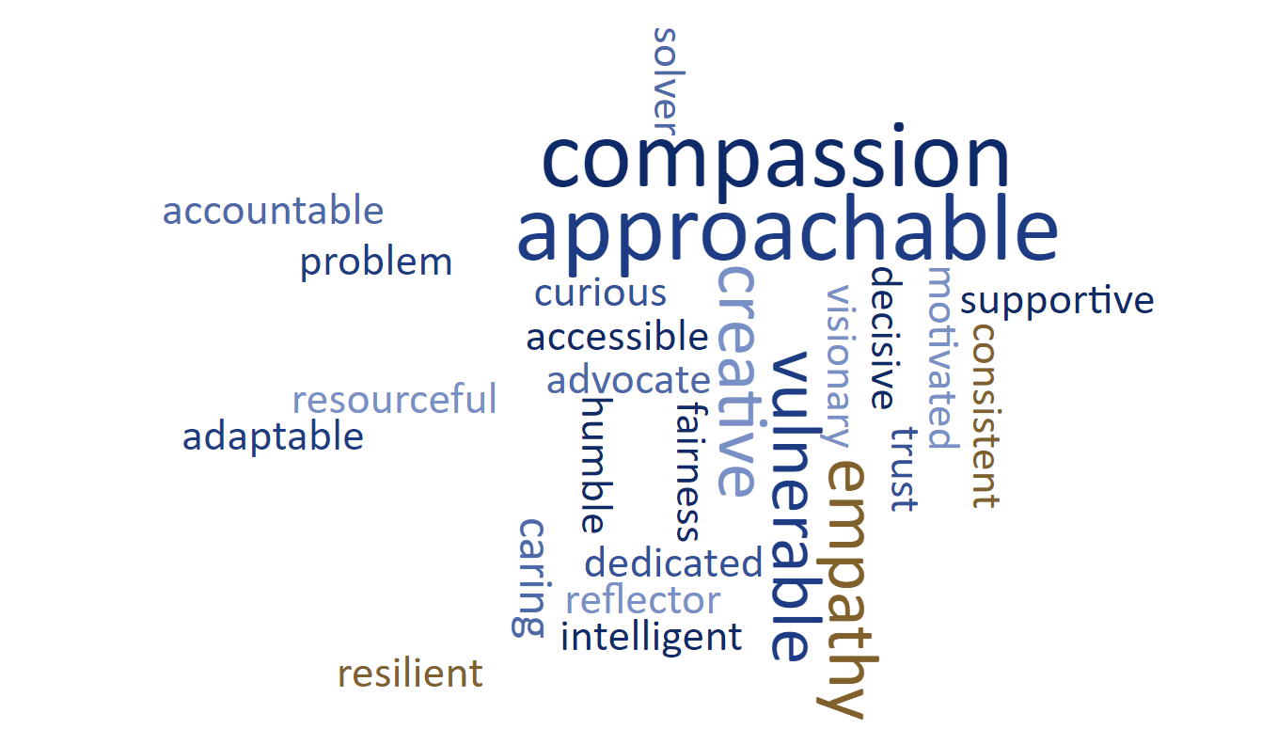

Core content for programmes- what is needed according to the feedback?
The table below outlines feedback from the focus groups and the questionnaire around programme content, mapped against what we already have in place/offer in our existing behavioural based programmes.
Emotional Intelligence | The work of Daniel Goleman is covered in Footprints and Bridges- also discussed in context in Impact and Courageous Conversations- links are given to his work and books
Person Centred Leadership | Highlighted in Footprints, Bridges and Courageous Conversations- explore both collective and Compassionate leadership
Coaching | As a leadership Style this is covered as an introduction in Footprints and Bridges- also available the stand alone module of Developing a Coaching habit.  Through out all of the courses the role of the coaching network is highlighted and the sharepoint details are given. The details are also in the complimentary workbooks for the programmes.
Personality Profiling-360 | This is not a part of the programmes at present due to cost and needing 360 facilitators to facilitate feedback.  Footprints looks at preferences through the work- Colours  Bridges – MBTI Step I
Mentoring | Not available
Clear outcomes and links to research | Links provided and references throughout the courses. Role of the HB libraries and librarians highlighted. Details of references, books, TEDs Talks and work further afield in workbooks and during the sessions in the chat
All Wales approach to leadership | Links to Gwella and Academi Wales supplied
Management Courses specifically for Band 5s to prepare for leadership roles | Can now attend Footprints if they have attended Impact (however this has resulted in backlog for footprints)
Support people’s aspirations | Links for coaching, also highlighting the role of the careers team
Clinical supervision training | Locally via Clinical team
Pathways through courses | Not available at present
Collective sharing of offering for ease of access | Difficult to navigate through which team training is sitting- for example Optimise is in Careers- Managers pathway sits in Education. Bridges in OD Culture and Staff Experience, plus additional leadership via Corporate Nursing
Guidance for supporting colleagues with Neuro diversity | Links to Neurodiversity Network given and discussions on where to find information.
Wellbeing as a leader | Highlighted through all programmes- reflection spaces in programmes, encouragement to take breaks and links to the Occupational Health and Staff Wellbeing Team
Vulnerability in leadership | Importance of vulnerability on Footprints, Bridges and Courageous Conversations. Highlighted through the work of Brene Brown on all of the courses.
Tool kits for Managers | Easy access to the knowledge of the practical tasks of management. Recognition that the delay in being able to attend courses is not ideal.

Additional themes from the survey and workshops:

The generational shift- how to bring those together to learn from each other and be supportive.

There needs to be a measure of the impact of attending training, what are the changes in behaviour, insight and how that develops into a shift on the ground.

Mentoring or buddying would be beneficial- there was some thoughts that we only support with mentors when things go wrong unless you are on the graduate programme.

Feeling that the managers role has changed in recent years- less freedom to “be creative and learn”

Succession planning is key, widen the opportunities that the graduate programme have so that others have access to mentorship

What is needed logistically?
- More preference towards face to face for the leadership programmes in order to build connections and network.
- No to modules of an hour as staff will not attend as its easier to roster days and consecutive days
- Allocation of time for CPD / training not enough at 26.5 hours. Just about covers mandatory and statutory training for some areas so no room for leadership training, therefore this gets dropped in order to meet the ask from Senior leadership. Cancelling study leave thought to lead to people not feeling valued and that career paths are not important - “just get the job done”, which correlates with one of the main reasons identified as part of the Thinking of Leaving Pilot.
- Reasons for drop-out rates include; pressures, guilt at leaving patients with low staffing levels on wards.
- Access to management training needs to be quicker- so that newly qualified are able to attend.
- Courses for those who need to develop, but don’t want to be managers

- Summary Findings – Technical Management Skills: Managers Pathway
Following sending a survey out to 205 participants of the programme, 68 were completed and returned which is a respectable return rate of 33% to support inform the review of our programmes. The following table summarises the responses:

Questions | Yes | No | Mixture of both
Thinking about the length of time you have to complete the Pathway, do you feel a year to complete the program is right? | 64 | 4 | N/A
Would you have preferred to undertake your modules as e-learning modules? | 2 | 35 | 31
In your opinion which of the Core modules below could be e-learning modules | Top 3  - Finance Basics  - Incident Reporting  - Recruitment
In your opinion which of the Optional modules below could be e-learning modules | Top 3  - E-Rostering  - Writing a Business case  - Minute Taking
Any further comments | - I think the course is perfect as it is. I don't think people learn much from e-learning  - The Manager's Pathway is an excellent opportunity for staff to learn and also interact with other professionals from around the Health Board.  - I was on the first Managers Pathway and enjoyed the modules I completed. Well done Team for providing these courses. I would encourage all to enrol onto this.  - Keep them as they are its an invaluable service, delivered by people who have a wealth of knowledge, a place where things can be discussed with others in a safe environment where you will not be judged  - I thoroughly enjoyed the course and can see no reason to change any of it. Thank you.

