Meeting Date | 16 June 2026 |  | Agenda Item |  |  | 5.5
Name of Meeting | Workforce and Organisational Development Committee
Report Title | Health & Safety Resources Paper
Report Author | Mark Parsons, Assistant Director of Capital Planning and Health & Safety, and Tim Harrison, Head of Health & Safety
Report Sponsor | Claire Osmundsen-Little, Director of Finance
Presented by | Mark Parsons, Assistant Director of Capital Planning (Health & Safety)
Freedom of Information | Open
Purpose of the Report | The purpose of this report is to update on the current health and safety resource and the required resources in initiate improvements in compliance across the health and safety disciplines.
Key Issues | The key issues highlighted in the report include:  - Health & Safety Resources  - Health & Safety Compliance  - Manual Handling Training  - Health & Safety Training  - Violence & Aggression Training  - Violence & Aggression/Case Management compliance/Support  - Fire Safety compliance  Health & Safety Resource Comparisons to other Health Boards & Trusts in NHS Wales
Specific Action Required  (please choose one only) | Information | Discussion |  | Assurance | Approval
Specific Action Required  (please choose one only) | ☒ | ☒ |  | ☐ | ☒
Recommendations | Members are asked to:  - Receive the report  - Approve Phase 1 recommendation to initiate improvements in statutory compliance and  - Endorse taking forward Phase 2 to provide a more sustainable Health and Safety structure.

HEALTH & SAFETY RESOURCES, and COMPLIANCE

- INTRODUCTION
The purpose of this report is to update the Committee on the Health & Safety resources and the challenges in being able to meet the legal obligations required of the Health Board.

- BACKGROUND
The Health and Safety at Work etc., Act 1974, places a primary duty on employers to ensure, so far as is reasonably practicable, the health, safety, and welfare of all employees. It also mandates duties for self-employed individuals, manufacturers, and employees to maintain safe environments and cooperate with safety requirements. The management of occupational health, safety and wellbeing is essential to effective running of the organisation.

The Health and Safety Executive (HSE), as part of their inspection programme for 2018-2019 covering violence and aggression and musculoskeletal disorders in healthcare, undertook several site/department inspections in November 2018.

As a result of these visits and inspections the Health Board was served with nine improvement notices in February 2019, covering Violence and Aggression x 4; Manual Handling x 4; and Reporting and Investigating Health and Safety Incidents. In July 2019, a further improvement notice was served relating to vehicle management (Vehicle & pedestrian separation). In October 2019, there were two further improvement notices for electrical low voltage and competent persons for statutory provisions. With a total of 12 improvement notices received in 2019.

In additional between 2020 and 2022 (COVID), there were several breaches identified by the HSE, that resulted in the health board receiving notices on contravention (NOC), covering Reporting of Injuries, Diseases and Dangerous Occurrences (RIDDOR) and Respiratory Protection/Personal Protective Equipment (PPE). This resulted in cost to the Health Board, as the HSE charge for their time until the breaches were deemed closed.

More recently, there has been enforcement by the Fire and Rescue Service, who have issued enforcement notices in June 2023 and in July 2025, issued Letters of Fire Safety Matters and the issues raised are being worked through.

3.0 HEALTH BOARD RISK REGISTER
Following the receipt of the improvement notices it was highlighted that resources within the health & safety team were insufficient to maintain regulatory compliance for the health board workforce and for the sites across SBUHB. This risk was submitted in September 2019 as Datix ID Number:2159, Health Board Reference Number: 64. This has been regularly updated, with the latest update in May 2026, showing a risk score of 20.

4.0 CURRENT HEALTH & SAFETY RESOURCE STRUCTURE & CAPACITY

The current H&S team is operating with significantly reduced capacity, with workload far exceeding the number of staff available. Key issues include:
- No dedicated Violence and Aggression resource available within the current team. However, the Administration B4 is currently seconded to B6 to provide a response to violence and aggression incidents and currently funded by the vacancies.
- High ratio of HB employees to the number of H&S Advisers/trainers, falling short of sector benchmarks.
- Increased demand for support due to legislative changes, Welsh Government national programmes (Ligature Management including ligature risk assessments, anti-violence initiatives), risk assessments, incident investigations, and operational pressures.
- High ratio of staff to Fire Safety advisors, falling short of sector benchmarks.
- High ratio of staff to Manual Handling advisors/trainers, falling short of sector benchmarks.
- Backlog of statutory tasks (audits, inspections, training, reviews) Insufficient administrative capacity, resulting in advisors undertaking a significant number of clerical duties.

4.1 Impact on Service Delivery
Due to insufficient staffing, the following risks are materialising:
- Low numbers of RIDDOR reporting compared to sector benchmarks
- Delayed incident investigations
- Reduced visibility of H&S support on operational sites
- Inability to complete statutory audits/inspections
- Delayed risk assessment reviews
- Reduced training provision particularly in relation to Violence and Aggression risks
- Increased pressure on advisors leading to burnout risk

4.2 Legal & Regulatory Risk
- Non‑compliance with statutory duties
- Increased scrutiny from the HSE that could lead to improvement or prohibition notices, notices of contravention and prosecution.
- Increased scrutiny from the Fire Service that could lead to enforcement notices and prosecution.

An example of the above consequences has recently been identified in relation to compliance to the Control of Substances Hazardous to Health and the Management of Health and Safety at Work Regulations, in not controlling staff exposure to formaldehyde in the Operating Theatre environment at Morriston and Singleton hospitals. *Controls exist in Neath Port Talbot Theatres, clearly showing an inconsistent management approach across the Health Board.

Formaldehyde is the main component in the specimen preservation/fixative agent formalin. This is a known respiratory sensitiser and carcinogen.

The table below shows the number of specimens prepared by Theatre staff during the 12 months of 2025; this equates in excess of 40 plus individual samples a week where staff have been exposed to formalin when adding it to specimen pots at Morriston hospital alone.

Theatre site | Number of specimens in buckets 01.01.25 – 31.12.25
Morriston | 2046
*NPT | 2074
Singleton | 837

The example above was identified by chance during the induction period for the recently appointed Head of Health and Safety and not as part of a structured, scheduled workplace inspection programme. If this was identified via an HSE inspection the likely outcome would have been the issuing of Improvement Notices or high probability of prosecution.

5.0 CURRENT SBUHB HEALTH & SAFETY RESOURCE STRUCTURE vs OTHER HEALTH BOARDS & TRUSTS in NHS WALES

A benchmarking review has been undertaken which analyses workforce structures across NHS Wales organisations, comparing Swansea Bay UHB (SBUHB) with peer Health Boards and Trusts in core safety‑related functions including:
• Health & Safety
• Fire Safety
• Violence and Aggression (V&A)/Case Management
• Manual Handling (MH)
• Respiratory (RPE) Fit Testing

It has highlighted that investment in health and safety is required to address the issues identified above, and for an immediate and medium-term investment plan to help manage health & safety being agreed.

The identity of the organisations has been redacted.

Table 1. Total H&S Workforce by Organisation (In-Post)
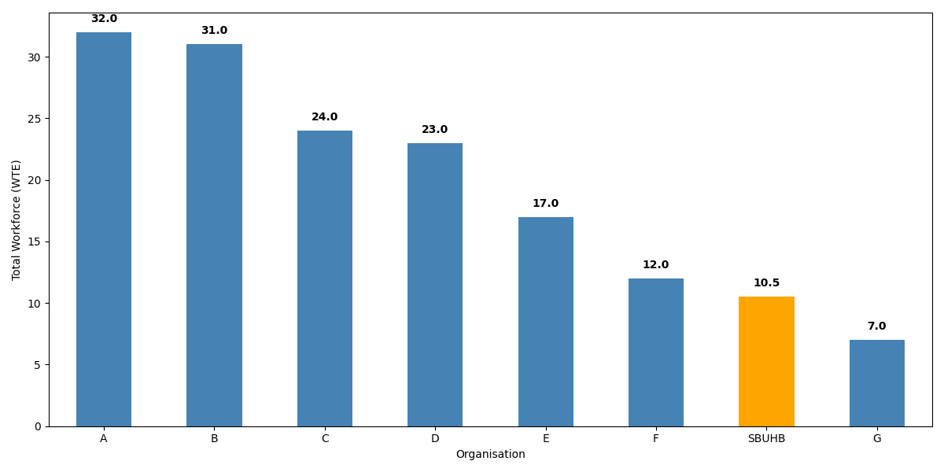

Table 2. Workforce Composition by Organisation
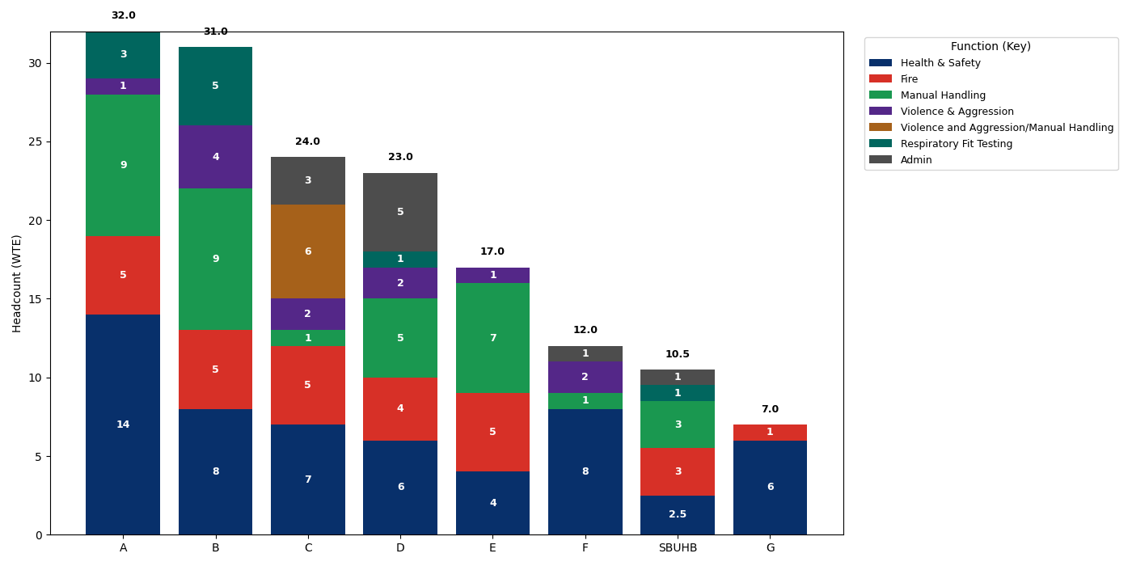

What the data shows:
The majority of organisations have between 60% and 200% more capacity. This gap is substantial and indicates a resourcing disparity between SBUHB and comparable organisations. This shows an under‑investment in health and safety, including V&A, fire, manual handling, and respiratory fit‑testing functions.

Using the WTE contribution, the dataset shows that:
- SBUHB Health & Safety Team resource is the smallest overall for any Health Board in Wales with considerably less resource than comparative organisations.

Table 3 - Percentage Difference Compared with SBUHB

Organisation | Total WTE | % Larger than SBUHB
A | 32 | +204.8%
B | 31 | +195.2%
C | 24 | +128.6%
D | 23 | +119.0%
E | 17 | +61.9%
F | 12 | +14.3%
SBUHB | 10.5 | 0% (Current Position)
G* | 7 | −33.3% (smaller)

Four Health Boards (A, B, C, D) have 119% to 205% more resource than SBUHB.
Organisation E is moderately larger (+62%).
Organisation F is only slightly above SBUHB (+14%).
Organisation G is the only organisation smaller (−33%) * but has 6 WTE Health and Safety professionals compared to the 2.5 in SBUHB and buy in other services.

Health and Safety Advisory Function
The H&S advisory role represents the primary function and plays a considerable contribution to organisational risk management.
Larger organisations (A–D) support between 119% and 205% more WTE than SBUHB, indicating a significantly enhanced capacity to undertake proactive site inspections, incident investigations, risk assessments, and organisational training.

By contrast and whilst prioritising work on a risk basis, SBUHB’s smaller advisory resource means the team is more heavily weighted toward reactive work, leaving limited capacity for preventative programmes.

This increases the likelihood that risk control measures may drift over time without routine H&S oversight and will potentially only come to light following incidents and harm or HSE inspections.

The Violence & Aggression service is one of the smallest
Across the organisations analysed, every health board and trust except SBUHB maintains dedicated Violence & Aggression (V&A) staffing, often including:
- Specialist V&A managers
- Case managers
- Personal safety advisers
- Behavioural safety trainers
- Combined V&A/Manual Handling trainers

SBUHB is the only organisation operating with zero dedicated V&A workforce.

Unlike peers such as A, B, C, D, and E—all of whom have clearly allocated V&A personnel.
SBUHB has no standalone V&A capacity, no case‑management provision, and no dedicated training resource. Instead, the organisation relies on generic health and safety roles absorbing V&A demands on top of their core duties.

SBUHB Manual Handling
Manual Handling services underpin musculoskeletal injury prevention.
Compared with peers, SBUHB’s smaller team has reduced bandwidth for proactive training coverage, meaning more staff may lapse beyond refresher cycles or receive delayed support during workplace injury investigations.

This has both safety implications and financial implications (sickness absence, agency spend, injury claims).
- Resource is joint bottom among Health Boards, only organisation F has fewer staff.
- One similar sized organisation has triple the Manual Handling resources of SBUHB. With three others each having more than double the SBUHB staffing levels.

RPE Fit Testing capacity is minimal (only equal to one other).
Although RPE demands have stabilised post‑pandemic, ongoing requirements persist across theatres, critical care, pathology, and infectious disease settings. Larger organisations maintain proportionally higher resourcing for:
- Fit‑testing new starters
- RPE training
- Ensuring compliance with mask models
- Managing supply and model updates

SBUHB’s modest staffing level in this area limits the ability to quickly scale up testing in response to outbreaks, emergencies, or equipment changes. Delays in fit‑testing can directly affect staff safety and patient flow.

Not the lowest (four organisations have zero RPE resource) but far behind Organisation B (+400%) and A (+200%), which have significantly larger capacity.
- Most have no formal RPE resource, meaning SBUHB is above some organisations

Fire Safety Resource
Fire safety functions in the dataset show consistent staffing across organisations but significantly higher capacity in A–D.
- SBUHB has 3 Fire Safety WTE, which places it: Below the major Health Boards (all at 5 WTE → 66.7% higher)
- Above organisation F and G

Typical UK Benchmarks for H&S Advisory Staffing
Across UK public‑sector and healthcare organisations, several widely observed norms are used:

1. Ratio of 1 H&S Adviser per 500–1,000 staff.
This is one of the most consistently reported benchmarks across UK local authorities, NHS organisations, and large public‑sector employers.

High‑risk sectors (healthcare, emergency services) trend toward 1:500–750.
Lower‑risk sectors may stretch to 1:1,000.

2. Ratio of 1 Senior H&S Manager per 5–10 H&S Advisers this ratio would support governance, audits, incident investigation oversight, and strategy.
For a 13,000-employee health organisation like SBUHB, the recommended number of H&S advisory staff is:17–26 staff.

This range aligns with standard UK benchmarks (1:500–1:750) and mirrors the composition of similarly sized NHS Health Boards, based on available organisational data and annual report structures.

The current ratio with 10.5 staff is 0.73 with the average across Wales being 1.66 and highest at 3.43 per 1000 employees.

6.0 NHS WALES HEALTH BOARDS & TRUSTS, ENFORCEMENT ACTION & PROSECUTIONS

All NHS organisations are inspected by the Health and Safety Executive and the Fire and Rescue Services covering their respective geographical locations.

Between 2019 and 2025, four Health Boards have been prosecuted for failure to meet the legislative requirement under the Health and Safety at Work etc. Act 1974 (HASWA). A brief outline of these is shown in table 4.

Table 4 – Prosecutions

Health Board | Act | Date of Hearing | Fine
Betsi Cadwalader | HSAWA Section 3 | 01/04/2025 | £250,000
Betsi Cadwalader | HSAWA Section 3 | 18/12/2023 | £200,000
Cardiff & Vale | HSAWA Section 3 | 16/07/2019 | £400,000
Cwm Taf Morganwg | HSAWA Section 3 | 08/07/2022 | £800,000
Cwm Taf Morganwg | HSAWA Section 3 | 08/07/2022 | £50,000
Powys Teaching Health Board | HSAWA Section 2 | 22/11/2022 | £160,000

The main sections used from the Health and Safety at Work etc. Act 1974 are section 2 and 3.

Section 2. Employers must do everything reasonably possible to protect the health, safety, and welfare of their employees at work.

Section 3. Employers must do everything reasonably possible to protect anyone who may be affected by their work, even if they are not employees, this would include patients and others.

Recently, a case against Cardiff and Vale University Health Board for failure to adequately record its management of its smoking policy (Failure to manage ignition sources), has resulted in the Heath Board being ordered to pay £25,000 fine and £75,000 in costs.

All the prosecutions identified cannot be insured against, therefore, any such prosecutions have a negative impact on revenue as well as a negative impact on the organisation’s reputation.

7.0 HSE PRESENTATION TO THE ALL-WALES HEALTH & SAFETY FORUM

In November 2025, the HSE Inspectors provided the All-Wales Health and Safety Forum with an update in relation to current activity and future programmes. As part of their presentation, some key areas were discussed including powers and responsibilities of individuals and organisations, some of which are highlighted.

Health & Safety Executive (HSE)
- Is the enforcing authority for NHS Health Boards and Trusts in respect of compliance with health and safety legislation.
- They will conduct a range of visits – both reactive, where they investigate accidents and proactive, where they will undertake an inspection of Health Board activities.
- Since November 2023 – two new HSE Divisions – Inspection and Investigation have been established.
- HSE Inspectors measure compliance against the legislative benchmark. This can be set by NICE (National Institute for Health and Care Excellence), NHS (England or Wales), or relevant industry guidance.
- Where we fall below this benchmark, enforcement action will be taken commensurate with the breach. These range from written information (Notification of Contravention letter), Improvement Notices, Prohibition Notices to Prosecution.
- Inspectors also have the power to exercise any other power necessary for the investigation or examination – this is much wider than the powers the Police have.

Corporate Responsibility
- Corporate Manslaughter and Corporate Homicide Act 2007 – Police led but based on health and safety breaches – fatal cases only.
- Health and Safety at Work etc Act 1974: -
- Section 2 (employees) and
- Section 3 (Contractors and persons affected by our work activity, e.g. patients).
Covers fatal injuries, injuries, illness, and dangerous occurrences.

Individual Responsibility
Gross Negligence Manslaughter
Police led – fatal cases only
- Breach of Care
- Gross offence
- Causation

Health and Safety at Work etc Act - Section 37
- that an offence has been committed under any of the relevant statutory provisions by a body corporate;
- that the offence has been committed with the consent or connivance of or has been attributable to any neglect on the part of the accused;
- that the person accused is a director, manager, secretary or other similar officer, or a person purporting to act in any such capacity, or a member of a body corporate whose affairs are managed by its members.

Section 7 - to take reasonable care for the health and safety of himself and other persons who may be affected by their acts or omissions at work (s.7(a)); and
as regards any duty or requirement imposed on his employer or any other person by or under any of the relevant statutory provisions, to co-operate with him so far as is necessary to enable that duty or requirement to be performed or complied with.

Individual Responsibilities / Point of Law
- Section 2(1) of the Company Directors Disqualification Act 1986 - disqualification order on conviction preventing the formation, promotion, or management of a company.
- HSE has to prove there has been a breach of legislation.
- Reverse Burden of Proof - where a duty holder is required to do something ‘so far as is practicable,’ the burden is on the defendant to prove that it was not practicable or reasonably practicable to do more than was in fact done.

Fee for Intervention/Cost Recovery
- The fee charged will recover costs incurred from any inspection or investigation, from the start of an initial visit through to the conclusion, including any administrative work or work completed in an office. This applies only where you have been informed of a material breach.
- FFI is costly. Average investigation fees over £50,000 for an investigation. Prosecution costs and any fine is in addition.

8.0 GOVERNANCE AND RISK ISSUES
Health and Safety governance is as important as any other aspect of governance. It is a fundamental part of an organisation’s overall risk management function which is a key responsibility of directors. Failure to manage health and safety risk effectively has both human and business costs. The price of failure can be the damaged lives of workers, patients, their families, and friends, as well as direct financial costs, damaged reputations, and the risk of legal prosecution.

9.0 FINANCIAL IMPLICATIONS
There are no direct financial implications arising from this report, however, to implement the recommendations, there are cost implications.

Phase 1 will incorporate regrading and skill mixing of overall WTE, this includes current vacancies that finance have confirmed remain within the health and safety budget. This will provide a positive base line with essential post and put the Health Board in a better position in preparation for phase 2. Phase 1 implementation will look internally to recruit where practicable to do so. This will depend on individuals identified having the appropriate knowledge, skill and qualifications or be able to achieve the required qualifications to support knowledge and experience within a specified time. There is likely that certain posts will require external recruitment based on specialist skill set required.

By using current resources and skill mixing, this will only incur a cost of £43,500 for pay costs from 1st April 2026, and a one-off non-pay IT cost of £5,400, this is based on external recruitment and potential recurring travel costs of £1,200 per annum to fully implement phase 1. Given the recruitment process it is more likely that costs will not be incurred until August 2026. This will require £29,000 in pay costs and travel non-pay costs of £500 - £600 for the remainder of 2026/27. This will be adjusted once the internal process has been exhausted.

The Recruitment to implement Phase 2 has been paused and will be revaluated following the full implementation of phase 1, and subject to affordability.

10. RECOMMENDATION
Members are asked to:
- Receive the report and Approve Phase 1 recommendation to initiate improvements in statutory compliance and Note taking forward Phase 2 once the full implementation of phase 1 has been completed, subject to financial affordability.

Governance and Assurance

Link to Enabling Objectives  (please choose) | Supporting better health and wellbeing by actively promoting and empowering people to live well in resilient communities
Link to Enabling Objectives  (please choose) | Partnerships for Improving Health and Wellbeing |  | ☒
Link to Enabling Objectives  (please choose) | Co-Production and Health Literacy |  | ☐
Link to Enabling Objectives  (please choose) | Digitally Enabled Health and Wellbeing |  | ☐
Link to Enabling Objectives  (please choose) | Deliver better care through excellent health and care services achieving the outcomes that matter most to people
Link to Enabling Objectives  (please choose) | Best Value Outcomes and High Quality Care |  | ☒
Link to Enabling Objectives  (please choose) | Partnerships for Care |  | ☒
Link to Enabling Objectives  (please choose) | Excellent Staff |  | ☒
Link to Enabling Objectives  (please choose) | Digitally Enabled Care |  | ☐
Link to Enabling Objectives  (please choose) | Outstanding Research, Innovation, Education and Learning |  | ☐
Health and Care Standards
(please choose) | Staying Healthy |  | ☒
(please choose) | Safe Care |  | ☒
(please choose) | Effective Care |  | ☒
(please choose) | Dignified Care |  | ☒
(please choose) | Timely Care |  | ☒
(please choose) | Individual Care |  | ☒
(please choose) | Staff and Resources |  | ☒
Quality, Safety and Patient Experience
The effective communication of information and coordination of team activities is essential to providing safe patient care. The Health and Safety Operational group is responsible for managing and overseeing effective quality, safety, and patient experience.

Financial Implications
To implement the recommendations contained within the report, will have financial implications for revenue resources for each of the phases. Phase one requires £29,000 from August 2026/27, plus £5,400 one off IT costs (this is based on external appointments) and £1,200 non-pay recurring. The Recruitment to implement Phase 2 has been paused. However, if funded was available a staggard approach could be implemented i.e. 2 posts in April, 2 posts September, with the final posts in January 2028. There will be a one-off none-pay IT costs of £8,100 for these posts and approximately £1,800 for non-pay travel costs.
Legal Implications (including equality and diversity assessment)
SBUHB is committed to providing and maintaining a safe and healthy workplace and to provide suitable resources, information, training and supervision on health and safety to all members of staff, patients Contractors and visitors to comply with the legislative and regulatory framework on health and safety. The health & safety team utilises current resources to the best it can, prioritising on a risk basis, however it is not possible to implement audits, inspections or provide appropriate levels of training and support to meet the organisations legal obligations.

Staffing Implications
Currently within Swansea Bay University Health Board, there are 10.5 wte in post across the following disciplines: Health & Safety; Fire Safety; Manual Handling; Violence & Aggression/Case Management and respiratory protection. Currently there are 3.88 wte vacancies. Phase 1 will enable remixing and aligning to priorities, with a new baseline wte of 14.5. Based on benchmarking with other Health Boards and Trusts, as a minimum a further 6 wte posts are required as outlined in phase 2, to provide the Health Board with the platform to initiate overall compliance for a more sustainable Health & Safety structure.

Long Term Implications (including the impact of the Well-being of Future Generations (Wales) Act 2015)
The Act requires the Health Board to think more about the long term, how we work better with people and communities and each other, look to prevent problems and take a more joined up approach with partners. There will be long term risks that will affect both the delivery of services; therefore, it is important that you use these five ways of working (Long Term Thinking, Prevention, Integration, Collaboration, and Involvement) and the wellbeing goals identified in the Act in order to frame what risks the Health Board may be subject to in the short, medium and long term. This will enable The Health Board to take the necessary steps to ensure risks are well managed now and in the future.
Report History |  | Performance & Finance Scrutiny Group, Performance & Finance Assurance Group
Appendices |  | Appendices 1. Current resources and budget and proposed implementation of phases 1 & 2, including budget required to provide a sustainable health and safety structure to support the organisation in adhering to its moral and legal obligations. With a pause on phase 2 recommended at PFAG

Appendix 1

Current Structure (In Post)

Including Vacancies - WTE 14.38
Vacancies Band 7 x 1.6 Band 6 x 0.28 Band 4 x 1 Band 3 x 1

Phase 1 Structure – Skill Mix/Re-banding –
Phase 1 WTE 14.5 and requires investment of £43,500

H&S Workforce based on 14.5 WTE
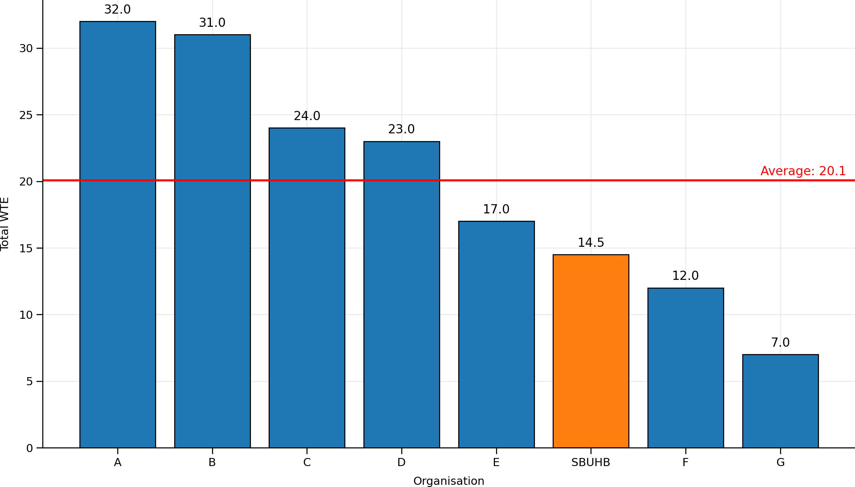

Phase 2 Structure
Phase 2 WTE 20.5 and requires investment of £283,000
H&S Workforce based on 20.5 WTE staff

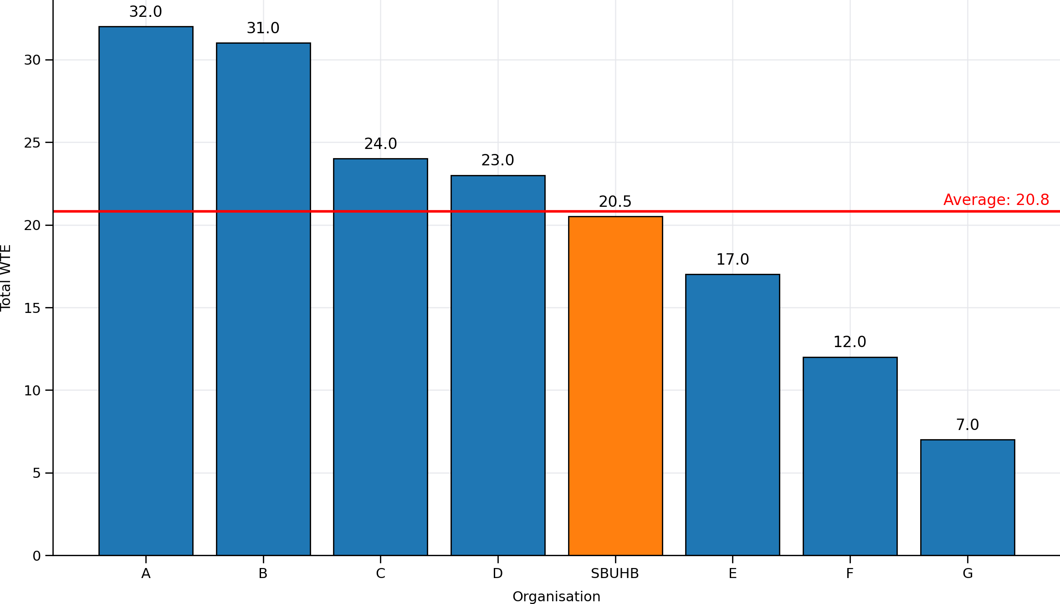

Thanks Mark. To confirm the decisions and actions from PFAG were:

Decision:
- Phase 1 was supported in principle to progress to Exec Board for approval, subject to using redeployment and existing resource where possible (See actions below).
- Phase 2 was not approved at this stage and will be reconsidered following evaluation of Phase 1 effectiveness and affordability.
Actions:
- Mark Parsons and Claire Osmundsen-Little to:
  - Finalise Phase 1 costs, clarifying assumptions on vacancies and redeployment.
  - Develop proposed KPIs and assurance measures for Phase 1 implementation.
- HR colleagues to advise on expressions of interest and redeployment processes to support Phase 1 resourcing, aligned to O4S.

There is an Exec Board next week (13th) however papers would be due today. Next opportunity would be 27th May (papers due 21st May), let me know if this is doable once you have clarified with Claire.

