Meeting Date | 16 June 2026 | Agenda Item | 3.4
Name of Meeting | Workforce and Organisational Development Committee
Report Title | Variable Pay Plan 2026/2027
Report Author | Emma Owen – Assistant Director of Workforce & OD
Report Sponsor | Executive Director of Workforce and Organisational Development
Presented by | Emma Owen – Assistant Director of Workforce & OD
Freedom of Information | Open
FoI Closed detail | If closed, choose detail
Impact Assessment Summary Outcome |  | IA Completion date
Not applicable |  | Click or tap to enter a date.
Purpose of the Report | For Assurance
Report Summary; detailing any action required
To update the Committee on the Variable Pay Reduction Plan for 2026/27, progress made to date, the scale of the remaining challenge, the principal risks to delivery and the actions in place to support further reduction.

Key Issues
This report provides the Committee with an update on delivery of the Variable Pay Reduction Plan for 2026/27, including progress to date, risks to delivery and the actions in place to support further reduction.

Good progress has been made in reducing reliance on variable pay. However, as part of the 2026/27 Annual Plan, a target has been set to reduce variable pay by 50%, equivalent to approximately 300 FTE. Whilst reductions have been achieved, the Health Board remains reliant on variable pay in a number of professional groups and service areas, and continued focus will be required to ensure delivery against trajectory. The Committee can take assurance that governance arrangements are in place through the Variable Pay Steering Group and Recovery and Sustainability governance structure, with service and professional group plans under regular review.

Decision / Action required | No
Recommendations
Members are asked to note the progress made to date in reducing variable pay, note the scale of the remaining challenge in delivering the 2026/27 target, take assurance from the governance and monitoring arrangements in place, and endorse the continued oversight of delivery through the Variable Pay Steering Group and Recovery and Sustainability governance arrangements.

VARIABLE PAY PLAN 2026/2027

- INTRODUCTION

Variable pay remains a key challenge for the Health Board. Whilst reductions have been achieved, the Health Board continues to rely on high levels of variable pay.

The 2026/27 plan requires a significant further reduction in variable pay, with a target equivalent to approximately 300 FTE. Whilst the data presented in this report shows continued improvement and some reduction in overall full-time equivalent usage, delivery remains challenging and is not yet assured across all service areas. The current position indicates that further sustained reduction will be required during the year if the Health Board is to achieve the planned level of savings and workforce change.

- BACKGROUND

The Health Board must achieve £55.4m in savings in 2025/26 if it is to meet its financial plan. The Recovery and Sustainability Programme Board was established to support delivery of the required savings through 12 overarching workstreams. Enhanced workforce controls have been implemented in addition to a dedicated Variable Pay Steering Group.

A multidisciplinary approach is being adopted to provide an overarching structure and cohesive approach to sustainable workforce change focused on:
- Variable Pay
- Staffing Unavailability
- Workforce establishment
The Variable Pay Steering Group has dedicated plans covering all professional groups that are led by Executive Directors. Overarching highlight reports are provided to the Recovery and Sustainability Board to monitor progress and ensure delivery.

- GOVERNANCE AND RISK ISSUES

Over the last 12 months, the Health Board has implemented a number of controls to ensure robust vacancy management and the appropriate use of variable pay. To support a sustainable future, work has been undertaken to define the workforce reduction of 900 FTE per year that the Health Board must achieve over the next three years, delivered through reductions in substantive full-time equivalent establishment and variable pay.

The financial and workforce context should be considered together. The Health Board's wider savings requirement, the planned workforce reduction over the medium term and the specific variable pay reduction target are linked components of the overall recovery plan. Reducing variable pay is therefore not only a financial requirement but also a key element of achieving a more sustainable workforce model that is closer aligned to funded establishment.

The graph below outlines the combined full-time equivalent (FTE) for both substantive staff and variable pay usage from April 2025 to April 2026.

Whilst the Health Board continues to face challenges in reducing variable pay, the overall combined substantive and variable pay full-time equivalent position is moving closer to the budgeted establishment. Further analysis of the professional groups is included in Appendix 1; however, the data shows significant gaps within Administrative, Estates and Facilities, and Additional Professional, Scientific and Technical staff. It is also important to note that this information focuses on full-time equivalent and not actual spend, which will be higher due to the use of variable pay.

Key risks and barriers
Delivery risk remains in a number of areas. These include hard-to-recruit specialist roles, continuing service pressures, the need to maintain safe staffing levels and variability in the availability of substantive staff.

Whilst the Health Board is focused on reducing areas of over-establishment within Nursing, significant risk remains in maintaining safe clinical care, which continues to drive the use of variable pay. There is also a risk that, unless substantive recruitment in hard-to-recruit roles, roster management and service redesign progress at sufficient pace, reductions in variable pay may not be deliverable within the required timescale.

Mitigating actions
A number of actions are in place to support further reduction. These include strengthened vacancy controls, executive-led oversight of professional group plans, regular review of service and corporate trajectories, scrutiny of agency and locum usage, and continued work to align staffing levels to funded establishment. In addition, service groups are being supported to refine granular delivery plans so that exception areas can be identified early and escalated through the Recovery and Sustainability governance arrangements where progress is insufficient.

Work is underway with all service groups and corporate directorates to review granular plans to ensure delivery against the 900 FTE reduction. Once agreed, the plans will be reviewed regularly to monitor trajectory and confirm delivery.

100 Leaders Engagement
During May, the 100 Leaders network met to support the wider workforce transformation context within which variable pay reduction plans are being developed. The session focused on breakthrough objectives, leadership ownership and the actions required to support more sustainable service models, which will help inform Transforming for the Future and the clinical service plan.

- FINANCIAL IMPLICATIONS

The information below outlines variable pay spend. Continued reductions are evident across some categories; however, a significant further reduction is still required to achieve the savings target. Variable pay reduced by £0.27m in Month 1, and the graph below shows a reduction in agency and waiting list initiative payments compared with average spend in 2025/26.

The information below outlines the variable pay spend for 2025/26 and the month 1 position highlighted.

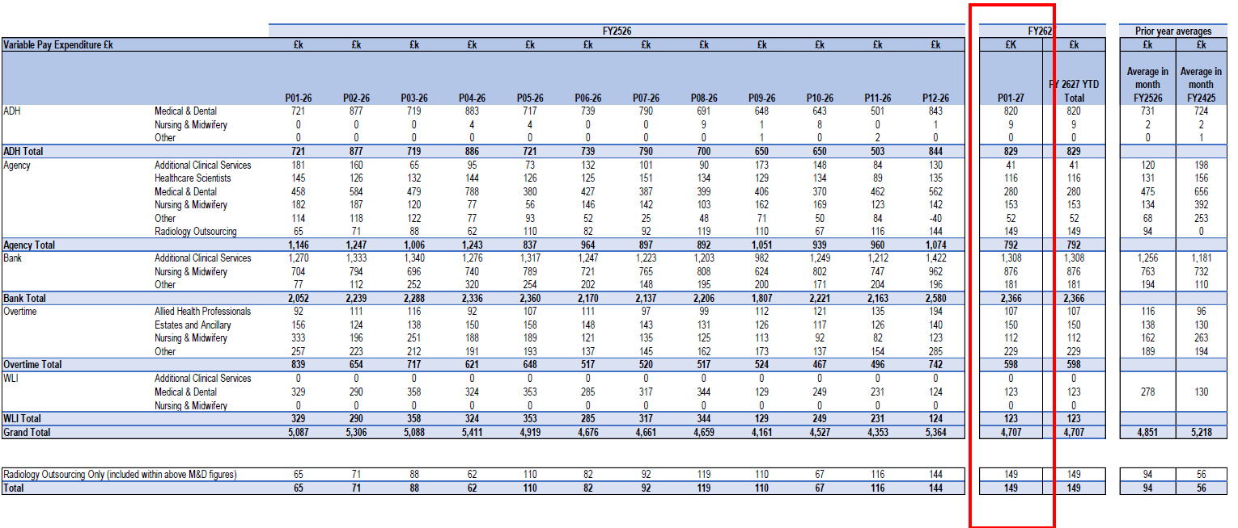

Agency

The table below outlines the full-time equivalent (FTE) agency usage for 2025/26, split between framework and non-framework expenditure. Usage within Neonatal Services and Allied Health Professionals reduced during March and April; however, this was offset by increased agency utilisation within the Intensive Treatment Unit and Mental Health services, reflecting the specialist skills required to support staffing in these areas. It is important to note that Richmond Nursing ceased trading in May 2026 and supplied the Health Board with approximately 198 candidates which may impact on the future ability to cover shifts via the framework providers.

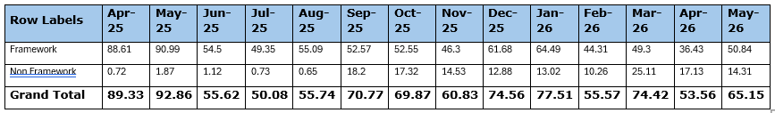

The table below outlines agency use for Medical, which confirms a level of usage comparable to the same period in 2025, despite a decline in usage between August and December 2025.

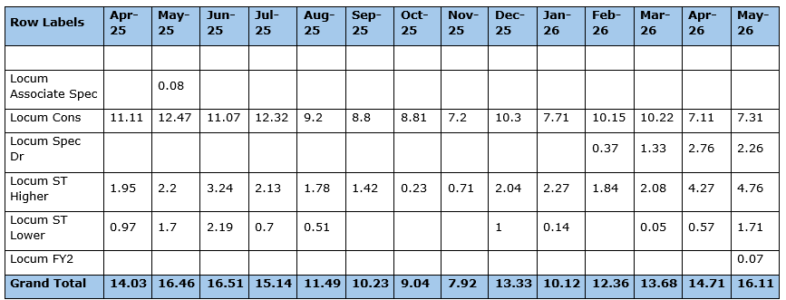

Please note that there is no off-framework agency usage recorded for medical cover.

Below is the capped rate information for Medical internal and agency locums for April & May 2026. Please note that data for May 2026 may change due to corrections being applied for pay processing periods.

 | Apr-26 |  | May-26
 | Internal | Agency | Internal | Agency
Individuals Booked | 287 | 11 | 272 | 20
Individuals Booked At/Below Cap | 209 | 0 | 190 | 0
Individuals Booked At/Below Cap % | 72.82% | 0.00% | 69.85% | 0.00%
Individuals Booked Above Cap | 90 | 11 | 95 | 20
Individuals Booked Above Cap % | 31.35% | 100.00% | 34.92% | 100.00%
Hours Booked | 7581.5 | 2653.5 | 7542.92 | 3390.89
Hours Booked At/Below Cap | 5691.08 | 0 | 5410.17 | 0
Hours Booked At/Below Cap % | 75.06% | 0.00% | 71.72% | 0.00%
Hours Booked Above Cap | 1890.42 | 2653.5 | 2132.75 | 3390.89
Hours Booked Above Cap % | 24.93% | 100.00% | 28.27% | 100.00%
Jobs Booked | 844 | 18 | 777 | 14
Jobs Booked At/Below Cap | 606 | 0 | 546 | 0
Jobs Booked At/Below Cap % | 71.80% | 0.00% | 70.27% | 0.00%
Jobs Booked Above Cap | 238 | 18 | 231 | 14
Jobs Booked Above Cap % | 28.19% | 100.00% | 29.72% | 100.00%

Next steps Work will continue with service groups and corporate directorates to finalise and regularly review detailed delivery trajectories against the 2026/27 target. Future updates will provide further detail on areas of variance, progress against planned reduction and any additional actions required where delivery is off trajectory.

In summary, variable pay remains a significant challenge for the Health Board. Whilst progress has been made and governance arrangements are in place, a substantial level of further reduction is still required to achieve the 2026/27 target. Continued scrutiny, service-led delivery and timely escalation of risks will therefore be essential.

- RECOMMENDATION

The Committee is asked to consider this report for assurance, note the progress made to date and the scale of the remaining challenge, and endorse the continued oversight of delivery through the Variable Pay Steering Group and Recovery and Sustainability Board.

Governance and Assurance
Strategic Objectives
Strategic Objectives  (please choose which is impacted) | People of Swansea Bay live healthier, fairer and more prosperous lives | ☐
Strategic Objectives  (please choose which is impacted) | Care is high quality, safe, efficient and delivers the best possible outcomes for people in partnerships | ☒
Strategic Objectives  (please choose which is impacted) | Care is delivered in partnership with our communities in safe and appropriate setting, supported by innovation | ☐
Strategic Objectives  (please choose which is impacted) | The Health Board is a great place to work where staff feel valued and work together towards a common goal | ☐
Strategic Objectives  (please choose which is impacted) | The Health Board is a resilient, sustainable and responsible organisation | ☒
Health and Care Standards
Standards (please choose which applies) | Safe Care | ☐
Standards (please choose which applies) | Timely Care | ☐
Standards (please choose which applies) | Effective Care | ☒
Standards (please choose which applies) | Efficient Care | ☐
Standards (please choose which applies) | Equitable care | ☐
Standards (please choose which applies) | Person-centred Care | ☐
Standards (please choose which applies) | Staff and Resources | ☒
Enablers (please choose which applies) | Whole Systems Approach | ☐
Enablers (please choose which applies) | Leadership | ☐
Enablers (please choose which applies) | Workforce | ☒
Enablers (please choose which applies) | Culture | ☐
Enablers (please choose which applies) | Information | ☐
Enablers (please choose which applies) | Learning, Improvement and Research | ☐
Quality, Safety and Patient Experience
Engaged, motivated and supported staff will have a positive impact on patient care, service quality and clinical outcomes.

Financial Implications
Delivery of the Variable Pay Reduction Plan is a key component of the Health Board’s financial recovery plan. A reduction of £34.5m in variable pay is required to support delivery of the overall financial target, and continued monitoring of trajectory will be essential throughout 2026/27.

Legal Implications (including equality and diversity assessment)
None identified.

Staffing Implications
Staffing issues will impact on both the quality and financial sustainability of services.
Long Term Implications (including the impact of the Well-being of Future Generations (Wales) Act 2015)
Best use of resources to ensure sustainability.

Report History
None

Appendices
Appendix 1 – Professional Group Analysis

