NHS Wales Staff Survey 2025 – Health Board Action Plan

Staff Survey Update - Health Board Wide |  |  | Date Agreed: May 2026  Lead: Abi Harris, CEO, supported by Executive Team aligned to portfolios
1. High level summary of survey findings: |  | 2. Response Rate
Swansea Bay UHB achieved a response rate of 19.1%. A breakdown of this response rate by Service Group is below  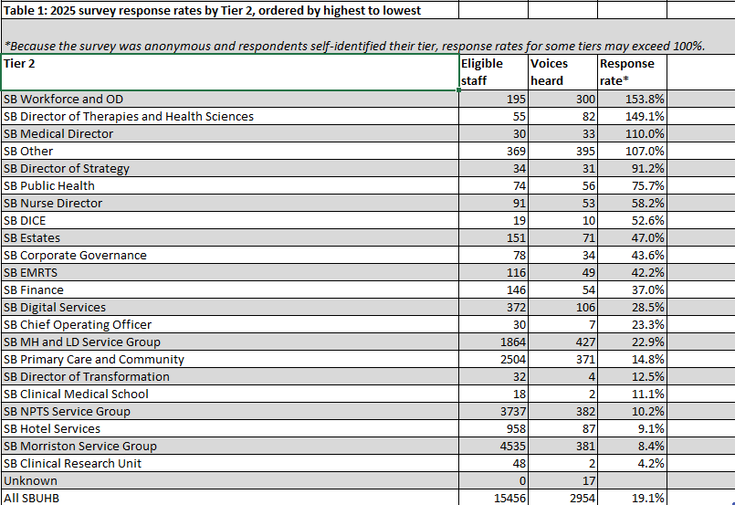  Swansea Bay UHB achieved a Staff Engagement Index score of 70.3% in 2025.  This is compared with the 70.8% average NHS Wales Staff Engagement Index  score.  The below table shows the Staff Engagement Index score across service groups and corporate areas in ascending order:  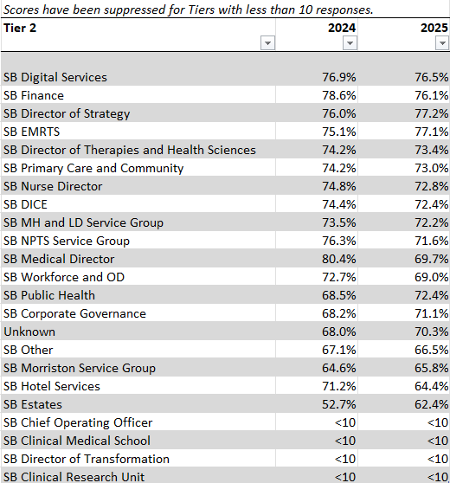 |  | Response Rate 2025: 19.1% |  | Target for 2026: 30% (min.)
 |  | 3. Key actions being taken to Improve Response Rate
Key Action | Lead | By When
Continue to promote via Health Board-wide communication channels i.e. Team brief, Mid-week message, Ask Abi, Top 100 Leaders, with the expectation to cascade across services. | RT, AH, TR | May -June 2026
Utilise DICE’S annual Comms Campaign to make a continuous, explicit link back to the voices of staff throughout the year, highlighting the meaningful change that has resulted from the staff survey and to enhance up-take i.e. flu campaign. | RT, TR | June 26 on-going
Development of a communication plan emphasising messages around confidentiality and anonymity. | HEIW, RT, TR | August-September 2026
Work with HEIW and Services to make improvements around the hierarchy to support accuracy of completion/returns. | HEIW, TR, Services | July-August 2026
Build in as an objective to Exec and Service Directors PADRs. | AH, DL | June to December 2026
Utilise national resources, incentives and branding to support drive messaging and response rate. | HEIW, RT, TR | September to December 2026

 |  | 4. Key Exit Criteria (what will success look like for the staff survey in 2026?) *linked to national survey measures in 2025.
- Improved staff engagement score
- Improved positivity score for “we nurture healthy working environments”
- Improved positivity score for “we are all able to speak up”
- Improved positivity score for “we are inclusive and compassionate”

5. Short term Goals 2026/27 | 6. Medium term Goals 2027/8 | 7. Key Actions/ Milestones leading up to 2026 staff survey
Priority 1: We Nurture Healthy Working Environments  - Re-launch wellbeing offer with senior sponsorship and endorsement for protected access time.  - Regular triangulation of workforce data (rostering, variable pay, sickness, ER cases) with team-level staff feedback; transparent sharing with services for cascade  - Reinforce Workforce Heatmap use within the new performance framework to highlight hotspots and drive accountability.  - Implement monthly sickness absence reviews for Services.  - Equip managers to hold safe workload and resource/equipment conversations and escalate risk early.  Priority 2: Staff Engagement  - Clear communication linking Organised for Success priorities to staff input/voice.  - Minimum standard set by central Delivery Unit for staff involvement and co-design in key change programmes.  - Enhance recognition of staff contribution and improvement activity on the ground.  Priority 3: We Are Compassionate and Inclusive  - Timely, compassionate and consistent responses to concerns raised to managers, supported through our Speaking Up Safely provision and infrastructure.  - Reset behaviour expectations aligned to the our Health Board Values and Behaviour Framework and Compact driven through Transforming for the Future.  - Proactive action in hotspot areas using survey and workforce data | Benchmarking of results from 2026 NHS Wales Staff Survey to identify improvements or gaps for action which will inform medium term Goals.  Alignment to Health Board Strategy, Transforming for the Future, WOD Delivery Actions as part of IMTP and 7 People Aims set out in SBU People strategy for 2027/8. | Actions/ Milestones |  | Lead | By When | Status
 |  | Utilise Team Brief, Ask Abi, Top 100 Leaders as mechanisms to share Staff Survey Results and actions planned for collective delivery. In addition, highlight target response rate for 2026. |  | AH, RT, TR | May-June 2026 | On-track
 |  | Managers and Leaders across services to discuss the results within their teams and actions to collectively implement, feeding into the overarching goals and success measures. |  | Execs and services | June/July 2026 | On-track
 |  | Work to be undertaken with HEIW, ESR Team and Services/HRBPs in relation to the National Survey 2026 hierarchy and wider actions required ahead October launch (taking into account Organised for Success) |  | WOD, Service Tri’s / HRBPs, ESR Team | June to October 2026 | On-track
 |  | Quarterly progress up-dates on delivery of action plans including examples of meaningful change linked to annual comms campaign through “You Said, We’re Delivering together” via WOD Committee |  | Services, TR, RT | June to October 2026 | On-track
8. Key Risks | 9. Mitigating Actions | 10. Interdependencies
Capacity to prioritise the national staff survey and attribute meaningful action and improvement due to operational and financial pressures along with organisational transformation through Organised for Success. | Review and streamlining of Delivery Actions and WOD priorities to ensure resource focuses on delivering what the Health Board and Services require most. | SBUHB’s Strategy – A Healthier Swansea Bay
 |  | Integrated Medium Term Plans and Delivery Actions
 |  | SBU Clinical Service Plan – Transforming for the Future
 |  | SBU People Strategy and local Service Group People Plans
 |  | We All Belong – SBUs Equality Strategy
 |  | NHS Wales Speaking Up Safely Framework
 |  | HEIW – National direction on NHS Wales Staff Survey and Leadership & Management Competency Framework

