

CORPORATE RISK REGISTER
April 2026

Risks assigned to the
Workforce & OD Committee

Datix ID Number: 843  Date Opened: April 2019 |  | Date Last Reviewed: Apr 2026 |  | CRR Ref Number: 3  Risk Target Date: 31/03/2026 |  | Current Risk Rating  4 x 4 = 16
Objective: The health board is a great place to work where all staff feel valued and work together towards a common goal |  |  | SRR Ref:  4.1 | Director Lead: Tina Ricketts, Director of Workforce and OD  Assuring Committee: Workforce & OD Committee
Risk: Recruitment of consultant medical & dental staff in hard to fill roles.
Due to national shortages, there is a risk that that the health board will be unable to recruit consultant medical & dental staff into particular hard-to-fill roles which may result in difficulties fulfilling rotas on all sites, and adverse impact upon patient safety, service provision, quality and financial matters.
Risk Rating  (consequence x likelihood):  Inherent: 5 x 4 = 20  Current: 4 x 4 = 16  Target: 4 x 3 = 12 | 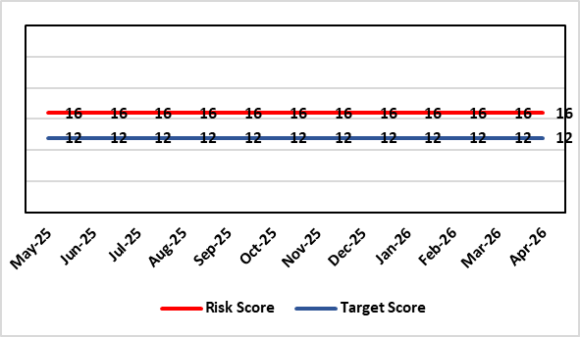 |  |  | Rationale for current score:  National shortages of numbers in some areas can lead to:  - Inability to recruit sufficient numbers of trainees to fulfil rotas on all sites  - Inability to attract non training grades to complete rotas  - Inability to fill Consultant grade posts in some specialties with adverse effects on patient safety and employer relations. Inability to recruit sufficient registered nursing staff.  Risk score has been reviewed and reflects current position across services as a whole. Services with particular difficulties are listed under the Assurance section. Where risk at service level is significant and/or interdependencies could lead to service collapse, these will be escalated separately.
Rationale for target score:
This remains a challenge and is also a national problem.
Controls (What is currently in place to manage the risk?) |  |  |  | Further Actions (What more are we going to do to address the risk?)
- Regular monitoring of recruitment position with reports to Executive Team and Board via Medical Director and Medical Workforce Board.  - Specialty based local workforce boards established to monitor and control specific issues. The Health Board Workforce & OD Committee will seek assurance of medical workforce plans to maintain services.  - Engagement of the Deanery about recruitment position.  - Weekly workforce delivery meetings with Executive Medical Director to review progress against critical medical and clinical posts  - Working with specialist agency and head-hunters to improve chances to fill hard to recruit posts  - Working with a marketing agency to develop a branding and attraction campaign for the health board.  - Consideration of the RPO (Recruitment Process Outsourcing) model.  - Implemented the CESR (Certificate of Eligibility for Specialist Registration) framework to grow our own consultants  - Revised Consultant Development Programme, sponsored by the Medical Director. |  |  |  | Action | Lead |  | Deadline
 |  |  |  | Medical training initiatives pursued in a number of specialties to ease junior doctor recruitment | Service Group Medical Directors |  | 31/03/2026
 |  |  |  | The Medical Workforce Group continues to monitor recruitment and junior doctor’s rotas. | Executive Medical Director |  | 31/03/2026
 |  |  |  | Continue to recruit internationally where appropriate. | Director W&OD |  | 31/03/2026
 |  |  |  | Continue to work with head-hunters | Director W&OD |  | 31/03/2026
Assurances (How do we know if the things we are doing are having an impact?)  - General situation monitored through W&OD Committee  - Regular communication with Deanery  - Ongoing and targeted recruitment campaigns  - Monitoring by Service Group teams and specialty based local workforce boards  - Monthly workforce planning and deployment taskforce meetings with service groups  - Weekly workforce delivery meetings with CEO as above  - Areas currently experiencing recruitment difficulties are: mental health, oncology, anaesthetics, acute care physicians, care of the elderly, pathology and haematology. |  |  |  | Gaps in assurance (What additional assurances should we seek?)  Locum cover  Adequate supply of doctors who can work in this country  Ability to flexibly deploy doctors in training.  Dedicated work between workforce and finance to review and confirm budgeted medical workforce establishment by service group to confirm SIP and vacancy factor.
Additional Comments / Progress Notes
28/10/2025: The Health Board is considering introducing a Medacs Bank which will include a Recruitment Process Outsourcing (RPO) offer which could help with some hard to fill consultant roles.

Datix ID Number: 3071  Date Opened: November 2022 |  | Date Last Reviewed: Apr 2026 |  | CRR Ref Number: 89  Target Risk Date: TBC |  | Current Risk Rating  4 x 5 = 20
Objective: The health board is a great place to work where all staff feel valued and work together towards a common goal |  |  | SRR Ref:  4.1 | Director Lead: Elizabeth Rix, Executive Director of Nursing  Supporting Director: Deb Lewis, Chief Operating Officer  Assuring Committee: Workforce & OD Committee
Risk: Healthcare Nursing Staff Levels at HMP Swansea
There is a risk that the men in HMP Swansea will not receive the appropriate standard of care. This is because the nursing establishment within the prison no longer fully meets the changed demographics and numbers of men being detained. The maximum operational capacity of the Prison can reach circa 480 men. The Health Board investment into the Prison is based on delivering services to 250 men. This was also highlighted as a risk in the June 2022 HIW governance review. In addition, there is no head room built into the Prison nursing establishment, so periods of sickness, leave and study render the roster short.
Risk Rating  (consequence x likelihood):  Inherent: 4 x 5 = 20  Current: 4 x 5 = 20  Target: 2 x 2 = 4 | 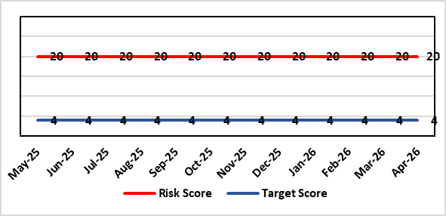 |  |  | Rationale for current score:  Consequence major – unable to fully deliver on the recommendations of HIW due to low healthcare staffing numbers, further impacted during periods of sickness or absence as no headroom. Recommendations also raised in Prison & Probation Ombudsman reports. Likelihood expected – suboptimal care provided on a daily basis.
Rationale for target score:
Consequence minor – With sufficient staffing numbers the prison will be able to deliver on HIW recommendations and fully implement the actions in the Health Delivery Plan. Likelihood unlikely – With full establishment and headroom, suboptimal care is less likely.
Controls (What is currently in place to manage the risk?) |  |  |  | Further Actions (What more are we going to do to address the risk?)
Daily communication with the Governor about the availability and priority of healthcare nursing staff.  Pharmacy technician role established – can administer drugs to support nursing establishment.  Agreed that Health Care Support Workers to be 2nd checkers for CD drugs and to support substance withdrawal monitoring (awaiting accreditation).  Bank and agency staff are used in a limited way, when skillset allows.  E-roster implemented and scrutinised with regular reporting to Service Group Patient Safety & Compliance Group.  Escalation for overtime and additional hours to fill shortfalls. |  |  |  | Action | Lead |  | Deadline
 |  |  |  | Review of staffing in prison. Royal College of Psychiatrists Substance Misuse and Mental Health Baseline assessment completed – analysis of outcome and agreement of further action next. (Following financial deep dives) | Deputy Head of Nursing |  | Complete
Assurances (How do we know if the things we are doing are having an impact?)  Prison feedback and complaint process  Progress reporting on action plans through Service Group PS&C Group, and Health Board Q&S structures (via Patient Safety & Compliance Group). |  |  |  | Gaps in assurance (What additional assurances should we seek?)  Implementation and reporting of clinical audits. Audit framework for HMP Swansea in development - Clinical Pathways/Audits and Health Promotion groups taking forward.
Additional Comments / Progress Notes
25/02/2026 - Vacancies appointed to. An additional 1.5 WTE Band 5 within budget also identified following finance review now added to TRAC for approval. Discussion with GND regarding rotation for future student stream liners to HMP. Review of actions of HNA and MHSMU ongoing. Identification of e learning for staff to complete. Gap analysis to be undertaken for HEIW Inclusion Health Competency and Education Framework in conjunction with the workforce plan.
15/05/2026: Action complete: Service Group now has a consolidated action plan for Royal College of Psychiatrists Substance Misuse and Mental Health Baseline and PHW Health Needs assessment for HMP Swansea that is monitored through Prison Partnership Board. Service has 2 WTE student streamliners proposed for September 2026 above establishment to support staffing. Further review of risk to be undertaken in May.

Datix ID Number: TBC  Date Opened: April 2026 |  | NEW RISK  Date Last Reviewed: April 2026 |  | HBR Ref Number: 114  Risk Target Date: TBC |  | Current Risk Rating  5 x 4 = 20
Objective: Care is high quality, safe, efficient and delivers the best possible outcomes for people in partnerships |  |  | SRR Ref:  2.7 | Director Lead: Deb Lewis, Chief Operating Officer  Supporting Director(s): Tina Ricketts, Director of Workforce & OD; Liz Rix, Executive Director of Nursing  Assuring Committee: Workforce & OD  Committee for Information: Quality & Safety
Risk: Mental Health & Learning Disabilities Staffing
If workforce shortages and fragility persist across Mental Health and Learning Disabilities services (vacancies, sickness, turnover, reliance on temporary staff and insufficient skill mix), then services will be unable to deliver safe staffing and consistent therapeutic input across community, crisis and inpatient pathways. This may lead to avoidable harm (including self-harm/suicide risk), increased restrictive practice, delayed access and extended length of stay, deteriorating staff wellbeing and retention, failure to meet national quality expectations and performance standards, and increased regulatory, financial and reputational impact.
Risk Rating  (consequence x likelihood):  Inherent: 5 x 5 = 25  Current: 5 x 4 = 20  Target: 5 x 3 = 15 | 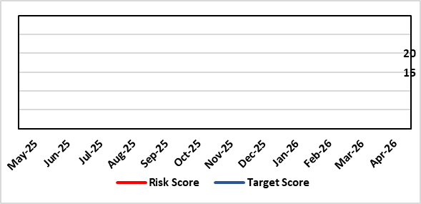 |  |  | Rationale for current score:  Current score reflects sustained gaps in key professional groups and registered nursing establishments, variable staffing fill and reliance on temporary staffing in high-acuity settings. This reduces continuity of therapeutic engagement and increases risk of incidents, restrictive interventions, delayed discharge and deteriorating access performance. Controls reduce (but do not remove) the likelihood of harm through escalation and prioritisation processes.  Inherent Risk: 5 x 5 = 25 (Catastrophic consequence; Likelihood is expected without controls due to sustained vacancy/absence and skill-mix gaps).  Current Risk: 5 x 4 = 20 (Catastrophic consequence; Likelihood reduced but probable given current mitigating controls but ongoing fragility).
Rationale for target score:
Target score assumes a remodelled model of care that reduces reliance on inpatient capacity, clarifies safe caseload/workload triggers, strengthens MDT capacity (including psychology/AHPs), and improves recruitment/retention so that staffing fill rates stabilise and temporary staffing reduces. Residual consequence remains major due to inherent clinical risk and demand volatility, but likelihood reduces to possible.
Target Risk: 5 x 3 = 12 (Catastrophic consequence; Likelihood reduction to possible once remodelled pathways, strengthened MDT capacity and stabilised staffing).
Controls (What is currently in place to manage the risk?) |  |  |  | Further Actions (What more are we going to do to address the risk?)
- Establishment review and safer staffing oversight (including escalation where staffing falls below agreed thresholds).  - Recruitment and retention activity for hard-to-fill roles (including international recruitment where appropriate) and use of temporary staffing controls.  - Clinical escalation, bed/capacity management and daily operational oversight of staffing and acuity.  - Workforce wellbeing support, mandatory training arrangements and supervision frameworks (where in place).  - Mental Health Transformation Programme governance and workstreams (including service redesign/model of care development). |  |  |  | Action | Lead |  | Deadline
 |  |  |  | Agree and implement a MH&LD workforce stabilisation plan (priority roles, recruitment pipeline, retention offers, sickness reduction actions) aligned to the remodelled clinical model. | ED Workforce & OD / COO |  | Q2 2026/27
 |  |  |  | Reduce agency and bank dependency through phased milestones (roster optimisation, substantive recruitment, incentive packages, internal staff bank expansion) and monthly exception reporting to Exec. | ED Workforce & OD / ED Finance |  | Q4 2026/27
 |  |  |  | Complete and approve the remodelled clinical model and demand/capacity plan (including safe caseload/workload triggers, pathway redesign and reduced reliance on inpatient beds where appropriate). | COO / MH&LD Clinical Leadership |  | Q3 2026/27
 |  |  |  | Strengthen MDT therapeutic capacity (psychology, OT, SALT and other AHPs) and clinical supervision arrangements; implement a skills/competency framework for priority pathways. | ED Nursing / EDAHPHS / COO |  | Q2 2027/28
Assurances (How do we know if the things we are doing are having an impact?)  - Quality and safety intelligence: incidents/SIs, restrictive practice, violence/aggression, complaints and safeguarding themes triangulated with staffing and acuity.  - Monthly workforce metrics (vacancy, sickness, turnover, staffing fill, reduction in temporary/agency staff spend) with exception escalation. |  |  |  | Gaps in assurance (What additional assurances should we seek?)  - Need clearer Board-level assurance on whether current staffing and skill mix is safe and sustainable against the remodelled model of care (including agreed safe caseload thresholds and ward staffing templates). Independent assurance is required on effectiveness of mitigation (not just activity), including: measurable improvement in therapeutic contact/continuity; reduction in restrictive practice; improved access/flow; and reduced staff harm/absence.
Additional Comments / Progress Notes
06/05/2026: This is the first draft of CRR risk: This risk captures the cumulative impact of workforce fragility on delivery of safe and effective MH&LD care and the dependency on timely service remodelling to reduce pressure on inpatient and crisis pathways.
13/05/2026: Risk agreed by Executive Board and current score of 20 indicated.

Risk Score Calculation

For each risk identified, the LIKELIHOOD & CONSEQUENCE mechanism will be utilised. Essentially this examines each of the risks and attempts to assess the likelihood of the event occurring (PROBABILITY) and the effect it could have on the Health Board (IMPACT). This process ensures that the Health Board will be focusing on those risks which require immediate attention rather than spending time on areas which are, relatively, a lower priority.

