Meeting Date | 12 June 2025 |  |  | Agenda Item |  |  | 4.2
Report Title | Medical Efficiencies
Report Author | Emma Owen, Head of Workforce – Insight and Effectiveness
Report Sponsor | Richard Evans Executive Medical Director & Deputy Chief Executive. Tina Ricketts, Executive Director of Workforce and Organisational Development
Presented by | Emma Owen, Head of Workforce – Insight & Effectiveness.
Freedom of Information | Open
Purpose of the Report | This paper outlines the medical locum spend and the activities being undertaken to improve medical effectiveness.
Key Issues | To acknowledge the medical locum spend.  To update the ongoing work to reduce variable pay for medical staff.
Specific Action Required  (please choose one only) | Information |  | Discussion |  | Assurance | Approval
Specific Action Required  (please choose one only) | ☒ | ☒ |  |  | ☒ | ☐
Recommendations | Members are asked to acknowledge the contents of this report.

Medical Efficiencies

- INTRODUCTION

To set out for the Workforce and OD Committee (WOD) salient information regarding the utilisation of agency and locum doctors during defined periods.

- BACKGROUND

Reducing the cost of medical spend is an extremely complex process that is multifaceted and requires a change programme to ensure sustained success. It has been usual practice to report medical agency and locum utilisation and expenditure to the WOD Committee. Below is a snapshot representing relevant periods tracking recent utilisation, expenditure, and costs during recent months.

- GOVERNANCE AND RISK ISSUES

The Health Board has made a reduction in the amount of temporary staffing that has been utilised within the medical workforce over the last 12 months.

The Health Board continues to rely on temporary staffing to cover gaps within the rotas. The total locum hours information for the last 12 months shows that there has been a reduction in the number of hours that have been worked across both bank and agency.

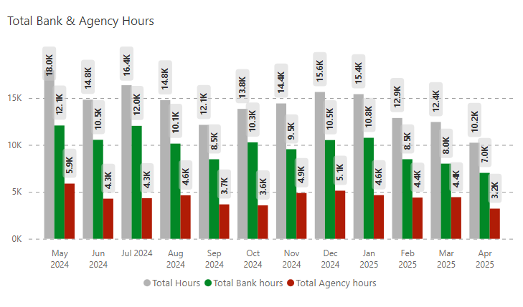

It is important to note that whilst there has been a reduction in the amount of locum hours worked the costs are higher due to the rate negotiations that are taking place.

It has previously been reported that during the last 12 months there has been a noticeable increase in the number of rates that are being negotiated above those agreed within the rate card. However, it is noted that the number of negotiations for internal bank locums is reducing slowly, there is also a reduction in the number of internal locum shifts that have exceeded the Welsh Government capped rates.

Work continues to ensure that service groups are utilising the MEDACS Healthcare (MEDACS) vantage model to book agency staff to avoid expensive off framework providers. However, it is important to note that the data is continuing to show that all agency workers are being paid higher than Welsh government capped rates which have not been updated since November 2017. The table below highlights the bank and MEDACS agency information for February, March & April 2025.

 | Feb-25 |  | Mar-25 |  | Apr-25
 | Bank | Agency | Bank | Agency | Bank | Agency
Individuals Booked | 306 | 21 | 337 | 24 | 290 | 22
Individuals Booked At/Below Cap | 186 | 1 | 198 | 1 | 174 | 0
Individuals Booked At/Below Cap % | 60.78% | 4.76% | 58.75% | 4.16% | 60% | 0%
Individuals Booked Above Cap | 148 | 20 | 169 | 23 | 140 | 22
Individuals Booked Above Cap % | 48.36% | 95.24% | 50.14% | 95.84% | 48.27% | 100.00%
Hours Booked | 9500.95 | 3,670.00 | 10757.93 | 3,281.00 | 8531.92 | 4,524.00
Hours Booked At/Below Cap | 5164 | 40 | 6265.9 | 20 | 4633.67 | 0
Hours Booked At/Below Cap % | 54.35% | 1.08% | 58.24% | 0.60% | 54.30% | 0.00%
Hours Booked Above Cap | 4336.95 | 3,630.00 | 4492.03 | 3,261.00 | 3898.25 | 4,524.00
Hours Booked Above Cap % | 45.64% | 98.92% | 41.75% | 99.40% | 45.69% | 100.00%
Jobs Booked | 1066 | 31 | 1209 | 39 | 932 | 31
Jobs Booked At/Below Cap | 545 | 2 | 678 | 1 | 513 | 0
Jobs Booked At/Below Cap % | 51.12% | 6.45% | 56.07% | 2.56% | 55.04% | 0.00%
Jobs Booked Above Cap | 521 | 29 | 531 | 38 | 419 | 31
Jobs Booked Above Cap % | 48.87% | 93.55% | 43.92% | 97.44% | 44.95% | 100.00%

Waiting List Initiative (WLI) spend
The graph below shows a noticeable reduction in the amount of waiting list initiative sessions that have been worked during the last 12 months. This is mainly due to ongoing work to ensure that WLI’s are appropriately distinguished and remunerated.
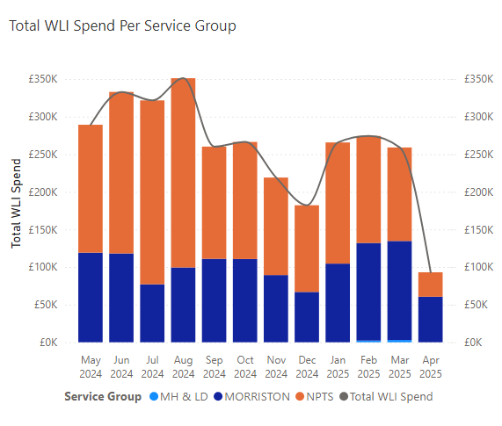
Revised control measures

Due to the ongoing financial challenges within the Health Board additional control measures have been implemented to understand the factors impacting the need for variable pay and to reduce spend.

A review of authorisation processes has taken place to ensure that all clinical gaps are scrutinised, appropriately approved (not retrospective) and shifts also being available to the entire locum bank to avoid being escalation to agency. The raising of the Variable Pay agenda as part of the financial plan and discussions at Management Board led by the Chief Executive Officer, has set out a number of key focuses on this agenda to ensure we reduce our variable pay significantly and enable a focus on more effective utilisation.

. Additional measures include:
- Medical vacancy control panels – Prior to advertising all medical vacancies are submitted to an executive scrutiny panel. Each post must have an appropriate business case, allocated budget and agreed job plan in order to be considered.
- Agency approvals – Daily meetings are led by the Executive Medical Director or deputy to approve any agency requests.
- Effective Job Planning – Job planning workshops led by the Executive Medical Directors Department have taken place and compliance has significantly increased.
- Revised Waiting list initiative processes.

Discussions are also ongoing with MEDACS to explore a fully managed service for both internal bank and agency which will also include a Recruitment Process Optimisation model.

- FINANCIAL IMPLICATIONS

The cost of filling medical gaps remains a significant pressure for the Health Board. The graph below shows the internal bank, MEDACS and WLI (available from April 2024) spend across the last 12 months.
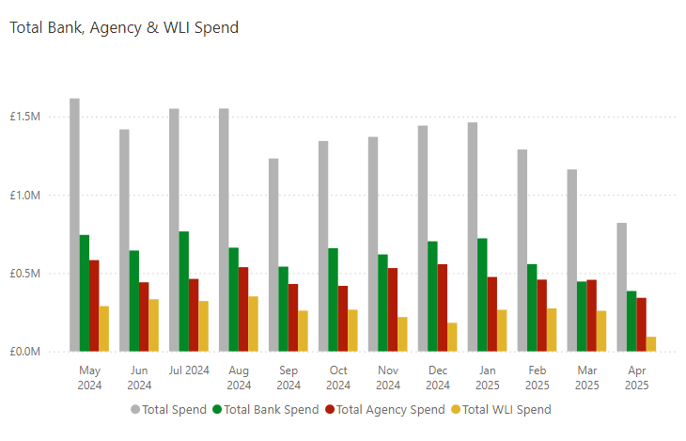

- RECOMMENDATION
The Committee is asked to acknowledge the contents of the report.

Governance and Assurance

Link to Enabling Objectives  (please choose) | Supporting better health and wellbeing by actively promoting and empowering people to live well in resilient communities
Link to Enabling Objectives  (please choose) | Partnerships for Improving Health and Wellbeing |  | ☐
Link to Enabling Objectives  (please choose) | Co-Production and Health Literacy |  | ☐
Link to Enabling Objectives  (please choose) | Digitally Enabled Health and Wellbeing |  | ☐
Link to Enabling Objectives  (please choose) | Deliver better care through excellent health and care services achieving the outcomes that matter most to people
Link to Enabling Objectives  (please choose) | Best Value Outcomes and High Quality Care |  | ☐
Link to Enabling Objectives  (please choose) | Partnerships for Care |  | ☐
Link to Enabling Objectives  (please choose) | Excellent Staff |  | ☒
Link to Enabling Objectives  (please choose) | Digitally Enabled Care |  | ☐
Link to Enabling Objectives  (please choose) | Outstanding Research, Innovation, Education and Learning |  | ☐
Health and Care Standards
(please choose) | Staying Healthy |  | ☐
(please choose) | Safe Care |  | ☐
(please choose) | Effective Care |  | ☐
(please choose) | Dignified Care |  | ☐
(please choose) | Timely Care |  | ☐
(please choose) | Individual Care |  | ☐
(please choose) | Staff and Resources |  | ☒
Quality, Safety and Patient Experience
Workforce Metrics cover a range of key performance targets that are linked to quality, safety and patient safety as the relate to workforce availability, training and other key compliance and governance issues
Financial Implications
None
Legal Implications (including equality and diversity assessment)
There are no financial implications.

Staffing Implications
None
Long Term Implications (including the impact of the Well-being of Future Generations (Wales) Act 2015)
There are no long term implications in relation to the impact of the Well-being of Future Generations Act.
Report History |  | None
Appendices |  | None

