10. Workforce Updates and Actions
This section of the report provides further detail on key workforce measures. Caveats and Limitations (C&L) detailed beneath data in each section.
Staff sickness rates - Percentage of sickness absence rate of staff (two metrics provided, ‘rolling 12 month’ and ‘in month’)  Sickness absence target – 5.5% | % of full time equivalent (FTE) days lost to sickness absence  Caveat & Limitations;- Report generated May 2025, within SBUHB (Performance Team) for substantive and FTC employee types. Data source – ESR. Target of 5.5% added as blue line
Current Performance
In month sickness absence has decreased from 7.06% to 6.82% reported in April 2025. Long term sickness has reduced by 0.49% since the last reporting period. Short term sickness has decreased by 0.24% since the last reporting period.
- Anxiety/stress related absence remains the highest reason for absence, a trend witnessed across NHS Wales. Anxiety/Stress/Depression reported in April 2025 accounts for 2.39% of all in month sickness absence, the number of Full Time Equivalent (FTE) days lost due to Anxiety/Stress/Depression has reduced by 0.01% since the last reporting period
- The number of FTE days lost due to Cold/Cough/Flu have also reduced by 0.13% which is expected due to seasonal illness trends
- The Directorate with the highest absence levels at the end of this quarter is the COO Directorate at 10.04%. This is as a result of high long term absences recorded as stress/depression/anxiety within Morriston Domestics and Singleton Domestics. Whilst this is the highest in month absence rate, there has been a reduction of 0.40% since the last reporting period
- Mental Health & Learning Disabilities remains the Service Group with the highest levels of absence at 7.34%, a 0.40% reduction since the last quarter
- Primary Community Care & Therapies Service Group remain to be the Service Group with the lowest level of sickness absence, but this has increased from 5.67% in February to 6.63% in April 2025 due to increased absences in the District Nursing team
- Sickness absence in Morrison (6.73%) has reduced since the last reporting period. Sickness in Neath Port Talbot Service Groups (7.05%) has increased since the last reporting period. Whilst Anxiety/Stress/Depression remains the highest reason for long term absence, both Service Groups saw a decrease in Cough, Cold and Flu cases.

Actions for Next Period
General
Current focus on areas with high absences rates, examples of initiatives to support our employees:
- Wellbeing resource pack – physical and electronic copies available – includes new starter feedback questionnaires continue to be distributed
- Case conference training for leaders in partnership with OH are continuing
- The HR Business Partners (HRBPs) leading on the initiatives listed above are working together to share best practice with the intention to deploy initiatives across the Health Board (HB)
- The Health Board sickness absence plan has been signed off and local Service Group action plans connected with this being shaped
- Work is taking place with digital colleagues to forecast sickness absence trajectories which will assist in assessing progress within the Executive Performance meetings.

Occupational Health and Staff Health and Wellbeing
The services continue to develop high quality multi-disciplinary interventions to contribute to an engaged, motivated and healthy workforce.
- Full Occupational Health (OH) Medical Service now established - substantive Occupational Health Specialist Doctor and Agency OH Consultant will provide financial and clinical sustainability/stability to the service – June 2025
- Continue undertaking the UK Occupational Health gold standard quality kite-mark initial assessment Safe Effective Quality Occupational Health Service (SEQOHS) and consistently meeting Welsh Government (WG) Occupational Health delivery Key Performance Indicators (KPI’s) – June /July 2025
- Evaluation of staff health checks to be undertaken and lessons learned implemented - June/July 2025.

Healthy People Forum
The Healthy People Forum was established in November 2024 and supports the people strategy aim of an engaged, motivated and healthy workforce. It aims to provide the health board with a strategic forum that includes working in partnership with public health colleagues to support synergy across the people strategy and the population health strategy, reducing duplication of effort across the service groups and improving equity of access for all staff to health & wellbeing interventions. The forum is co-chaired between staff side and well-being colleagues, supporting the commitment to work in partnership with our trade union colleagues and supporting a prevention/early intervention approach across the Health Board.

Outcomes include:
- ensuring funding for the rollout of Carers Wales support across the health board with the launch coinciding with carers week in June. This includes access to digital support for staff via the Carers Wales app
- a baseline survey to understand the experiences of staff who are also informal carers and a series of staff and manager workshops to understand the challenges faced by working carers and explore support both within the workplace and externally
- Analysis of the range of available data that will further inform understanding of our staff’s health and wellbeing. This will include anonymised data of staff health checks undertaken during the first 12 months and local population health data to inform any additional strategies or interventions that may help our staff remain healthy in work.

One of the aims of the forum was to engage with service group senior managers to ensure that developments are undertaken in collaboration with service groups . Ensuring service group attendance at the forum has been challenging with regular membership from Mental Health & Learning Development (MH&LD) colleagues and Support Services; however, we continue to consider ways to ensure wider service group representation.

Mandatory & Statutory Training-  Percentage compliance for all completed Level 1 competencies within the Core Skills and Training Framework by organisation  Mandatory & Statutory Training target – 85% | % of compliance (Headcount) with Core Skills and Training Framework  C&L;- Report generated May 2025, within SBUHB (Performance Team) for substantive and FTC employees. Data source – ESR (OLM Module). Accuracy levels subject to local maintenance and validation standards. Target of 85% added as blue line
Current Performance
- Welsh Government (WG) requirement for All Staff (Target 85%) – Overall compliance rate of 89.88% achieved in the 12 modules
- Welsh Government (WG) requirement for Staff in Public Facing Role (Target 85%), achieved 64.06% to date **
**Please note: Paul Ridd Learning Disabilities Awareness Training was mandated for completion by ALL Staff in SBUHB as of 30th April
2025. The figure of 64.06% is in reference to All Staff, this is an improvement on the compliance rate of 46.08% as of February 2025
- SBU Health Board requirement for All Staff (Target 85%) - Overall Compliance - 88.18% achieved in the full 15 mandated modules:
- Service Groups - MH&LD 90.33%, PCCT 92.03%, Morriston 84.64%, Finance & Estates 85.81%, NPTS 92.08%
Staff Groups - Medical and Dental Staff Group remain the lowest performing area with 68.54%. Support for this staff group is ongoing by the E-learning Project Support Manager and Executive Medical Directors Department. Support provided has already seen a positive outcome and continuing improvement of compliance.

Actions for Next Period
- Subscription to Learning Certification and Enrolment onto Statutory/Mandatory Courses – User issues identified are being supported on a case-by-case basis via Action Point and from direct contact. The number of queries seen are minimal, and these have been investigated and resolved with no impact to compliance figures reported
- Medical and Dental Staff Group – Ongoing support sessions arranged in conjunction with the Executive Medical Directors Department and the E-Learning Project Support Manager to assist Dr’s with e-learning access issues to continue through 2025
- Monitoring Compliance – Completion of e-learning and compliance rates to be scrutinised bi-monthly to identify where learning has been completed but compliance not recorded due to technical issues experienced by user when undertaking the e-learning, this is to ensure that the learning has been updated accurately for the user and to reflect in overall levels of compliance
- Safeguarding Adults and Safeguarding Children Level 2 – May 2022 SBUHB mandated NHS Core Skills Training Framework NHS|CSTF|Safeguarding Adults - Level 2 - 3 Years and NHS|CSTF|Safeguarding Children - Level 2 - 3 Years for All staff. Achievable collectively with NHS|CSTF|Safeguarding Adults - Level 1 - 3 Years and NHS|CSTF|Safeguarding Children - Level 1 - 3 Years on completion of respective Safeguarding Training Level 2. Levels of compliance for Safeguarding Adults and Safeguarding Children Level 2 are expected to be reportable as a SBU Health Board requirement for All Staff (Target 85%) from August 2025
- Neath Port Talbot & Singleton Service Group (NPTSSG) updated that there is a need to continue to focus on improving Mandatory Training compliance within the Medical Staff Group.

Vacancies  Medical and Nursing and Midwifery | Vacancies (FTE) Mar 25 to Apr 25  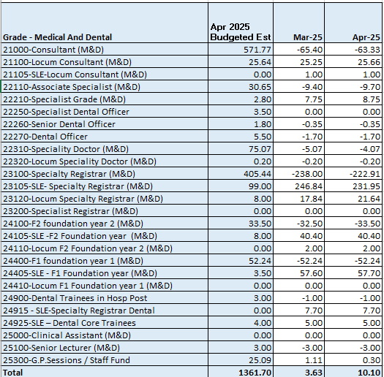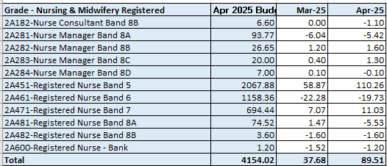  C&L;- Report generated May 2025, within SBUHB (ESR Team), using currently available methodology. Data source – ESR (Workforce) and General Ledger (Finance). We compare the SIP v’s the finance ledger, appreciating limitations on accuracy in some areas. Accuracy levels are subject to local validation practices based on budget holders intelligence.
Current Performance
- The registered nursing establishment data indicates that we continue to show an over-recruited position as at the end of April 2025 by 89.51 FTE, which is an increase of 41.18FTEs compared to the previous report dated February 2025
- For Band 5 nurses, we were over-recruited by 110.26 FTE as of April 25. This is due to the Health Board continuing to accommodate newly qualified nurses starting in Band 5 roles through our student streamlining programme, whereby 145 have started in post between 01/09/24 and 18/03/2025. From the March 2025 cohort, 11 applicants are waiting on their registration/ NMC PIN (due to needing to re-sit/make back time), 1 has a start date booked, and 1 is waiting for a start date to be confirmed. Following Recovery & Sustainability meeting on 28th May 2025, a request was made for Service Groups to review this position in the context of a wider piece of work about ensuring we are “Organised for Success” this will include consideration of workforce plan
- For the financial year 2025-26 the HB has recruited 16 international nurses for the NPTS Service Group to work in theatres (10), cancer services (5) and medicine (1). These nurses will arrive in the HB in May and July 2025 and will remain on a Band 4 salary until OSCE training is completed and their NMC PIN is received, after which point, they will then move to a Band 5 post. There are no further plans for international recruitment currently
- In addition to the above, our Central Resourcing Team (CRT) continue to support service groups with any other Band 5 Nursing or Band 2 HCSW recruitment. They are currently supporting Morriston Service Group with their latest recruitment round, which is currently in the shortlisting stage. They also continue to receive and provide support for the Mental Health and Learning Disabilities Service Group for various Nursing and HCSW vacancies
- The rich supply of Band 5 nurses from all three recruitment sources should ensure that no band 5 nursing gaps arise over the next 12 months due to turnover and/or internal movements into higher banded roles
- It is important to note that the vacancy exception process remains in place which is impacting on timescales, staff wellbeing/experience and can be demonstrated within the high levels of variable pay.

Actions for Next Period
- International recruitment to cease.
- The Community Resource Team (CRT) will continue to support Student streamlining and are preparing for the September 2025 cohort.
- Domestic recruitment will continue as approved by the HB
- The CRT will continue to support with chasing pre-employment checks for key roles to reduce time to hire and fill vacancies (e.g. currently supporting up to 25 WTE physiotherapy posts)
- The CRT have been supporting with the implementation of Welsh Language compliance actions in recruitment. They have supported a further 18 vacancies to become compliant since the previous reporting period (cumulative total of 220 vacancies since 1st November 2024)
- The CRT have developed a checklist of actions for recruiting managers to consider when trying to fill hard to recruit roles, which is now published and available on the intranet
- The CRT will continue supporting the Executive Clinical Vacancy Scrutiny Panel which takes place weekly, including collating submissions, attending the panel meetings, and distributing outcomes to the Service Groups. The recovery and sustainability group representatives will continue to support the Admin and Clerical Executive Vacancy Scrutiny Panels.
Recruitment  Metrics provided by NWSSP. Comparison with all-Wales benchmarking  Target 44 days | Vacancy Creation to Conditional Offer April 2025 (working days) T13 (exc outliers)  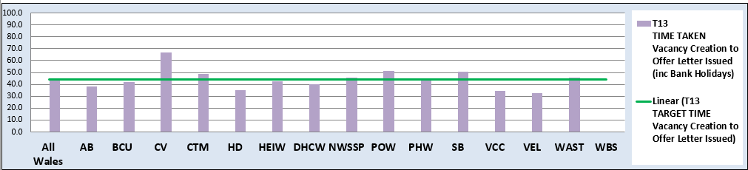  C&L;- Report generated May 2025, by NWSSP (Recruitment). Data source – TRAC system. Outliers are excluded. This is day to day vacancy management. Data excludes outliers.
Current Performance
- Swansea Bay UHB’s in-month time to hire performance for April 2025 continues to exceed the 44 day All Wales T13 target for the second month running, which had previously been under target for the 12 months prior. This is mainly due to Welsh language translation requirements, which came into force in November 2024 and the admin and clerical recruitment pause, whereby managers have been asked to submit vacancy requests on the Trac recruitment system while waiting for approvals to be received from our executive team and for Welsh translation to be returned. SBUHB’s T13 average for the previous 12 months as of April 2025 is now also above the 44-day target at 50.7 days, which is an increase of 9.2 days compared to the 12m average, as of March 2025. The All-Wales monthly average performance remains below target at 43.5 days
- For April 2025, SBUHB’s time to hire performance continues to be significantly below the All Wales T23 metric (target of 27 days) which is the measure from the point of issuing an offer letter to agreeing a start date. However, SBUHB’s 12-month average is 15.6 days (without outliers) which is above the All-Wales figure of 14.4 days
- The Central Resourcing Team (CRT) have continued to coach candidates through the pre-employment check process for Band 5 nursing roles and Band 2 Health Care Support Worker roles in particular and have also been supporting with other stages of the recruitment process for some areas (e.g., shortlisting for mental health nursing and HCSW roles) to continue to assist in reducing the T13 and T27 time to hire targets, mentioned above.

Actions for Next Period
- NWSSP continue to provide training sessions and drop-in sessions for SBU recruiting managers to improve time to hire. They are also delivering a recruitment module as part of SBU’s management development programme
- The CRT will continue focussing on the recruitment of B5 nurses, B2 ward based HCSWs, assisting with overseas nurse recruitment and newly qualified nurses, as well as specific hard to recruit posts and Exec recruitment
- In collaboration with NWSSP, the CRT will continue to chase outstanding management actions on vacancies and pre-employment checks with applicants, to further improve the Health Board’s (HB) overall time to hire performance. This includes the Welsh language translation requirement as of 01/11/24 to comply with legislation. The CRT continue to support managers who are adding vacancies to Trac with Welsh language requirements to ensure they are compliant
- Members are asked to note that the HB’s time to hire performance is likely to continue to deteriorate over the coming months due to the ongoing changes to the recruitment process. To address this, a new paper-free process has been proposed to streamline the recruitment approval process and a focus group is being set up over the coming months to discuss the proposals with key stakeholders
- Since April 2025, the CRT have taken over the granting of all A4C posts in the HB, allowing them to be the final quality checker and ensure strong governance prior to publishing
- The CRT are now also aiming to work on an interview framework, to help support managers through the interview process.

Turnover  % turnover by occupational group | 12 month rolling Turnover Rate (Swansea Bay) – 01 May 2024 – 28 Apr 2025  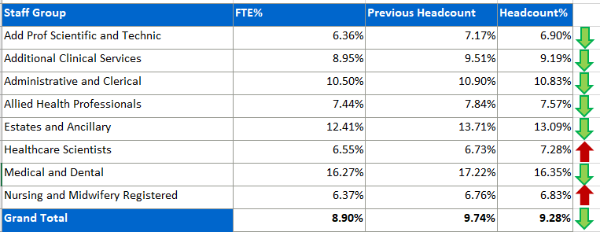  C&L;- Report generated May 2025, within SBUHB (ESR Team). Data source – ESR (Workforce). Small risk of margin of error due to late communication of terminations. Report excludes Bank, Locum, Honorary & Widow/Widower, Junior M&D staff. Internal movement not included – measure is about leaving Swansea Bay UHB.
Current Performance
- Organisationally, turnover has remained stable over the reporting period, with a 0.19% improvement in headcount and 0.15% in FTE, suggesting a continued, albeit modest, impact of retention initiatives
- Medical and Dental has demonstrated the most significant decrease in turnover, with a 0.87% reduction in headcount and 0.77% in FTE, highlighting successful retention efforts that should be reinforced moving forward
- Estates and Facilities also showed a positive trend, with a 0.62% reduction in headcount turnover and a 0.79% reduction in FTE turnover, marking this as a standout area for continued investment in retention initiatives
- Additional Clinical Services turnover has improved, with a 0.32% reduction in headcount and 0.25% in FTE, reinforcing the success of targeted workforce stability measures in this staff group
- Allied Health Professionals (AHPs) saw a 0.27% decrease in both headcount and FTE turnover, suggesting effective and balanced retention strategies for this workforce segment
- Add Prof Scientific & Technical staff experienced a 0.27% decrease in headcount turnover and 0.37% decrease in FTE, reflecting positive progress in this group and demonstrating the impact of improved support or working conditions
- Nursing and Midwifery remained relatively stable, with a marginal increase in headcount turnover (0.07%) and 0.03% in FTE, indicating minimal change and the need for continued monitoring to ensure this does not escalate
- Admin and Clerical has seen a slight increase in FTE turnover by 0.18%, despite a 0.07% improvement in headcount turnover, suggesting that while fewer staff may be leaving, those who do may be in full-time roles, this may impact service delivery and is indicative of the current vacancy freeze within this group
- Healthcare Scientists have experienced the greatest increase in turnover, with headcount turnover rising by 0.55%, despite a slight 0.16% improvement in FTE. This reversal from previous positive trends warrants exploration to identify underlying causes.
Actions for Next Period
- The organisational retention plan is currently being designed with an external company to ensure it is engaging
- The ESR flexible working request system launched in April will be further embedded, with dedicated sub-groups enhancing visibility, training, and review processes to improve staff experience and uptake
- The Retention Lead will continue collaborating with Workforce Business Partners to ensure effective rollout of targeted actions, particularly in hotspot areas of increased turnover
- Particular attention will be paid to staff groups showing rising turnover: Healthcare Scientists, Admin and Clerical, and Nursing and Midwifery, with bespoke interventions and diagnostics to mitigate emerging risks

- Stakeholder engagement within Medical and Dental will remain a key focus, capitalising on current improvements to understand success factors and reinforce long-term workforce stability.

PADR  % staff who have a current PADR review recorded  PADR target – 85% | % of staff (Headcount) who have had a PADR in previous 12 months  C&L;- Report generated May 2025, within SBUHB (Performance Team). Data source – ESR Optical Link Modules (OLM Module). Accuracy levels subject to local maintenance and validation standards. Target of 85% added as blue line.
Current Performance
- Staff who have had a Personal Appraisal and Development Review (PADR) as of 30th April 2025 is 72.04 %
- During March and April 2025, a total of 39 staff completed Personal Appraisal Review for Managers delivered by the Education and Learning Team. In addition, the How to Complete PADR Documentation and PADR Hints & Tips bitesize learning modules have been added to the Brilliant Basics Platform from January 2025. Colleagues are signposted to SBU ESR - ESR User Guides SharePoint Page for resources on how enter PADR Dates in ESR This is also linked to the Brilliant Basics platform
- Compliance figures per Service Group (excluding Medical and Dental Staff) – MH&LD 72.20%, NPTS 78.85%, PCCT 81.66%, Morriston 62.43%, Finance and Estates 63.83%

Actions Planned for Next Period
- Supporting activity outlined in previous reports continues, Service Groups continue to focus on highlighting areas for focus.
NPTSSG updated that Improvement plans should be in place for Divisions below the target of 85% (this is coordinated via the Divisional Workforce Groups) and that they are using PADRs as an enabler to support Quality and Safety Strategy.

Operational Casework  Number of current operational cases. | C&L;- Report generated March 2024, within SBUHB (Workforce Digital). Data source – ER Tracker. Accuracy levels subject to local maintenance and validation standards.
Current Performance
- No. of open Formal Disciplinaries since the last reporting period have increased from 45 to 49 open cases
- Number of Formal requests for Resolution which remain open within this period have decreased from 41 to 37
- Suspensions, since the last reporting period have decreased from 12 to 11
- ET’s have remained at 3.
Actions for Next Period
- A number of actions are on-going in line with the Best Practice Review
- The Best Practice Review project has been refreshed with the introduction of multidisciplinary subgroups focusing on priority areas of work, reporting into the Core Working Group
- The Management Review document was previously launched, to replace the initial assessment. The intent was to allow us to determine the most appropriate course of action at an early stage with the intention to resolve cases informally where possible – education and training ongoing with HR and leaders, this is being embedded and continually reviewed. We will be reviewing the effectiveness of this now it has been used for a reasonable period of time
- Suspension Guidance for leaders and employees has been shared for comment with the aim of supporting both groups and clarifying the process. A comprehensive suspension checklist is utilised to help inform and record the right decisions
- Review of case reporting categorisation.

