NHS Wales Staff Survey 2024 – Health Board Action Plan Template

1. Staff Survey Update for (Neath Port Talbot & Singleton Service Group) |  |  | Date Agreed: May 2025  Lead: Ceri Gimblett
1. High level summary of survey findings: |  | 2. Response Rate
NPTSSG achieved a Staff Engagement Index score of 73.6% in 2024. This is compared with the 72% average NHS Wales Staff Engagement Index score.  Below is a summary of responses by theme for NPTSSG:  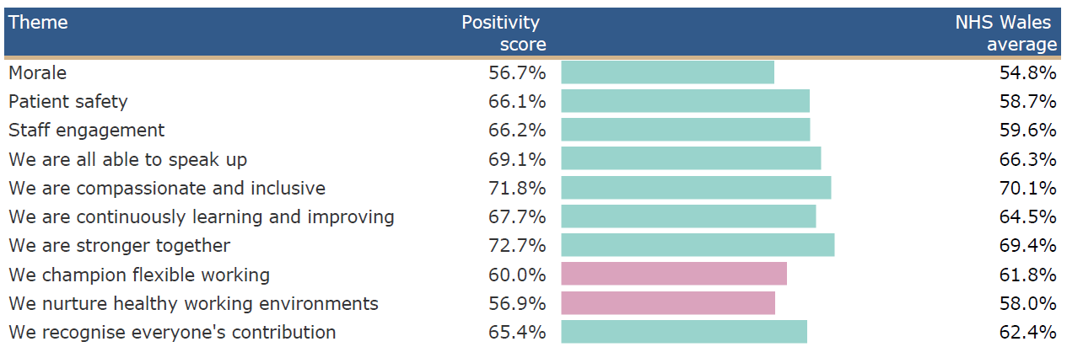 |  | Response Rate 2024: 4.6% |  | Target for 2025: 25% (min.)
 |  | 3. Key actions being taken to Improve Response Rate
- Communicate the purpose
- Leadership Engagement and Accountability at Divisional Level
- Active ongoing promotion
- Give staff sufficient time to respond
- Encourage the ‘you said we did’ approach to build trust and encourage staff to engage in future surveys
- Assurance on the independent management of the survey which maintains anonymity

 |  | 4. Key Exit Criteria (what will success look like for the staff survey in 2025?) *linked to national survey measures in 2024.
- Improved staff engagement score
- Improved positivity score for “we are all able to speak up”
- Improved positivity score for “we are inclusive and compassionate”

5. Short term Goals 2025/26 | 6. Medium term Goals 2026/7 | 7. Key Actions/ Milestones leading up to 2025 staff survey
Leadership, Engagement and Accountability at Divisional Level.  Share 3 key areas of focus for the Health Board along with Divisional level themes:  - Leadership & Management  - Speaking Up Safely / Raising concerns,  - Values & Behaviours  - Flexible Working  - Healthy Woking Environments  Divisions take a collective and compassionate leadership approach to developing local plans.  Involve representatives from local teams as well as managers and Trade Union Representatives to develop plans.  Each Divisional plan to include a communication and engagement section.  Consider aligning the staff survey plan to the development of the Staff Experience, Wellbeing and Retention Plan for Divisions that have commenced this work. | Benchmarking results against 2025 survey to assess improvements and highlight areas for further improvement which will form the medium-term goals.  Continued development and implementation of the Staff Experience, Wellbeing and Retention Plan | Actions/ Milestones |  | Lead | By When | Status
 |  | Nominate SG leads to access staff survey results via dashboard. |  | CG | 03/25 | Complete
 |  | Attend webinars to support running local reports from the dashboard. |  | CG | 04/25 | Complete
 |  | Share 3 key areas of focus for the Health Board along with Divisional level staff survey results highlighting the specific themes for NPTSSG. |  | CG | 05/25 | Complete
 |  | Management teams to discuss the results and to agree how they will shape local Divisional Staff Survey Plans. |  | ASGDs and CD Pharmacy | 05-07/25 | Ongoing
 |  | Divisional Staff Survey Plan to be shared during BAAM. |  | ASGDs and CD Pharmacy | 07/25
 |  | Progress update on Divisional Staff Survey Plan to be reported during BAAM ahead of the launch of the 2025 Staff Survey (Oct 25). |  | ASGDs and CD Pharmacy | 09/25
8. Key Risks | 9. Mitigating Actions
- Operational priorities and competing demands which may limit progression of actions linked to staff survey plans.  - Concerns about the confidentiality of individual survey returns for staff.  - A lack of confidence from staff that anything would change as a result of their feedback. | - Use dedicated time in Divisional Workforce Groups to monitor Divison Staff Survey action plans. HR BP Teams to support.  - Progress updates against plans will be monitored via BAAM.  - Provide assurance on the independent management of the survey which maintains anonymity.  - Regular promotion of actions that have been taken as a result of the feedback from colleagues.  - Communication and engagement section to be built into each Divisional plan.
10. Interdependencies
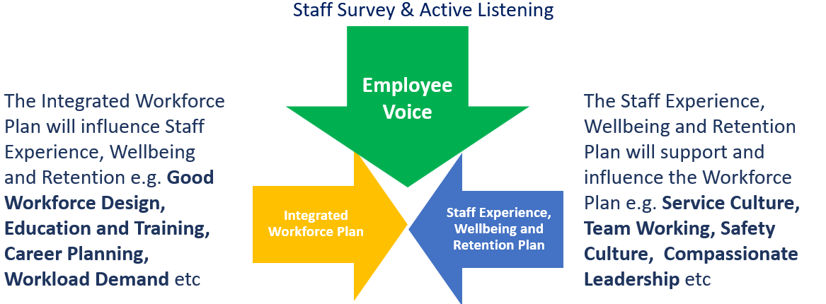
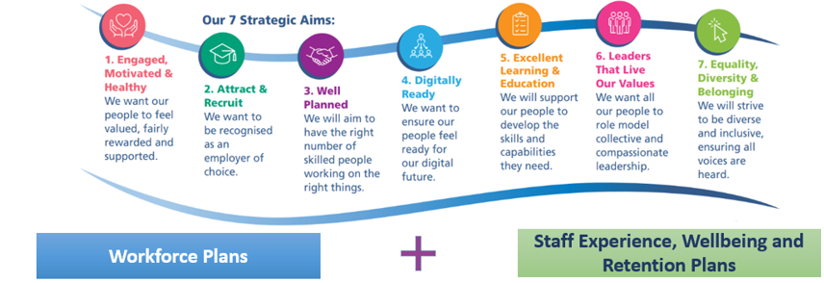

NHS Wales Staff Survey 2024 – Health Board Action Plan Template

Staff Survey Update for (Primary Community & Therapy Service Group) |  |  | Date Agreed: May 2025  Lead: Craige Wilson
1. High level summary of survey findings: |  | 2. Response Rate
PCTSG achieved a Staff Engagement Index score of 74.2% in 2024. This is compared with the 71% SBUHB and 72% average NHS Wales Staff Engagement Index score.  Below is a summary of responses by theme for PCTSG:  PCTSG Theme Positivity score NHS Wales average  Morale 60.1% 54.8%  Patient safety 66.6% 58.7%  Staff engagement 65.2% 59.6%  We are all able to speak up 71.1% 66.3%  We are compassionate and inclusive 77.0% 70.1%  We are continuously learning and improving 68.4% 64.5%  We are stronger together 77.2% 69.4%  We champion flexible working 66.4% 61.8%  We nurture healthy working environments 58.9% 58.0%  We recognise everyone's contribution 68.9% 62.4% |  | Response Rate 2024: 9.5%  Compared to a SBUHB response rate 12.9% and NHS Wales 21.9% |  | Target for 2025: 25% (min.)
 |  | 3. Key actions being taken to Improve Response Rate
- Promote via local service meetings and service group Team Brief/OBM with the expectation to cascade into local teams.
- Development of a communication plan emphasising messages around confidentiality and examples of staff stories around the ‘You Said, We’re Delivering Together’ campaign confirming action taken as a result of the survey.
- Leadership engagement and accountability at service level
- Utilise national resources and branding to support drive messaging and response rate.
 |  | 4. Key Exit Criteria (what will success look like for the staff survey in 2025?) *linked to national survey measures in 2024.
- Improved staff engagement score
- Positive score for “we are all able to speak up”
- Positive score for “we are inclusive and compassionate”
- Improved positivity score “we nurture healthy working environments”

5. Short term Goals 2025/26 | 6. Medium term Goals 2026/7 | 7. Key Actions/ Milestones leading up to 2025 staff survey
Leadership, Engagement and Accountability at Service Level.  Share 3 key areas of focus for the Health Board along with Service level themes:  - Leadership & Management  - Speaking Up Safely / Raising concerns,  - Values & Behaviours  - Healthy Working Environments  - We are continuously learning and improving  - We are compassionate and inclusive  Services take a collective and compassionate leadership approach to developing local plans.  Each service plan to include a communication and engagement section.  Align the staff survey plan to the development of the PCT People Plan for 25/26. | Benchmarking results against 2025 survey to assess improvements and highlight areas for further improvement which will form the medium-term goals.  Continued development and implementation of the PCT People Plan, including staff experience, well-being and retention.  Alignment to service group delivery actions, People Plan, and 7 People Aims set out in SBU People strategy for 2026/7. | Actions/ Milestones |  | Lead | By When | Status
 |  | Utilise Service Group Team Brief and OBM to share overarching and local Staff Survey Results and actions planned for collective delivery. |  | CW | 06/25 | On-track
 |  | Managers and Leaders across PCTSG to discuss the results within their teams and actions to collectively implement, feeding into the overarching goals and success measures |  | PCTSG Senior Managers | 06/-07/25 | On-track
 |  | Progress up-date on delivery of action plans including examples of staff stories around “You Said, We’re Delivering together” culminated from Service Group and launch of 2025 staff survey to WOD Delivery Group and Committee. |  | CW/RG | 09-10/25 | On-track
8. Key Risks | 9. Mitigating Actions
- Operational priorities and competing demands which may limit progression of actions linked to staff survey plans.  - Survey fatigue.  - A lack of confidence from staff that anything would change as a result of their feedback. | - Use dedicated time in service meetings to monitor Service Staff Survey action plans. HR BP Teams to support.  - Progress updates against plans will be monitored via OBM/PCT Board.  - Regular promotion of actions that have been taken as a result of the feedback from colleagues.  - Communication and engagement section to be built into each service plan.
10. Interdependencies
- SBU 10-Year Vision for a High-Quality Organisation and the Health Board’s Strategic Aims
- Integrated Medium Term Plans and Delivery Actions
- SBU Clinical Service Plans
- SBU People Strategy and local Service Group People Plans
- We All Belong – SBUs Equality Strategy
- NHS Wales Speaking Up Safely Framework
- HEIW – National direction on NHS Wales Staff Survey and Leadership & Management Competency Framework

NHS Wales Staff Survey 2024 – Health Board Action Plan Template

1. Staff Survey Update for (Mental Health and Learning Disabilities Service Group) |  |  |  | Date Agreed: May 2025  Lead: Dermot Nolan
1. High level summary of survey findings: |  |  | 2. Response Rate
Mental Health and Learning Disabilities achieved a Staff Engagement Index score of 73.5% in 2024. This is compared with the 72% average NHS Wales Staff Engagement Index score.  The following table summarises results against the 10 question themes for MH&LD:  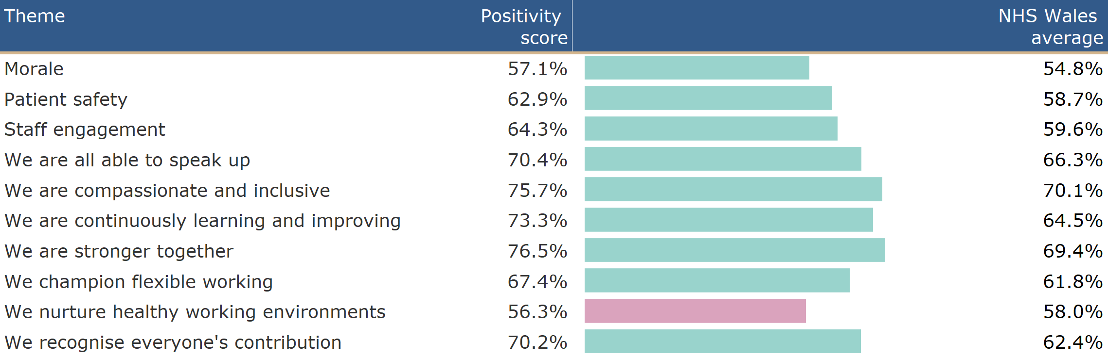 |  |  | Response Rate 2024: 14.7% |  | Target for 2025: 25%
 |  |  | 3. Key actions being taken to Improve Response Rate
- Continue to promote via local Divisional/Directorate brief with the expectation to cascade into local teams
- Leadership Engagement and Accountability at MH&LD SMT/Divisional/Directorate Level
- Communicate the plan including examples of staff stories
- Encourage the ‘you said we did’ approach to build trust and encourage staff to engage in future surveys
- Focus on PADRs and staff engagement regarding change and modernisation
- Assurance on the independent management of the survey which maintains anonymity

 |  |  | 4. Key Exit Criteria (what will success look like for the staff survey in 2025?) *linked to national survey measures in 2024.
- Improved staff engagement score
- Improved positivity score for “we are all able to speak up”
- Improved positivity score for “we are inclusive and compassionate”
- Improved positivity score for “we nurture healthy working environments”

5. Short term Goals 2025/26 | 6. Medium term Goals 2026/7 |  | 7. Key Actions/ Milestones leading up to 2025 staff survey
Leadership, Engagement and Accountability at SMT/Divisional/Directorate Level.  Share 3 key areas of focus for the Health Board along with Divisional level themes:  - Leadership & Management  - Speaking Up Safely / Raising concerns  - Values & Behaviours  In addition share the need to focus on:  - Healthy Working Environments  Continue to promote Workforce Strategies focussing on retention.  Divisions take a collective and compassionate leadership approach to developing local plans.  Involve representatives from local teams as well as managers and Trade Union Representatives to develop plans. Share details of plans in MH&LD Partnership meeting.  Each Divisional plan to include a communication and engagement section.  Continue to develop talent pathway through the “Grow your own” ethos for MH&LD.  Benchmarking results against 2023 survey to assess improvements. | Identify leadership, management (including compassionate leadership) and professional development needs and plans as part of MH&LD PADRs to inform MH&LD development plan.  Benchmarking results against 2025 survey to assess improvements and highlight areas for further improvement which will form the medium-term goals.  Implement training and education to enhance use of digital systems within MH&LD  Alignment to IMTP and 7 people aims set out in SBU People Strategy. |  | Actions/ Milestones |  | Lead | By When | Status
 |  |  | Nominate SG leads to access staff survey results via dashboard. |  | DN | 03/25 | Complete
 |  |  | Share 3 key areas of focus for the Health Board along with Divisional level staff survey results highlighting the specific themes for MH&LD |  | DN | 05/25 | Complete
 |  |  | Management teams to discuss the results and to agree how they will shape local Divisional Staff Survey Plans. |  | Divisional Leads | 05/25 | Complete
 |  |  | Utilise the “Meet the Senior Team” quarterly briefing to share overarching and Divisional results and actions planned. In addition highlight the launch of the 2025 survey |  | SMT | 06/25 | On track
 |  |  | Divisional Staff Survey Plan to be shared during Divisional and Directorate Meetings |  | Divisional Leads | 06/25 | On track
 |  |  | Progress update on Divisional Staff Survey Plan to be reported during SMT ahead of the launch of the 2025 Staff Survey (Oct 25). |  | Divisional Leads | 09/25 | On track
8. Key Risks | 9. Mitigating Actions
- Operational priorities and competing demands which may limit progression of actions linked to staff survey plans.  - Concerns about the confidentiality of individual survey returns for staff.  - A lack of confidence from staff that anything would change as a result of their feedback.  - Environment - client group  - V&A training | - Use dedicated time in Divisional Workforce Groups to monitor Divison Staff Survey action plans. HR BP Teams to support.  - Progress updates against plans will be monitored via SMT.  - Provide assurance on the independent management of the survey which maintains anonymity.  - Regular promotion of actions via staff engagement mechanisms i.e. “Meet the Senior Team”  - Communication and engagement section to be built into each Divisional plan.  - Review and streamline MH&LD actions and priorities to ensure resource focus.
10. Interdependencies
- SBU 10 year vision for a high quality organisation and Health Board Strategic aims  - Integrated Medium Term Plans  - SBU Clinical Service plans  - SBU People Strategy |  | - “We all belong” SBU’s Equality Strategy  - NHS Wales Speaking up Safely Framework  - HEIW Leadership and Management Competency Framework  - Strategic Workforce Plans

NHS Wales Staff Survey 2024 – Health Board Action Plan Template

1. Staff Survey Update for Morriston Service Group |  |  | Date Agreed: May 2025  Lead: Sue Moore
1. High level summary of survey findings: |  | 2. Response Rate
MSG achieved a Staff Engagement Index score of 64.5% in 2024. This is compared with the 72% average NHS Wales Staff Engagement Index score.  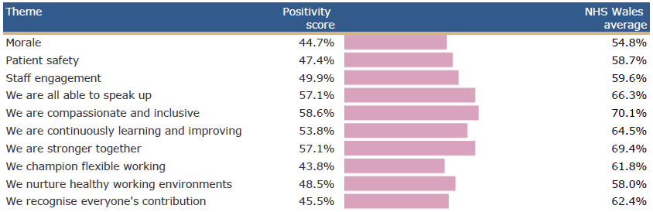  Below is a summary of responses by theme for MSG: |  | Response Rate 2024: 5.8% |  | Target for 2025: 25% (min.)
 |  | 3. Key actions being taken to Improve Response Rate
- Leadership Engagement and Accountability at Divisional Level
- Active ongoing promotion
- Give staff sufficient time to respond
- Development of a communication plan emphasising messages around confidentiality and examples of staff stories around the ‘You Said, We’re Delivering Together’ campaign confirming action taken as a result of the survey.
- Assurance on the independent management of the survey which maintains anonymity
- Due to low response rates from Band 2/3's and to boost engagement, consider exploring a hands-on approach where teams will visit with iPads to support participation as well as paper based copies where appropriate.

 |  | 4. Key Exit Criteria (what will success look like for the staff survey in 2025?) *linked to national survey measures in 2024.
- Improved staff engagement score
- Improved positivity score for “we are all able to speak up”
- Improved positivity score for “we are inclusive and compassionate”
5. Short term Goals 2025/26 | 6. Medium term Goals 2026/7 | 7. Key Actions/ Milestones leading up to 2025 staff survey
Strengthening Leadership, Engagement, and Accountability at Divisional Level  Share the 3 key areas of focus for the Health Board along with Divisional level themes:  - Leadership & Management  - Speaking Up Safely / Raising concerns,  - Values & Behaviours  - Flexible Working  - Healthy Woking Environments  Divisions should adopt a collective and compassionate leadership approach to developing their local staff experience plans.  Plans should be co-designed with input from:  - Local team representatives  - Line managers  - Trade Union representatives  Each divisional plan must include a dedicated communication and engagement section, outlining how staff will be:  - Informed  - Involved  - Updated on progress and outcomes  Where applicable, divisional staff survey plans should be aligned with the development of the Staff Experience, Wellbeing, and Retention Plans, particularly in areas where this work is already underway. | Benchmark 2025 survey results to measure progress and identify ongoing priorities, which will inform medium-term improvement goals.  Continue to develop and implement the Staff Experience, Wellbeing, and Retention Plan to address key themes and sustain positive change. | Actions/ Milestones |  | Lead | By When | Status
 |  | Nominate SG leads to access staff survey results via dashboard. |  | SM | 03/25 | Complete
 |  | Attend webinars to support running local reports from the dashboard. |  | SM | 03/25 | Complete
 |  | Share 3 key areas of focus for the Health Board along with Divisional level staff survey results highlighting the specific themes for MSG. |  | SM | 05/25 | Complete
 |  | Management teams to discuss the results and to agree how they will shape local Divisional Staff Survey Plans. |  | ASGDs | 05-07/25 | Ongoing
 |  | Divisional Staff Survey Plan to be shared during Divisional Board Meetings |  | ASGDs | 07/25
 |  | Progress update on Divisional Staff Survey Plan to be reported during Divisional Board Meetings ahead of the launch of the 2025 Staff Survey (Oct 25). |  | ASGDs | 09/25
 |  | Progress up-date on delivery of action plans including examples of staff stories around “You Said, We’re Delivering together” culminated from Service Groups / Directorates and launch of 2025 staff survey to WOD Delivery Group and Committee |  |  | Sept-Oct 2025 | On-track
8. Key Risks | 9. Mitigating Actions
- Operational pressures and competing priorities may delay progress on staff survey-related actions.  - Staff concerns about confidentiality may impact willingness to provide honest feedback.  - Low confidence in follow-through may lead to scepticism about whether feedback will result in meaningful change. | - Allocate time within Divisional Workforce Groups to regularly review and track progress on staff survey action plans, with support from HR Business Partner teams.  - Monitor and report on progress against agreed actions to ensure accountability.  - Reinforce the independence and anonymity of the survey process to build staff trust.  - Regularly communicate actions taken in response to staff feedback to demonstrate impact.  - Include a dedicated communication and engagement section in each Divisional plan to support visibility and involvement.
10. Interdependencies

NHS Wales Staff Survey 2024 – Health Board Action Plan

1. Staff Survey Update for Workforce & OD |  |  | Date Agreed: May 2025  Lead: Tina Ricketts
1. High level summary of survey findings: |  | 2. Response Rate
SB Workforce and OD achieved a Staff Engagement Index score of 72.7% in 2024. This is compared with the 72% average NHS Wales Staff Engagement Index score. The following table summarises results against the 10 question themes:  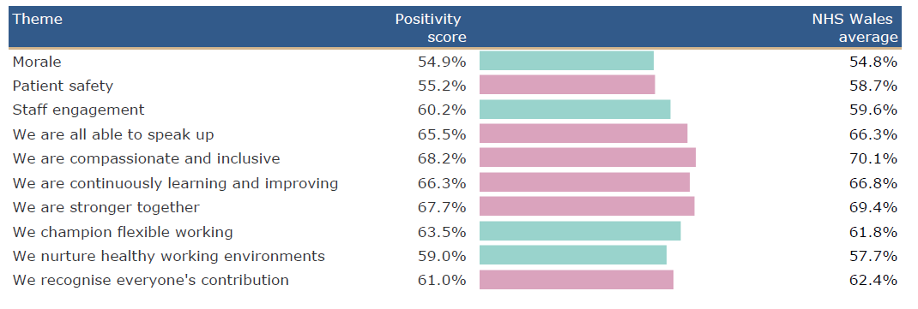 |  | Response Rate 2024: 125% |  | Target for 2025: 25% (min.)
 |  | 3. Key actions being taken to Improve Response Rate
- Continue to promote via local Directorate brief with the expectation to cascade into local teams.
- Work with HEIW to make improvements around the hierarchy to support accuracy of completion/returns
- Development of a communication plan emphasising messages around confidentiality and examples of staff stories around the ‘You Said, We’re Delivering Together’ campaign confirming action taken as a result of the survey.
- Build in as an objective to WOD Leader & Managers PADRs.
- Utilise national resources and branding to support drive messaging and response rate.
 |  | 4. Key Exit Criteria (what will success look like for the staff survey in 2025?) *linked to national survey measures in 2024.
- Improved staff engagement score
- Improved positivity score for “we are all able to speak up”
- Improved positivity score for “we are inclusive and compassionate”

5. Short term Goals 2025/26 | 6. Medium term Goals 2026/7 | 7. Key Actions/ Milestones leading up to 2025 staff survey
- Improve Attendance and Engagement within WOD  - Deliver Speaking Up Safely audit recommendations specific to Workforce & OD, in collaboration with key stakeholders  - Embed retention plan across Directorate  - Identify Leadership, management (including compassionate Leadership) and professional development needs and plans as part of WOD PADRs to inform Directorate Development plan  - Develop a talent pathway aligned to the ‘grow your own’ ethos for WOD, linked to ‘development of the People Profession’ led by HEIW  - Implement Training and Education to enhance Digital Systems use within WOD  - Build on the Workforce Metrics Dashboard to increase insights for WOD  - Implement SBU Equality Strategy ‘We All Belong’ within WOD | Benchmarking of results from 2025 NHS Wales Staff Survey to identify improvements or gaps for action which will inform medium term Goals.  Alignment to WOD Delivery Actions as part of IMTP and 7 People Aims set out in SBU People strategy for 2026/7. | Actions/ Milestones |  | Lead | By When | Status
 |  | Utilise WOD Directorate briefing to share overarching and local Staff Survey Results and actions planned for collective delivery. In addition, highlight the launch of the 2025 survey (1st October 2025) |  | TR | June 2025 | On-track
 |  | Managers and Leaders across WOD to discuss the results within their teams and actions to collectively implement, feeding into the overarching goals and success measures. |  | WOD SMT | June/July 2025 | On-track
 |  | Work to be undertaken with HEIW, ESR Team and HRBPs in relation to the National Survey 2025 hierarchy and wider actions required ahead October launch |  | JL, HRBPs, ESR Team | June to October 2025 | On-track
 |  | Progress up-date on delivery of action plans including examples of staff stories around “You Said, We’re Delivering together” culminated from Service Groups / Directorates and launch of 2025 staff survey to WOD Delivery Group and Committee |  | TR, JL | Sept-Oct 2025 | On-track
8. Key Risks | 9. Mitigating Actions | 10. Interdependencies
Capacity to prioritise WOD actions based on the demands and needs of the Health Board and Service Groups. | Review and streamlining of Delivery Actions and WOD priorities to ensure resource focuses on delivering what the Health Board and Services require most. | SBU 10-Year Vision for a High-Quality Organisation and the Health Board’s Strategic Aims
 |  | Integrated Medium Term Plans and Delivery Actions
 |  | SBU Clinical Service Plans
 |  | SBU People Strategy and local Service Group People Plans
 |  | We All Belong – SBUs Equality Strategy
 |  | NHS Wales Speaking Up Safely Framework
 |  | HEIW – National direction on NHS Wales Staff Survey and Leadership & Management Competency Framework

NHS Wales Staff Survey 2024 – Health Board Action Plan Template

1. Staff Survey Update for Planning and Partnerships (formerly Strategy) |  |  | Date Agreed: May 2025  Lead: Marie Davies
1. High level summary of survey findings: |  | 2. Response Rate
SB Strategy achieved a Staff Engagement Index score of 76.0% in 2024. This is compared with the 72% average NHS Wales Staff Engagement Index score. The following table summarises results against the 10 question themes:  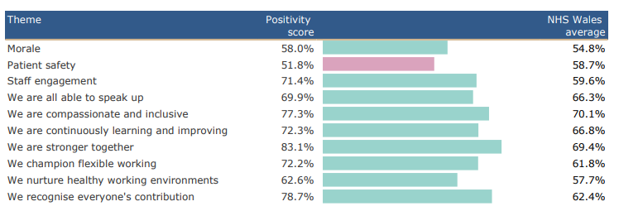 |  | Response Rate 2024: 75% |  | Target for 2025: 100%
 |  | 3. Key actions being taken to Improve Response Rate
- Continue to promote via local Directorate brief which includes all Directorate staff teams.
- Continue to request that Managers actively promote within their teams
- Build into Managers PaDRS
 |  | 4. Key Exit Criteria (what will success look like for the staff survey in 2025?) *linked to national survey measures in 2024.
- Improved staff engagement score
- Improved positivity scores particularly for morale, patient safety and being able to speak up

5. Short term Goals 2025/26 | 6. Medium term Goals 2026/7 | 7. Key Actions/ Milestones leading up to 2025 staff survey
- Continue to embed and deliver the Directorate wide monthly Development sessions  - Re-instate regular ‘Time-out sessions’ led by Director – next one on Oct 25, with CEO in attendance – aim to support improvement in morale and review the Directorate’s role and purpose in delivering the Organisational Strategy, Annual Plan and enabling Strategic Plans across our portfolio  - Via PaDR process, review professional development needs and plans |  | Actions/ Milestones |  | Lead | By When | Status
8. Key Risks | 9. Mitigating Actions | 10. Interdependencies

NHS Wales Staff Survey 2024 – Health Board Action Plan
1. Staff Survey Update for SB Medical Director Support |  |  | Date Agreed: June 2025  Lead: Richard Evans
1. High level summary of survey findings: |  | 2. Response Rate
SB Medical Director Support achieved a Staff Engagement Index score of 80.4% in 2024. This is compared with the 72% average NHS Wales Staff Engagement Index score. The following table summarises results against the 10 question themes: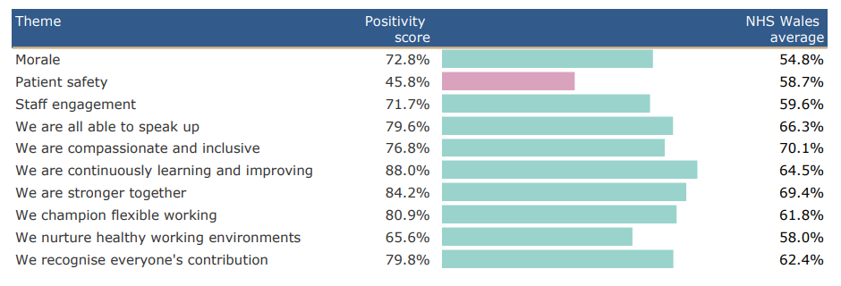 |  | Response Rate 2024: 69.2% |  | Target for 2025: 75% (min.)
 |  | 3. Key actions being taken to Improve Response Rate
- Clarification of departments listed under EMD directorate (for example it does not appear R&D is included);
- Encouragement of participation in survey to be a core objective in team leader PADRs;
- Promotion in monthly department catch-ups;
- Sharing of findings and actions at department meetings for team leaders to cascade;
- Inclusion in EMD newsletter to encourage wider clinical workforce to participate even though no impact on department response rate.
 |  | 4. Key Exit Criteria (what will success look like for the staff survey in 2025?) *linked to national survey measures in 2024.
- Improved staff engagement score
- Improved positivity score for “patient safety”
- Improved positivity score for “we are inclusive and compassionate”
- Improved positivity score for ‘we nurture healthy working environments’

5. Short term Goals 2025/26 | 6. Medium term Goals 2026/7 | 7. Key Actions/ Milestones leading up to 2025 staff survey
- Identify reasons for low positivity score for ‘patient safety’ – likelihood is this relates to it being a corporate department and the majority of responses were ‘neither agree or disagree’ as there is no ‘not applicable’ option;  - Consider ways appropriate assurance can be provided as to action and learning around patient safety incidents;  - Work with team leaders to review work/life balances and any barriers or obstacles, taking into account priorities for the year in-line with available resources to look at new ways of working and succession planning/development opportunities;  - Promotion of ‘Brilliant Basics’ within the department’;  - Work with team leaders to identify any causes for concern within the workforce which led to the low positivity score around equality and diversity; | - Benchmarking of results from 2025 NHS Wales Staff Survey to identify improvements or gaps  - Review of team capacity and succession planning/development | Actions/ Milestones |  | Lead | By When | Status
 |  | Use EMD department team brief to discuss the results and actions set to date, as well as explore in detail potential reasons for low positivity scores. |  | LW | June 2025 | On-track
 |  | Team leaders to discuss the results and actions, with potential attendance by the head of service if welcomed by the teams, to feed into the progress needed. |  | LW | October 2025 | On-track
 |  | Clarify the SB Medical Director Support hierarchy ready for the launch of the next survey |  | LW | August 2025 | On-track
8. Key Risks | 9. Mitigating Actions | 10. Interdependencies
- Identifying the key areas of improvement needed against those with a low positivity score due to being not-applicable | - Wider, general discussions with teams as to concerns they may have in each of the areas highlighted. | SBU 10-Year Vision for a High-Quality Organisation and the Health Board’s Strategic Aims
 |  | Integrated Medium Term Plans and Delivery Actions
 |  | SBU Clinical Service Plans
 |  | SBU People Strategy
 |  | We All Belong – SBUs Equality Strategy
 |  | NHS Wales Speaking Up Safely Framework

NHS Wales Staff Survey 2024 – Health Board Action Plan Template

1. Staff Survey Update for Support Services (Hotel Services) |  |  | Date Agreed: June 2025  Lead: Joanne Jones/Rob Daniel
1. High level summary of survey findings: |  | 2. Response Rate
Support Services achieved a Staff Engagement Index score of 71.2% in 2024. This is compared with the 72% average NHS Wales Staff Engagement Index score.  Below is a summary of responses by theme for Support Services(Hotel Services) |  | Response Rate 2024: 5.3% |  | Target for 2025: 25% (min.)
 |  | 3. Key actions being taken to Improve Response Rate
- Communicate the purpose
- Ensure staff are supported to complete
- Paper copies available as not all staff are able to access electronically
- Active ongoing promotion
- Give staff sufficient time to respond
- Assurance on the independent management of the survey which maintains anonymity

 |  | 4. Key Exit Criteria (what will success look like for the staff survey in 2025?) *linked to national survey measures in 2024.
- Improved staff engagement score
- Improved positivity score for “we are all able to speak up”
- Improved positivity score for “we are inclusive and compassionate
5. Short term Goals 2025/26 | 6. Medium term Goals 2026/7 | 7. Key Actions/ Milestones leading up to 2025 staff survey
Leadership, Engagement and Accountability  Share 3 key areas of focus for the Health Board along with the Support Services key focus:  - Leadership & Management  - Speaking Up Safely / Raising concerns,  - Values & Behaviours  - Flexible Working  - Healthy Woking Environments  Managers take a collective and compassionate leadership approach to developing local plans.  Involve representatives from local teams as well as managers and Trade Union Representatives to develop plans.  Each department to l plan to include a communication and engagement section.  Consider aligning the staff survey plan to action plans developed form staff listening events. | Benchmarking results against 2025 survey to assess improvements and highlight areas for further improvement which will form the medium-term goals. | Actions/ Milestones |  | Lead | By When | Status
 |  | Nominate SG leads to access staff survey results via dashboard. |  | JJ/RD | 03/25 | Complete
 |  | Attend webinars to support running local reports from the dashboard. |  | JJ/RD | 04/25 | Complete
 |  | Share 3 key areas of focus for the Health Board along with Departmental level staff survey results highlighting the specific themes for Support Services. |  | JJ/RD | 06/25 | Complete
 |  | Management team to discuss the results and to agree how they will shape local departmental Staff Survey Plans. |  | SSMT | 05-07/25 | Ongoing
 |  | Staff Survey Plan to be shared during board/partnership forum. |  | JJ/RD | 07/25
 |  | Progress update on Staff Survey Plan to be reported during Support Servies Board |  | JJ/RD | 09/25
 |  | Support Services has developed its own working group to improve communication strategies with staff |  | JJ/RD | 05/25
8. Key Risks | 9. Mitigating Actions
- Operational priorities and competing demands which may limit progression of actions linked to staff survey plans.  - Concerns about the confidentiality of individual survey returns for staff.  - A lack of confidence from staff that anything would change as a result of their feedback. | - Progress updates against plans will be monitored via Support Services Management Board  - Provide assurance on the independent management of the survey which maintains anonymity.  - Regular promotion of actions that have been taken as a result of the feedback from colleagues.
10. Interdependencies
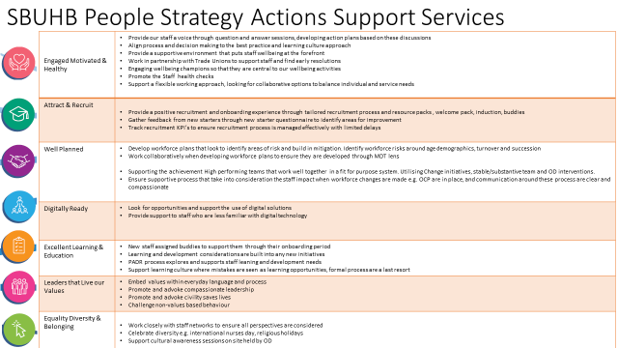

NHS Wales Staff Survey 2024 – Health Board Action Plan Template

1. Staff Survey Update for (Finance Department) |  |  | Date Agreed: May 2025  Lead: Stuart Davies
1. High level summary of survey findings: |  | 2. Response Rate
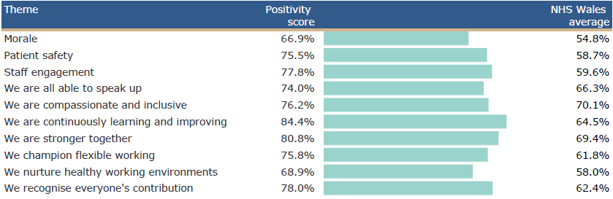 |  | Response Rate 2024: 41.7% |  | Target for 2025: 25% (min.)
 |  | 3. Key actions being taken to Improve Response Rate
- Cascading through Senior Leadership Team (SLT)
- Embedding associated responsibilities into Core Objectives & PADR process
- Engage with Staff Experience colleagues in the promotion of the Staff Survey
- Promote and encourage completing via monthly Open Forum sessions
 |  | 4. Key Exit Criteria (what will success look like for the staff survey in 2025?) *linked to national survey measures in 2024.
 |  | Success for Finance would look like 80% response rate based on the 41.7% for 2024 and core Finance numbers.
5. Short term Goals 2025/26 | 6. Medium term Goals 2026/7 | 7. Key Actions/ Milestones leading up to 2025 staff survey
- Link associated responsibilities to completing staff survey into Core Objectives and PADR process  - Engage with Staff Experience colleagues in the promotion of the Staff Survey  - Work with SLT to allocate time slots for people to complete the survey | - Arrangement of engagement sessions with staff experience colleagues  - Agreed protected time in diary for completing staff survey | Actions/ Milestones |  | Lead | By When | Status
 |  | - To gain agreement with Quality PADR Working Group to incorporate standard objective around completing staff surveys  - Link with Staff Experience colleagues to arrange engagement sessions in and around staff survey time frame  - Gain agreement through SLT route regarding protected time for completing staff survey  - Identify launch and closure dates for the 2025 Staff Survey and use Open Forums as a means of sharing progress and reminding staff to complete. |  | Stuart | September
8. Key Risks | 9. Mitigating Actions | 10. Interdependencies
- Finance covers a breadth of services from Counter Fraud, Performance, Health & Safety & Capital Planning, which don’t come under core Finance processes.  - Reliance upon leads within these areas to follow the same processes  - Timings of surveys – Survey Fatigue | - Communication with all key stakeholders, within the wider Finance directorate, to ensure alignment with expectations around survey responses  - Stagger response rate to surveys to mitigate survey fatigue | Leads from the wider Finance Directorate  - Counter Fraud  - Health & Safety  - Performance  - Capital Planning

