Meeting Date | Thursday 19 June 2025 |  | Agenda Item |  |  | 2.2
Name of Meeting | Workforce & OD Committee
Report Title | Managing Attendance at Work
Report Author | Nicola Garnon Assistant HR Business Partner
Report Sponsor | Craige Wilson, Director Primary Care, Community and Therapies and Tina Ricketts, Executive Director of Workforce and OD
Presented by | Craige Wilson, Director Primary Care, Community and Therapies  Ruth George, Human Resources Business Partner
Freedom of Information | Open
Purpose of the Report | This paper provides an overview of current levels of absence within Primary Care, Community and Therapies Service Group and what plans are in place to address attendance at work.
Key Issues | Attendance at Work supports the People Strategy for engaged, motivated and healthy staff.
Specific Action Required  (please choose one only) | Information | Discussion |  | Assurance | Approval
Specific Action Required  (please choose one only) | ☒ | ☐ |  | ☐ | ☐
Recommendations | Members are asked to:  - Note the content for information

- INTRODUCTION

This report provides an overview of the current sickness absence levels within Primary Care, Community and Therapies Service Group and outlines processes in place to both prevent and enable the return of staff from absence.

- BACKGROUND

  - Overall In Month Position

Sickness in month position for April 2025 was 6.63%, an increase from the final March 2025 position of 5.58%.

The ESR Sickness report for April 2025 shows the cumulative (rolling) sickness percentage for the group as 6.59%, a slight increase from the March 2025 position of 6.54%.

From May 2024 to April 2025 there were on average 163 working days lost due to sickness absence on any given date with individual absences ranging between 119 to 203 days.

Long-term sickness increased in month from the final position of 4.08% in March 2025 to 4.34% in April 2025.

Short-term sickness in month increased from 1.51% in March 2025 to 2.29% in April 2025.
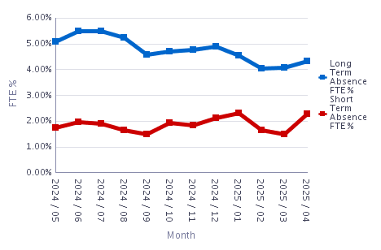
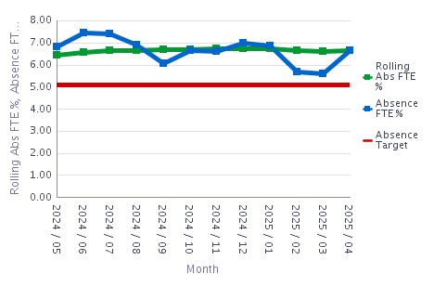

Comparison of Service Groups – 12 Month Rolling % Absence FTE
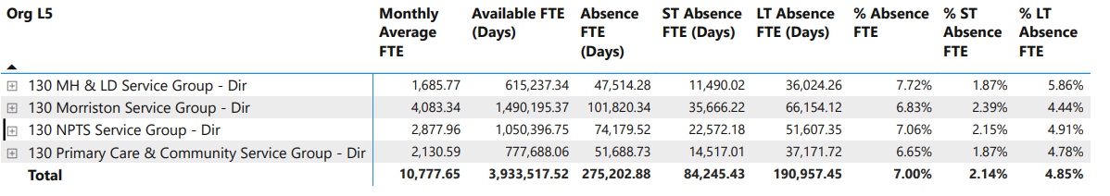

* Variations in data due to timing of reporting

  - Reasons for Absence
Cold, cough, flu – influenza was the highest reason for absence for April 2025 (decrease of 3 headcount on comparison to March 25). Gastrointestinal problems was the second highest reason for sickness absence (increase of 1 headcount on comparison to March 25), with anxiety/stress/depression/other psychiatric illness as the third highest reason for absence (increase of 9 headcount on comparison to March 25). These absence reasons accounted for over 57.5% of the total absences within the Service Group.

  - Patterns of Absence
Mondays are the highest day of absence with a steady decline through the remaining week. The highest level of absences was between 0 days and 1 days in April with absences of 2 days duration as the second highest level and absences between 28 days and 6 months the next highest area.
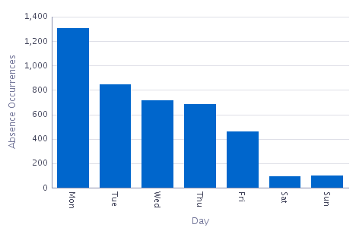
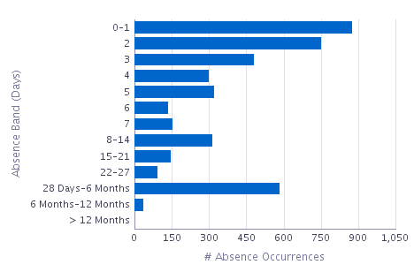

For April 2025, Add Prof Scientific and Technical were the staff group with the highest absence FTE at 12.51%, a small decrease from the previous months figure of 12.55%.

Staff Group | Absence FTE | Available FTE | Absence FTE %
Add Prof Scientific and Technic | 1,066.30 | 8,520.49 | 12.51%
Additional Clinical Services | 15,406.99 | 194,298.28 | 7.93%
Administrative and Clerical | 6,155.07 | 98,706.21 | 6.24%
Allied Health Professionals | 9,733.21 | 240,045.03 | 4.05%
Estates and Ancillary | 0.00 | 326.65 | 0.00%
Healthcare Scientists | 105.62 | 10,238.25 | 1.03%
Medical and Dental | 455.79 | 17,707.64 | 2.57%
Nursing and Midwifery Registered | 18,765.75 | 207,845.52 | 9.03%

  - Deep Dive into Sickness Absence

In line with Primary Care, Community and Therapies and Workforce and OD Staff Health and Wellbeing strategies, together with a Health Board increased focus on managing attendance at work, a piece of work was commissioned by the HR Business Partner team in June 2024 to look to understand the underlying reasons behind one of the Group’s main reasons for sickness absence, that being ‘anxiety/ stress/ depression/ other psychiatric illnesses related illnesses’. The period reviewed was from 1 March 2022 to 29 February 2024.
All staff absences are recorded on ESR however this is limited in terms of providing further detail for ‘anxiety/ stress/ depression/ other psychiatric illnesses related illnesses’. A total of 823 entries were reviewed as part of this exercise.
The main sub-reasons for ‘anxiety/ stress/ depression/ other psychiatric illnesses related illnesses’ were found to be:

- Family Issues
- Personal health issues
- Bereavement

In consideration of staffing groups, the main sub-reasons for Additional Clinical Services were ‘Personal Health Issues’ at 54 responses and ‘Family Issues’ at 53 responses. For Administrative and Clerical Staffing Group the main sub-reason was ‘Family Issues’ at 29 responses. For Allied Health Professionals the main sub-reason was ‘ bereavement’ at 35 responses and ‘personal health issues’ at 34 responses. For Nursing and Midwifery staffing group the main sub-reasons were ‘family issues’ at 50 responses and ‘bereavement’ at 42 responses.

- Addressing the High Levels of Absence in the Workplace
Several approaches are being taken to address the high level of absence within the Service Group, which are outlined below.

3a) Action Plans and Scrutiny

The Service Group have an overall People Action Plan for which Managing Attendance at Work and Wellbeing is one of the key priority areas.

Absence is an agenda item in the monthly Operational Business meeting, monthly E-Rostering meetings and weekly Nursing Bank and Agency Meetings as well as the monthly Nursing Professional Nurse Forums. Data is critical to monitoring patterns and this is accessed via the BI Dashboard, ESR and the E-Rostering weekly unavailability report. Focused Absence Submits for sickness hotspot areas are to commence in June 2025.

In addition, the allocated HR Operations representative for the Service Group meets with managers on a frequent basis to address individual long term sickness cases to facilitate staff return to work and reviews short term absence in line with policy to address underlying issues. In respect of additional oversight, the Assistant HR Business Partner for the Service Group meets with the respective HR Operations representative on a monthly basis to review long term sickness cases to provide additional assurance, identify themes, trends and to provide additional support to managers where appropriate.

With two Sickness Absence Auditors now appointed within Primary Care, Community and Therapies, a programme of sickness audits is to commence effective June 2025 focusing on sickness hot spot areas.

The aim of the oversight listed above is to provide assurance that all areas within Primary Care, Community and Therapies are managing sickness absence in line with the Health Board’s Managing Attendance at Work Policy, and that managers are ensuring that the appropriate wellbeing support is available to staff to support them to remain in work rather than take sick leave or to support them back to work following absence, in the most appropriate manner.

3b) Education

A total of six Managing Attendance at Work sessions were held during 2024, and a rolling programme is being undertaken for 2025. 46 managers have attended the session within the Service Group within the last three years. This will have reinforced the importance of compassionate leadership and engagement with staff in addition to policy knowledge and processes.

Regular promotion of the ‘Brilliant Basics’ resources has taken place to include materials on managing attendance at work take place within the Service Group via all available verbal and written communication channels.

Workforce hold a regular spot focusing on health and wellbeing as part of the Service Groups’ monthly Team Brief. This offers the opportunity to raise awareness and understanding on what the Health Board has to offer in respect of wellbeing, notable inclusion and diversity events in the diary as well as offering an opportunity for guest speakers to focus on particular topics. The Service Group have enjoyed presentations focusing on the Sharing Hope Project, Men’s Health Forum, Carers Support and Flexible Working, all of which aims to provide a more holistic approach to supporting managing attendance at work.

Staff are encouraged to attend Health Board staff wellbeing events, and the programmes are circulated to all staff within the service group via email, the monthly Team Brief, departmental meetings and via the PCT Wellbeing Champions. Staff are encouraged to take flu / covid vaccination via these channels also.

Bi-monthly ‘Lunch and Connect’ sessions are held for the PCT Champions, where sharing ideas, awareness raising and wellbeing initiatives are celebrated. Further health and wellbeing communications with the PCT Wellbeing Champions takes place via a MS Teams Channel. Wellbeing Champions sub-groups exist in Nursing and Therapies where similar initiatives take place.

Wellbeing segments are included as part of the monthly Senior Management Development session. More recently as part of the April session, presentations on TRiM and Culture and Climate, the aim of which is to raise awareness and understanding amongst the senior management team, and encourage discussion and discussion in respect of managing and supporting staff within a compassionate management lens.

3c) Post Incident Support

We recognise that staff during the course of their employment may experience traumatic events, and this may be inside or outside of the workplace. The Service Group has engaged fully with the Health Board’s TRiM team to help raise staff awareness of trauma and support staff health and wellbeing. A total of 28 staff members have been trained in TRiM support, comprising of 4 TRiM Practitioners, and 24 TRiM supporters. The TRiM Lead identified for the Service Group is currently awaiting TRiM Manager training.
Staff are offered to self-refer or have a management referral to Occupational Health and Wellbeing for direct support from them has for any absence reason. Staff are encouraged to utilise 111 press 2 should they warrant psychological support post incident, for which they can seek a cross Health Board referral to a neighbouring Health Board for a service. Staff can also access Group Traumatic Episode Protocol (GTEP), which is a gentle but powerful therapy adapted from *EMDR therapy (* Eye Movement Desensitisation Reprocessing). It helps to reduce distress from traumatic events staff may have been exposed to over the past few months (in work or at home). Events can be single events or a build-up of distress from routine work exposure (regardless of role, profession or banding).
3d) Prevention Measures

A programme of Staff Pulse Surveys is currently being undertaken across the Nursing Directorate and is due for completion in June 2025. To date a total of 460 staff have been invited to complete the survey across eight areas. 148 responses received so far, giving a 32.1% response rate. The top five themes identified during the mid-point review are:
- A feeling of lack of capacity from staff to undertake their role;
- The majority of staff have experienced work-related stress in the last 12 months;
- Overall a supportive team culture;
- Good job satisfaction;
- A mix of line management approaches and styles.

Feedback sessions have been arranged with staff to further engage and provide input into future health and wellbeing initiatives, culminating in Staff Wellbeing Action Plans for each area. Examples of identified actions include:
- Recommencement of regular team meetings;
- Reviewing competency framework and induction letter;
- Support mechanisms for team leaders;
- OD Support for specific areas.

Future follow-up Staff Pulse Surveys are planned for 6 to 12 months’ time with the aim to measure progress against specific action plans.

This work is undertaken in conjunction with the results from the All Wales Staff Survey 2024.
Flexible working is also actively supported within the Service Group. It is noted that two of the main sub-reasons for ‘stress / anxiety/ depression’ related absences identified during the 2024 deep dive was those of ‘family issues’ and ‘caring for another’. By actively supporting the use of flexible working as a preventative measure to help support staff with work/life balance can enable the return of an individual to work through a period of absence.

The Nursing Directorate has appointed Swansea Bay’s first Professional Nurse Advocate (PNA), who has provided vital guidance and wellbeing support to the District Nursing teams, helping to strengthen and sustain the workforce. Building on this success, Nursing are now expanding the PNA model to other teams, including Sexual Health and Specialist Palliative Care, to ensure wider access to this important support.
The Service Group has also worked closely with OD representatives since 2023 to provide targeted support in respect of leadership and development, teamworking and developing positive cultures within several areas with Primary Care, Community and Therapies Service Group, with the aim to further strengthen staff engagement, culture, health and wellbeing.

A programme of ‘Drop In’ HR Clinics is continuing to be rolled out for staff, with a particular focus on hot spot areas. The purpose of which is to offer staff the opportunity to meet with HR representatives to raise any concerns, discuss absence management, share good working practices and offer wellbeing support.

Staff health and wellbeing initiatives are included as standard as part of the Workforce Development Plans within Primary Care, Community and Therapies, which aims to further embed a holistic cultural approach to managing and supporting staff health, wellbeing and attendance.

- RECOMMENDATION

The committee are asked to note the content of the report.

Governance and Assurance

Link to Enabling Objectives  (please choose) | Supporting better health and wellbeing by actively promoting and empowering people to live well in resilient communities
Link to Enabling Objectives  (please choose) | Partnerships for Improving Health and Wellbeing |  | ☐
Link to Enabling Objectives  (please choose) | Co-Production and Health Literacy |  | ☐
Link to Enabling Objectives  (please choose) | Digitally Enabled Health and Wellbeing |  | ☐
Link to Enabling Objectives  (please choose) | Deliver better care through excellent health and care services achieving the outcomes that matter most to people
Link to Enabling Objectives  (please choose) | Best Value Outcomes and High Quality Care |  | ☐
Link to Enabling Objectives  (please choose) | Partnerships for Care |  | ☐
Link to Enabling Objectives  (please choose) | Excellent Staff |  | ☐
Link to Enabling Objectives  (please choose) | Digitally Enabled Care |  | ☐
Link to Enabling Objectives  (please choose) | Outstanding Research, Innovation, Education and Learning |  | ☐
Health and Care Standards
(please choose) | Staying Healthy |  | ☐
(please choose) | Safe Care |  | ☐
(please choose) | Effective Care |  | ☐
(please choose) | Dignified Care |  | ☐
(please choose) | Timely Care |  | ☐
(please choose) | Individual Care |  | ☐
(please choose) | Staff and Resources |  | ☒
Quality, Safety and Patient Experience
If staff attendance is improved there will be a direct correlation with patient experience, managers and leaders who have responsibility for managing attendance at work and who are appropriately trained and supported to manage attendance at work will also result in improved patient experience

Financial Implications
N/A

Legal Implications (including equality and diversity assessment)
N/A

Staffing Implications
To reduce staff absence or enable the earliest return to work for staff, improve attendance in the workplace.

Long Term Implications (including the impact of the Well-being of Future Generations (Wales) Act 2015)
Report History |  | Version 1.
Appendices |  | None.

