Meeting Date | 20 June 2024 |  | Agenda Item |  |  | 2.1
Report Title | Medical Workforce Efficiencies
Report Author | Emma Owen, Interim Assistant Director of Workforce & OD
Report Sponsor | Sharon Vickery, Interim Deputy Director of Workforce & OD
Presented by | Sarah Jenkins, Interim Executive Director of Workforce & OD
Freedom of Information | Open
Purpose of the Report | This paper outlines the locum spend and the activities being undertaken to improve medical effectiveness.
Key Issues | To note the locum spend.  To update the ongoing work to reduce variable pay for medical staff.
Specific Action Required  (please choose one only) | Information | Discussion |  | Assurance | Approval
Specific Action Required  (please choose one only) | ☒ | ☐ |  | ☒ | ☐
Recommendations | Members are asked to note the contents of the paper.

Medical Workforce Efficiencies
- INTRODUCTION

To set out for the Workforce and OD Committee (WOD) salient information regarding the utilisation of agency and locum doctors during defined periods.

- BACKGROUND

Reducing the cost of medical spend is an extremely complex process that is multifaceted and requires a change programme to ensure sustained success. It has been usual practice to report medical agency and locum utilisation and expenditure to the WOD Committee. Below is a snapshot representing relevant periods tracking recent utilisation, expenditure, and costs during recent months.

- GOVERNANCE AND RISK ISSUES

Locum usage

The Health Board is maintaining a 70/30% split between bank and agency use. This is lower than what has been experienced in previous months and further analysis shows that this is due to the number of long-term locums being supplied via agency has increased. This trend has remained consistent since the last reporting period.

The Health Board continues to rely on temporary staffing to cover gaps within the rotas. The total locum hours information for the last 12 months shows that there has been a slight reduction in the number of hours that has been worked.

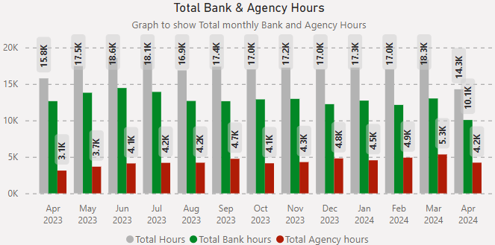

It is important to note that whilst there has been a reduction in the amount of locum hours worked the costs are significantly higher due to the rate negotiations that are taking place. Fortnightly meetings with the service group medical directors have been established to reduce the locum spend.

Industrial Action

During January, February and March 2024, the junior medical staff took industrial action. Consequently, this resulted in a significant increase in locum costs as the Health Board was reliant upon consultant and specialist grade staff to cover gaps within the rosters.

The table below outlines the number of medical staff who were recorded as absent either due to sickness, annual Leave, rostered days off and industrial action during January, February & March 2024. The data has shown that the number of medical staff who participated in the strike action remained relatively consistent across the periods. However, the annual leave unavailability of all (junior and senior) medical staff significantly increased during the April action which coincided with the Easter break.

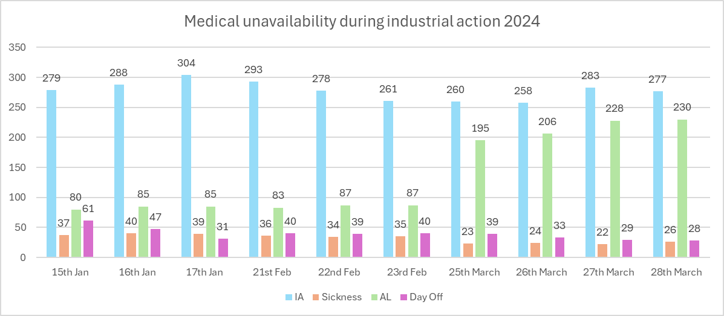

Compliance with rates

Internal Bank

During the last 12 months there has been a noticeable increase in the number of rates that are being negotiated above those agreed within the rate card. The data shows that approximately 53% of internal bank shifts are breeching the Swansea Bay rate card. However, the remaining 47% were paid at Swansea Bay rate (or lower).

Rate negotiations remain relatively high, however, it is important to note that the ongoing BMA national pay dispute challenge may limit the amount of rate reduction. Additional scrutiny measures will be undertaken by the service group medical directors to ensure appropriate the booking of bank and agency workers. The current process requires any rate negotiations to be approved by a service manager and the service group Medical director will approve rates that are above the Welsh government capped rate in advance of the shift being worked. However, the graph below shows that a number of shifts are being booked retrospectively which will be addressed as part of the variable pay reduction plan.

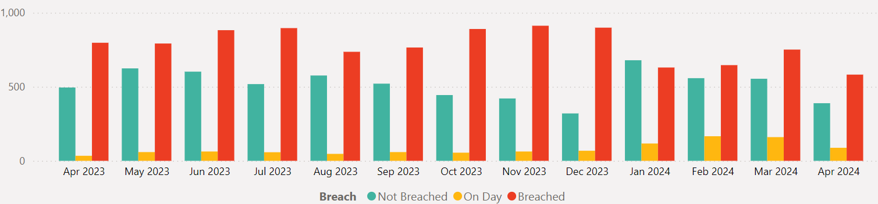

The data continues to show that the majority of locum requests are due to vacancies. The reported vacancy reason whole time equivalent for Health Board employed medical staff the month of April is 223, however, there are currently 136 adverts actively in the recruitment process. This could be attributed to a coding error or may suggest that vacancies are not being actively advertised and are being filled with locums. This will be addressed as part of the fortnightly discussions with the service groups and forms part of the variable pay reduction plan.

The continued implementation of establishment control (which is planned for completion early Autumn 2024) will assist the Health Board in effectively understand and managing vacancies. To date, establishment control has been implemented in Mental Health & Learning Disabilities, PCTS and corporate areas. Singleton & NPT and Morriston service groups are due to be completed early September 2024.

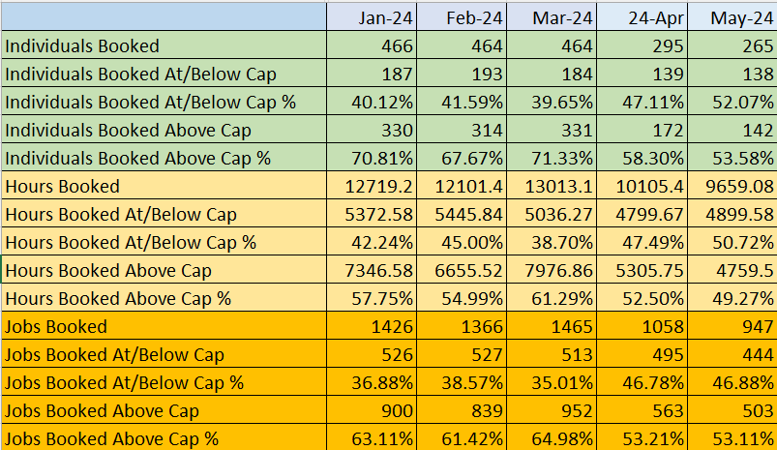

It is important to note that due to the industrial action during January, February and March 2024 there was an increase in rates paid above the WG capped rate, this is due to an all Wales extraordinary strike rate, which was agreed across Wales.

Agency

Work continues to ensure that service groups are utilising the MEDACS vantage model to book agency staff to avoid expensive off framework providers. There has been a noticeable reduction in the number of agency hours/workers being booked. This could be attributed to a number of measures including the increased visibility of locum reporting and the implementation of the dashboard and will be monitored to establish. However, it is important to note that the data is continuing to show that all agency workers are being paid higher than Welsh government capped rates.

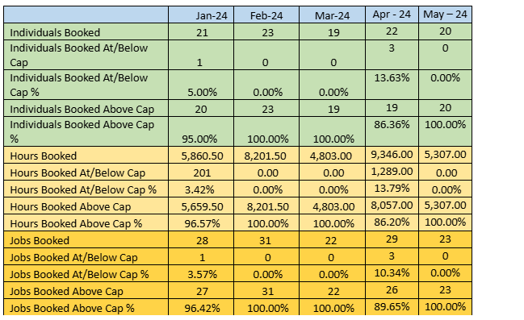

A review of authorisation processes will take place to ensure that all clinical gaps are scrutinised, appropriately approved (not retrospective) and also available to the entire locum bank to avoid being escalated out to agency. The Medical locum dashboard has been implemented and is being utilised to challenge medical locum spend within the service groups.

The raising of the Variable Pay agenda as part of the financial plan and discussions at Management Board led by the Chief Executive Officer, has set out a number of key focuses on this agenda to ensure we reduce our variable pay significantly and enable a focus on more effective utilisation. Shifting to proactive approval and requiring Service Group Medical Directors to ensure a deeper dive to understand utilisation.

The Health Board is also working with MEDACS to present a bank optimisation model to assist with the medical spend reduction.

Medic on Duty

The Health Board continues to implement Medic on Duty. Medic on Duty is rostering software that also includes the ability to manage and record absences. During the industrial action the Health Board utilised Medic on Duty to record activity across all service groups. The industrial action has highlighted the importance of Medic on Duty and as a Health Board we were able to use the system to record absence figures and manage the payroll activities for medical staff covering the services. This is a good example of where investment in the right digital solution can enable more effectiveness.

From 1st April 2024 all waiting list initiative (WLI) activity is now being processed via the Medic on Duty system. The table below outlines the activity during April & May 2024.

Department | WLI sessions processed
Department | April 24 | May 24
Medics Acute Medicine MH | 1 | 0
Medics Anaesthetics Department | 108 | 142.6
Medics Breast Services | 6 | 1
Medics Burns & Plastics Morriston | 6 | 3
Medics Dermatology | 2 | 0
Medics ENT Morriston Hospital | 2 | 0
Medics Gastro Morriston Hospital | 18 | 11
Medics General Rheumatology NPTH | 5 | 2
Medics Gynaecology Singleton Hospital | 6 | 0
Medics ICU Morriston Hospital | 4 | 2.66
Medics Lower GI | 4 | 6
Medics Ophthalmology Singleton | 3 | 3
Medics Oral & Maxillofacial Morriston Hospital | 1 | 2
Medics Radiology Morriston | 7 | 5
Medics Renal Morriston Hospital | 16 | 9
Medics Respiratory Morriston Hospital | 0 | 1
Medics Spinal Medical Specialty | 2 | 2
Medics Stroke Medicine | 1 | 0
Medics Trauma & Ortho Morriston Hospital | 10 | 5
Medics Upper GI | 2 | 16
Medics Urology Morriston Hospital | 2 | 1
Medics WFI NPTH | 9 | 0
Grand Total | 215 | 212.26
Cost | £178,089 | £146,459

Now that we are able to understand where this is being utilised, it will provide us with an opportunity to understand the appropriateness of its usage as part of our variable pay agenda.

Medic on duty rollout

Mental Health & Learning Disabilities is the only service group that has completely implemented all modules. Work is being undertaken with the service group to test appropriate key performance indicators for the medical workforce. The first scrutiny sessions have taken place and were well received by the service group. Following feedback the KPI report is being amended.

In terms of the wider rollout programme implementation is in progress with Anaesthetics, Cardiac Anaesthetics, ED and EMERTS and due to be completed by October 2024. The remainder of the rollout programme is outlined below:

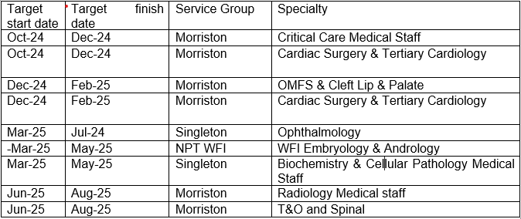

- FINANCIAL IMPLICATIONS

The cost of filling medical gaps remains a significant pressure for the Health Board. The graph below shows the internal bank and MEDACS spend across the last 12 months.

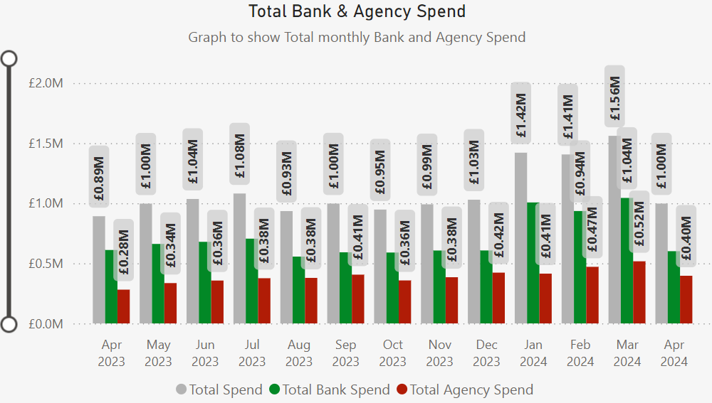

The tables below show the top highest spend across the service Groups.

Internal Bank
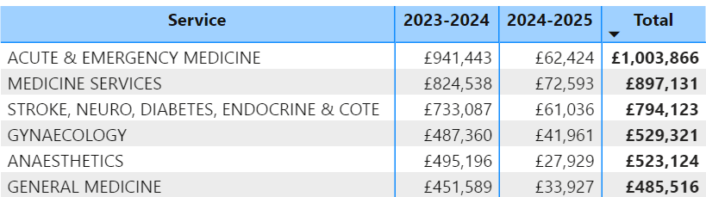

Agency

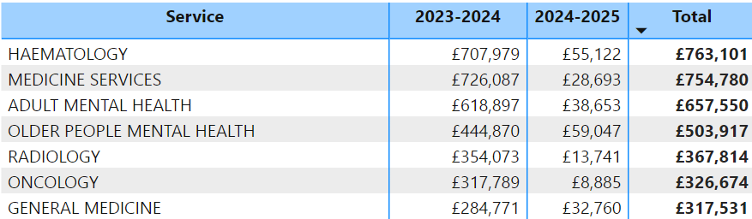

In order to reduce the locum expenditure fortnightly meetings have been set up with each service group that are being led by the Medical Directors. The meetings are targeting rates, locum usage and compliance with the process.

- RECOMMENDATION
It is recommended that the Health Board

- Continues to support the implementation of Medic on Duty ad expansion of functionality.
- Note the contents of this paper

Governance and Assurance

Link to Enabling Objectives  (please choose) | Supporting better health and wellbeing by actively promoting and empowering people to live well in resilient communities
Link to Enabling Objectives  (please choose) | Partnerships for Improving Health and Wellbeing |  | ☒
Link to Enabling Objectives  (please choose) | Co-Production and Health Literacy |  | ☐
Link to Enabling Objectives  (please choose) | Digitally Enabled Health and Wellbeing |  | ☐
Link to Enabling Objectives  (please choose) | Deliver better care through excellent health and care services achieving the outcomes that matter most to people
Link to Enabling Objectives  (please choose) | Best Value Outcomes and High Quality Care |  | ☒
Link to Enabling Objectives  (please choose) | Partnerships for Care |  | ☐
Link to Enabling Objectives  (please choose) | Excellent Staff |  | ☒
Link to Enabling Objectives  (please choose) | Digitally Enabled Care |  | ☐
Link to Enabling Objectives  (please choose) | Outstanding Research, Innovation, Education and Learning |  | ☐
Health and Care Standards
(please choose) | Staying Healthy |  | ☐
(please choose) | Safe Care |  | ☐
(please choose) | Effective Care |  | ☒
(please choose) | Dignified Care |  | ☐
(please choose) | Timely Care |  | ☐
(please choose) | Individual Care |  | ☐
(please choose) | Staff and Resources |  | ☐
Quality, Safety and Patient Experience
Appropriately skilled medical staff will improve the patient outcomes and delivery of care.

Financial Implications
There are no financial implications outlined in the paper.

Legal Implications (including equality and diversity assessment)
N/A
Staffing Implications
There are no staffing implications identified.

Long Term Implications (including the impact of the Well-being of Future Generations (Wales) Act 2015)
Briefly identify how the paper will have an impact of the “The Well-being of Future Generations (Wales) Act 2015, 5 ways of working.

Report History |  | 1
Appendices |  | N/A

