Meeting Date | 23 February 2026 |  | Agenda Item |  |  | 5.2
Name of Meeting | Workforce and OD Committee
Report Title | Management of Staffing Establishment and Unavailability – Maternity Services
Report Author | Kathryn Greaves, Director of Midwifery
Report Sponsor | Elizabeth Rix, Executive Director, Nursing & Patient Experience
Presented by | Kathryn Greaves, Director of Midwifery
Freedom of Information | Open
Purpose of the Report | To set out the progress on the actions identified to improve the management of sickness absence across Maternity Services. The information will cover:  - Data analysis: An analysis of the current staffing establishment and performance data for Maternity Services (2025).  - Progress against development of the Perinatal Staff, Engagement, Wellbeing and Retention [SEWR] Plan: An overview of progress against agreed actions to improve the experience of staff.
Key Issues | Drivers for improving staff availability and sickness absence rates across the Maternity Service:  - Previous Maternity Services Board Papers have referred to both the Health Inspectorate Wales (HIW) Reports and the Welsh Government Enhanced Monitoring Terms of Reference documents that have identified the need to improve staff availability across the Maternity Service to support the delivery of safe and effective care.  - The Welsh Government requires Health Boards to put in place plans to achieve the <5% target absence rate across all services.  - Recognise and accept the evidence that demonstrates staff health and wellbeing has an impact on staff engagement and experience, and how this enables organisational productivity, individual performance and ultimately the quality of patient care and outcomes across the Maternity Service. The Swansea Bay University Health Board Perinatal SEWR Plan has been developed alongside the Perinatal Workforce Plan [HEIW], the All-Wales Strategy for Perinatal Services and The NHS Wales Staff Health and Wellbeing – A Best Practice Guide has been used across the service as an enabler to unlock the benefits of improving staff Health and Wellbeing.
Specific Action Required  (please choose one only) | Information | Discussion |  | Assurance | Approval
Specific Action Required  (please choose one only) | ☒ | ☐ |  | ☒ | ☐
Recommendations | - ACKNOWLEDGE the progress being made by the Service Group in strengthening workforce planning and achieving strategic alignment with national guidance and HR recommendations. This includes actions to improve the management of sickness absence and to enhance employee wellbeing across Maternity Services.  - BE ASSURED of the continued progress against the Birthrate Plus workforce modelling, noting that a refreshed assessment will be required following completion of the national work.

MANAGEMENT OF STAFFING ESTABLISHMENT AND UNAVAILABILITY – MATERNITY SERVICES (NPTSSG)
1.Data Analysis – Current / Updated Staffing Establishment and Unavailability Rates
This report will provide an update on the staffing establishment and performance within the Registered Midwife and Additional Clinical Services (Maternity Health Care Assistants, Maternity Care Assistants, Nursery Nurses) staff groups, working across all teams within the Maternity Service.
Additional Clinical Services | - Completed vacancy management in view of band 2 and band 3 workforce assessment, validation and realignment of budgets. Workforce planning activity undertaken and vacancies out to advert on TRAC.  - Overall, absence levels over the last year have fluctuated with a peak in December 2025 at 9.98%. During November and December 2025, the increased absence rates were related to short-term absence in the main, impacted by an increase in absence due to coughs, cold and flu. Whilst there was a slight increase in Long-Term absence due to stress, anxiety and depression, there was no trend to these being solely related to working conditions or experience in the service following the publication of the Independent Report.
Registered Midwives | - Staffing establishment is Birth Rate Plus compliant. Whilst we are over established on band 5 midwives, we are under established on band 6. The planned progression of band 5 Midwives to band 6 will correct the establishment in time. This will be a junior workforce and whilst progression to band 6 will be achieved there is a need to acknowledge as an added pressure on the senior band 6 workforce continued support in their development.  - Overall, absence levels over the last year have fluctuated with a peak in December 2025 of 9.987%.  - An improvement in Midwife availability across the rosters has been sustained since our last report.  - Shifts remain compliant with Birthrate+ over 85%.

The current midwifery staffing establishment remains aligned with the Birth Rate Plus (BR+) modelling. Both the budgeted FTE and the actual FTE are currently above the original BR+ model. This variance reflects two key factors: the implementation of HIW recommendations relating to Maternity Triage services, and the organisational commitment to supporting newly qualified midwives entering the workforce through a streamlined recruitment approach.
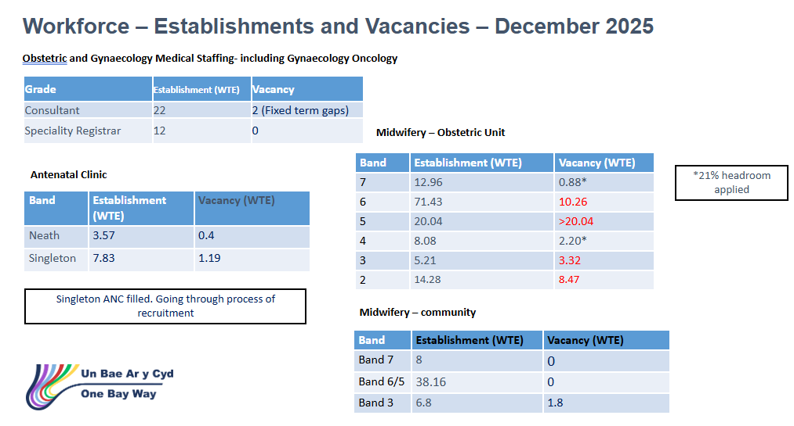

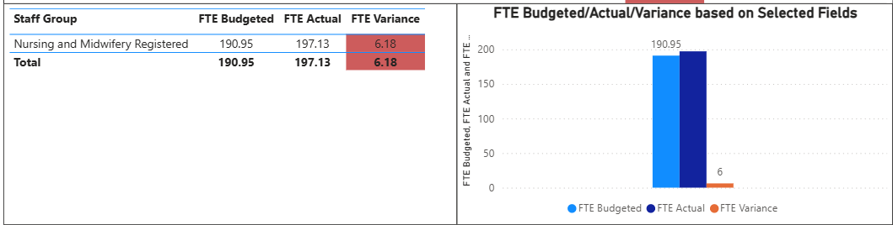
While this represents a recognised cost pressure, the service is scheduled for a full reassessment of its Birth Rate Plus modelling in 2026. The timing of this review will take place following the completion of national work examining the validity of BR+ in the context of today’s increasingly complex population needs and its effectiveness in determining safe staffing levels within maternity services.

Work is ongoing to fully determine the establishment and any variances for the unregistered workforce. This follows completion of the Band 2 and Band 3 validation processes, and commencement in post in line with the All Wales job descriptions implemented in 2025.

There are currently unregistered workforce vacancies within the service that are in the process of being approved for advertisement. These gaps in the workforce are affecting our ability to maintain an appropriately trained and orientated unregistered workforce to support the maternity service in meeting required Infection Prevention and Control (IPC) standards on our maternity wards. The postnatal ward is experiencing the greatest impact because of these shortages.

- Data Analysis - Workforce turnover

The graph below outlines turnover within the registered workforce during 2025. Over this period, we welcomed 16 new starters and recorded 10 leavers. Of the 10 leavers, eight were due to retirement, flexible retirement, or voluntary resignation linked to relocation. Of the remaining two leavers, only one is recorded as a voluntary resignation with the reason listed as unknown.

Exit interviews are promoted across the service. Work is underway to ensure we capture all exit interview feedback to strengthen our service intelligence and better inform workforce needs and planning within our SEWR plan.

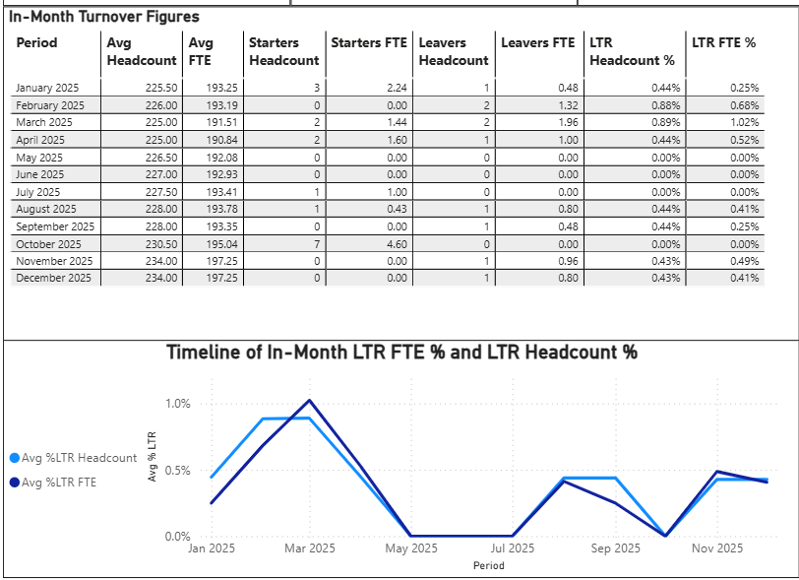

- Data Analysis – Sickness and absence

The graphs below present the sickness absence trends for Additional Clinical Services and Registered Midwives from January 2025 to December 2025. As anticipated, sickness levels in November and December 2025 were higher than in preceding months. This increase was primarily attributable to several staff members being on long term sickness absence related to anxiety, depression, and stress. Long term sickness declined for Unregistered staff in December with a small increase in short term sickness which we'd expect in flu season. Registered long term sickness increased in December with no real peak in short term sickness absence related to anxiety, depression, and stress.

It is important to note that, for most of these cases, the absences were not associated with work related stress and were not linked to the publication of the independent report. All cases continue to be managed appropriately in line with organisational HR policy.

Sickness absence - Additional Clinical Services
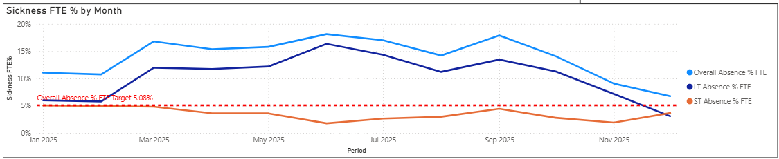

Sickness absence - Registered Midwives
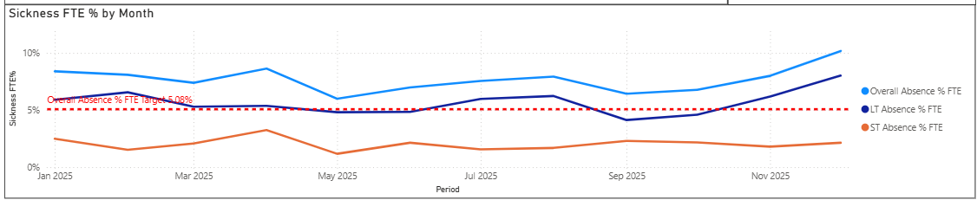

- Sickness Absence Improvement Actions - Progress

Following the presentation of the previous report to the Workforce and OD Committee in October 2025, the service has focused on developing the Sickness Management Improvement Plan, with the implementation phase commencing in February 2025.

The service has continued to make progress against the additional actions designed to strengthen and support delivery of the Improvement Plan. Progress against each action is monitored through ongoing sickness and absence summits, which provide oversight of performance against HR policy and ensure that staff are supported to return to and remain in work. These processes also help identify and address staff needs proactively, with the aim of reducing avoidable sickness absence across the service.

- PADR / Training Compliance
Compliance with annual Professional Development Discussions has improved significantly, with current completion rates at 87.39%. Strengthening the approach to staff development, in alignment with the Perinatal Staff Experience, Wellbeing and Retention Plan, represents an important service improvement. This work ensures that we continue to develop our current workforce and proactively plan for future workforce needs through effective horizon scanning, supporting the strategic aims of Maternity Services within Swansea Bay University Health Board.
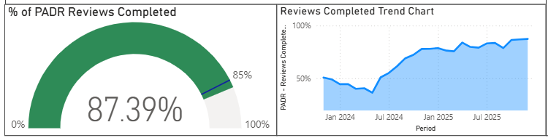

While compliance levels have plateaued during November and December, this is primarily attributable to staff availability during this period. The service remains focused on maintaining and improving compliance, with progress monitored and reported through the Perinatal Assurance Group and the Perinatal Committee. These updates are then escalated to the Quality and Safety Committee and the Board, forming part of the overarching governance arrangements for perinatal services within Swansea Bay University Health Board.

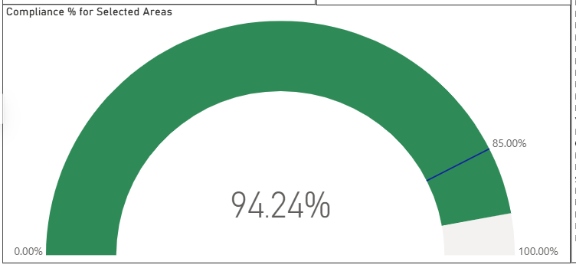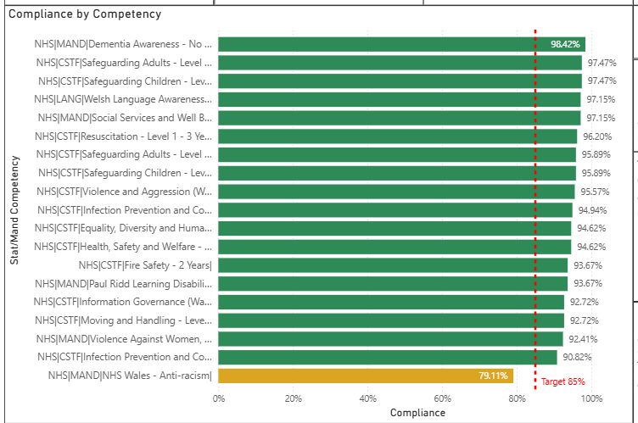

Staff compliance with mandatory and statutory training remains strong at 87.39%, exceeding the Welsh Government targets. In addition to these core requirements, staff within Maternity Services are also required to complete specialty specific mandatory training. Compliance in these areas is similarly high, supported by robust governance processes that ensure ongoing monitoring and timely escalation through the Quality and Safety Committee and ultimately to the Board.
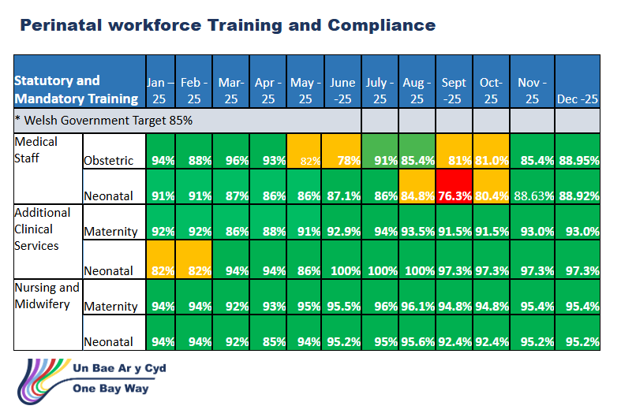
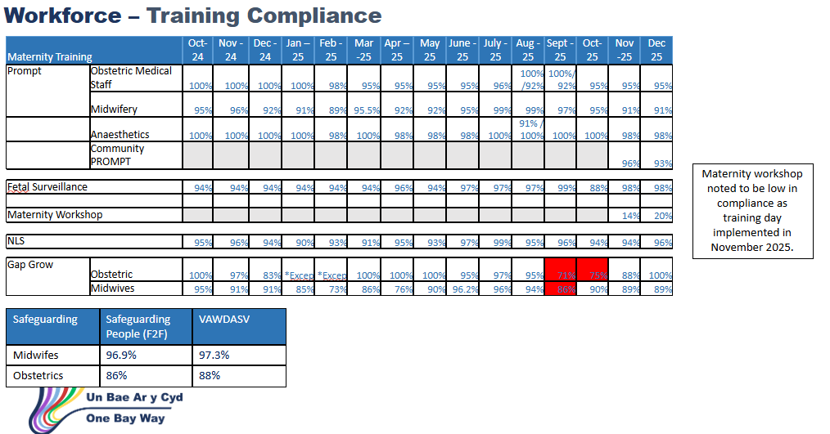

- Staff Experience, Wellbeing and Retention Plan.
Extensive work has been undertaken to ensure the Staff Experience, Wellbeing and Retention Plan is fully aligned with wider strategic frameworks and informed directly by workforce insight. The plan has been mapped to the priorities set out within the HEIW Perinatal Workforce Plan, ensuring consistency with national expectations for workforce development, professional standards and improved staff experience across maternity and perinatal services.

In addition, the plan is aligned to the Health Board’s organisational workforce strategies, particularly those relating to recruitment, retention, wellbeing, and compassionate leadership. This ensures that local actions and priorities directly reinforce the Health Board’s overarching workforce objectives and enable coherent delivery across services.

A key component of shaping this plan has been the valuable feedback gathered from staff through a series of listening exercises. These sessions provided insight into lived experience, barriers to wellbeing, and opportunities for improvement. Themes raised by staff—such as support from leadership, wellbeing resources, psychological safety, and workload pressures have been directly incorporated, ensuring the plan reflects the genuine needs and expectations of the workforce.

The plan also considers the recommendations from the Independent Review, particularly those relating to culture, staff support, communication, leadership visibility and strengthened mechanisms for staff voice. These recommendations have been embedded within the plan’s actions to ensure sustained improvement, stronger governance and a more supportive working environment for all staff.

The plan also aligns closely with the recommendations from the Independent Review, as well as those highlighted through external inspections by Healthcare Inspectorate Wales (HIW) and Health Education and Improvement Wales (HEIW). Key themes from these inspections—including the need for strengthened governance, enhanced staff support, improved communication systems, clearer leadership visibility and accountability, and more robust mechanisms for staff voice—have been embedded directly into the plan’s actions. This ensures sustained improvement, reinforces a culture of safety and transparency, and promotes a more supportive and responsive working environment for all staff.

Collectively, this alignment work ensures that the Staff Experience, Wellbeing and Retention Plan is evidence‑based, strategically coherent and fully responsive to the needs of the Perinatal workforce.

Members are asked to:
- ACKNOWLEDGE the progress being made by the Service Group in strengthening workforce planning and achieving strategic alignment with national guidance and HR recommendations. This includes actions to improve the management of sickness absence and to enhance employee wellbeing across Maternity Services.
- BE ASSURED of the continued progress against the Birthrate Plus workforce modelling, noting that a refreshed assessment will be required following completion of the national work.

Governance and Assurance

Link to Enabling Objectives  (please choose) | Supporting better health and wellbeing by actively promoting and empowering people to live well in resilient communities
Link to Enabling Objectives  (please choose) | Partnerships for Improving Health and Wellbeing |  | ☐
Link to Enabling Objectives  (please choose) | Co-Production and Health Literacy |  | ☐
Link to Enabling Objectives  (please choose) | Digitally Enabled Health and Wellbeing |  | ☐
Link to Enabling Objectives  (please choose) | Deliver better care through excellent health and care services achieving the outcomes that matter most to people
Link to Enabling Objectives  (please choose) | Best Value Outcomes and High-Quality Care |  | ☐
Link to Enabling Objectives  (please choose) | Partnerships for Care |  | ☐
Link to Enabling Objectives  (please choose) | Excellent Staff |  | ☒
Link to Enabling Objectives  (please choose) | Digitally Enabled Care |  | ☐
Link to Enabling Objectives  (please choose) | Outstanding Research, Innovation, Education and Learning |  | ☐
Health and Care Standards
(please choose) | Staying Healthy |  | ☐
(please choose) | Safe Care |  | ☐
(please choose) | Effective Care |  | ☐
(please choose) | Dignified Care |  | ☐
(please choose) | Timely Care |  | ☐
(please choose) | Individual Care |  | ☐
(please choose) | Staff and Resources |  | ☒
Quality, Safety and Patient Experience
The report details should contribute to improved employee availability and have a positive impact on staff health and wellbeing and ultimately quality, safety and patient experience.
Financial Implications
There are potential financial implications linked to absence.
Legal Implications (including equality and diversity assessment)
Staffing Implications
The report details should contribute to improved employee availability and have a positive impact on staff health and wellbeing.
Long Term Implications (including the impact of the Well-being of Future Generations (Wales) Act 2015)
Report History |  | Previous report was presented at the October 2024 WOD Committee.
Appendices |  | N/A

