Meeting Date | 23 February 2026 |  | Agenda Item |  |  | 4.2
Name of Meeting | Workforce & OD Committee
Report Title | Speaking Up Safely Report
Report Author | Julie Lloyd, Head of Culture, OD and Staff Experience
Report Sponsor | Tina Ricketts, Director of Workforce and OD
Presented by | Julie Lloyd, Head of Culture, OD and Staff Experience, Sharron Price, Director of Nursing for Neath Port Talbot & Singleton and Dermot Nolan, Service Group Director for Mental Health & Learning Disabilities
Freedom of Information | Open
Purpose of the Report | This report provides an overarching up-date of progress against the remaining recommendations and actions from the Speaking Up Safely Internal Audit Report, 2025.  As per the commitment set out in response to recommendation 3.1, it also facilitates rotational, localised reporting from Service Groups.
Key Issues | - Speaking Up Safely is the cornerstone of our People Strategy and supports delivery of our Strategic Objectives.  - Organisation-wide ownership of the Speaking Up agenda was a key area for improvement as part of the 2025 Internal Audit Report. Following Morriston and Primary, Community & Therapies Services reporting in August 2025, this report is supplemented with local reporting from Mental Health & Learning Disabilities and Neath Port Talbot & Singleton Service Groups.  - The review being undertaken of the current speaking up provision and infrastructure and resulting decision from the options appraisal after April 2026, will impact the remaining internal audit recommendation management response and timeframes. In line with this, elements of the internal audit response to 3.1 due by 31 March 2026 require reviewing and up-dating.  - The Guardian Service Summary Report for April to December 2025 is detailed in appendix 1 and includes activity for that period and an update on progress against the remaining recommendations and actions to be taken to mitigate or address these.
Specific Action Required  (please choose one only) | Information | Discussion |  | Assurance | Approval
Specific Action Required  (please choose one only) | ☐ | ☐ |  | ☒ | ☐
Recommendations | Members are asked to:  - TO NOTE the Guardian Service Summary Report for April to December 2025.  - RECEIVE FOR ASSURANCE the Speaking Up safely progress report, including the summary report and up-date on recommendations from the Guardian Service.  - RECEIVE FOR ASSURANCE the continued improvement in local ownership through the central capture and local rotational reporting of concerns raised (themes, trends, actions taken, lessons learned) by Neath Port Talbot & Singleton and Mental Health & Learning Disabilities.

SPEAKING UP SAFELY REPORT

- INTRODUCTION
This report provides an overarching up-date of progress against the remaining recommendations and actions from the Speaking Up Safely Internal Audit Report, 2025. As per the commitment set out in response to recommendation 3.1, it also facilitates rotational, localised reporting from Service Groups.

- BACKGROUND
Swansea Bay University Health Board is committed to enabling our people to feel safe and confident to speak up and ensuring that when they do, we listen and act. It is the cornerstone of our People Strategy; People Aim 1 – Engaged motivated and Healthy. It also supports us deliver our Strategic Objective, which commits to the Health Board being a great place to work, where staff feel valued and work together towards a common goal.
During August and September 2025, Workforce & OD Committee and Audit Committee issued assurance sign off on the progress delivered and evidenced against the Speaking Up Safely Internal Audit Report recommendations and action plan for 2025/6, following a ‘limited assurance’ rating issued in January 2025. Momentum has since continued in respect of the Speaking Up Safely priority and around collective ownership and responsibility.
Organisation-wide ownership of the Speaking Up agenda was a key area for improvement as part of the 2025 Internal Audit Report. Following Morriston and Primary, Community & Therapies Services recording and reporting in August 2025, this report is supplemented with local reporting from Mental Health & Learning Disabilities and Neath Port Talbot & Singleton Service Groups who have used the central live template to both locally self-assess against section 6 of the national framework and capture key concerns, themes, actions taken and lessons learned. Whilst access to the template is restricted, it has been issued to audit. Extracts of the template are provided below in figures 1a and 1b.

Figure 1a. Self-Assessment Template
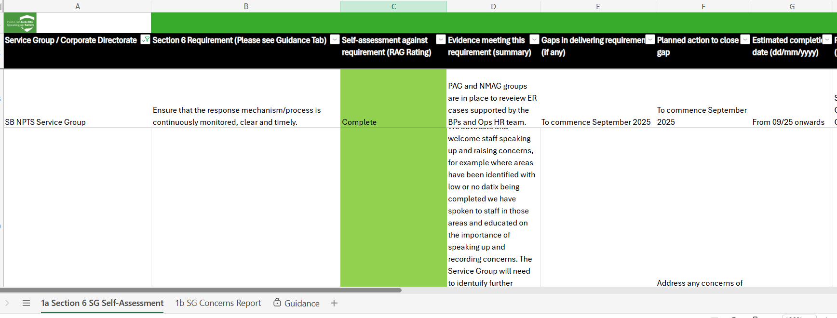

Figure 1b. Central Concerns Report
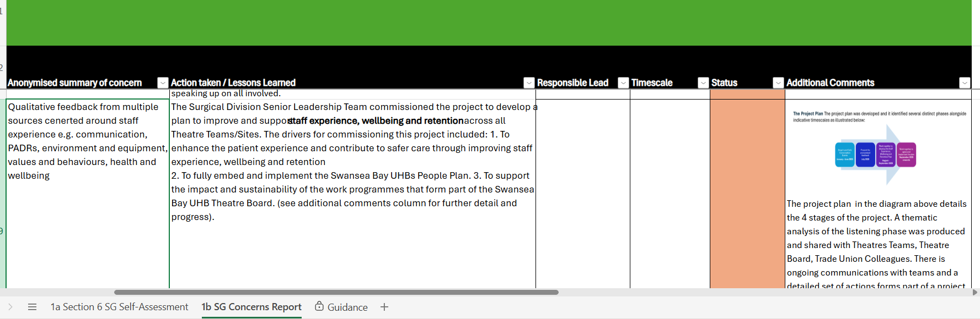

  - Continued Delivery of IA Recommendations
To implement the National Speaking Up Safely Framework and as part of promoting a culture that enables staff to raise concerns, Table 1 below outlines the position and status of those remaining recommendations and actions due by 31 March 2026. As per August’s Report, the progress outlined continues to be completed in collaboration with stakeholders, particularly that part of the Speaking Up Safely Working Group and Service Groups.
It is important to highlight that an element of internal audit action 3.1 (below) along with the original management response and associated timeframe requires reviewing and up-dating based on the current options appraisal due to be finalised by the end of April 2026. This is due to the potential impact it will result in for the current provision, infrastructure, recording and reporting/data triangulation. There is also due to be a review of the Workforce & OD Delivery Group Terms of Reference and membership which aims to further enhance triangulation.
Table 1.
Action | Status / Progress | Responsible Lead | Timeframe
IA Action 1.2  Outputs of the Speaking Up Safely Working / Stakeholder Group are to be monitored and reported quarterly via the Workforce & OD Delivery Group and 6-monthly via the Health Board Workforce & OD Committee. | COMPLETED  Speaking Up Safely Working Group established in November 2024, meeting bi-monthly since. Terms of Reference, notes and recordings evidenced.  Local rotational reporting by Service Groups commenced during August 2025 in line with the agreed reporting structure, a minimum of twice yearly. | Director of Workforce & OD | July / August 2025 and Feb/March 2026
IA Action 3.1  Development of an integrated report including data from all sources that receive concerns should be finalised to empower the health board to have complete oversight of all concerns, themes and trends. | TO BE REVIEWED  Investigations are being finalised, liaising with other NHS Wales and England organisations to understand their provision and how they gather and triangulate concerns raised. The NHS Wales Speaking Up Safely Learning Exchange has confirmed that there is no central platform that exists to capture and triangulate all concerns, with a majority using Work in Confidence to purely capture Workforce & ER related concerns. Further detail is to be provided in an options appraisal of Speaking up Provision and infrastructure by 30th April 2026.  The outcome and decision resulting from the options appraisal will significantly impact this recommendation and the original management response and timeline which will need to be reviewed. | Director of Workforce & OD | 31 March 2026
IA Action 3.2  Service Groups should amalgamate the detail of concerns raised (themes, trends, actions taken, lessons learned) and report to an appropriate Board-level committee to have an organisation-wide understanding of incidents arising. The reporting should also provide assurance that policy requirements, including timescales etc, are being adhered to. | COMPLETED  The first round of rotational reporting commenced in August 2025 and embedded local reporting from Service Groups into the overarching Speaking Up Safely Report, starting with Morriston & Primary Community & Therapy Services. Mental Health & Learning Disabilities and Neath Port Talbot & Singleton Service groups will report in February/March 2026 WOD Committee alongside the overarching Speaking Up Report.  Assurance against policy requirements being adhered to were also reported to WOD Committee last year as part of the Best Practice Review and is up-dated further in the Guardian Service Summary Report in appendix 1. | Director of Workforce & OD and Service Groups | 14 August 2025 and Feb/March 2026 WOD Committee

In addition, the following progress has been made:
- The final action for Workforce & OD, detailed in the Speaking Up Safely Action Plan (appendix 2) remains on track with plans being reviewed and finalised to integrate high-level Speaking Up Safely measures into the Workforce Performance Dashboard to support triangulation of workforce intelligence.
- The Raising Concerns Hub and associated Speaking Up Safely Resources, continues to be a standing item cascaded to Managers and Staff through the monthly Team Brief. The hub has also been made available to staff via the staff section of the Swansea Bay external internet site to enhance ease of access: Staff info - Swansea Bay University Health Board
- In addition to Brilliant Basics, Speaking Up Safely has been integrated into the New Consultant Development Programme to provide the strategic context, signposting and enhance their understanding of their leadership role in fostering a psychologically safe culture, locally. A copy of the presentation has been provided to internal audit.

  - Guardian Service Summary Report
Due to the timing of this report being ahead of the end of the financial year, the Guardian Service have provided a Summary Report in appendix 1 which includes activity between 1st April and 31st December 2025 and up-dates have been provided against those actions/recommendations that remain on-going from their 2024-2025 End of Year Report.
A summary of the actions being taken against the top two primary concern themes reported between April and December 2025 is summarised in table 2 below, however please see appendix 1 for more detail.
Table 2.
Main Concern Themes | Action Taken
- Management Concerns and System/Process | - ER cases reviewed monthly by the HR BPs with the Operational HR teams.  - HR BPs working with services / managers to provide support/guidance to employees where cases are prolonged/not in line with process.  - Best Practice Review working group on-going in social partnership.  - Individual case management sits with the Operational HR team who receive feedback and up-dates from the Best Practice Review Working Group to support collective improvement.  - ER Case dashboard developed and due to go live for use by HR BPs to report on case numbers, actions etc. as part of Service Group performance meetings.  - Training, resources and guidance for Managers is being built into the Brilliant Basics Platform in addition to stand alone training sessions offered.  - Progress up-date on the Best Practice Review presented to Health Board Partnership Forum in November 2025.  - Programme of work focusing on Leadership Development being finalised under WOD Director.  - A redesign of our behaviour-based Leadership Development offering completed and launched in September 2025 as ‘LEAD’. It is open to all Leaders and Managers and aligned to our Values, compassionate Leadership Principles and current organisational context in line with the CEO and Chair signing the NHS Wales Compassionate Leadership Pledge. The programme is run in collaboration with the QI Team to support focus around efficiencies and improvement. The 6-month impact and evaluation report will be undertaken in March 2026 for reporting through Workforce & OD Committee.

- GOVERNANCE AND RISK ISSUES

- An element of internal audit action 3.1 and the associated timescale for delivery require reviewing and up-dating in line with the outcome and decision resulting from the options appraisal (due for completion 30 April 2026).
- As per the risk submitted and detailed in April 2025’s report, delivery of Section 6 requirements of the national Speaking Up Safely Framework is reliant on Service Delivery Groups taking continual action to monitor and report. On-going capacity and operational pressures continue to present a risk. This will be further impacted by the impending Organised for Success, affecting current governance and reporting structures and arrangements.

- FINANCIAL IMPLICATIONS
The sustained cost and value for money from the Guardian Service are risks in the current financial climate of the Health Board and the likelihood of us exceeding 100 contacts this reporting year, due to the increase in the number of concerns being raised.

Costings of alternative options will be set out alongside the wider risks and associated costs in a review of our provision and infrastructure in mitigating against the risks whilst also ensuring staff remain safe and able to raise concerns anonymously, in addition to the other internal options available to them.

- RECOMMENDATION
Members are asked to:
- NOTE the Guardian Service Summary Report for April to December 2025.
- RECEIVE FOR ASSURANCE the Speaking Up safely progress report, including the summary report and up-date on recommendations from the Guardian Service.
- RECEIVE FOR ASSURANCE the continued improvement in local ownership through the central capture and local rotational reporting of concerns raised (themes, trends, actions taken, lessons learned) by Neath Port Talbot & Singleton and Mental Health & Learning Disabilities.

Governance and Assurance

Link to Enabling Objectives  (please choose) | Supporting better health and wellbeing by actively promoting and empowering people to live well in resilient communities
Link to Enabling Objectives  (please choose) | Partnerships for Improving Health and Wellbeing |  | ☒
Link to Enabling Objectives  (please choose) | Co-Production and Health Literacy |  | ☐
Link to Enabling Objectives  (please choose) | Digitally Enabled Health and Wellbeing |  | ☐
Link to Enabling Objectives  (please choose) | Deliver better care through excellent health and care services achieving the outcomes that matter most to people
Link to Enabling Objectives  (please choose) | Best Value Outcomes and High Quality Care |  | ☐
Link to Enabling Objectives  (please choose) | Partnerships for Care |  | ☐
Link to Enabling Objectives  (please choose) | Excellent Staff |  | ☒
Link to Enabling Objectives  (please choose) | Digitally Enabled Care |  | ☐
Link to Enabling Objectives  (please choose) | Outstanding Research, Innovation, Education and Learning |  | ☐
Health and Care Standards
(please choose) | Staying Healthy |  | ☐
(please choose) | Safe Care |  | ☐
(please choose) | Effective Care |  | ☐
(please choose) | Dignified Care |  | ☐
(please choose) | Timely Care |  | ☐
(please choose) | Individual Care |  | ☐
(please choose) | Staff and Resources |  | ☒
Quality, Safety and Patient Experience
Our Speaking Up Safely offerings, including the Guardian Service aims to improve staff experience through helping to create a culture of openness and honesty. The direct correlation between patient experience and staff experience is well documented. The previous Raising Concerns process with no dedicated pathway or infrastructure to support staff created risk to staff, patients and the wider organisation.
Financial Implications
The sustained cost and value for money from the Guardian Service are risks in the current financial climate of the Health Board and the likelihood of us exceeding 100 contacts this reporting year, due to the increase in the number of concerns being raised.

Costings of alternative options will be set out alongside the wider risks and associated costs in a review of our provision and infrastructure in mitigating against the risks whilst also ensuring staff remain safe and able to raise concerns anonymously, in addition to the other internal options available to them.
Legal Implications (including equality and diversity assessment)
It is important to consider the internal policies and the legislation which are linked to the wider National Framework for Speaking Up Safely, 2023 and provision of a confidential, safe and effective pathway and process for staff to raise concerns.

Internal policies include but are not limited to –
-Respect & Resolution
-Disciplinary Policy
-Procedure for NHS Staff Raising concerns

Public Interest Disclosure Act 1998
If workers bring information about a wrongdoing to the attention of their employers or a relevant organisation, they are protected in certain circumstances under the Public Interest Disclosure Act 1998. This is commonly referred to as 'blowing the whistle'. The law that protects whistle-blowers is for the public interest - so people can speak out if they find malpractice in an organisation. Blowing the whistle is more formally known as 'making a disclosure in the public interest'.

Duty of Candour, 2023
The duty of candour is a legal requirement for all NHS organisations in Wales. It requires them to be open and transparent with service users when they experience harm whilst receiving health care. They will be required to:
- talk to service users about incidents that have caused harm
- apologise and support them through the process of investigating the incident
- learn and improve from these incidents
- find ways to stop similar incidents from happening again
Staffing Implications
Delivery of Section 6 requirements of the national Speaking Up Safely Framework is reliant on Service Delivery Groups taking continual action to monitor and report. On-going capacity and operational pressures continue to present a risk. This will be further impacted by the impending Organised for Success, affecting current governance and reporting structures and arrangements.
Long Term Implications (including the impact of the Well-being of Future Generations (Wales) Act 2015)
Briefly identify how the paper will have an impact of the “The Well-being of Future Generations (Wales) Act 2015”, 5 ways of working.

The paper impacts on the Well-being of Future Generations (Wales) Act 2015 as it will impact on the long-term culture and behaviours of the organisation and its staff now and in the future. It aims to support staff, through working together to improve staff wellbeing and improve the quality of patient care and outcomes through early raising of concerns, intervention and nipping concerns in the bud before they escalate.
Report History |  | - Presented to WOD Committee, 20 February 2025 - Speaking Up Safely Report, including Internal Audit Report and Guardian Service 6-month Activity Report  - Reported to Q&S Committee, 8 April 2025 - Speaking Up Safely Quality & Safety Systems Quarterly Reporting  - Presented to WOD Committee, 10 April 2025 - Revised action plan and risks associated with the limited assurance internal audit report on Speaking Up Safely  - Presented to WOD Delivery Group, 29 July 2025 – Speaking Up Safely and Guardian Service End of Year Report 2024-5  - Presented to WOD Committee, 14 August 2025 - Speaking Up Safely and Guardian Service End of Year Report 2024-5  - Presented to Audit Committee – 18 September 2025 - Speaking Up Safely and Guardian Service End of Year Report 2024-5
Appendices |  | Appendix 1 – The Guardian Service Summary Report, 1 April to 31 December 2025.  Appendix 2 – Speaking Up Safely Action Plan, 2025-6

