Meeting Date | 23 February 2026 |  | Agenda Item |  |  | 3.6
Name of Meeting | Workforce & OD Committee
Report Title | Variable Pay Overview and Progress Update
Report Author | Emma Owen, Assistant Director of Workforce & OD
Report Sponsor | Tina Ricketts, Executive Director of Workforce & OD
Presented by | Tina Ricketts, Executive Director of Workforce & OD
Freedom of Information | Open
Purpose of the Report | To update the Committee on the variable, pay reduction plan and the progress that has been made to date.
Key Issues | Variable pay has reduced to 6.1% of total pay cost in January 2026 (compared to 7.4% in January 2025). Year to date (month 1 to 10) variable pay has reduced to 6% of the total pay bill compared to 7.78% for the same period last year.  Five workforce boards (each led by an Executive Director) meet weekly to review the drivers of variable pay for each staff group. The workforce boards also have responsibility for scrutinising all vacancies ahead of final review by the Vacancy Control Panel.  Medical and Nursing Staff Groups remain the highest users of variable pay.  A target of 50% reduction in variable pay (based on the 2025/6 outturn) has been set for 2026/7 as part of our cost improvement plan. This will be the equivalent of 300 WTE.
Specific Action Required  (please choose one only) | Information | Discussion |  | Assurance | Approval
Specific Action Required  (please choose one only) | ☐ | ☐ |  | ☒ | ☐
Recommendations | The Committee is asked to CONSIDER the report which is provided for assurance.

VARIABLE PAY PLAN OVERVIEW AND PROGRESS UPDATES

- INTRODUCTION
Variable pay remains a key challenge for the Health Board. Whilst reductions have been achieved the Health Board continues to use high levels of variable pay. A target of 50% reduction in variable pay has been set for 2026/7 as part of our cost improvement plans.

- BACKGROUND
The Health Board must achieve £55.4m in savings this year if it is to meet its financial plan. The Recovery and Sustainability Programme Board was established to achieve the required savings with 12 overarching workstreams. Enhanced workforce controls have been implemented in addition to a dedicated variable pay steering group.

A multi-disciplinary approach is being adopted to provide an overarching structure and cohesive approach to sustainable workforce changes focussed on:
- Variable Pay
- Staffing Unavailability
- Workforce establishment
The Variable Pay Steering Group has dedicated plans covering all professional staff groups that are led by Executive Directors. Overarching highlight reports are provided to the Recovery & Sustainability Board to monitor progress and ensure delivery.

- GOVERNANCE AND RISK ISSUES
The variable pay steering group has approved several plans for each professional group to address the on-going workforce challenges.

The key deliverables during the last reporting period (December 2025 and January 2026) include:

3.1 Top 100 leader's network
A network of leaders has been established to focus on a Healthier Swansea Bay that supports us to deliver services in a way that’s financially sustainable. The first session was held in December 2025 to engage with senior leaders to focus on “making every £ count”. The second session was held on 4 February 2026 and focused on sickness absence. It is planned that the network will meet quarterly.
3.2 Nursing Variable pay
Nursing have implemented changes to how bank work is managed within the acute sites (Morriston, NPT & Singleton). Central variable pays rosters have been created to manage the variable pay cap that has been agreed with the overall aim of achieving a 50% reduction in avoidable variable pay. The central rosters will allow the service groups to deploy bank workers to the greatest area of need based on staffing levels and acuity of patients. The reliance on variable pay will be gradual and monitored to ensure patient safety and management of clinical risk.

3.3 Vacancy/establishment management
An enhanced focus on vacancy and establishment management has continued. All contractual changes are now approved at service group workforce boards to ensure oversight and overall impact on the workforce. The Health Board are also in the process of removing all vacancies from budgets with exception to those areas covers by the Nurse Staffing Levels (Wales) Act 2016. This will not impact on the 2025/6 financial position but will improve our starting position for 2026/7.

3.4 Plans for 2026/2027
Analysis shows that since 2019 the Health Board workforce has increased its workforce by 2,321 full time equivalents where growth is visible across all the professional groups.

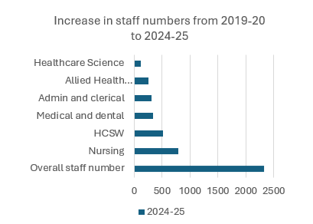

To support a sustainable workforce model, revised plans beginning April 2026 have been agreed to address some of the key workforce challenges. These include:

Sickness absence: All managers will have corporate objectives in relation to sickness absence management. These include:
- To complete and record all return-to-work interviews
- To complete and record all formal escalations under the managing attendance at work policy. Work is ongoing to identify central recording to monitor compliance.
- Sickness absence targets – each budget will be given an improvement target ranging from 0.5% -2% based on existing rates.

Headcount reduction: The Health Board has committed to re-shaping and right sizing the workforce to achieve a 900 whole time equivalent reduction over the next three years. This will be achieved in two ways:
- Reducing variable pay by 50%
- Turnover management – each budget has been allocated a 5% target based on their establishment on 1 April 2026.
- Fixed term contract reviews to establish if agreements can be terminated early.

Vacancy management: In addition to the existing measures that have been implemented on vacancy control there will be a vacancy rate of 5% will be applied to all budgets. Changes to the vacancy control process will also be implemented to include:
- A standardised business case to support each vacancy being requests. This will ensure that posts are considered on clinical need, funding, establishment growth and effective budgetary management.
- Vacancy categorisation for all posts to ensure that posts are prioritised.

- FINANCIAL IMPLICATIONS

During the last 12 months the Health Board has experienced challenges in significantly reducing the spend relating to variable pay. The information below outlines the variable pay spend. It is possible to see some continued reductions across all categories however this needs to significantly reduce to achieve target.

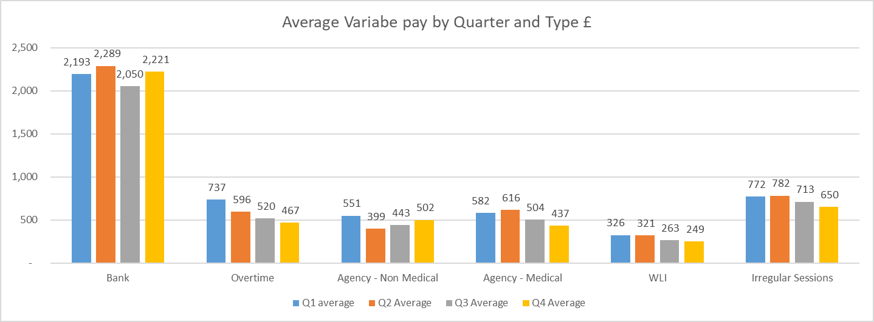

- Agency

The table below outlines the whole time equivalent (WTE) usage for 2025/6 split between framework and non-framework. Please note that the increase seen in the information was due to the visibility & reporting of Healthcare Scientists and Allied Health Professionals.

Whilst good progress has been achieved in non-medical agency usage, we are still experiencing challenges with medical agency usage (outlined below).

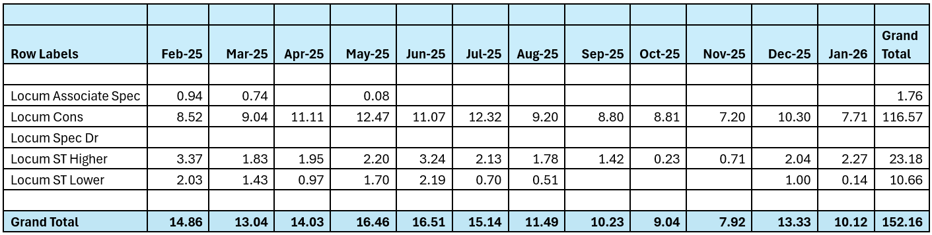

Please note that there is no off-framework agency usage recorded for Medical cover. Below is the capped rate information for internal medical locums and agency for November 2025, December 2025 and January 2026. Please note that data for January 2026 may change due to corrections being applied for pay processing periods.

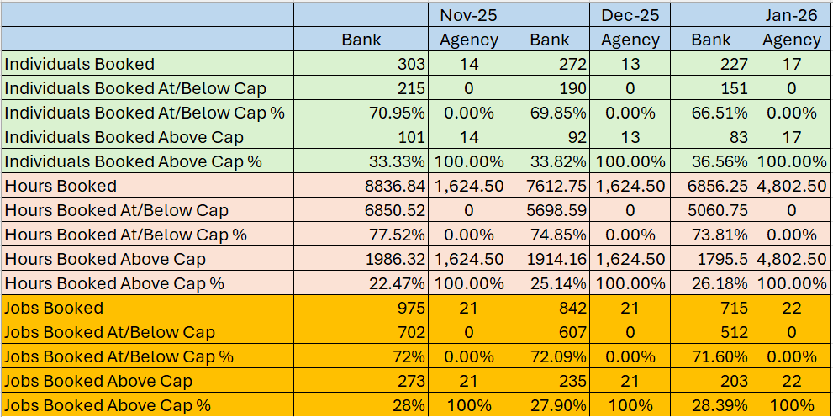

5.1 Agency Audit
During 2024 an internal audit investigation took place to seek assurance regarding the management of agency workers. The audit recommended further action in the following areas:

- No overarching agency/temporary staffing policy (key finding 1:1) – this is in development and will be signed off at the variable pay steering group as it encompasses all professional groups.
- ID checks for agency workers (Key finding 6:1) – all service groups have been made aware of their responsibilities in undertaking ID checks for all temporary staff. The bank office has also implemented an audit programme for nurse agency workers which will report compliance to the workforce & OD committee on a 6 monthly basis.
- Pre employment check audits for Nurse agency workers (Key finding 4:1 & 4:2) – The Health Board engages with several agency workers. Agencies are required to provide assurance that they have completed the necessary governance checks for workers and are asked to complete a checklist when presenting a new worker to the Health Board. However, the Health Board does not have the ability to audit these checks as the employer is the agency itself which is part of all Wales nursing framework. The Health Board has engaged with NWSSP in respect of this risk who have advised that there will be a potential charge to the Health Board for completing the audits. This is being pursued by NWSSP and further updates will be provided. However, whilst this continues to be a challenge the Health Board will on a 6 monthly basis receive written confirmation from Shared Services that they have obtained this assurance on the checks being undertaken which will be reported to workforce and OD committee.

- RECOMMENDATION
The committee is asked to consider the report which is provided for assurance.

Governance and Assurance

Link to Enabling Objectives  (please choose) | Supporting better health and wellbeing by actively promoting and empowering people to live well in resilient communities
Link to Enabling Objectives  (please choose) | Partnerships for Improving Health and Wellbeing |  | ☒
Link to Enabling Objectives  (please choose) | Co-Production and Health Literacy |  | ☐
Link to Enabling Objectives  (please choose) | Digitally Enabled Health and Wellbeing |  | ☐
Link to Enabling Objectives  (please choose) | Deliver better care through excellent health and care services achieving the outcomes that matter most to people
Link to Enabling Objectives  (please choose) | Best Value Outcomes and High-Quality Care |  | ☒
Link to Enabling Objectives  (please choose) | Partnerships for Care |  | ☐
Link to Enabling Objectives  (please choose) | Excellent Staff |  | ☒
Link to Enabling Objectives  (please choose) | Digitally Enabled Care |  | ☐
Link to Enabling Objectives  (please choose) | Outstanding Research, Innovation, Education and Learning |  | ☐
Health and Care Standards
(please choose) | Staying Healthy |  | ☐
(please choose) | Safe Care |  | ☐
(please choose) | Effective Care |  | ☒
(please choose) | Dignified Care |  | ☐
(please choose) | Timely Care |  | ☐
(please choose) | Individual Care |  | ☐
(please choose) | Staff and Resources |  | ☒
Quality, Safety and Patient Experience
Engaged motivated and health staff will impact on patient care and clinical outcomes.
Financial Implications
We need to reduce our variable pay by £34.5m if we are to meet the financial target set by the Government.
Legal Implications (including equality and diversity assessment)
None identified.

Staffing Implications
Staffing issues will impact on both the quality and financial sustainability of services.

Long Term Implications (including the impact of the Well-being of Future Generations (Wales) Act 2015)
Best use of resources.
Report History |  | Not applicable
Appendices |  | None.

