Meeting Date | 23 February 2026 |  | Agenda Item |  | 3.4
Name of Meeting | Workforce and OD Committee
Report Title | Organised for Success Programme Update
Report Author | Tina Ricketts, Director of Workforce & OD & Dr Matt Lewis, Programme Lead
Report Sponsor | Tina Ricketts, Director of Workforce & OD
Presented by | Tina Ricketts, Director of Workforce & OD
Freedom of Information | Open
Purpose of the Report | This report updates the Board on the progress of the Organised for Success programme. The current status of the programme is as follows:
  Phase | Description | Status
  A | Executive Portfolios | Stage 1 completed
  B | Deputy/ Tier 2 Management Structure | In progress
  C | The Establishment of a Delivery Unit | In progress
  D | Joint Posts across the Regional Partnership | Not started
  E | The establishment of a new care group structure | In progress
  F | A review of the care group leadership structure – confirming the Triumvirate Leadership model (e.g. operationally led or clinically led) | In progress
  G | A review of the number of divisions or directorates within each new care group to ensure spans of control are reasonable and equitable. This will include a review of the specialities and services managed under each of the care groups to ensure they are organised in the best way for our patients | In planning
  H | A review of the number of management layers within the new care groups with the aim to have a maximum of 6 layers, where appropriate, from Board to front line staff with a focus for this programme on the top 4 layers (Tri, Division, Directorate, speciality/ service) | In planning
  I | A review of the wraparound support for each new care group (e.g. HRBP, Finance BP) to ensure this is reasonable and equitable | Not started
  J | A review of corporate functions sitting in/ out of care groups to ascertain the most appropriate design of the function (e.g. hub and spoke, centralised) | Not Started
Key Issues | General Update  The board agreed the following updates on 29 January 2026:  - Transition from four geographically based service groups to six thematic based care groups.  - Neighbourhood Care Group to be renamed as Integrated Community Services Care Group  - Wider consultation to be undertaken for Phase 2F (Leadership Model)  - Go Live date for Care Groups confirmed as 1 September 2026  Programme Specific Updates  Phase 1; Stage A: The executive team portfolios. Portfolios issued with Board paper.  Phase 1; Stage B: The executive team deputy structure. Ongoing, this will be completed by 30 June 2026.  Phase 1; Stage C: Delivery Unit Update. Work has progressed on the establishment of the Delivery Unit.  Through ongoing work, the proposed structure of the Delivery Unit has now crystallised around two central pillars:  - Pillar 1 – PMO  - Pillar 2 – Performance and Business Intelligence  An initial scoping review has identified up to 232 staff potentially in scope across functions related to transformation, PMO, improvement, BI and performance. The initial sift is ongoing and will conclude who is in scope and an accurate figure regarding numbers and associated costs. An engagement process will take place during February and possibly March to gain greater clarity regarding staff identified as in scope, this will include a survey to gain clarity about current staff roles and responsibilities.  On completion a refocussing will occur to align the Delivery Unit to the Health Board’s priorities.  Phase 2; Stages F, G and H (Care Group & Management Structures): Preparation Phase (February)  A Triumvirate request for leadership support and accompanying survey has been developed for distribution to the current Service Group Triumvirate Directors.  The purpose is to:  - Seek views on whether Phases F, G, H should be completed sequentially or concurrently  - Determine the appropriate level of organisational engagement (Triumvirate only, or extending to Divisions, Directorates and Specialities)  - Validate which groups, functions or specialities are be included or excluded.  - Identify risks, constraints and service pressures that may affect sequencing  - Test early thinking on Care Group clustering (strawman configurations)  The email and survey will formally request Triumvirate leaders’ involvement to ensure a shared understanding and alignment ahead of the Care Group go live date of 1 September 2026.  Phase 2; Stages F, G and H: Engagement, Analysis and Reporting Phase (March & April)  A comprehensive engagement process is being designed to involve broader leadership from within the current service groups in shaping the future leadership model and organisational structure.  This engagement will run in March, followed by analysis and reporting during April.  The engagement seeks views on:  - Stage F: The preferred Care Group leadership model (clinically led, operationally led, or hybrid), including clear definitions of accountability through RACI options.  - Stage G: The number of divisions and directorates within each Care Group, including clustering principles and spans of control.  - Stage H: The number of management layers from Board to frontline (aiming for ≤6 layers where safe to do so)
Specific Action Required  (please choose one only) | Information | Discussion | Assurance | Approval
Specific Action Required  (please choose one only) | ☐ | ☐ | ☒ | ☐
Recommendations | The Committee is asked to CONSIDER the contents of the Programme update, which is provided for assurance.

Organised for Success Programme

- Introduction/ Background
The Organised for Success programme has been set up to support us to be organised in the most effective way to delivery in year and medium terms improvements. The programme is a key enabler in the delivery of the savings benefit associated with headcount reduction (as identified by the Recovery and Sustainability Board), which will include a management restructure of our clinical services and corporate functions.
This programme of work will review executive portfolios, service group structures and management spans of control and will make recommendations on how we organise ourselves for success. The programme will also bring together our PMO, transformation, business intelligence, performance and improvement capability through the establishment of a Delivery Unit.
- Terms of Reference
The terms of reference of the programme were shared with Board in January 2026. The governance structure for the programme is set out in the diagram below. The Formal Executive Team Meeting will be the Steering Group for the programme with key decisions being made by the Board. The Management Board will receive regular progress updates and will be consulted and engaged on key decisions.
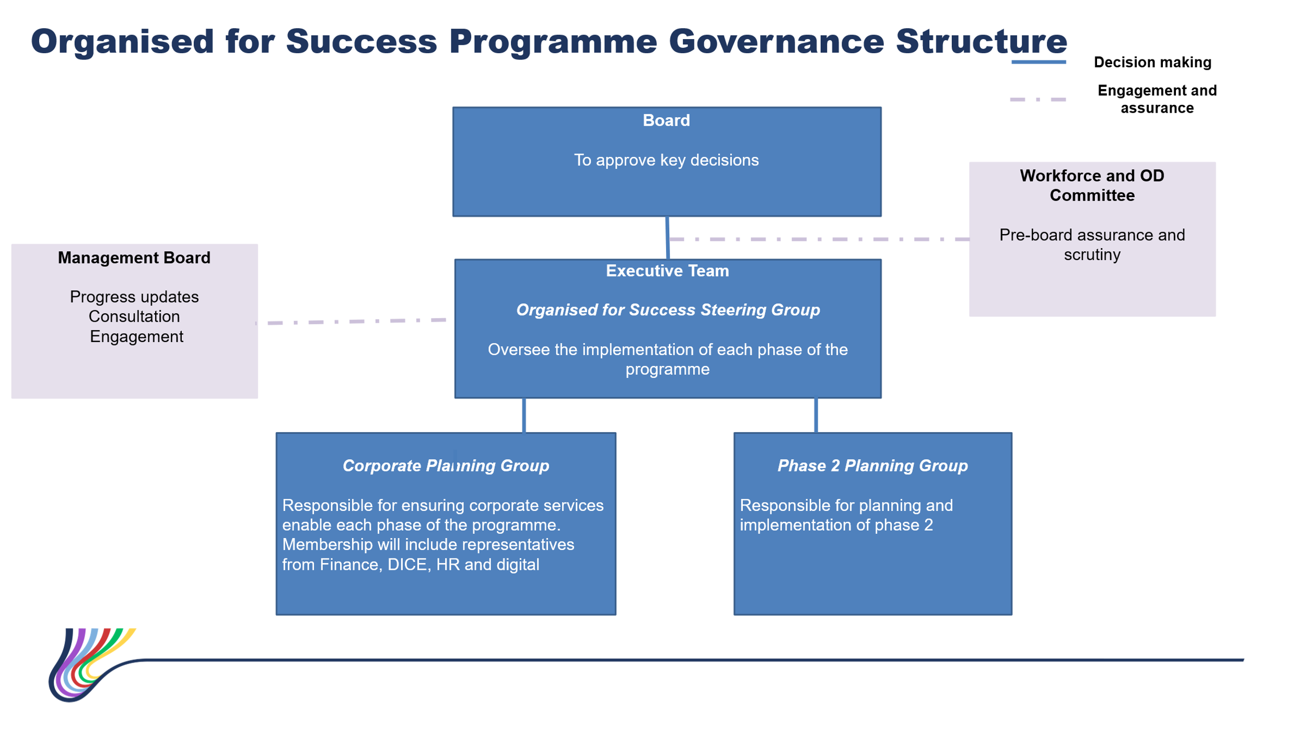
- Executive Portfolios
The review of the executive team portfolios has been completed.
The portfolios may be subject to further review following the resignation of the Director of Finance. This will be completed by 31 March 2026.

- Executive Team Deputy Structure
Meetings are taking place with each executive team director to review their deputy structure in response to the changes to executive team portfolios.
This work will be completed by 30 June 2026.
- Central Delivery Unit
A central delivery unit will be established by 1 April 2026. The following functions are being considered for the delivery unit, subject to consultation:
- PMO programme/project management
- Transformation
- Improvement
- Business Intelligence
- Performance

The purpose of the Delivery Unit continues to be refined, with the following proposed core objectives:
- Oversight and Coordination: To oversee and coordinate the identification, development, and monitoring of savings plans.
- Programme Support: To support the delivery of transformational, operational improvement and productivity programmes.
- Benefits Realisation: To track and evidence the realisation of benefits arising from these programmes.
- Unified Framework and Methodology: To operate within an agreed accountability framework and apply a single, consistent improvement methodology.
- Performance Management: To establish and maintain a performance management infrastructure, including KPIs, tracking, reporting and data analysis to support insight driven decision making.
In support of this structure, three key leadership roles have been identified:
- Interim Director of Transformation & Delivery (Indicative VSM):
A newly created role, subject to approval, that will oversee the establishment of the Delivery Unit, lead the initial “lift and shift”, and subsequently head the Unit. The postholder will initially be accountable to the Chief Executive Officer.
- Interim Director of Performance & BI (Indicative Band 9):
The new job description has been developed, is currently being evaluated through the Job Evaluation Panel, and the role will then be advertised.
- Interim Head of PMO (Indicative Band 8D):

The new job description has been developed, is currently being evaluated through the Job Evaluation Panel, and the role will then be advertised internally through expressions of interest.
An initial scoping review has identified up to 232 staff potentially in scope across functions related to transformation, PMO, improvement, BI and performance. The initial sift is ongoing and will conclude who is in scope and an accurate figure regarding numbers and associated costs.
An engagement process will take place during February and possibly March to gain greater clarity regarding staff identified as in scope, this will include a survey to gain clarity about current staff roles and responsibilities.
On completion a refocussing will occur to align the Delivery Unit to the Health Board’s priorities.
Stage 1 will be to “lift and shift” the agreed functions into the delivery unit. Stage 2, a review of how the delivery unit should be structured, will be led by the Interim Director of Transformation & Delivery when they are in post (subject to the post being approved). It should be noted that Stage 2 is outside the scope of the Organised for Success Programme.
- Proposed Care Group Structure
The proposed Care Group Structure, with one name change (Integrated Community Services Care Group) was approved by the Board on 29 January 2026.
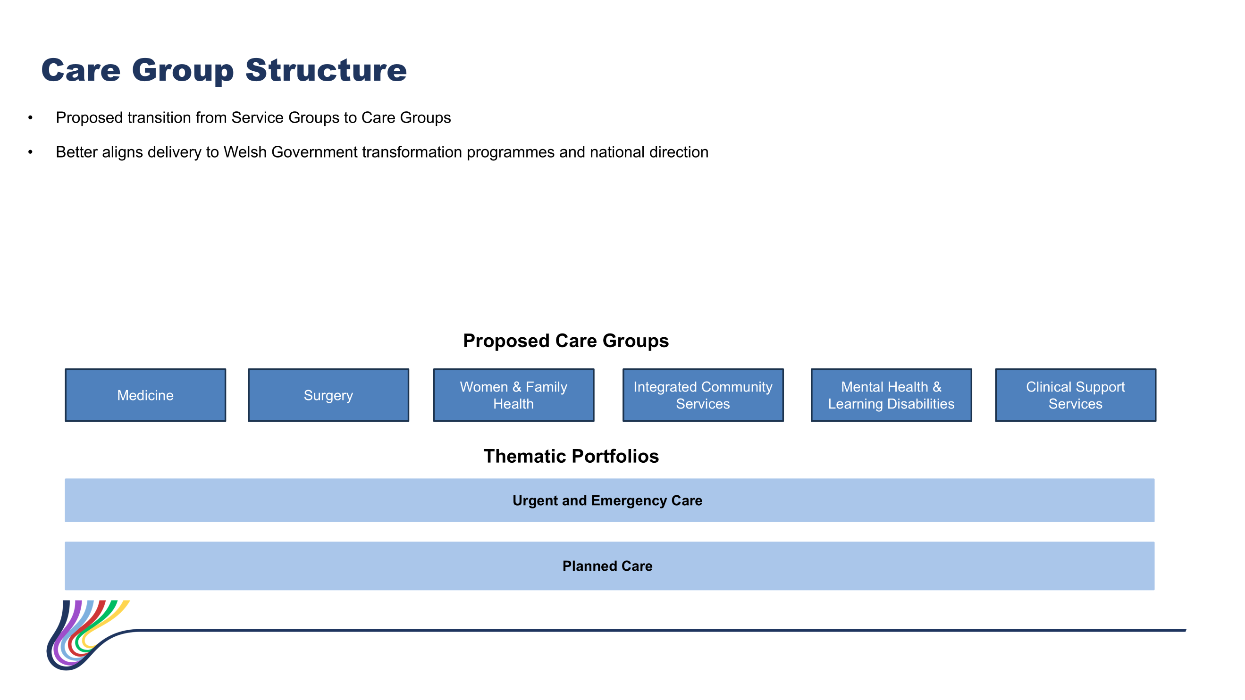

Further consultation and enagement on the structure and content of each Care Group will take place as part of Phase 2 G i.e., where each service/ speciality will sit and how they will be grouped.
Following the inconclusive feedback regarding the leadership model and implementation date, support was gained for broadening the engagement and an extension approved for implementation (September 2026).
Planning will continue at pace to establish the new care group structures and to support the identification of priority services for transformation.
- Key Risks
The Workforce and OD Committee should be aware of the following risks:
Key Risks | Current risk rating | Mitigating Actions | Risk Owner
There is a risk that the implementation of the programme will be delayed due to lack of programme management capacity | 8 | Programme Lead appointed and commenced full-time on 2 January 2026 | Director of Workforce & OD
There is a risk that the challenging timelines of the programme will not be met due to senior colleagues not seeing this programme as a priority/ not releasing the required resource | 12 | The resourcing of the programme will be overseen by the Steering Group.  The establishment of a central delivery unit has been incorporated in phase 1 of the programme. This will be responsible for ensuring that all key HB programmes are adequately resourced. | Director of Workforce & OD
There is a risk that the operational performance of the Health Board is negatively impacted as colleagues become distracted with the programme/ associated organisational change processes | 9 | Operational performance will be overseen by the central delivery unit. The establishment of a delivery unit has been incorporated in phase 1 of the programme.  Gateways are being developed for each phase of the programme so that a decision can be made on whether we can “go” safely. The criteria for each gateway will be shared with the Board for approval. | Chief Operating Officer  Programme Lead
The programme will require a restructure of our budgets and corporate systems (e.g. the Electronic Staff Record System). There is a risk that this may limit the capacity of the corporate teams to work on other priorities. | 12 | Two planning groups have been set up with one focused on the restructure of our budgets and corporate systems. Regular updates on progress will be provided to the Steering Group. The impact on other priorities will be managed through the delivery unit. | Programme Lead

- Next Steps
The programme lead’s priorities are as follows:
- Finalise and publish updated Executive Team job descriptions
  - Complete the revisions to Executive Team JDs to reflect the updated portfolios (Phase 1; Stage A) and prepare for evaluation where required.
- Progress the Delivery Unit establishment and engagement alongside the Task and Finish Group
  - Finalise the staff in scope list for the initial “lift and shift”.
  - Support recruitment actions for the Director of Performance & BI and next steps for the Director of Transformation & Delivery.
  - Continue refining the Delivery Unit operating model ahead of formal consultation.
  - Lead the February–March engagement process with staff potentially in scope for the Delivery Unit, including issuing/analysing the staff roles/responsibilities survey.
- Support the preparation and execution of Phase 2F–H engagement
  - Oversee the distribution, monitoring and analysis of the Triumvirate Support Request and survey (February).
  - Finalise the full engagement pack, including slide decks, FAQs, supporting materials and RACI options. (February)
  - Coordinate Executive led workshops / webinars with Triumvirate, Directorate and additional leaders. (March)
  - Lead the leadership engagement for Phase 2F–H (March)
- Continue development of gateway criteria for all phases
  - Complete the draft gateway criteria for Phase 2F–H.
  - Begin preparing system readiness assessments aligned to the 1 September 2026 Care Group go live.
- Setting up and lead two planning groups
  - Support operational alignment activities for the new Care Group model

- Recommendations
The Workforce and OD committee is asked to CONSIDER the contents of the Programme update, which is provided for assurance.

Governance and Assurance

Link to Enabling Objectives  (please choose) | Supporting better health and wellbeing by actively promoting and empowering people to live well in resilient communities
Link to Enabling Objectives  (please choose) | Partnerships for Improving Health and Wellbeing |  | ☐
Link to Enabling Objectives  (please choose) | Co-Production and Health Literacy |  | ☐
Link to Enabling Objectives  (please choose) | Digitally Enabled Health and Wellbeing |  | ☐
Link to Enabling Objectives  (please choose) | Deliver better care through excellent health and care services achieving the outcomes that matter most to people
Link to Enabling Objectives  (please choose) | Best Value Outcomes and High-Quality Care |  | ☒
Link to Enabling Objectives  (please choose) | Partnerships for Care |  | ☐
Link to Enabling Objectives  (please choose) | Excellent Staff |  | ☒
Link to Enabling Objectives  (please choose) | Digitally Enabled Care |  | ☐
Link to Enabling Objectives  (please choose) | Outstanding Research, Innovation, Education and Learning |  | ☐
Health and Care Standards
(please choose) | Staying Healthy |  | ☐
(please choose) | Safe Care |  | ☐
(please choose) | Effective Care |  | ☐
(please choose) | Dignified Care |  | ☐
(please choose) | Timely Care |  | ☐
(please choose) | Individual Care |  | ☐
(please choose) | Staff and Resources |  | ☒
Quality, Safety and Patient Experience
The aim of phase 2 of the programme is to structure our services to improve patient experience. Currently services are structured on a geographical basis.
Financial Implications
The financial savings from the programme have not yet been quantified as we are still working through potential scenarios including the impact of the pay protection policy.
Legal Implications (including equality and diversity assessment)
An equality and diversity impact assessment will be undertaken for each phase of the programme.
Staffing Implications
The aim of the programme is to see a reduction in management tiers and equity in spans of control where possible. Staffing implications are still being scoped.
Long Term Implications (including the impact of the Well-being of Future Generations (Wales) Act 2015)
As set out in the report.
Report History |  | Not applicable
Appendices |  | None.

