Meeting Date | 23 February 2026 |  | Agenda Item |  |  | 3.2
Report Title | Regular Report from the Director of Workforce & OD
Report Author | Tina Ricketts, Executive Director of Workforce & OD
Report Sponsor | Tina Ricketts, Executive Director of Workforce & OD
Presented by | Tina Ricketts, Executive Director of Workforce & OD
Freedom of Information | Open
Purpose of the Report | This is a regular report to notify the Committee of key national and local issues that may impact on our workforce. The report covers the period 1 January to 28 February 2026.
Key Issues | The report contains the following updates:  National issues:  - New legal powers to protect NHS staff in Wales  - The Employment Rights Act 2025  - A healthy NHS Workforce case for change  - The new Electronic Staff Records System  Local issues:  - Anonymous emails relating to Gorseinon  - Equality, Diversity and Inclusion Compliance  - Workforce Transformation & Modernisation
Specific Action Required  (please choose one only) | Information | Discussion |  | Assurance | Approval
Specific Action Required  (please choose one only) | ☒ | ☐ |  | ☐ | ☐
Recommendations | The Committee is asked to ACCEPT the report which is provided for information.

Workforce HORIZON SCANNING

- INTRODUCTION
This is a regular report to alert the Committee to matters and issues that may impact on our workforce. We work within a complex and changing environment with many factors that may impact on our workforce. It is therefore important that the Committee are notified of these updates to help anticipate impact and risk.

The aim of this report is to horizon scan on a national, regional and local basis.

- NATIONAL ISSUES

2.1 New legal Powers to Protect NHS Staff in Wales
New legal protections for NHS staff against nuisance and disruptive behaviour in hospitals have come into force in Wales. The changes create a specific offence of causing nuisance or disturbance on NHS premises and give the police and authorised NHS officers the power to remove people.
Nuisance and disruptive behaviour includes verbal abuse, physically obstructing corridors, preventing staff from carrying out their duties and creative excessive noise in waiting areas, wards and other areas. The powers do not apply to patients seeking medical advice, treatment or care for themselves.
People who cause a nuisance or disturbance; who refuse to leave when asked by staff or police and are not on the premises to receive medical care themselves, could be affected by the powers.
The new powers, which are part of the Criminal Justice and Immigration Act 2008, are designed to protect staff, patients and visitors so that NHS services can continue without disruption. It will also give police the power to remove a person suspected of committing the offence, using reasonable force if necessary. It has been developed in partnership with the Anti-Violence Collaborative, Police, Crown Prosecution Service, NHS Wales organisations and trade unions.

2.2 The Employment Rights Act 2025
The employment rights bill officially became law on 18 December 2025 after receiving Royal Assent. It is now known as the Employment Rights Act 2025.The act introduces new provisions and amendments to existing employment legislation, including updates to the Employment Rights Act 1996. The provisions within the act will come into place over a phased two-year period, with most scheduled for 2026 and 2027. However, the Strikes (Minimum Service Levels) Act 2023 is to be repealed with immediate effect (i.e. from 18 December) and we expect parts of the Trade Union Act 2016, specifically those relating to ballot turnout and thresholds, to take effect from February 2026.
We are working with NHS Employers Wales and other Health Boards to review the impact of the Act on current policies and practices. Regular updates will be provided to the Committee going forward.

2.3 Update on ‘A Healthy NHS Workforce – Case for Change’
This review, led by Health Education and Improvement Wales (HEIW) and Public Health Wales (PHW), provides a comprehensive analysis of workforce wellbeing across NHS Wales. It responds to the urgent need to improve staff health, resilience, and retention in the face of rising service demands, workforce pressures, and evolving national policy commitments. The review draws on national data, extensive stakeholder engagement, and global best practice to inform a coordinated, preventative, and inclusive approach to workforce wellbeing.

Health Board colleagues have contributed to the review and it is anticipated the final version, to be released in the Spring, will contribute to our plans to reduce sickness absence and ensure ‘good work’ for all staff.

2.4 New Electronic Staff Records System
The NHS Business Services Authority (NHSBSA) has awarded a £1.2 billion contract to Infosys to deliver a new and enhanced workforce management solution for the NHS including across Wales.
The solution will support the Health Board and our staff by providing a complete employment lifecycle platform, generating significant benefits over the 15-year contract duration. It will support everything from recruitment and onboarding to career development, workforce management, payroll and retirement.
Hywel Dda Health Board has been identified as an early adopter for NHS Wales and we will benefit from their learning through the regional partnership. The system will be funded by Government for the first 2 years but will incur revenue costs from 2027/8 onwards as set out in the table below.
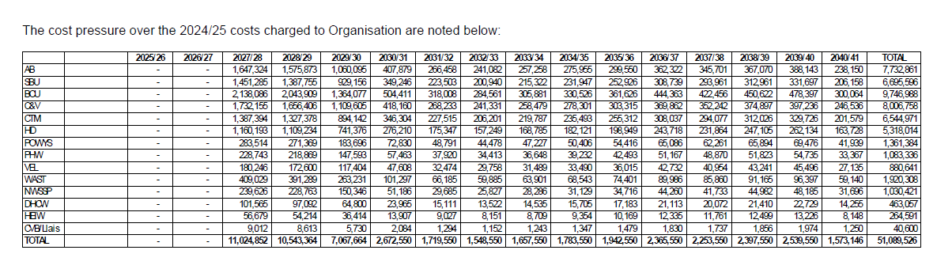
- LOCAL ISSUES/MATTERS

3.1 Concerns raised by staff at Gorseinon
During January 2026 we received several anonymous emails raising concerns about the outcome of a respect and resolution case relating to the culture of the inpatient ward at Gorseinon. Some of the emails also raised concerns that the band 7’s and 8’s at Ward 3 in Singleton (where some of the Gorseinon staff have moved to) were under undue scrutiny. Similar emails were sent to several external stakeholders including the Welsh Government and Audit Wales.

This matter was discussed at the Health Board Partnership Forum in January with staffside raising concerns about the validity of the emails as they were from a source outside of the NHS. Furthermore, staffside confirmed that they had not been contacted by staff working in these areas with any concerns and therefore they questioned whether the emails were a true representation of the views of staff.

All emails have been responded to, and we have offered to meet with the author(s) of the emails to listen to their concerns and support them to take them forward in line with Health Board Policy.

3.2 Assurance on EDI Training Compliance
A referral has been made to the Committee to seek assurance on Equality, Diversity and Inclusion training compliance.

All staff are required to complete an e-learning module as part of their mandatory training compliance and as of 10 February 2026 our compliance is at 91%.

  - Transformation and Modernisation
The Board has asked the Committee to seek an update on current capacity and any constraints to support the transformation and modernisation of the workforce. The Health Board does have sufficient capacity as evidenced by the work being undertaken through the Organised for Success programme, but this is not currently organised in the best way to focus on Health Board priorities.

We are working at pace to establish a Central Delivery Unit which will become the “engine room” of the organisation. Please refer to the Organised for Success Programme Update report for further information.

- RECOMMENDATION
The Committee is asked to ACCEPT the report which is provided for information.
Governance and Assurance

Link to Enabling Objectives  (please choose) | Supporting better health and wellbeing by actively promoting and empowering people to live well in resilient communities
Link to Enabling Objectives  (please choose) | Partnerships for Improving Health and Wellbeing |  | ☐
Link to Enabling Objectives  (please choose) | Co-Production and Health Literacy |  | ☐
Link to Enabling Objectives  (please choose) | Digitally Enabled Health and Wellbeing |  | ☐
Link to Enabling Objectives  (please choose) | Deliver better care through excellent health and care services achieving the outcomes that matter most to people
Link to Enabling Objectives  (please choose) | Best Value Outcomes and High-Quality Care |  | ☐
Link to Enabling Objectives  (please choose) | Partnerships for Care |  | ☐
Link to Enabling Objectives  (please choose) | Excellent Staff |  | ☒
Link to Enabling Objectives  (please choose) | Digitally Enabled Care |  | ☐
Link to Enabling Objectives  (please choose) | Outstanding Research, Innovation, Education and Learning |  | ☐
Health and Care Standards
(please choose) | Staying Healthy |  | ☐
(please choose) | Safe Care |  | ☐
(please choose) | Effective Care |  | ☐
(please choose) | Dignified Care |  | ☐
(please choose) | Timely Care |  | ☐
(please choose) | Individual Care |  | ☐
(please choose) | Staff and Resources |  | ☒
Quality, Safety and Patient Experience
None identified
Financial Implications
As identified in the report
Legal Implications (including equality and diversity assessment)
As identified in the report.
Staffing Implications
As set out in the report.
Long Term Implications (including the impact of the Well-being of Future Generations (Wales) Act 2015)
There are no long-term implications in relation to the impact of the Wellbeing of Future Generations Act unless identified specifically.
Report History |  | None
Appendices |  | None

