Meeting Date | 23 February 2026 |  | Agenda Item |  |  | 2.2
Name of Meeting | Workforce and OD Committee
Report Title | Workforce Report – Primary Community and Therapy Service Group (PCTSG)
Report Author | Craige Wilson, Service Group Director PCTSG  Ruth George, Human Resources Business Partner PCTSG
Report Sponsor | Tina Ricketts, Executive Director of Workforce and Organisational Development, Swansea Bay University Health Board.
Presented by | Craige Wilson, Service Group Director PCTSG
Freedom of Information | Open
Purpose of the Report | The purpose of the report is to provide an update on the following:  - Workforce performance against key metrics  - An overview of workforce risks and issues affecting PCTSG.  - Staff Survey Action Plan Progress
Key Issues | The key issues relate to the following:  - Ongoing unavailability challenges across nursing and additional clinical services staff groups  - Overview of main workforce risks
Specific Action Required  (please choose one only) | Information | Discussion |  | Assurance | Approval
Specific Action Required  (please choose one only) | ☒ | ☐ |  | ☒ | ☐
Recommendations | - ACKNOWLEDGE the Service Groups Workforce Metrics, Risks and Staff Survey Progress Actions.  - BE ASSURED of the actions being taken to ensure compliance with workforce metrics to support and improve the health and wellbeing of staff.
WORKFORCE REPORT - PCTSG

- INTRODUCTION

This report will provide a workforce update on the following:

- Performance against key workforce metrics
- An overview of workforce risks/issues affecting PCTSG.
- Staff Survey Action Plan Progress

- BACKGROUND

2.1 Performance against key workforce metrics and associated action

Heatmap of key workforce metrics as of January 2026

Primary Care Community and Therapy Group | Absence FTE | Leavers Turnover FTE (12months) | PADR  Completed | Stat & Mandatory  Compliance
Total | 7.49% | 6.50% | 82.33% | 92.68%

Sickness Absence

- Total absence across the Service Group as of January 2026 was 7.49% (in month), this is an improvement in comparison to December 2025 when the in-month rate was 8.08%.
- Over the last 12 months, the in-month absence rate has ranged been between 5.48% (March 2025) and 8.08% (November and December 2025).
- In month long term absence rates peaked at 6.36% in December 2025, with the lowest rates at 3.90% (February 2025) and 4.65% (January 2026).
- In month short term absence rates across the Service Group have ranged between 1.45% (March 2025) and 2.84% (January 2026).
- The majority of absence during the previous 12 months, can be attributed to Anxiety, Stress and Depression followed by Musculo-Skeletal (for long term absence) and Anxiety, Stress and Depression followed by Cough, Cold and Flu and Gastrointestinal Problems for short term absence. These absence reasons accounted for over 58% of the total absences.

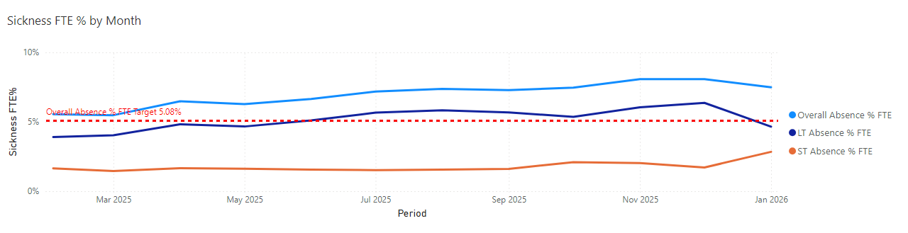
- In month absence rates across the Service Group have been below the projected (forecasted) rates until June 2025.
- Absence rates since July 2025 have been increasing above projected rates, but in January 2026 there was an improved position compared to previous months.

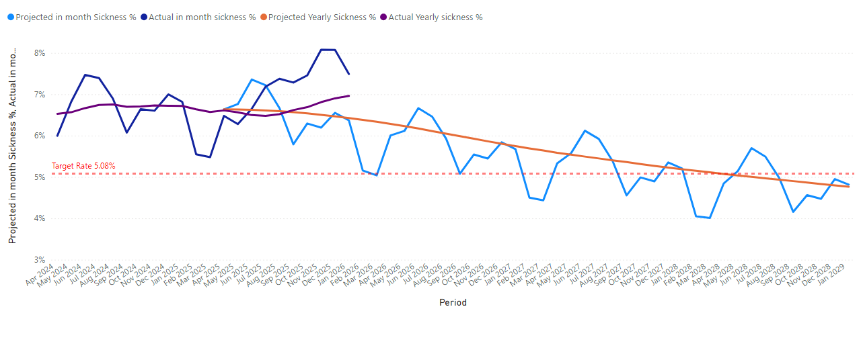

In order to address these issues, the following actions are ongoing:

Overarching Sickness Improvement Actions

Themes | Actions | Timescales
Leadership Engagement and Managerial Accountability | Strengthening Our Focus on Sickness Improvement:  - Clear messaging around sickness being a key priority.  - Reinforcing the message that this is a key area that requires our collective attention and commitment.  - As leaders there is a vital role to play in shaping the environment our teams work in and by taking clear ownership of sickness performance, each leader could make a real difference. | 08/25 Onwards
Sickness Management | - Roll out programme of sickness audits for Hot Spot Areas scheduled from 07/25.  - Absence Summits – undertaken in Hot Spot Areas from 06/25. These summits have been designed to enable a proactive approach to managing attendance at work, to include understanding the underlying data and themes contributing to sickness absence, the development of local managing attendance at work action plans and to support both Long and Short-Term staff absence.  - Monthly sickness surgeries - The HR Business Partner team and Operational HR Team work alongside the management team to ensure Long and Short-Term cases are being appropriately managed, supported, and progressed. The surgeries also instigate Case Reviews which may require specialist advice input e.g., Occupational Health. | 06/25 Onwards
Key improvement actions relating to top 3 absence reasons | Specific actions taken for Anxiety, Stress and Depression are:  - Early contact – with a compassionate approach  - Regular contact / touch points during absence period  - Regular sickness review meetings with support from HR Ops Team in line with the revised HR Sickness Pathway  - Immediate support and signposting  - Tailored and flexible return to work plans  - Ongoing monitoring and touchpoints on return to work  - Occupational Health referral  - Stress risk assessment to be completed.  - Referral and signpost to relevant support groups and wider support  - Promotion of well-being support at group team brief and guest speakers.  - Promotion of the TRiM pathway, TRiM Supporter training and REACT training.  - Promotion of bereavement support and Care After Death service  Specific actions taken for Musculo-Skeletal are:  - Early contact – with a compassionate approach  - Regular contact / touch points during absence period  - Regular sickness review meetings  - Occupational Health referral  - Workplace adjustments applied where possible.  - Tailored and flexible return to work plans  - Workplace risk assessment to be completed.  - Support with attending physio or other recovery appointments.  - Consider manual handling refresher training where appropriate.  - Ongoing monitoring and touchpoints on return to work  Specific actions taken for Cough/Cold/Flu:  - Early contact – with a compassionate approach  - Regular contact / touch points during absence period  - Provide guidance on when it is appropriate be in work vs. stay home.  - Explore alternative options such as Homeworking if staff are well enough to work.  - Monitor trends and action review prompts / escalate.  - Occupational Health referral where appropriate  - Promotion of flu vaccine  - Promotion and education on IPC measures, e.g., handwashing. | Ongoing
Staff Experience, Wellbeing and Retention | - Development of PCT People Plan and Wellness plans for hotspot areas - the approach to developing the plan draws on the evidence and best practice contained within the Staff Health and Wellbeing – A Best Practice Guide for NHS Wales, HB Overall People Strategy, Staff Survey, Exit Questionnaire themes and Staff Pulse Survey Results  - Quarterly exit interview themes collated and shared at Operational Business meeting.  - Pulse survey roll-out throughout 2025 in nursing hotspot/high sickness absence areas. | Ongoing
Monitoring and Assurance | - Monthly Workforce Report (KPIs are reviewed and presented at Operations Business Meeting with all Heads of Service).  - Audit / Workforce KPI Reports  - Monthly Roster Scrutiny Meetings  - Absence Summits/Audits  - Nursing Workforce Assurance meetings (sickness performance is reviewed as part of this assurance and accountability process)  - Weekly variables pay scrutiny meetings.  - Monthly review with HR Operations and HR Business Partner Team to review open ended sickness cases.  - Deep dive reports completed for hotspot areas (please see appendices).  - Increase awareness and compliance rates for RTW entered ESR. | Ongoing
Education and Training | - Improve managers confidence in managing sickness in accordance with Managing Attendance at Work (MAAW) Policy - 7 MAAW Training sessions held in 2025, including 2 prioritised for hot spot areas. (96 managers PCT managers trained as at 01/26). Further sessions scheduled for 2026.  - Brilliant Basics and Lead Platform (interactive learning and education tool accessible 24/7).  - Support/coaching from HR Business Partner Team and HR Advisors.  - Promotion and signposting of on-line hubs and BI dashboard information. | Ongoing
Workforce Planning | - The HEIW Strategic Workforce Planning Toolkit has been used to develop Workforce Plans across nursing and therapy services in 2025. These plans are subject to continual review.  - Workforce planning sessions for managers rolled out in 2025 and future training sessions in 2026 signposted.  - Ad-hoc support provided from workforce planning team to managers within the service to support workforce planning challenges.  - Workforce planning sessions to be arranged in 2026 to revisit workforce plans, in line with the HB workforce and financial requirements.  - Service group reviewing current leaderships structures, as part of the Organising for Success HB re-structure. | Ongoing

PADR

- Overall PADR completion rates have consistently been between 78.71% October 2025 to 82% in January 2026.
- The improvement actions will also look at how the quality of PADRs in the service can be enhanced and ensure how the PADR process will provide valuable insight into the training and development needs of the workforce.

Specific actions being taken to increased PADR compliance, include:
- PADR compliance reports shared and discussed in Performance and Workforce Report at PCTSG Operational Business Meeting.
- Time allocated by leaders to conduct PADR’s and enter onto ESR.
- ESR training is signposted and shared for PADR input.
- Regular establishment review to ensure hierarchy is correct.
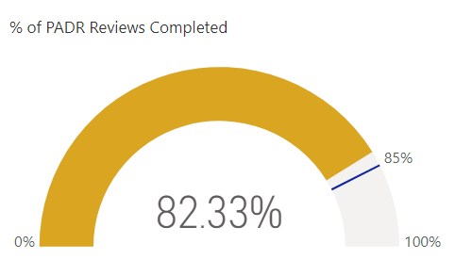

Mandatory Training

- Mandatory training compliance across the Service Group exceeds the Welsh Government target rate of 85%. The rate as of January 2026 was 92.68%. All 19 mandatory training modules were also over 85% as of January 2026.
- Robust arrangements are being maintained to sustain this performance.
- All staff groups are above 90% compliance with the exception of Medical and Dental staff group. There is continuous focus on improving Mandatory Training compliance within the Medical Staff Group (further increased to 74% in January 26).

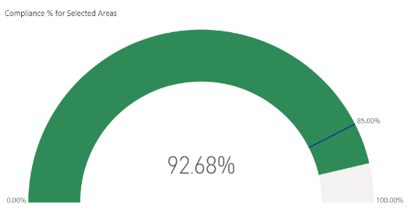

Turnover (all staff groups)
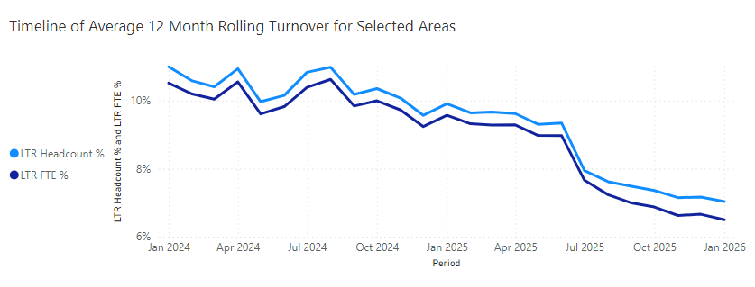

- The service group has seen an improving trend in relation to turnover. The top three reasons for leaving between February 2025 and January 2026 have been Retirement Age, Voluntary Resignation – Relocation and Voluntary Resignation – Promotion. The highest number of leavers have been between the age of 56-60.
- The service group has highlighted to service teams the importance of recording accurately the reason why staff leave our organisation as it is essential for understanding workforce trends, identifying retention challenges, and shaping our support for staff and services. In addition, the service continues to promote the use of Exit Interviews to provide critical intelligence to further inform staff experience and retention approaches.

Vacancies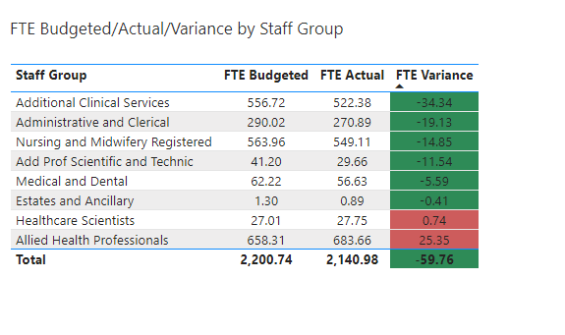
- All vacancies continue to be subject to the current enhanced Workforce Controls in place across the Health Board.
- Allied Health Professional over establishment is due to including Virtual Ward posts in PCTSG staff in post list as they are managed by PCTSG but the budget sits within Morriston SG. This is currently being worked through pending some future organisational changes scheduled from April 2026.
- Work is ongoing for all areas to review current establishments in line with the Health Board requirements and the impact on any service risks.
On-going actions regarding the vacancy position, include:
- Strategic workforce planning events held for Nursing and AHP Staff Groups. Group and Service Workforce plans in place.
- Continue to seek alternative ways to fill vacancies through role redesign, skill mixing, rotation, pooled resource, identifying opportunities to develop new roles and salaried roles.
- Weekly vacancy control scrutiny panels
- Fixed term contract and secondment quarterly review
- Recruitment update reports shared on a monthly basis from data provided from NWSSP recruitment services.

Variable Pay
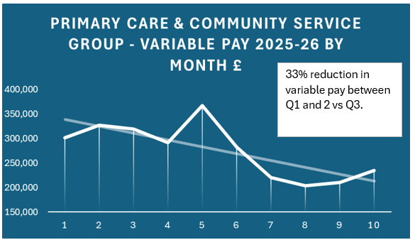

- The table above shows month on month expenditure on variable pay. The PTCSG variable pay position has seen a 33% reduction in quarter 1 and 2 compared to quarter 3 last year. Expenditure on registered and unregistered nursing bank making up the majority of the variable pay, with bank making most of the expenditure.
- Areas spending the most on variable pay continue to be Gorseinon (ward 3 Singleton), District Nursing, HMP Swansea and Ty Olwen. The main reasons include sickness, vacancies, acuity, and additional beds. These services make up over 80% of the total service group variable pay.

Actions in place to reduce variable pay, include:

- All variable pay requests subject to the Health Board enhanced scrutiny controls.
- Weekly nursing variable pay scrutiny meetings.
- Monthly roster scrutiny meetings
- Weekly vacancy control panels
- Improvements with rota fill and salaried GP recruitment in GP OOH.
- Deep dives and absence summits held regarding sickness absence position for Gorseinon, District Nursing and Ty Olwen.
- On-going review of establishment control and vacancy position in areas with high variable pay due to vacancies.

2.2 An overview of workforce risks and issues affecting PCTSG

Workforce Risks/Issues

Unavailability | High levels of sickness absence contribute to unavailability which impacts on the variable pay spend and service delivery. This applies to Nursing and the Additional Clinical Services Workforce.
Gorseinon | Staff have been relocated to Ward 3, Singleton on a temporary basis until March 2026. A paper is being prepared for Executive review and decision on the long-term plans for Gorseinon ward areas.
Community Nursing | Staffing levels and unavailability. External Community Services Review is currently in progress, due to conclude by March 2026.
Therapies | These predominantly relate to insufficient staffing levels to meet required clinical standards, for example within cancer services or neonates, where AHP staffing does not meet clinical standards.  In summary, several specialties have budgeted establishments that are not sufficient to meet the staffing levels required for clinical standards. For example, AHP funded staffing levels in Neonates do not meet BAPM (British Association of Perinatal Medicine) standards.  There is also a significant workforce risk linked to recruitment challenges in highly specialised areas due to national shortages in some professions, such as musculoskeletal podiatry.
Medical | GP OOH –on-going risks regarding worker status. National discussions being held.

2.3 Staff Survey Action Plan Progress

The service group presented the Staff Survey Action Plan at Workforce and OD Committee in 2025. It highlighted the key actions below and an update on progress is included below:

Actions/ Milestones | Lead | By When | Status
Utilise Service Group Team Brief and OBM to share overarching and local Staff Survey Results and actions planned for collective delivery. | Group Director | 06/25 | Complete
Managers and Leaders across PCTSG to discuss the results within their teams and actions to collectively implement, feeding into the overarching goals and success measures. | PCTSG Senior Managers | 06/-07/25 | Complete
PCT Team brief updates emphasising messages around confidentiality and examples of staff stories around the ‘You Said, We’re Delivering Together’ campaign confirming action taken as a result of the survey. | Group Director | 06-10/25 | Complete
Progress up-date on delivery of action plans to WOD Delivery Group/Committee. | Group Director | 02/26 | In progress

To further enhance the work and to respond to the feedback from the previous staff survey, the Service Group has developed a PCT People Plan for 2025/26, which is also aligned to the Health Board’s People Plan (please see appendices).

GOVERNANCE AND RISK ISSUES

The Workforce Metrics, Risks and Staff Survey Progress will continue to be monitored and evaluated through the Group’s Operational Business and Workforce Meetings.

From a risk perspective the impact of unavailability and specifically sickness can impact on service delivery.

- FINANCIAL IMPLICATIONS

High absence levels above funded levels will result in variable pay usage to maintain service capacity and safeguard patient and service user care.

- RECOMMENDATION
ACKNOWLEDGE the Service Groups Workforce Metrics, Risks and Staff Survey Progress.
BE ASSURED of the actions being taken to ensure compliance with workforce metrics to support and improve the health and wellbeing of staff.

Governance and Assurance

Link to Enabling Objectives  (please choose) | Supporting better health and wellbeing by actively promoting and empowering people to live well in resilient communities
Link to Enabling Objectives  (please choose) | Partnerships for Improving Health and Wellbeing |  | ☐
Link to Enabling Objectives  (please choose) | Co-Production and Health Literacy |  | ☐
Link to Enabling Objectives  (please choose) | Digitally Enabled Health and Wellbeing |  | ☐
Link to Enabling Objectives  (please choose) | Deliver better care through excellent health and care services achieving the outcomes that matter most to people
Link to Enabling Objectives  (please choose) | Best Value Outcomes and High-Quality Care |  | ☐
Link to Enabling Objectives  (please choose) | Partnerships for Care |  | ☐
Link to Enabling Objectives  (please choose) | Excellent Staff |  | ☒
Link to Enabling Objectives  (please choose) | Digitally Enabled Care |  | ☐
Link to Enabling Objectives  (please choose) | Outstanding Research, Innovation, Education and Learning |  | ☐
Health and Care Standards
(please choose) | Staying Healthy |  | ☐
(please choose) | Safe Care |  | ☐
(please choose) | Effective Care |  | ☐
(please choose) | Dignified Care |  | ☐
(please choose) | Timely Care |  | ☐
(please choose) | Individual Care |  | ☐
(please choose) | Staff and Resources |  | ☒
Quality, Safety and Patient Experience
Staff health and wellbeing have an impact on staff engagement and experience, and this in turn enables organisational productivity, individual performance and ultimately the quality of patient care and outcomes across the Service Group.
Financial Implications
High absence levels will result in variable pay usage in order to maintain the services capacity and safeguard patient care.
Legal Implications (including equality and diversity assessment)
Actions taken by the service will be required to comply with employment legislation.
Staffing Implications
Actions taken should contribute to improved employee availability and have a positive impact on staff health and wellbeing.
Long Term Implications (including the impact of the Well-being of Future Generations (Wales) Act 2015)
Developing and retaining a skilled workforce is a key objective of the Health Board and is a fundamental principle of the One Bay Way.
Improving population health is a key objective of the Health Board and the workforce plays a critical role in influencing the wellbeing of future generations.
Report History |  | None
Appendices |  | Appendix 1 – Deep Dive Sickness Report District Nursing January 2026  Appendix 2 – Deep Dive Sickness Report Specialist Palliative Care January 2026  Appendix 3 – Deep Dive Sickness Report Ty Olwen November 2025  Appendix 4- Deep Dive Sickness Report HMP Swansea November 2025  Appendix 5 – PCT People Plan  *Deep Dive sickness report for Gorseinon/ward 3 Singleton in progress at time of drafting this report.

