Appendix 4
Report Title | Sickness Absence in HMP  Primary Care, Community and Therapies  November 2025
Report prepared by | Nicola Garnon Assistant HR Business Partner
Report commissioned by | Ruth George, HR Business Partner
Date | 10 December 2025

- Introduction
This report aims to give a deep dive of sickness absence and variable pay within HMP, two priority areas within the Health Board’s People Priorities. Although HMP does not meet the criteria for a sickness absence hot spot (areas which the latest 3-month position being at or above 8% absence FTE together with a WTE of 20 or more (12-month average)) it has been above the Welsh Government target for sickness absence of 5.08% for 7 out of the previous 12 calendar months, with an increase in sickness absence for August, September and October 2025. There is an additional Health Board target to reduce sickness absence by 25% effective August 2025 to March 2026.

- Current Absence Rates
Sickness unavailability data from Allocate gives an indication of the current absence rate across the workforce under W300 Swansea Prison cost code. For the current period the sickness rate stands at 0.81%.
Allocate RosterPerform 11 - PCC DU Unavailability Report (08/12/2025 - 14/12/2025)
Org.Units/Metrics | Annual Leave % | Other Leave % | Parenting % | Sickness % | Study Day % | Total Unavailability % | Working Day %
130 W300 Swansea Prison | 10.69% | 0.00% | 3.59% | 0.81% | 4.26% | 20.36% | 1.00%

- Absence Rates - ESR / BI Dashboard Data
Sickness absence FTE% reports have been run from 1 November 2024 to 31 October 2025. A direct comparison to Allocate data cannot be made as teams and cost centres are grouped differently.
October 2025 reporting shows the cumulative (rolling) sickness percentage for HMP as 5.98%, with overall sickness absence peaking in months August (9.14%), September (15.01%) and October (7.20%) 2025. Peaks for all staffing groups except for Add Prof Scientific and Technical showed a corresponding trend for an increase in sickness for these months

For the period November 2024 to October 2025 absence rates have fluctuated significantly over the three-year period, with notable peaks in late 2024 and September 2025. September 2025 recorded the highest absence rate at 15.0% (128.95 FTE lost), driven mainly by long-term absence (11.5%). June 2023 saw the lowest rate at 0.28% (2.5 FTE lost). Across the timeline, absence averaged around 6.0%, with long-term absence consistently contributing more than short-term absence during peak months. Winter months (Dec–Feb) show moderate increases (e.g., Jan 2024 at 9.6%) with these likely linked to seasonal illness. Peaks in August–October across multiple years indicate recurring stress points and a recurring operational risk in late summer/autumn.
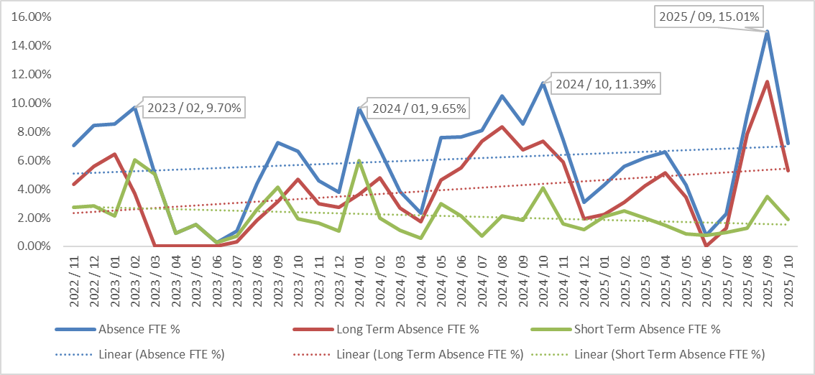
A further deep dive into the reasons for absence over the last three year reveals the overall top 5 reasons for absence are:
- Cold, cough, flu
- Other known causes
- Gastrointestinal problems
- Anxiety/ stress/ depression/ other psychiatric illnesses
- Infectious diseases
The main reason for absence for long term was ‘anxiety/ stress/ depression/ other psychiatric illnesses’ and the top reason for short term absence was ‘cold, cough – influenza’.

Absence Reason | Long Term | Short Term | Grand Total
S10 Anxiety/stress/depression/other psychiatric illnesses | 9 | 8 | 17
S11 Back Problems | 2 | 7 | 9
S12 Other musculoskeletal problems | 2 | 2 | 4
S13 Cold, Cough, Flu - Influenza |  | 23 | 23
S14 Asthma |  | 1 | 1
S15 Chest & respiratory problems | 2 | 7 | 9
S16 Headache / migraine |  | 5 | 5
S17 Benign and malignant tumours, cancers | 1 |  | 1
S19 Heart, cardiac & circulatory problems | 1 | 3 | 4
S21 Ear, nose, throat (ENT) |  | 8 | 8
S25 Gastrointestinal problems |  | 21 | 21
S26 Genitourinary & gynaecological disorders |  | 6 | 6
S27 Infectious diseases |  | 16 | 16
S28 Injury, fracture | 1 | 3 | 4
S29 Nervous system disorders |  | 1 | 1
S30 Pregnancy related disorders | 1 | 1 | 2
S31 Skin disorders |  | 2 | 2
S98 Other known causes - not elsewhere classified | 4 | 18 | 22
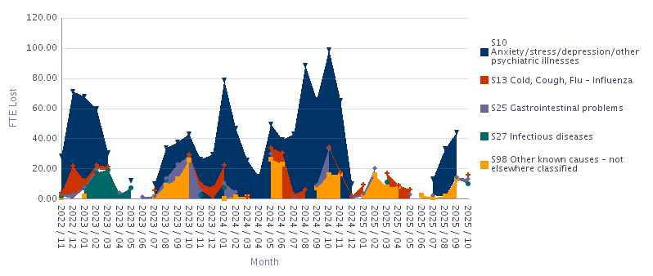
Reviewing the main reasons only for sickness from November 2022 to October 2025, mental health (S10: anxiety/stress/depression/other psychiatric illnesses) is the dominant driver, accounting for 64.4% of all FTE lost. Other known causes (S98) contribute 15.5% of FTE lost suggesting that this may be due to a coding error. Respiratory (S13: colds/flu) accounted for 7.9% of FTE lost, Infectious diseases (S27) accounted for 6.3%, and Gastrointestinal (S25) stood at 5.9%.

The peak month for total absence for the main reasons of absence was October 2024 (98.7 FTE) and the lowest was June 2023 (1.0 FTE).

Mental health (S10) is responsible for nearly two-thirds of the main reasons for absence reviewed across the period. The top mental health months are August 2024, October 2024 and September 2024, suggesting a sustained late-summer/early-autumn pattern.

On average, winter months (Dec–Feb) show higher absence versus summer (Jun–Aug), reflecting typical winter respiratory/infectious pressures. However, summer 2024 showed elevated levels, culminating in the October 2024 peak, which implies non-seasonal drivers (likely mental health and other known causes).

Respiratory and infectious disease spikes are episodic rather than structural. While respiratory (S13) and infectious diseases (S27) causes contribute materially at points, their combined share suggests episodic spikes rather than a persistent, structural driver of the overall absence.

All staff absences are recorded on ESR however this is limited in terms of providing further detail for ‘anxiety/ stress/ depression/ other psychiatric illnesses related illnesses’.

As of August 2025, the Health Board introduced an aim to reduce sickness by 25% by 31 March 2025. The overall estimated sickness absence cost for HMP for the last 12 months (1 November 2024 to 31 October 2025) stands at £94,289, with a reduction of 25% at £23,572 over a 12-month period. As of August 2025, the in-month absence FTE % stood at 9.14%. A reduction of 25% would take the target to 6.85%. The in-month absence FTE % for October 2025 was 7.20%.
 | 2024 / 11 | 2024 / 12 | 2025 / 01 | 2025 / 02 | 2025 / 03 | 2025 / 04 | 2025 / 05 | 2025 / 06 | 2025 / 07 | 2025 / 08 | 2025 / 09 | 2025 / 10 | Grand Total | Ask of 25%
Add Prof Scientific and Technic | £2,953 | £1,526 | £2,123 | £2,387 | £2,436 | £1,100 | £142 |  | £178 |  |  |  | £12,844 | £3,211
Additional Clinical Services | £1,602 |  |  |  |  |  |  | £139 | £1,017 | £2,866 | £2,774 |  | £8,398 | £2,100
Administrative and Clerical |  |  | £311 |  |  | £74 |  |  | £37 | £444 |  | £148 | £1,013 | £253
Medical and Dental |  |  |  |  |  | £2,750 |  |  |  | £1,164 | £6,542 | £6,760 | £17,216 | £4,304
Nursing and Midwifery Registered | £5,416 | £2,456 | £2,889 | £4,007 | £5,394 | £4,905 | £5,029 | £628 | £794 | £4,948 | £11,195 | £7,157 | £54,817 | £13,704
Grand Total | £9,972 | £3,982 | £5,323 | £6,393 | £7,829 | £8,829 | £5,171 | £766 | £2,026 | £9,422 | £20,511 | £14,065 | £94,289 | £23,572

- Current Long Term Sickness Case Management
There were 4 individuals absent due to sickness absence effective 10 November 2025. Absence reasons include work related stress, cancer, MSK and skin disorders.

- Impact on Variable Pay
Variable pay data from Allocate gives further insight in respect of the impact of sickness on variable pay.
Over the 12-month period, total variable pay usage amounted to 5,639.75 hours, with an average of 470 hours per month. Vacancy cover is the dominant driver, accounting for 89.7% of variable pay hours (5,056.5 hours). Sickness (long-term and short-term combined) contributes 10.2%, and surge accounts for 0.1%; parental/special and high acuity are negligible.
Sickness impact tapered across the year with long-term sickness reduced to nil from June 2025 onwards; short-term sickness declined to nil in September to October 2025. Overall sickness across the year totals 578 hours (350.5 LT, 227.25 ST).

All Staff
Month | LT Sick | ST Sick | Vacancy | Parental/Special | Surge | High Acuity | Total (hrs)
Nov-24 | 86.5 | 80 | 181.75 | 0 | 0 | 0 | 348.25
Dec-24 | 92 | 33.75 | 227 | 0 | 3 | 0 | 355.75
Jan-25 | 40.25 | 42.75 | 419.75 | 0 | 0 | 0 | 502.75
Feb-25 | 16.5 | 3.75 | 321.5 | 0 | 0 | 0 | 341.75
Mar-25 | 21 | 16.5 | 484.75 | 0 | 0 | 0 | 522.25
Apr-25 | 32.25 | 25 | 487 | 0 | 0 | 0 | 544.25
May-25 | 62 | 0 | 512.75 | 0 | 0 | 0 | 574.75
Jun-25 | 0 | 3.75 | 496 | 0 | 0 | 0 | 499.75
Jul-25 | 0 | 8 | 408.5 | 0 | 2.5 | 0 | 419
Aug-25 | 0 | 13.75 | 600 | 0 | 0 | 0 | 613.75
Sep-25 | 0 | 0 | 489.5 | 0 | 0 | 0 | 489.5
Oct-25 | 0 | 0 | 428 | 0 | 0 | 0 | 428

The drivers of overtime and additional hours are not captured by Allocate therefore this report is unable to provide further analysis in respect of sickness absence on this aspect of variable pay.

- PCT People Plan to Support Attendance and Employee Wellbeing

The HR Business Partner Team developed the PCT People Plan 2025/26 to support the Service Group as a whole, to maximise attendance at attendance at work and improve staff and patient experience. The embedded attachment below summaries the previous and ongoing/ planned interventions to support attendance and employee wellbeing by the HRBP team.
Service areas are also encouraged to ensure staff are aware of internal and external wellbeing services, resources and support.
7 Conclusion
This deep dive highlights that sickness absence within HMP has shown an overall upwards trend over the past three years, driven by long term sickness absence and seasonal peaks in short term sickness. There has been a significant increase in sickness in August to October 2025. Although there has been a month on month reduction from September to October 2025, sickness absence continues to exceed the Welsh Government target of 5.08%. The analysis confirms that anxiety, stress, and depression remain the leading cause of long-term absence, while short-term absence is primarily driven by seasonal illnesses such as colds and influenza and gastrointestinal reasons.

- Recommendations
- A local level focused approach and action plan to:
  - Address the themes arising for absence as listed within this report.
  - Continue to reduce the absence percentage to the Welsh Government target of 5.08%.
  - A review of all stress/anxiety/depression related absences to ensure appropriate support is being provided.

- Continuation of the scrutiny of variable pay against sickness drivers, in line with the Health Board objectives.

- Consideration of an Absence Summit for HMP to discuss the content of the report and proposed action plan.

- Consideration of a sickness absence audit to determine any further improvement to the management of attendance.

