Appendix 3
Report Title | Sickness Absence in Ty Olwen  Primary Care, Community and Therapies
Report prepared by | Nicola Garnon Assistant HR Business Partner
Report commissioned by | Ruth George, HR Business Partner
Date | 4 December 2025

- Introduction

This report aims to give a deep dive of sickness absence and variable pay within Ty Olwen, two priority areas within the Health Board’s People Priorities. Although Ty Olwen does not currently meet the criteria for a sickness absence hot spot (areas which the latest 3-month position being at or above 8% absence FTE together with a WTE of 20 or more (12-month average)) it had previously met the criteria before November 2025. It has also been above the Welsh Government target for sickness absence of 5.08% for 12 consecutive months. In response to high sickness levels and enhanced financial controls in relation to variable pay, there is a Health Board requirement for services reduce sickness absence by 25% effective August 2025 to March 2026.

- Current Absence Rates

Sickness unavailability data from Allocate gives an indication of the current weekly absence rate across the workforce under B322 Ty Olwen - Morriston cost code, for employees currently on the e-rostering system. For the current period the sickness rate stands at 3.35%.
Allocate RosterPerform 11 - PCC DU Unavailability Report (01/12/2025 - 07/12/2025)
Org.Units/Metrics | Annual Leave % | Other Leave % | Parenting % | Sickness % | Study Day % | Total Unavailability % | Working Day %
130 B322 Ty Olwen - Morriston | 15.73% | 0.00% | 0.00% | 3.35% | 1.29% | 24.08% | 3.71%

- Absence Rates - ESR / BI Dashboard Data

The most recent ESR data is available up until 31 October 2025. The reports have been run from 1 November 2024 to 31 October 2025. A direct comparison to Allocate data cannot be made as teams, cost centres are grouped differently, and reporting periods may differ.

November 2024 reporting shows the cumulative (rolling) sickness percentage for Ty Olwen as 12.49%, with overall sickness absence peaking in months April (21.13%) and May (20.59%). Peaks for Additional Clinical Services matched this pattern with the highest absences seen in April and May, with a notable sharp peak in January. Peaks for Nursing and Midwifery staffing group were seen April to June.
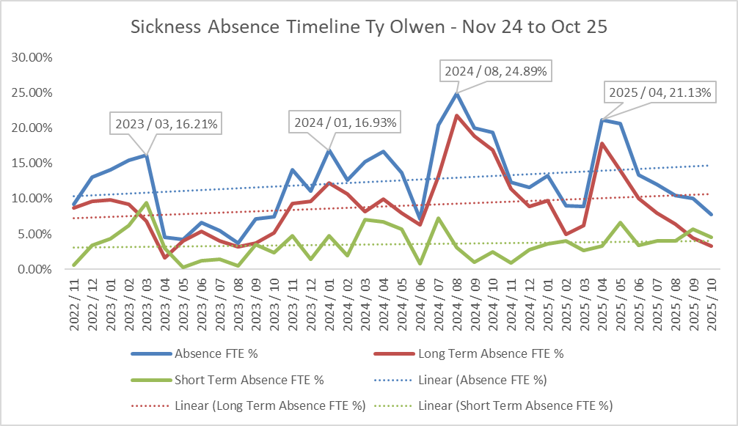
Over the past three years, sickness absence at Ty Olwen has shown periods of stability punctuated by sharp increases that placed significant strain on staffing and service delivery. For much of 2023 and early 2024, sickness absence followed a predictable seasonal pattern being higher in winter and lower in summer. In July and August 2024, absence rose dramatically, reaching its highest point in August (24.9%). After some improvement over winter 2024, April and May 2025 saw another spike with a 21.1% absence rate at its highest, though this was shorter lived than the previous summer surge. From June 2025 onwards, absence has steadily declined reaching its lowest levels in October 2025. This suggests that interventions introduced during the year may be starting to work.
A further deep dive into the reasons for absence over the last three year reveals the overall top reason for absence is ‘anxiety/ stress/ depression/ other psychiatric illnesses’, followed by ‘cold, cough – influenza’, ‘gastrointestinal problems’ and ‘infectious diseases’. The main reason for absence for long term was ‘anxiety/ stress/ depression/ other psychiatric illnesses’ and the top reason for short term absence was ‘cold, cough – influenza’.

Absence Reason | Long Term | Short Term | Grand Total
S10 Anxiety/stress/depression/other psychiatric illnesses | 23 | 21 | 44
S11 Back Problems | 2 | 8 | 10
S12 Other musculoskeletal problems | 2 | 7 | 9
S13 Cold, Cough, Flu - Influenza |  | 32 | 32
S14 Asthma |  | 1 | 1
S15 Chest & respiratory problems | 2 | 15 | 17
S16 Headache / migraine | 1 | 11 | 12
S17 Benign and malignant tumours, cancers |  | 1 | 1
S19 Heart, cardiac & circulatory problems | 1 | 4 | 5
S20 Burns, poisoning, frostbite, hypothermia |  | 1 | 1
S21 Ear, nose, throat (ENT) | 1 | 5 | 6
S22 Dental and oral problems |  | 6 | 6
S23 Eye problems |  | 3 | 3
S24 Endocrine / glandular problems |  | 1 | 1
S25 Gastrointestinal problems |  | 32 | 32
S26 Genitourinary & gynaecological disorders | 1 | 3 | 4
S27 Infectious diseases | 1 | 14 | 15
S28 Injury, fracture | 4 | 7 | 11
S29 Nervous system disorders |  | 2 | 2
S30 Pregnancy related disorders | 2 | 4 | 6
S31 Skin disorders | 1 | 3 | 4
S98 Other known causes - not elsewhere classified | 1 | 12 | 13

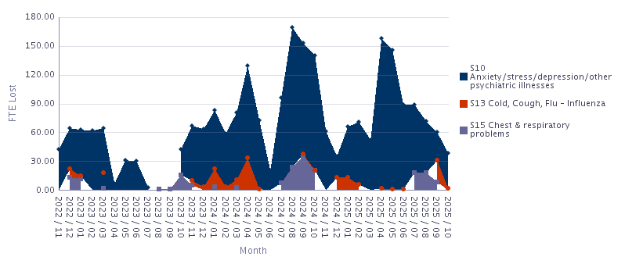
Anxiety, stress, and depression were the single biggest contributors during the highest sickness absence months. In August 2024, these accounted for more than half of all absence time. The same pattern repeated in April and May 2025, where mental health related absence represented two-thirds or more of the total. Respiratory problems and coughs, cold and flu played a secondary role, particularly in autumn and early winter. While these did not drive the major spikes, they compounded the challenge during already high-pressure periods.
As overall absence has fallen in the latter half of 2025, the mix of reasons has become more balanced. Mental health related absences remain significant but less dominant, while short-term illnesses like colds and flu have become visible.

As of August 2025, the Health Board introduced an aim to reduce sickness by 25% by 31 March 2026. The overall estimated sickness absence cost for Ty Olwen for the last 12 months (1 November 2024 to 31 October 2025) stands at £153,596, with a reduction of 25% at 38,399 over a 12-month period. As of August 2025, the in-month absence FTE % stood at 10.42%. A target of 7.82% is required by 31 March 2026 to meet this Health Board requirement. The in-month absence FTE % for October 2025 was 7.76%.
 | 2024 / 11 | 2024 / 12 | 2025 / 01 | 2025 / 02 | 2025 / 03 | 2025 / 04 | 2025 / 05 | 2025 / 06 | 2025 / 07 | 2025 / 08 | 2025 / 09 | 2025 / 10 | Total | Estimated 25% Saving
Add Prof Scientific and Technic | £0 | £0 |  |  | £1,298 | £1,882 | £269 |  |  |  | £336 |  | £3,785 | £946
Additional Clinical Services | £3,378 | £5,165 | £4,927 | £1,452 | £2,091 | £7,005 | £6,535 | £2,065 | £5,987 | £5,307 | £5,250 | £3,140 | £52,304 | £13,076
Administrative and Clerical | £246 |  |  | £410 |  | £1,956 | £2,636 | £2,084 | £510 |  |  |  | £7,843 | £1,961
Nursing and Midwifery Registered | £6,847 | £6,649 | £7,047 | £6,521 | £6,957 | £12,263 | £13,194 | £10,894 | £5,380 | £4,868 | £4,359 | £4,687 | £89,663 | £22,416
Grand Total | £10,472 | £11,814 | £11,973 | £8,383 | £10,346 | £23,107 | £22,634 | £15,043 | £11,877 | £10,174 | £9,945 | £7,827 | £153,596 | £38,399

- Current Long Term Sickness Case Management
There is currently one employee in the service who is absent due to long term sickness absence effective November 2025. Reason for absence is personal stress.

- Impact on Variable Pay

Variable pay data from Allocate gives further insight in respect of the impact of sickness on variable pay. For the period November 2024 to October 2025, variable pay totalled 13,593.5 hours across the period. The breakdown of variable pay is:
  - High Acuity: 38.1% (5,176 hrs).
  - Long-term sickness: 21.2% (2,888.5 hrs).
  - Vacancy cover: 20.3% (2,761.5 hrs).
  - Short-term sickness: 18.4% (2,507.5 hrs).
  - Parental/Special leave (0.6%) and Surge (1.3%).
Between January and March 2025 variable pay progressively increased (January – 746 hours, February - 1,184 hours, March 1,502 hours) because of high acuity and vacancy cover. April (1,646 hours) and May (1,961 hours) 2025 saw the highest demand driven by high acuity and LT/ST sickness. June (1,463 hours) to August (995 hours) 2025 saw a decrease in demand with vacancy cover still sizeable but acuity easing. September (716 hours and October (383 hours) 2025 has seen a marked reduction in the use of variable pay as sickness and vacancy pressures ease and acuity drops sharply.

All Staff
Month | LT Sick | ST Sick | Vacancy | Parental/Special | Surge | High Acuity | Total (hrs)
Nov-24 | 432.5 | 147 | 38 | 11.5 | 42 | 207.5 | 878.5
Dec-24 | 149.5 | 274 | 53 | 0 | 53.5 | 378 | 908
Jan-25 | 11.5 | 179 | 264.5 | 0 | 23 | 268 | 746
Feb-25 | 61.5 | 195 | 266.5 | 11.5 | 11.5 | 638 | 1184
Mar-25 | 338 | 42.5 | 288 | 0 | 26.5 | 807 | 1502
Apr-25 | 361 | 320 | 193.5 | 46 | 0 | 725 | 1645.5
May-25 | 610.5 | 471 | 179.5 | 0 | 11.5 | 688 | 1960.5
Jun-25 | 351 | 135.5 | 391 | 11.5 | 11.5 | 562 | 1462.5
Jul-25 | 173.5 | 297.5 | 386 | 0 | 0 | 355.5 | 1212.5
Aug-25 | 147 | 171 | 421 | 0 | 0 | 256 | 995
Sep-25 | 152.5 | 143.5 | 152 | 0 | 0 | 268 | 716
Oct-25 | 100 | 131.5 | 128.5 | 0 | 0 | 23 | 383

The drivers of overtime and additional hours are not captured by Allocate therefore this report is unable to provide further analysis in respect of sickness absence on this aspect of variable pay.

6. Sickness Absence Interventions at Ty Olwen
A range of initiatives are in place at Ty Olwen to strengthen attendance and improve consistency in managing absence.
A Staff Pulse Survey undertaken in June 2025 highlighted persistent workload pressures, with staff reporting high stress levels and burnout. Development opportunities and CPD support were highlighted as an area for improvement, and staff comments focused on the emotional strain of working in a palliative setting, the difficulties around the use of bank/agency staff, and perceived barriers to implementing ideas.
Three Absence Summits (June to November) have taken place to provide further oversight and scrutiny in respect of managing absence as well as helping to proactively facilitate further attendance initiatives at a local level. A sickness audit was undertaken in August 2025 and found a good level of management understanding on managing attendance at work, with consistent application of the policy and good record keeping. Recommendations on the use of the 8th day welfare letter and a re-focus on the use of Occupational Health services were made, and these have now been implemented. A follow up mini audit to access the implementation of the recommendations is scheduled for December 2025.
The HR sickness pathway has been circulated to staff and displayed across the department, and managers are actively using prompt reports and a live tracking database to monitor prompts and actions weekly. BI dashboard training has been delivered to the Matron and Ward Manager, enabling better data interpretation and proactive management. Statutory and mandatory compliance training remains strong, with infection control above 90%, manual handling above 85%, with overall compliance at 93.75% (October 2025), alongside PADR compliance at 91% (October 2025). Cultural interventions are also underway, including person-centred workshops and multidisciplinary team engagement sessions, which have received positive feedback.
Bereavement support has been prioritised, recognising the unique challenges of working in a palliative care setting. A psychologist has been embedded within the team to lead bereavement literacy initiatives, and flexible working options are being explored to support staff following significant loss and manage burnout. Ty Olwen has an older workforce, with a large proportion of the workforce falling under the 50 – 60-year-old age category. Monitoring of MSK-related absences continues as a result, with recent cases identified as non-work-related but flagged for appropriate support.

- PCT People Plan to Support Attendance and Employee Wellbeing

The HR Business Partner Team developed the PCT People Plan 2025/26 to support the Service Group as a whole, to maximise attendance at attendance at work and improve staff and patient experience. The embedded attachment below summaries the previous and ongoing/ planned interventions to support attendance and employee wellbeing by the HRBP team.
Service areas are also encouraged to ensure staff are aware of internal and external wellbeing services, resources and support.
7 Conclusion
Sickness absence at Ty Olwen has been shaped by two main factors: sustained long-term cases linked to mental health and seasonal short-term illnesses. While absence levels peaked in summer 2024 and again in spring 2025, recent months show a clear downward trend, indicating that interventions introduced during the year are beginning to work. Continued focus on early intervention for stress, anxiety and depression related absence, proactive planning for seasonal illness, and consistent application of the Managing Attendance at Work policy will be essential for a continuation of a reduction in overall sickness absence.

- Recommendations

- A local level focused approach and action plan to:
  - Address the themes arising for absence as listed within this report.
  - Sustain the 25% reduction in sickness from the August 2025 figure.
  - Continue to reduce the absence percentage to the Welsh Government target of 5.08%.

- Continuation of the scrutiny of variable pay against sickness drivers, in line with Health Board objectives.

- Continuation of Absence Summits to discuss the content of the report and to further develop a targeted action plan.

