Appendix 2
Report Title | Deep Dive into Sickness Absence for Specialist Palliative Care  Primary Care, Community and Therapies
Report prepared by | Nicola Garnon Assistant HR Business Partner
Report commissioned by | Ruth George, HR Business Partner
Date | 29 January 2026

- Introduction

This report aims to give a deep dive of sickness absence and variable pay within Specialist Pallative Care, two priority areas within the Health Board’s People Priorities. Although Specialist Pallative Care does not currently meet the criteria for a sickness absence hot spot (areas which the latest 3-month position being at or above 8% absence FTE together with a WTE of 20 or more (12-month average)) it has experienced high levels of sickness since September 2025. It has also been above the Welsh Government target for sickness absence of 5.08% for 6 out of the last 12 calendar months..

- Unavailability Data

Sickness unavailability data from Allocate gives an indication of the current weekly absence rate across the workforce under B321 cost code, for employees currently on the e-rostering system. For the current period the sickness rate stands for Specialist Palliative Care as below.
Allocate RosterPerform 11 - PCC DU Unavailability Report (26/01/2026 - 01/02/2026)
Org.Units/Metrics | Annual Leave % | Other Leave % | Parenting % | Sickness % | Study Day % | Total Unavailability % | Working Day %
130 B321 CNS Palliative Care & EOLC | 6.74% | 0.00% | 4.81% | 7.70% | 0.00% | 19.24% | 0.00%

Reviewing the BI Dashboard for Specialist Pallative Care effective 29 January 2026 the annual leave entitlement used to date stood at 71%.
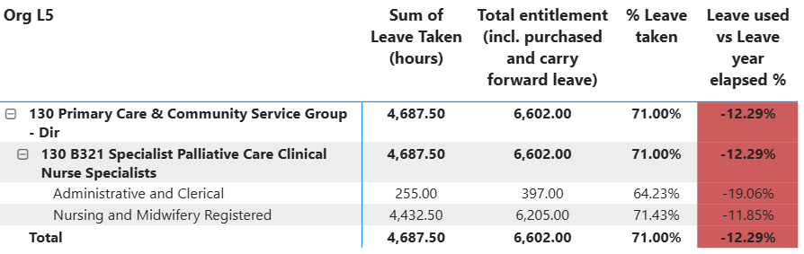
83.29% should have been taken effective 29 January 2026, leaving a deficit of 12.29%.

- Absence Data - ESR / BI Dashboard Data

The most recent ESR data is available up until 31 December 2025. The reports have been run from 1 January 2025 to 31 December 2025. A direct comparison to Allocate data cannot be made as teams, cost centres are grouped differently, and reporting periods may differ.

December 2025 reporting shows the cumulative (rolling) sickness percentage for Specialist Palliative Care as 6.41%, with overall sickness absence peaking in December 2025 at 14.28%. The peaks for Administrative and Clerical and Nursing and Midwifery staffing groups matched this pattern with the highest absences seen September to December 2025.

Reviewing overall sickness over the past three years for Specialist Pallative Care shows a clear surge in 2024, with pressures lasting throughout the year rather than being confined to winter. Reviewing long term sickness cases for summer 2024 reveals at its peak 9 staff members were absent due to several absence reasons including conditions relating to women’s health, bereavement, broken bones, neurological and personal stress. Three staff members were absent with work related stress also at this time. It is noted that early staff communication had started at this point in time in relation to a subsequent OCP in spring 2025. This creates a picture of a service facing sustained strain, with both more short-term seasonal illnesses and longer periods of sickness contributing to the elevated levels. By 2025, sickness patterns began to settle down, although month-to-month variation remained noticeable. 2025 ends with sickness levels more in line with 2023, indicating a gradual stabilisation after the unusually high levels seen in 2024.
Short-term sickness follows a more seasonal pattern, peaking around winter and early summer, but the picture changes significantly in 2025. After a noticeable rise in 2024, short-term sickness drops sharply the following year, with some months showing minimal or no short-term absence. This sharp reduction is the key factor behind the more stable overall sickness profile in 2025. It suggests that the immediate, short-duration absences that disrupted staffing in 2024 became far less frequent as the service moved into the following year.
It is noted that sickness absence has once again peaked in December 2025, review of current long-term sickness cases gives reasons for absence as bereavement and other MSK issues.
Deep Dive Reasons for Absence
A further deep dive into the reasons for absence over the last three year reveals the overall top reason for absence is cold, cough – influenza’ followed by ‘anxiety/stress/depression/other psychiatric illness’ and ‘gastrointestinal problems’. The main reason for absence for long term was ‘anxiety/ stress/ depression/ other psychiatric illnesses’ and the top reason for short term absence was ‘cold, cough – influenza’.

Absence Reason | Long Term | Short Term | Grand Total
S10 Anxiety/stress/depression/other psychiatric illnesses | 10 | 11 | 21
S11 Back Problems |  | 2 | 2
S12 Other musculoskeletal problems | 2 | 4 | 6
S13 Cold, Cough, Flu - Influenza | 2 | 23 | 25
S15 Chest & respiratory problems |  | 11 | 11
S16 Headache / migraine | 1 | 7 | 8
S19 Heart, cardiac & circulatory problems | 1 |  | 1
S21 Ear, nose, throat (ENT) |  | 4 | 4
S22 Dental and oral problems |  | 1 | 1
S23 Eye problems |  | 1 | 1
S25 Gastrointestinal problems | 2 | 15 | 17
S26 Genitourinary & gynaecological disorders | 2 | 2 | 4
S27 Infectious diseases |  | 5 | 5
S28 Injury, fracture | 2 | 1 | 3
S29 Nervous system disorders | 1 |  | 1
S30 Pregnancy related disorders |  | 4 | 4
S98 Other known causes - not elsewhere classified | 1 | 4 | 5

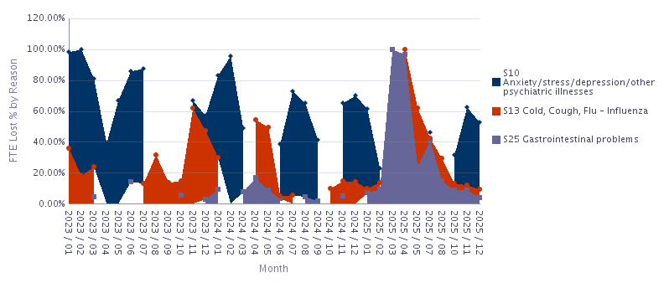

Anxiety/Stress/Depression/Other Psychiatric (S10)
Mental-health-related absence is the leading cause for sickness absence across the first two years, reaching high points in February 2023 and February 2024, where it accounts for the clear majority of FTE lost. This pattern speaks to a sustained, non-seasonal pressure that extends beyond typical winter effects.
Cold, Cough, Flu – Influenza (S13)
Respiratory reasons for absence follow a classic winter-centred profile. It is most visible across late autumn and early winter 2023 (notably November–December), and then gradually tapers through 2024, becoming much less prominent by 2025. The shape of this curve—sharp seasonal peaks followed by a marked easing—indicates that routine winter pressures recede over time and do not underpin the sustained strain seen elsewhere in the reasons mix.
Gastrointestinal Problems (S25)
GI absence is modest through 2023–2024, then registers a step-change in early–mid 2025, with March and April showing high absence. The spike is short and concentrated, consistent with an acute, outbreak-style pattern rather than a persistent trend.

Notional Cost of Sickness Absence
The overall notional sickness absence cost for Specialist Pallative Care for the last 12 months (1 January 2025 to 31 December 2025) stands at £75,647. As of August 2025, the in-month absence FTE % stood at 4.06%, below the Welsh Government target of 5.08%. The in-month absence FTE % for December 2025 was 14.28%.

4 Age Profile and Potential Impact on Staff Health and Wellbeing
The latest Staff in Post data for Specialist Pallative Care shows a workforce of 24 staff (21.19 FTE).
The SPC workforce is predominantly mid-career, with just over half of staff in the 31–40 age range, a smaller younger cohort in 26–30, and about a quarter in the 51–60 bracket. Average FTE per head is lower in the oldest band (indicating more part-time working), while the 41–50 bands tend toward full-time equivalent, painting a picture of a team balancing experienced practitioners with a modest pipeline of newer entrants and a meaningful later-career group.
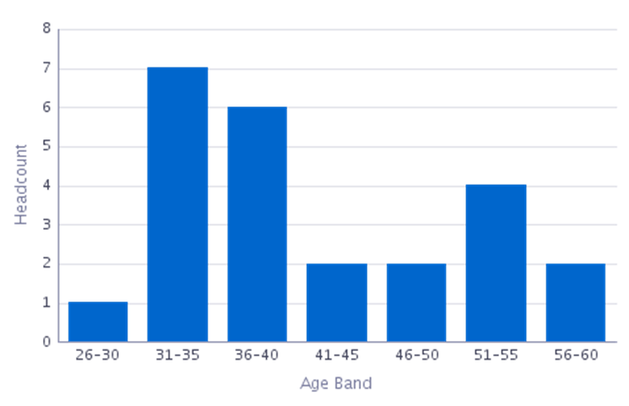
From a health and wellbeing perspective, this mix suggests distinct needs across life stages. Mid-career staff often juggle peak role intensity with family and caring responsibilities, increasing fatigue risk in a service characterised by emotional labour and exposure to end-of-life stressors. The later-career cohort may experience menopause-related symptoms, musculoskeletal (MSK) strain, or longer-term conditions, and the higher prevalence of part-time arrangements points to the value of flexible rostering and paced recovery after demanding shifts. Meanwhile, a smaller younger cohort underscores the importance of supportive supervision and structured development to retain and grow capability
Age Band | Headcount | FTE
26-30 | 1 | 0.80
31-35 | 7 | 5.93
36-40 | 6 | 5.60
41-45 | 2 | 2.00
46-50 | 2 | 2.00
51-55 | 4 | 3.60
56-60 | 2 | 1.25
Grand Total | 24 | 21.19

5 Return to Work Discussions
Reviewing Return to Work compliance on the BI Dashboard for Specialist Palliative Care, compliance is as follows:
- Ended sickness episodes (in the selected period): 104
- RTW Discussion date entered (Yes): 37
- RTW Discussion date entered (No): 67
- RTW compliance: 35.58%
- Avg days taken to enter sickness: 22.08
- Avg days taken to end sickness: 18.36
It is noted that recorded RTW compliance is low at just under 36% with a large ‘not recorded’ gap at 64%, alongside long apparent admin/recording delays (based on the “days taken to enter/end” indicators).
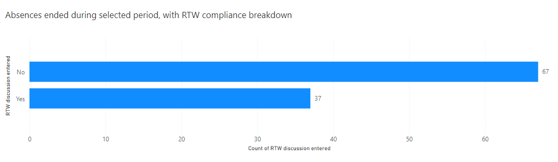
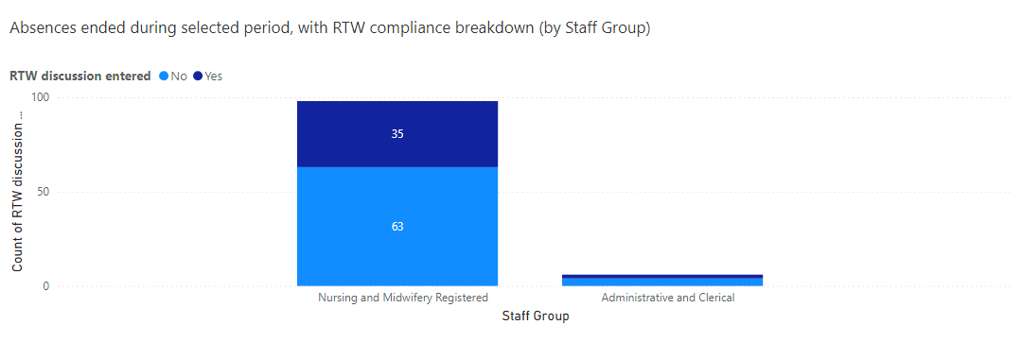
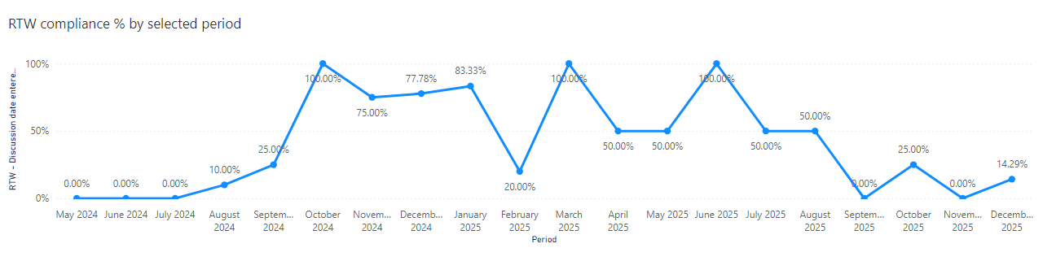

- Impact on Variable Pay

Review of variable pay data from Allocate reveals no variable pay has been used over the last 12 months for Specialist Pallative Care.

- PCT People Plan to Support Attendance and Employee Wellbeing

The HR Business Partner Team developed the PCT People Plan 2025/26 to support the Service Group as a whole, to maximise attendance at attendance at work and improve staff and patient experience. The embedded attachment below summaries the previous and ongoing/ planned interventions to support attendance and employee wellbeing by the HRBP team.
Service areas are also encouraged to ensure staff are aware of internal and external wellbeing services, resources and support.

- Conclusion
Sickness absence within Specialist Palliative Care has shown sustained pressure, driven primarily by mental-health related conditions and seasonal respiratory illness. While 2025 brought greater stability following the exceptional peaks of 2024, the spike in December 2025 illustrates that attendance remains a significant operational risk.
Despite these challenges, the service has maintained zero use of variable pay and has seen improvements in short-term absence patterns, providing a solid basis for further progress. Focused local action and continued wellbeing support will be essential in enabling the service to meet Welsh Government’s sickness target of 5.08%.

9 Recommendations
- A local level focused approach and development of an action plan to:
  - Address the themes arising for absence as listed within this report.
  - Reach and sustain the sickness target of 5.08%.

- Continuation of the scrutiny of variable pay against sickness drivers, in line with Health Board objectives.

