Appendix 1
Report Title | Deep Dive into Sickness Absence for District Nursing  Primary Care, Community and Therapies
Report prepared by | Nicola Garnon Assistant HR Business Partner
Report commissioned by | Ruth George, HR Business Partner
Date | 22 January 2026

- Introduction

This report aims to give a deep dive of sickness absence and variable pay within District Nursing, two priority areas within the Health Board’s People Priorities. District Nursing currently meets the criteria for a sickness absence hot spot (areas which the latest 3-month position being at or above 8% absence FTE together with a WTE of 20 or more (12-month average)). It has also been above the Welsh Government target for sickness absence of 5.08% for 12 consecutive months. In response to high sickness levels and enhanced financial controls in relation to variable pay, there is a Health Board requirement for services reduce sickness absence by 25% effective August 2025 to March 2026.

- Current Absence Rates

Sickness unavailability data from Allocate gives an indication of the current weekly absence rate across the workforce under N016 cost code, for employees currently on the e-rostering system. For the current period the sickness rate stands for each sub area as below. It is acknowledged that 5 out of the 8 clusters have unavailability of over 30% at the time of this report.
Allocate RosterPerform 11 - PCC DU Unavailability Report (19/01/2026 - 25/01/2026)
Org.Units/Metrics | Annual Leave % | Other Leave % | Parenting % | Sickness % | Study Day % | Total Unavailability % | Working Day %
130 N016 Afan Cluster DN | 20.29% | 1.36% | 4.90% | 8.40% | 4.77% | 39.72% | 0.00%
130 N016 Bay Cluster | 11.66% | 3.13% | 7.99% | 5.55% | 5.17% | 34.15% | 0.66%
130 N016 CHC - Swansea | 0.00% | 0.00% | 0.00% | 0.00% | 0.00% | 0.00% | 0.00%
130 N016 CHC- NB | 9.56% | 4.30% | 0.00% | 4.66% | 0.00% | 18.52% | 0.00%
130 N016 City Cluster | 10.72% | 4.62% | 3.30% | 16.74% | 2.16% | 37.90% | 0.35%
130 N016 Cwmtawe Cluster | 11.12% | 0.00% | 9.19% | 13.52% | 2.63% | 36.46% | 0.00%
130 N016 District Nursing OOH | 8.13% | 0.00% | 0.00% | 10.16% | 0.00% | 18.50% | 0.20%
130 N016 DN Specialist Nurse Roster | 0.00% | 0.00% | 15.06% | 0.00% | 0.00% | 15.06% | 0.00%
130 N016 Llwchwr Cluster | 8.11% | 0.00% | 3.17% | 6.98% | 5.21% | 23.47% | 0.00%
130 N016 Neath Cluster | 14.37% | 0.57% | 3.05% | 7.73% | 2.73% | 28.45% | 0.00%
130 N016 North Hub Team | 0.00% | 0.00% | 0.00% | 0.00% | 0.00% | 0.00% | 0.00%
130 N016 Out of Hours DN NPTH | 0.00% | 0.00% | 0.00% | 0.00% | 0.00% | 0.00% | 0.00%
130 N016 Penderry Cluster | 12.28% | 0.00% | 3.27% | 18.60% | 3.27% | 37.42% | 0.00%
130 N016 Single Point Access NPTH DN | 10.95% | 0.00% | 0.00% | 20.18% | 2.62% | 33.75% | 0.00%
130 N016 SPICE West | 0.00% | 0.00% | 0.00% | 0.00% | 0.00% | 0.00% | 0.00%
130 N016 Upper Valley Cluster | 11.07% | 2.89% | 0.00% | 7.87% | 1.99% | 23.82% | 0.00%

- Absence Data - ESR / BI Dashboard Data

The most recent ESR data is available up until 31 December 2025. The reports have been run from 1 January 2025 to 31 December 2025. A direct comparison to Allocate data cannot be made as teams, cost centres are grouped differently, and reporting periods may differ.

December 2025 reporting shows the cumulative (rolling) sickness percentage for District Nursing as 11.67%, with overall sickness absence peaking in months July 2025 (13.70%), November 2025 (13.15%) and December 2025 (13.24%). Peaks for Additional Clinical Services and Nursing and Midwifery staffing groups matched this pattern with the highest absences seen in July, November and December.
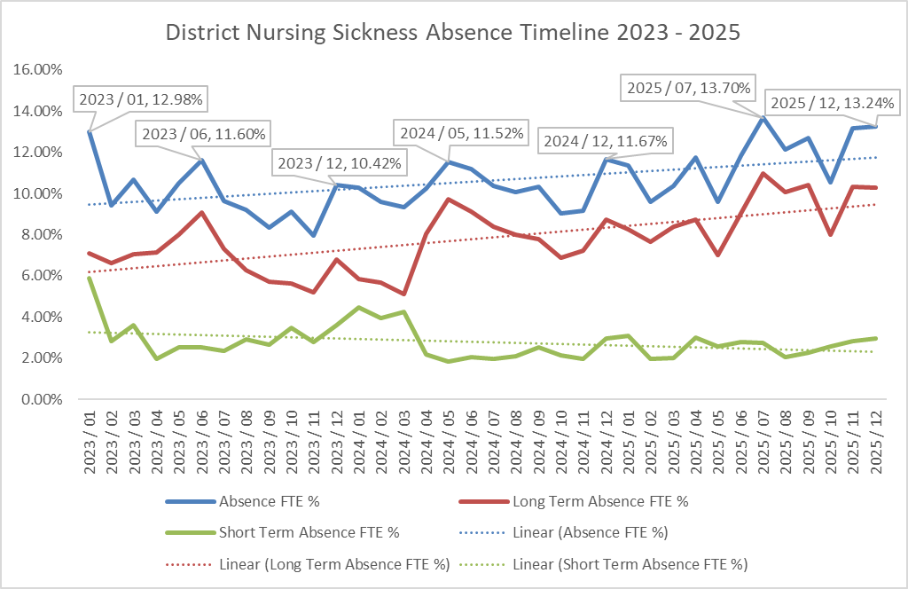
Sickness levels in District Nursing have increased steadily over the past three years, with the clearest rise seen in long-term absence. Short-term absence has generally reduced, but not enough to offset the growth in longer-duration cases.

Overall Sickness
- Overall sickness has moved upwards each year, rising from just under 10% in 2023 to over 11.5% in 2025.
- The lowest point across the period was in November 2023, showing how much the position has shifted since then.
- While winter drives short-term absence, the highest overall sickness levels occur in summer rather than winter.
- The overall peak is in July 2025 (13.7%), which is driven mainly by a surge in long-term absence during that period.

Long Term Sickness
- Long-term sickness is the main reason overall absence has risen, increasing every year and now accounting for around four-fifths of all sickness in 2025.
- The sharpest rise occurred in 2025, peaking in July 2025, mirroring the overall sickness peak.
- The lowest long-term levels were seen in March 2024, but this was followed by renewed increases.

Short Term Sickness
- Short-term sickness has reduced slightly each year, dropping from just under 3% in 2023 to around 2.5% in 2025.
- The dataset shows the peak short-term month for the entire period is January 2023 (5.88%), which aligns with typical winter pressures (respiratory illness, flu, norovirus etc.).
- Short term rates tend to drop into late spring, reaching their lowest level in May 2024 (1.82%).

Reasons For Absence
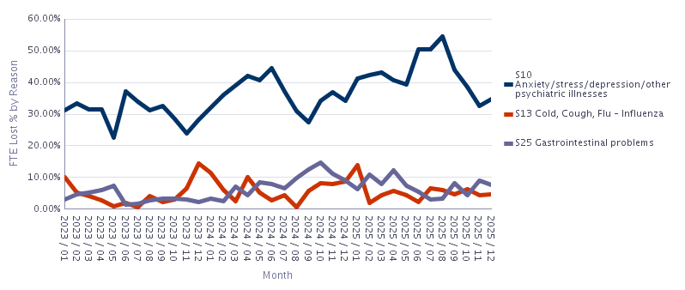
A further deep dive into the reasons for absence over the last three year reveals the overall top reason for absence is ‘anxiety/stress/depression/other psychiatric illness’ followed by ‘cold, cough – influenza’, and by ‘gastrointestinal problems’. The main reason for absence for long term was ‘anxiety/ stress/ depression/ other psychiatric illnesses’ and the top reason for short term absence was ‘cold, cough – influenza’.

Absence Reason | Long Term | Short Term | Grand Total
S10 Anxiety/stress/depression/other psychiatric illnesses | 120 | 125 | 245
S11 Back Problems | 17 | 25 | 42
S12 Other musculoskeletal problems | 28 | 62 | 90
S13 Cold, Cough, Flu - Influenza | 11 | 228 | 239
S14 Asthma |  | 2 | 2
S15 Chest & respiratory problems | 10 | 76 | 86
S16 Headache / migraine | 6 | 32 | 38
S17 Benign and malignant tumours, cancers | 3 | 2 | 5
S18 Blood disorders | 1 | 3 | 4
S19 Heart, cardiac & circulatory problems | 9 | 14 | 23
S20 Burns, poisoning, frostbite, hypothermia |  | 1 | 1
S21 Ear, nose, throat (ENT) | 3 | 43 | 46
S22 Dental and oral problems |  | 17 | 17
S23 Eye problems | 2 | 13 | 15
S24 Endocrine / glandular problems | 2 | 6 | 8
S25 Gastrointestinal problems | 13 | 190 | 203
S26 Genitourinary & gynaecological disorders | 15 | 39 | 54
S27 Infectious diseases | 4 | 101 | 105
S28 Injury, fracture | 12 | 17 | 29
S29 Nervous system disorders | 4 | 3 | 7
S30 Pregnancy related disorders | 12 | 37 | 49
S31 Skin disorders | 4 | 10 | 14
S98 Other known causes - not elsewhere classified | 27 | 93 | 120

Mental-health related absence is the largest and most persistent driver across all three years, consistently reporting the highest FTE lost % each month. 2024 and 2025 show a continued rise, mirroring the pattern seen in long-term absence in the previous dataset, where long-term sickness increased significantly year on year. Peaks in mental-health-related absence occur in mid-2024 and mid-2025, aligning with the overall sickness peak in summer 2025
Cold and flu-related absences show a predictable winter pattern, with peaks in December–January and much lower levels in spring and summer. The highest value appears in Dec 2023 and again in Jan 2024, matching the general short-term winter sickness spike identified in the overall sickness graph. Despite seasonal peaks, the overall contribution of flu-type illnesses remains modest compared with mental-health related absence.
Gastrointestinal absences show a notable rise through 2024, peaking at Oct 2024 and remaining elevated during several other months. Levels are higher and more variable in 2024–2025 than in 2023, suggesting more frequent or more prolonged episodes. This pattern differs from the overall sickness dataset, where long-term absence was the dominant driver, but GI sickness may be contributing to fluctuating short-term absence.

Estimated Cost of Sickness Absence
As of August 2025, the Health Board introduced an aim to reduce sickness by 25% by 31 March 2026. The overall estimated sickness absence cost for District Nursing for the last 12 months (1 January 2025 to 31 December 2025) stands at £1,361,922, with a reduction of 25% at £340,481 over a 12-month period. As of August 2025, the in-month absence FTE % stood at 12.4%. A target of 9.5% is required by 31 March 2026 to meet this Health Board requirement. The in-month absence FTE % for December 2025 was 13.24%.

- Current Long Term Sickness Case Management

The January 2026 open-ended long-term sickness report includes 41 sickness cases in total:
- Long-term sickness cases: 25
- Short-term sickness cases (included for completeness): 16
Since the report was generated, it is acknowledged that the position may have changed in respect of final figures for January.
Theme | Approx. Count | Notes
Mental health | 14 | Largest category; includes work and personal stress
MSK conditions | 10 | Includes back pain, MSK, fractures, post-operative recovery
Chronic/complex illness | <10 | Cancer, cardiac, stroke, liver/kidney disease
Pregnancy-related/gynaecological | <10 | Pregnancy illness, gynaecological surgery
Viral/respiratory/ENT | <10 | Cold/flu, ENT, shingles, respiratory
Bereavement/emotional trauma | <10 | Based on narrative notes

Mental Health Related Absences are a Significant Proportion of Cases
A prominent theme is the high number of long-term absences related to anxiety, stress, depression, or wider psychological distress. This includes:
- Personal stress arising from bereavement, relationship breakdowns, caring responsibilities, or traumatic events.
- Work-related stress, including workload pressures, emotional impact of the role, and challenges adjusting to new responsibilities.
- Co-occurrence of mental health symptoms with menopause-related issues, neurodivergence, or ongoing health diagnoses.

Associated patterns include:
- Frequent referrals to Occupational Health (OH) and Wellbeing Services, including support via Canopi.
- Use of antidepressant medication and GP involvement in ongoing monitoring.
- Extended absence periods, often exceeding 100–190+ calendar days in several cases.
- Repeated DNAs for Long Term Sickness Review meetings in a small number of cases, potentially suggesting avoidance linked to wellbeing challenges.

Musculoskeletal Absences are Often Prolonged
The second major theme is the prevalence of musculoskeletal illness, including:
- Back problems
- Other MSK diagnoses (e.g., shoulder/limb pain)
- Post-operative recovery from joint replacements and orthopaedic surgery
- Fractures and injuries following accidents or falls

Characteristics observed:
- Many MSK cases involve lengthy rehabilitation periods with physiotherapy and repeated OH reviews.
- Several cases involve delayed recovery, fluctuating symptoms, or complications (e.g., infection post-surgery).
- A subset of staff experience recurrent MSK absences, raising questions about job demands vs. physical capacity.

Complex or Chronic Health Conditions Contribute to Sustained Absence
Multiple staff members are absent due to serious, chronic, or life-limiting conditions, such as:
- Cancer diagnoses and chemotherapy
- Stroke recovery and neurological impairments
- Cardiac conditions
- Liver disease requiring transplant consideration
- Kidney failure and transplant waitlists
- Complications such as leaking spinal fluid, neurological fatigue, and post-surgical complications

These cases share several features:
- Regular specialist involvement, including consultants, physiotherapy, neurology, and oncology.
- OH input is common, especially when considering redeployment capability or ill-health retirement.
- Recovery times are often extended and unpredictable.

ENT, Respiratory and Viral Illnesses Feature Mainly as Shorter Long-Term Cases
Some staff are recorded as long-term absent due to:
- Recurrent or severe respiratory illness
- Shingles (including repeated infection)
- ENT issues such as severe sinus or ear infections

Emotional Trauma and Bereavement are a Common Feature
Several entries include references to:
- Bereavement of close family members
- Emotional shock from unexpected events
- Compounding of grief with pre-existing stress or health conditions
This theme overlaps with mental health absence but stands out as a common situational trigger.

5 Age Profile and Potential Impact on Staff Health and Wellbeing
The latest Staff in Post data for District Nursing shows a workforce of 364 staff (311.78 FTE).
- A predominantly mid-to-late career workforce, with relatively few new entrants.
- A demographic profile that matches national high-risk groups for sickness.
- Sickness patterns that echo Welsh NHS and national ONS trends, especially in mental health and musculoskeletal categories. [ons.gov.uk]
- A workforce that is likely to face increasing pressure due to age-related illness, mirroring wider regional increases in long-term sickness in Wales.
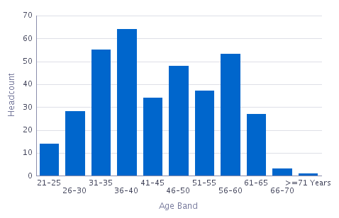
Age Band | Headcount | FTE
21-25 | 14 | 13.80
26-30 | 28 | 24.71
31-35 | 55 | 49.01
36-40 | 64 | 54.57
41-45 | 34 | 29.64
46-50 | 48 | 45.96
51-55 | 37 | 30.99
56-60 | 53 | 40.58
61-65 | 27 | 20.13
66-70 | 3 | 1.80
>=71 Years | 1 | 0.60
Grand Total | 364 | 311.78

The dataset indicates that the 31–49 age cohort is the single largest segment of the District Nursing workforce (201 staff in total). While the data does not provide any information on personal circumstances, it is recognised that people within this age range often belong to what is commonly referred to as the ‘sandwich generation’, individuals who are more likely to be balancing both childcare responsibilities and caring roles for older relatives, potentially leading to increased levels of personal stress, and susceptibility to infectious diseases.

  - Impact on Variable Pay

Variable pay data from Allocate gives further insight in respect of the impact of sickness on variable pay. For the period November 2024 to October 2025, variable pay totalled 13,593.5 hours across the period. The breakdown of variable pay is:
Driver | Total hours | Share of overall total
Long-term sickness | 16,710.00 | 43.69%
Vacancy cover | 10,316.50 | 26.97%
Short-term sickness | 7,541.50 | 19.72%
Surge activity | 1,548.75 | 4.05%
High acuity | 1,437.75 | 3.76%
Parental/Special leave | 875.50 | 2.29%

Combining long- and short-term sickness accounts for 24,251.5 hours (63.4%) of all variable-pay hours in the period confirming that absence remains the principal driver of reliance on variable staffing.
Vacancy cover is the second structural driver. Vacancy-related hours form just over a quarter of total variable pay, pointing to ongoing recruitment challenges that keep the baseline establishment under strain.
Surge and high-acuity together make up roughly 8% of the overall total.

Month | LT Sick | ST Sick | Vacancy | Parental/Special | Surge | High Acuity | Total (hrs)
Nov-24 | 1289.5 | 531.5 | 1329.5 | 76.0 | 129.8 | 128.5 | 3484.8
Dec-24 | 1044.5 | 572.5 | 806.5 | 37.0 | 276.8 | 143.8 | 2881.0
Jan-25 | 1127.0 | 634.3 | 737.5 | 16.0 | 91.5 | 105.0 | 2711.3
Feb-25 | 1327.3 | 457.3 | 616.3 | 15.5 | 52.5 | 79.0 | 2547.8
Mar-25 | 1283.0 | 579.8 | 741.5 | 114.0 | 55.8 | 176.5 | 2950.5
Apr-25 | 1175.5 | 631.5 | 859.0 | 206.5 |  | 42.0 | 2914.5
May-25 | 1284.5 | 1011.5 | 918.0 | 97.0 | 28.5 | 141.0 | 3480.5
Jun-25 | 1089.0 | 927.8 | 590.3 | 78.0 | 59.0 | 180.5 | 2924.5
Jul-25 | 1200.3 | 609.0 | 501.8 | 36.0 | 353.5 | 127.5 | 2828.0
Aug-25 | 2049.3 | 585.0 | 907.8 | 19.5 | 286.0 | 90.0 | 3937.5
Sep-25 | 2136.0 | 521.0 | 1158.0 | 69.0 | 135.0 | 44.5 | 4063.5
Oct-25 | 1704.3 | 480.5 | 1150.5 | 111.0 | 80.5 | 179.5 | 3706.3

The drivers of overtime and additional hours are not captured by Allocate therefore this report is unable to provide further analysis in respect of sickness absence on this aspect of variable pay.

7 Sickness Absence Interventions at District Nursing
Four District Nursing Absence Summits have taken place between June and November 2025, providing strengthened oversight, scrutiny and collective problem-solving around sickness management across all clusters. Further Absence Summits are planned monthly. These summits have shifted from primarily data-focused reviews to driving consistent practice, enabling earlier intervention, improved documentation, and clearer support pathways. They have also supported local ownership of attendance initiatives, including improved communication standards and earlier escalation to HR for complex or prolonged cases.
A comprehensive programme of cluster sickness audits has been undertaken from August to December 2025. The audits found a strong level of awareness of the Managing Attendance at Work Policy and a clear commitment to supporting staff back into work. However, several areas requiring reinforcement were identified around a back-to-basics and consistent application approach: the introduction of a standardised first point of contact reporting pathway, more consistent use of return-to-work documentation, routine use of communication logs, and formalised weekly phased-return reviews. Recommendations relating to 8th-day welfare letters, fit-note management, and more systematic use of Occupational Health have also been recommended. A DN-wide electronic sickness tracker is in development to support consistent monitoring. A follow-up audit cycle is planned for spring 2026 to assess implementation.
In addition, a structured pulse-survey programme across the clusters (Nov 2024–Feb 2025), generated actionable insights into workload, team culture, communication, and wellbeing. The feedback has informed targeted actions such as reinstating regular team meetings, strengthening induction and competency frameworks. Cluster-level feedback sessions have taken place, with staff in several areas reporting noticeable improvements following interventions.
The revised HR sickness pathway is now widely embedded within District Nursing. It has been circulated to all staff, shared through the District Nursing Hub, and displayed across cluster bases to support clarity and consistency. Managers are using ESR prompt reports and adopting local live absence-tracking spreadsheets to ensure timely action on triggers, fit-note expiry and review cycles. ESR/BI training has also been delivered to support improved data interpretation and proactive management.
District Nursing’s improvement programme is reinforced by strong organisational performance in mandatory training (90.51% effective 31 December 2026) and a continuing focus on PADR compliance (69.23% effective 31 December 2025), supported by the District Nursing and Community Wound Care Action Plan. This includes leadership development (MAAW, Footprints, Brilliant Basics), team communication standards (minimum two meetings per month), and improved onboarding via Entry and Stay interviews. The service has also strengthened access to pastoral and psychological support through Restorative Clinical Supervision (over 100 staff supported), promotion of Wellbeing Champion roles, TRiM support and ongoing Care After Death support sessions, with positive feedback from staff.
A particular focus has been placed on workload, wellbeing, and cultural improvement, informed by the pulse survey findings. Person-centred practices, such as civility saves lives sessions, enhanced wellbeing signposting and improved leadership visibility, have been promoted and implemented, alongside OD led team interventions for the leadership team.

  - PCT People Plan to Support Attendance and Employee Wellbeing

The HR Business Partner Team developed the PCT People Plan 2025/26 to support the Service Group as a whole, to maximise attendance at attendance at work and improve staff and patient experience. The embedded attachment below summaries the previous and ongoing/ planned interventions to support attendance and employee wellbeing by the HRBP team.
Service areas are also encouraged to ensure staff are aware of internal and external wellbeing services, resources and support.
7 Conclusion
The findings of this deep dive confirm that sickness absence within District Nursing remains a significant and sustained challenge, driven primarily by long-term health conditions, most notably mental health related illness. The data demonstrates a clear upward trend in long-term absence over the last three years, accompanied by seasonal fluctuations in short-term sickness. This pattern, combined with a mid-to-late career workforce profile and substantial personal and professional pressures, highlights the need for sustained, targeted, and person-centred interventions.
The impact of sickness on service delivery is evident, with absence accounting for more than 60% of all variable pay hours (not including overtime and additional hours), with the driver of long-term sickness alone responsible for almost half of the total. This reliance on temporary staffing underscores the interconnectedness of wellbeing, workforce stability, and financial sustainability across the service.
The programme of Absence Summits, local sickness audits, targeted wellbeing initiatives, and enhanced managerial support structures have already begun to strengthen consistency and early intervention across clusters. These improvements will provide a strong foundation on which to continue building. However, further collective action is required to meet the Health Board target of reducing sickness by 25% by March 2026 and ultimately returning absence levels to the Welsh Government target of 5.08%.
Achieving these ambitions will require continued focus on the priority themes identified in this report - mental health, musculoskeletal health, chronic conditions, and workload-related pressures, alongside robust and consistent application of attendance management processes. Maintaining momentum on cultural, leadership and wellbeing initiatives will also be essential to ensuring staff feel supported, valued, and able to thrive in the demanding context of District Nursing.
District Nursing has already demonstrated engagement and willingness to drive improvement. With ongoing collaboration, clear accountability, and sustained organisational support, the service is well positioned to make meaningful progress in improving staff wellbeing, reducing absence, and strengthening care delivery for patients and communities.

- Recommendations

- A local level focused approach and revisitation to current action plan to:
  - Address the themes arising for absence as listed within this report.
  - Reach the sickness target of 9.5% as required by 31 March 2026 to meet the Health Board objective of a reduction in sickness absence FTE from the August 2025 figure.
  - Continue to reduce the absence percentage to the Welsh Government target of 5.08%.
  - Follow up sickness audits to be scheduled for spring 2026.

- Continuation of the scrutiny of variable pay against sickness drivers, in line with Health Board objectives.

- Continuation of Absence Summits to discuss the content of the report and to further develop and support the current action plan

